INT308 Session Management and Web Security

CTF Challenge: Testing for Session Hijacking on OWASP Juice Shop
Name: Patrick Damian Ozimede
Environment: Kali Linux (legion@pastor, 192.168.5.139) targeting a locally deployed OWASP Juice Shop instance (Docker, 127.0.0.1:3000)

Introduction
Session hijacking occurs when an attacker gains unauthorized access to a legitimate user's session, typically by stealing, predicting, fixating, or replaying a session token. Because a valid session token often grants the same level of access as a username and password, weaknesses in session management can completely undermine an otherwise secure authentication system. This report documents a session hijacking assessment performed against a locally deployed instance of OWASP Juice Shop, covering session token predictability, session fixation, session expiration, and transport security.

Methodology
OWASP Juice Shop was deployed locally via Docker (bkimminich/juice-shop image), exposed on http://127.0.0.1:3000. Testing was performed using the Kali Linux browser's built-in Developer Tools (Storage/Cookies panel) to inspect the application's authentication cookie, and jwt.io was used to decode the JSON Web Token (JWT) issued by the application. Each of the four focus areas specified in the challenge -- session ID predictability, session fixation, session expiration, and transport security -- was tested directly against this instance using only the tester's own account.

Findings

1. Session ID Predictability
Unlike a simple sequential or random session ID, Juice Shop issues a signed JSON Web Token (JWT) as its authentication cookie ('token'). The token is not predictable in the traditional sense, since it is cryptographically signed by the server. However, decoding the token's payload (which is base64-encoded, not encrypted) revealed the full account record, including the account ID, email address, role, and -- notably -- the account's password hash (MD5). This means anyone who obtains the token, whether via network interception or client-side script access, can read this sensitive data without needing the server's signing key.
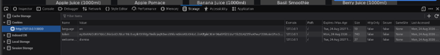
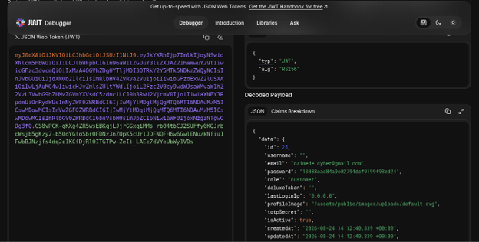

2. Session Fixation
A token value ('fixedtoken12345') was manually set in the browser's cookie store before logging in, replicating the fixation technique used successfully against DVWA in Lab 1. Upon logging in, Juice Shop issued a brand-new, properly signed JWT, completely overwriting the fixed value. This confirms Juice Shop is not vulnerable to session fixation: because a valid token must be cryptographically signed with the server's private key, a client cannot pre-plant or forge an acceptable token value, unlike DVWA's server-generated-but-unvalidated PHPSESSID.
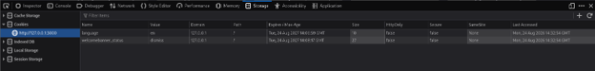
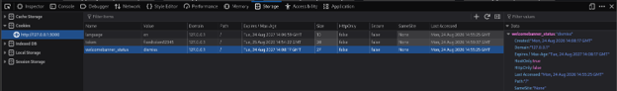


3. Session Expiration
Decoding an active JWT via jwt.io showed no 'exp' (expiration) claim in the payload, meaning the token contains no built-in, self-enforced expiry. Logging out correctly cleared the token cookie client-side, and re-adding the same (old) token value afterward did not restore the logged-in state in the application UI. This suggests session termination is enforced at the application/front-end state level rather than by the JWT itself becoming cryptographically invalid, since a JWT with no exp claim would otherwise remain valid indefinitely if replayed directly against a backend API endpoint. The absence of a token blocklist or expiration mechanism represents a real gap, even though the front-end behavior appeared secure in this test.
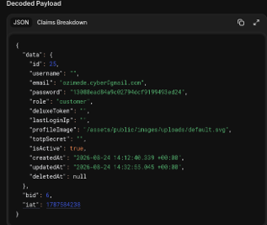

4. Transport Security
The Juice Shop instance was served over plain HTTP (http://127.0.0.1:3000), and the 'token' cookie's Secure attribute was set to false, meaning the session token could be transmitted over an unencrypted connection and intercepted by anyone able to observe network traffic between the client and server, such as on a shared or untrusted network.

Countermeasures
- Add an exp (expiration) claim to issued JWTs with a reasonable, short expiration window, and implement refresh-token rotation for maintaining longer sessions.
- Avoid embedding sensitive fields, such as password hashes, inside JWT payloads, since JWT payloads are base64-encoded and readable by anyone who obtains the token, not encrypted.
- Implement a server-side token revocation or blocklist mechanism for logout events, since JWTs cannot otherwise be invalidated before their natural expiry once issued.
- Enforce HTTPS in all environments and set the Secure flag on authentication cookies to prevent transmission over unencrypted connections.
- Set the HttpOnly flag on the token cookie to reduce its exposure to theft via client-side script injection (XSS).

Conclusion
This assessment of OWASP Juice Shop found that while its JWT-based authentication architecture inherently resists session fixation, since tokens must be cryptographically signed by the server, it introduces different risks compared to the traditional session-ID model tested against DVWA in earlier labs. Most notably, the JWT payload exposed sensitive account data, including a password hash, in plainly decodable form, and the token itself carried no expiration claim. Securing web sessions requires understanding the specific architecture in use: a defense that closes one class of vulnerability, such as fixation, does not guarantee protection against others, such as data exposure or indefinite token validity. Comparing DVWA's legacy session-ID model against Juice Shop's modern JWT model over the course of this course's labs demonstrated that both older and newer session management approaches carry their own distinct risks if not implemented carefully.

