INT307 Web Application Security

Lab 5: Security Misconfiguration in DVWA

Name: Patrick Damian Ozimede
Program: ICDFA Internship
Date: August 2026

Lab Environment
Attacker machine (Kali Linux): legion@pastor, 192.168.5.139
Target (OWASP BWA VM): 192.168.5.130 (DVWA v1.8, Apache/2.2.14 Ubuntu, PHP 5.3.2-1ubuntu4.30)
Tools used: Firefox Developer Tools, Burp Suite Community Edition v2026.3.2

Exercise 1: Default Credentials and Permissions

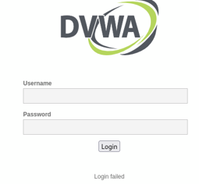

An attempt to log in using the commonly documented DVWA default credentials (admin / password) failed. Testing revealed the actual working credentials configured on this instance are admin / admin.
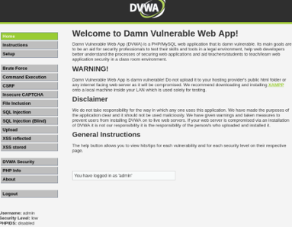

Reflection
The credentials in active use (admin / admin) are arguably weaker than the documented default (admin / password), since the username and password are identical and require no reference to documentation to guess. This demonstrates that default credential risk is not limited to "textbook" defaults - any predictable, weak, or unchanged credential set exposes the application to trivial unauthorized access. Default and weak credentials remain one of the most common initial access vectors in real-world breaches because they require no technical exploitation, only a guess.

Exercise 2: Directory Listing
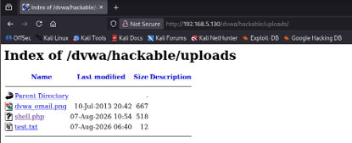

Navigating directly to http://192.168.5.130/dvwa/hackable/uploads/ returned a full Apache-generated directory index rather than a 403 Forbidden or 404 error. The listing exposed the presence, filenames, and upload timestamps of every file in the folder, including dvwa_email.png, shell.php, and test.txt - the exact malicious PHP web shell and test file uploaded during the previous file upload lab.

Reflection
Directory listing being enabled is a serious misconfiguration in its own right, and it significantly compounds file upload vulnerabilities. An attacker does not need to guess or predict an uploaded filename in advance; they can simply browse the directory and click straight through to any shell, backup file, or sensitive document sitting in an exposed folder. This finding directly links Exercise 2 to the file upload vulnerability explored in Exercise 5, demonstrating how multiple small misconfigurations combine into a much more serious exploitation chain.

Exercise 3: Error Handling Misconfiguration
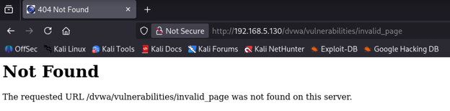

Accessing a non-existent page (/dvwa/vulnerabilities/invalid_page) returned a generic Apache 404 "Not Found" message with no stack trace, internal file paths, or server version banner - a properly handled web-server-level error.
To test error handling at the application layer, a malformed parameter was submitted to the SQL Injection page (?id=test'&Submit=Submit).

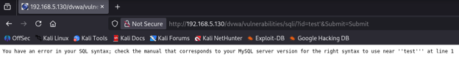

This returned a raw, unhandled MySQL error: "You have an error in your SQL syntax; check the manual that corresponds to your MySQL server version for the right syntax to use near ''test''' at line 1."

Reflection
This is a clear inconsistency in error handling across layers of the stack. The web server itself (Apache) handles routing errors like 404s cleanly, with no information disclosure. However, at the application layer, unsanitized input reaching the database directly triggers a verbose, unhandled MySQL error message. This confirms the backend database technology (MySQL) and reveals that raw database errors are surfaced directly to end users rather than being caught and replaced with a generic error page. This gives an attacker a significant head start in crafting SQL injection payloads, since they receive direct feedback confirming both the database type and that their input is reaching the query layer unfiltered. Effective error handling must be applied consistently across every layer of an application, not just at the web server.

Exercise 4: Security Headers

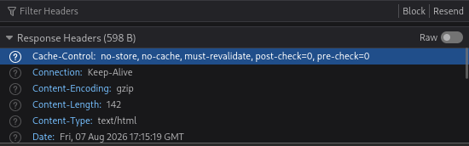
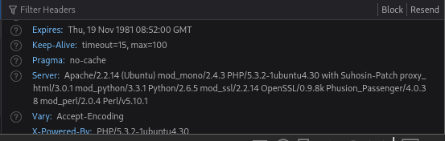

HTTP response headers were inspected using Firefox Developer Tools (Network tab) while loading a DVWA page.

Headers Present
Standard headers observed included Cache-Control, Connection, Content-Encoding, Content-Length, Content-Type, Date, Expires, Keep-Alive, Pragma, and Vary - none of which are security-specific.
Notably, the Server header disclosed extensive version information: Apache/2.2.14 (Ubuntu) mod_mono/2.4.3 PHP/5.3.2-1ubuntu4.30 with Suhosin-Patch, along with mod_python, mod_ssl, OpenSSL, and Perl version details. An X-Powered-By header additionally confirmed PHP/5.3.2-1ubuntu4.30.

Security Headers Checked
Security Header | Present?
X-Content-Type-Options | Missing
X-Frame-Options | Missing
Content-Security-Policy | Missing
Strict-Transport-Security | Missing

Reflection
None of the four requested security headers are implemented on this application. Their absence has concrete consequences: missing X-Frame-Options or a Content-Security-Policy frame-ancestors directive leaves the application vulnerable to clickjacking via iframe embedding; missing X-Content-Type-Options: nosniff permits MIME-sniffing attacks where a browser may misinterpret a file's content type; and the missing Strict-Transport-Security header is consistent with the application running over plain HTTP without TLS, meaning secure transport has not been configured at all. Compounding this, the server actively over-shares detailed version information via the Server and X-Powered-By headers, effectively handing an attacker a precise software fingerprint that can be matched directly against known CVEs for those exact component versions. Best practice is to implement all relevant security headers and to suppress or minimize version-disclosing headers to reduce the attack surface available through reconnaissance alone.

Exercise 5: Insecure File Upload Configuration
This exercise was addressed by revisiting and reframing findings from the prior File Upload Vulnerabilities lab, viewed here specifically through a misconfiguration lens rather than an exploitation lens.

Access and Test Summary
DVWA's Upload feature was previously tested extensively. At Low security level, a Weevely-generated PHP web shell (shell.php) was uploaded with no restriction on file type, content, or size, and stored directly under the publicly web-accessible path /dvwa/hackable/uploads/.

Reflection: Was the File Uploaded?
Yes, at Low security level the upload succeeded outright with no validation. At Medium level, upload was blocked based only on the client-supplied Content-Type header, and this check was bypassed using Burp Suite by changing the header from application/x-php to image/jpeg - the server never verified the actual file content. At High level, both header spoofing and a combined filename/header bypass attempt (renaming to shell.phtml plus spoofing the header) failed, indicating deeper content-based validation at that tier.

Misconfiguration Analysis
1. Uploads are stored inside the web root, in a location where PHP execution is enabled - the hackable/uploads/ directory is both publicly reachable via HTTP and configured to execute PHP files directly, rather than being isolated outside the web root or in a non-executable directory.
2. Directory listing is enabled on the uploads folder (confirmed in Exercise 2), which significantly compounds the file upload risk: an attacker does not need to guess or predict the uploaded filename, since the entire directory is browsable and clickable.
3. Validation is inconsistent across configurable security levels - Low applies zero validation, while Medium applies only a client-trusted header check that is trivially defeated with basic tooling such as Burp Suite. This indicates upload security was not treated as a first-class design concern.

Implications
Combined, these misconfigurations allow an attacker to achieve remote code execution on the server via a straightforward upload-then-execute chain, with directory listing removing even the minor obstacle of needing to know the uploaded filename in advance.

Mitigation Recommendations
Store all uploaded files outside the web root, or in a directory with script execution explicitly disabled at the web server level. Validate file content (magic bytes/structure) rather than trusting headers or extensions. Disable directory listing globally (Options -Indexes in Apache configuration). Rename uploaded files to random, non-guessable values server-side. Apply consistent, content-based validation regardless of any configurable "security level" - production systems should not offer a low-security mode at all.

Conclusion
This lab explored a range of security misconfigurations across DVWA, demonstrating that vulnerabilities are not limited to application logic flaws but frequently arise from how an application and its underlying server are configured and maintained. Weak default credentials (admin/admin), directory listing exposing sensitive uploaded files, inconsistent error handling between the web server and application layers, a complete absence of standard security headers combined with excessive version disclosure, and insecure file upload storage all compounded one another to create a much more serious overall attack surface than any single issue alone. This reinforces a core lesson of secure application design: misconfigurations are cumulative, and addressing them requires a defense-in-depth approach across every layer of the stack, from server hardening and credential management to HTTP header policy and file handling logic.

