INT308: Session Management and Web Security

Lab 3: Cross-Site Request Forgery (CSRF) Protection
Name: Patrick Damian Ozimede
Environment: Kali Linux (legion@pastor, 192.168.5.139) targeting DVWA v1.8 on OWASP BWA VM (192.168.5.130) via root SSH access

Introduction
Cross-Site Request Forgery (CSRF) is an attack that exploits the trust a web application places in an authenticated user's browser, tricking that browser into submitting unwanted requests on the user's behalf. This lab demonstrated a working CSRF attack against DVWA's password-change function, implemented server-side CSRF token protection directly in DVWA's source code, and verified that the same attack was blocked once the protection was in place.

Exercise 1: Understanding CSRF Attacks

Steps Performed
- DVWA's CSRF page (vulnerabilities/csrf/) allows an authenticated user to change the admin password via a GET request with password_new, password_conf, and Change parameters. A standalone HTML file was created outside of DVWA, containing a form with hidden inputs pre-filled with an attacker-chosen password, disguised as a prize-claim page. This file was opened in the same browser session already authenticated to DVWA, and the submit button was clicked.
- An initial attempt appeared to succeed based on the resulting URL parameters, but logging in with the new password failed, while the original admin/admin credentials still worked. Reviewing DVWA's server-side source (source/low.php) revealed the handler only processes the request if isset($_GET['Change']) is true -- the initial attack form omitted this hidden field. Adding a hidden Change=Change input to the attack form resolved this, and the subsequent attack successfully changed the account password without any credentials or direct interaction with DVWA.

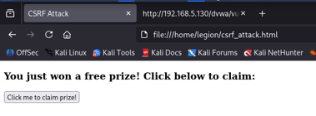

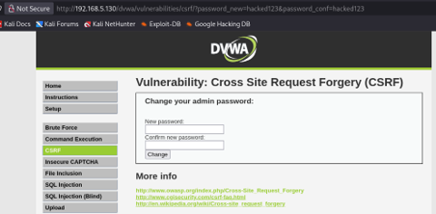

Findings
The unprotected CSRF endpoint allowed a fully external, attacker-controlled page to change the admin account password using only the victim's existing authenticated session -- no credentials, confirmation, or additional user interaction beyond a single click were required.

Reflection
This exercise demonstrated a working CSRF attack against DVWA's unprotected password-change function. A form hosted entirely outside DVWA, containing hidden fields matching the target's expected parameters, was able to submit a password-change request using the victim's existing authenticated session, without any user interaction beyond a single click. Notably, an initial attack attempt appeared to fail because the form omitted the submit button's name/value (Change), which DVWA's backend checks via isset($_GET['Change']). This silently prevented the update with no error shown, illustrating that even minor mismatches in required parameters can not only cause an attack to fail undetected, but also that an attacker who studies the target form closely can trivially replicate every required field.

Exercise 2: Implementing CSRF Protection

Steps Performed
- CSRF token protection was added directly to DVWA's low-security CSRF handler (source/low.php): a per-session token is generated if one does not already exist, and any password-change request is now rejected unless it includes a csrf_token parameter matching the value stored in $_SESSION. Since this environment runs PHP 5.3.2, the modern random_bytes() function used in the lab's example was unavailable and md5(uniqid(mt_rand(), true)) was used instead to generate the token. The token is regenerated after each use to prevent reuse. The legitimate form in index.php was updated to include a hidden csrf_token field populated from the session.
- While implementing this, an unrelated bug from Lab 2's session-expiration code surfaced: the redirect header('Location: logout.php') used a relative path, which resolved incorrectly (to a non-existent nested path) when triggered from within the csrf/ subdirectory. This was fixed by changing the redirect to an absolute path (/dvwa/logout.php).
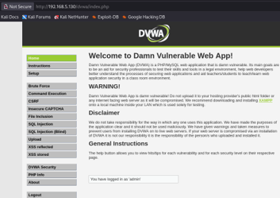

Findings
The legitimate DVWA form, now including the correct csrf_token, successfully changed the password and displayed "Password Changed", confirming the token generation and validation logic did not break normal application functionality.

Reflection
Implementing a CSRF token involved generating a random token per session, embedding it as a hidden field in the legitimate form, and validating it server-side before processing any password change. Since this environment runs PHP 5.3.2, the modern random_bytes() function was unavailable and md5(uniqid(mt_rand(), true)) was used as a legacy-compatible alternative for token generation. This exercise also surfaced an unrelated but real bug from the previous lab's session-expiration code: a relative redirect path (logout.php) failed when triggered from a nested URL, requiring a fix to use an absolute path (/dvwa/logout.php). This is a good reminder that redirect paths in web applications should generally be absolute to avoid breaking depending on which page triggers them.

Exercise 3: Testing CSRF Protection

Steps Performed
- The original attack HTML file, which does not include a csrf_token field, was re-opened and submitted again while authenticated to DVWA, to test whether the new protection would block the same attack that succeeded in Exercise 1.
- The password was then verified to remain unchanged by logging out and logging back in with the original admin/admin credentials.
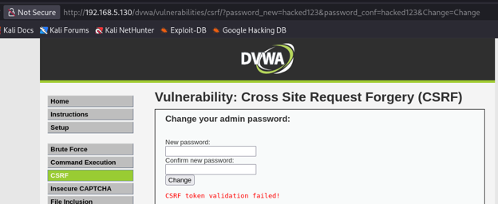

Findings
The attack request was rejected with a "CSRF token validation failed!" message, and the account password remained unchanged, confirming the token-based protection successfully blocked the same attack that previously succeeded.

Reflection
Re-running the original attack form, which did not include a csrf_token field, against the now-protected endpoint resulted in a clear "CSRF token validation failed!" message, and the password was confirmed unchanged. This confirms the token-based protection is effective against a naive replay of the original attack. However, this protection has limitations: if the token were leaked via another vulnerability (such as XSS, explored in INT307), an attacker could still forge a valid request. CSRF protection should therefore be treated as one layer of defense, complemented by measures such as the SameSite cookie attribute (limited by this environment's legacy PHP, as seen in Lab 2), re-authentication for sensitive actions, and general output encoding to prevent token theft via XSS.

Conclusion
This lab demonstrated the full lifecycle of a CSRF vulnerability: successful exploitation against an unprotected endpoint, implementation of a server-side token-based defense compatible with a legacy PHP 5.3.2 environment, and verification that the same attack was blocked once the defense was in place. Understanding both how to exploit and how to properly defend against CSRF is essential for building and maintaining secure web applications.

