INT309: Web Technologies and Database Security

Lab 2: Web Development Components and Security Threats
Patrick Damian Ozimede

Overview
This report documents the completion of Lab 2, which explored front-end and back-end web development components and the security threats commonly associated with each. A small custom web application (an HTML/CSS/JavaScript front end backed by a PHP and MariaDB back end) was built on Kali Linux to demonstrate SQL injection and cross-site scripting vulnerabilities firsthand, followed by a cross-site request forgery test against a previously hardened DVWA instance.

Environment Setup
PHP 8.4 and MariaDB were installed locally on Kali Linux to host a standalone vulnerable application, separate from the OWASP BWA virtual machine used in prior labs. A database (test1) and a dedicated application user (webapp) were created, and PHP's built-in development server was used to serve the application at http://127.0.0.1:8080. One environment note worth recording: PHP 8.1 and later throw exceptions on mysqli errors by default, rather than failing silently. This meant that malformed injection payloads produced visible 500 errors with full stack traces in the server log, which turned out to be useful evidence of the injection reaching the database layer, rather than an obstacle.

Exercise 1: Exploring Front-End Development Components
Common front-end technologies (HTML, CSS, JavaScript, and frameworks such as React, Angular, and Vue.js) were reviewed. A simple front-end application was then built, consisting of a header with a navigation menu, a contact form (First Name, Last Name, School), and an interactive button that toggles displayed text using JavaScript.
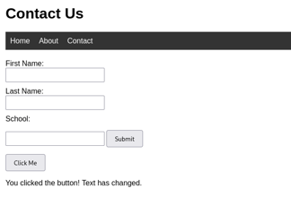

Reflection
Front-end technologies work together to create a cohesive user experience by dividing responsibilities: HTML provides structure and content, CSS handles presentation and layout, and JavaScript adds interactivity and dynamic behavior. In this exercise, this division was visible in a simple form: HTML defined the header, navigation, and input fields, CSS styled the layout and spacing, and JavaScript powered the button that changed the displayed text on click without requiring a page reload. This separation of concerns is what makes modern front-end frameworks like React, Angular, and Vue.js effective, they build on the same fundamental model but add structure for managing state and reusable components at scale.
However, this exercise also demonstrated how easily front-end code becomes an attack surface. Because the form submits directly to a back-end script with no client-side or server-side sanitization, an attacker can inject malicious JavaScript into an input field, and if that input is later rendered back to a page without escaping, the browser executes it as if it were legitimate code. This is exactly how cross-site scripting occurs, and it highlights that front-end trust boundaries are not enough. Similarly, a form that performs a state-changing action without a CSRF token can be triggered from an entirely different site the user happens to have open, since the browser will still send the user's session cookies along with the forged request. Both vulnerabilities stem from the same root issue: treating user input, or a browser request, as inherently trustworthy.

Exercise 2: Understanding Back-End Development Components
Common back-end technologies were reviewed, including server-side languages (PHP, Python, Java, Node.js), databases (MySQL/MariaDB, MongoDB, PostgreSQL), and web frameworks (Express, Django, Laravel). A basic back-end script (process.php) was built using PHP and the mysqli extension to connect to a MariaDB database, insert submitted form data, and display stored records. The script was written to be intentionally vulnerable, mirroring the lab's example: user input was concatenated directly into the SQL query with no sanitization or prepared statement, and retrieved data was echoed back to the page without output escaping.

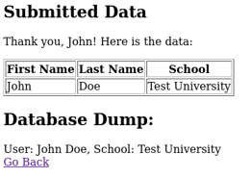

Reflection
Back-end components form the trust boundary of a web application: they process user input, communicate with databases, and enforce (or fail to enforce) business logic and access rules. In this exercise, the back-end consisted of a PHP script using the mysqli extension to insert form data directly into a MariaDB database. Because the query was built through direct string concatenation rather than a prepared statement, user input was able to escape its intended context as a quoted string value and be interpreted as executable SQL syntax, which is the definition of a SQL injection vulnerability.
Attempting this firsthand made the mechanism concrete rather than theoretical: a single unescaped quote character was enough to break the query, and in a differently structured query such as a login check, could be used to bypass authentication entirely. Beyond injection, the back-end code also exposed a broader issue: the application echoed raw database contents back to the page, including a full "database dump" with no access control, meaning any visitor could view every record ever submitted by any user.
This illustrates that back-end vulnerabilities tend to have more severe consequences than front-end ones, since the back-end is where data persistence, authentication, and authorization actually happen. A compromised or poorly written back-end can expose an entire database, not just a single user's session, which is why input validation, prepared statements, and the principle of least privilege for database accounts are considered foundational rather than optional security practices.

Exercise 3: Identifying Security Threats
Five common OWASP Top Ten threats were reviewed: SQL Injection, Cross-Site Scripting (XSS), Cross-Site Request Forgery (CSRF), Security Misconfiguration, and Insecure Deserialization. Three of these (SQLi, XSS, and CSRF) were then tested directly.

SQL Injection Test
The payload ' OR '1'='1 was submitted in the First Name field of the custom application. Because the field value is concatenated directly into an INSERT query with no sanitization, the injected quote terminated the intended string early and caused the remaining OR '1'='1 fragment to be parsed as SQL syntax rather than text. This produced an unhandled mysqli exception (a 500 Internal Server Error), with the server log confirming a "Truncated incorrect DOUBLE value" error, direct evidence that the injected input reached and altered the structure of the SQL query sent to the database.
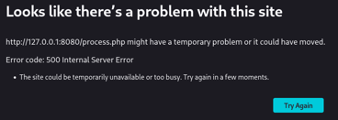

Cross-Site Scripting (XSS) Test
A script payload was submitted in the School field. An initial attempt using single quotes inside the payload also broke the SQL query (the same unsanitized concatenation issue affecting every field), producing another 500 error. A revised payload using double quotes instead, <script>alert("XSS")</script>, avoided breaking the SQL syntax and was successfully stored and later executed by the browser when the page rendered the stored data back without output escaping, confirming a stored XSS vulnerability. The alert fired twice, once for the "Submitted Data" table and once for the "Database Dump" section, since both display the same unsanitized field. The affected School column rendered as empty in the page, not because no data was stored, but because the browser executed the payload as a script rather than displaying it as visible text.

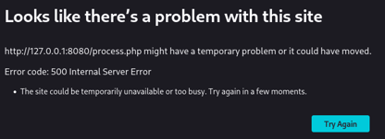

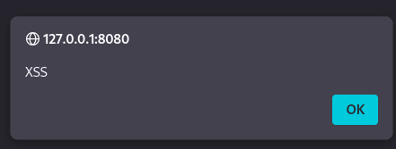

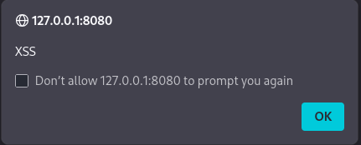

Cross-Site Request Forgery (CSRF) Test
CSRF was tested against the DVWA CSRF module, which had previously been patched with a custom per-session token system in an earlier lab. A classic CSRF attack URL was crafted (a GET request with password_new and password_conf parameters but no csrf_token), and submitted while logged in as admin to simulate a forged request from an attacker-controlled page. The application correctly rejected the request with a "CSRF token validation failed!" message, confirming the token-based protection was functioning. A legitimate password change was then submitted through the actual form, which succeeded normally, confirming the protection blocks forged requests without interfering with genuine use. The password was reverted to its original value afterward.

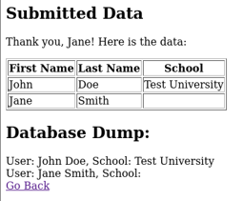

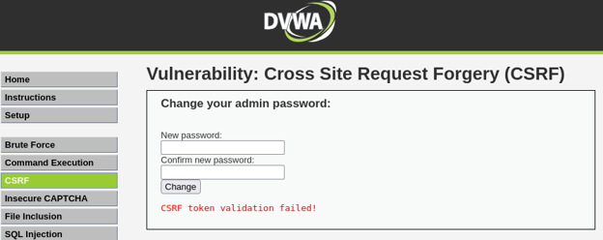
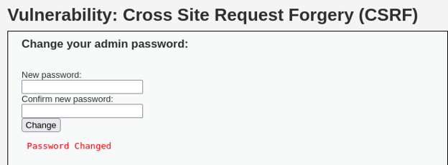

Reflection
This exercise brought together SQL injection, cross-site scripting, and cross-site request forgery, three of the OWASP Top Ten's most consistently ranked threats, and demonstrated each one against a real application rather than as abstract concepts. The SQL injection test showed how directly concatenated user input can escape its intended string context and be parsed as executable SQL, in this case triggering a database-level type conversion error, but in a differently structured query (such as a login check) the identical technique is capable of bypassing authentication entirely. The stored XSS test showed how unsanitized output allows attacker-supplied script tags to execute in the context of any user who later views that data, with the added danger that the payload persists in the database and re-executes on every page load, not just at the moment of submission. This is a meaningfully more serious risk than reflected XSS, since it requires no ongoing interaction from the attacker once the payload is stored. The CSRF test, run against a previously hardened DVWA instance from earlier coursework, demonstrated the opposite side of the equation: a properly implemented per-session token successfully rejected a forged request while still allowing the legitimate, intentional request to succeed. Together, these three tests reinforce a common theme across all of the OWASP Top Ten: nearly every major web application vulnerability traces back to a failure to treat user-controllable input, whether from a form field, a URL parameter, or a cross-origin request, as untrusted until it has been validated, sanitized, or cryptographically verified. The practical mitigations demonstrated or discussed here, prepared statements for SQL injection, output encoding and escaping for XSS, and per-session CSRF tokens, are not exotic defenses; they are foundational practices that, when omitted, account for a disproportionate share of real-world application breaches.

Recommendations for Secure Coding Practices
- Based on the findings above, the following practices are recommended:
- Use parameterized queries or prepared statements for all database interactions, never concatenate user input directly into SQL strings.
- Escape or encode all output rendered back to a page (e.g., htmlspecialchars() in PHP) to prevent stored and reflected XSS.
- Implement per-session, unpredictable CSRF tokens on all state-changing forms, and validate them server-side before processing the request.
- Apply the principle of least privilege to database accounts; avoid using a root or administrative account for routine application queries.
- Avoid exposing full database contents or debug information (such as unhandled exception stack traces) to end users in production environments.
- Validate and sanitize all user input on the server side, client-side validation alone is not a security control.

Conclusion
This lab provided hands-on experience building both sides of a simple web application and identifying how vulnerabilities are introduced through common coding shortcuts. Constructing a custom vulnerable application, rather than only exploiting a pre-built one, clarified exactly how SQL injection and stored XSS arise from unsanitized input and output handling. Revisiting DVWA's CSRF module after an earlier hardening exercise also demonstrated that the same principles apply in reverse: a correctly implemented defense measurably blocks the same class of attack without disrupting legitimate functionality. Together, these exercises reinforce that secure coding is not an afterthought but a set of concrete, well-understood practices that must be applied consistently across both front-end and back-end components.

