INT307 Web Application Security

Lab 4: File Upload Vulnerabilities in DVWA
Name: Patrick Damian Ozimede
Program: ICDFA Internship
Date: August 2026

Lab Environment
Attacker machine (Kali Linux): legion@pastor, 192.168.5.139
Target (OWASP BWA VM): 192.168.5.130 (DVWA v1.8, PHP 5.3.2-1ubuntu4.30)
Tools used: Weevely 4.0.1, Burp Suite Community Edition v2026.3.2

Exercise 1: Exploring the File Upload Page
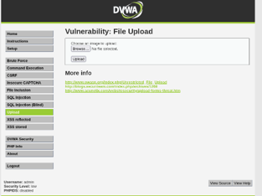

Observations
The Upload page presents a minimal form: a single file input labeled "Choose an image to upload," a Browse button, and an Upload button. No visible client-side restriction on file type or size was displayed on the page itself.

Test Upload (test.txt)

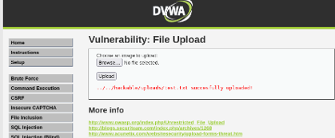

A harmless text file (test.txt) was uploaded successfully with no restriction, confirming the form label ("image") is not enforced. The success message revealed the storage path: ../../hackable/uploads/test.txt, with the original filename preserved unmodified.

Exercise 2: Generate a PHP Shell Using Weevely
Weevely 4.0.1 was already installed as a system package on Kali (/usr/bin/weevely), so no manual clone of the legacy weevely3 repository was required.
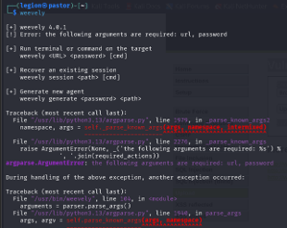

Shell Generation
Command used: weevely generate YourPassword123 shell.php
Result: shell.php generated successfully, 696 bytes.

Code Review
Inspecting shell.php with cat revealed obfuscated/encoded binary-like content rather than readable PHP source. Weevely 4.x obfuscates its generated payload by design, making static signature detection more difficult for WAFs or antivirus tools.

Exercise 3: Upload the Malicious Shell at Different Security Levels

Low Security Level
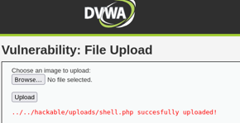

shell.php was uploaded successfully with no validation whatsoever. Upload path confirmed: ../../hackable/uploads/shell.php. This demonstrates a critical vulnerability: no file type, extension, or content checking is performed at Low security level.

Medium Security Level

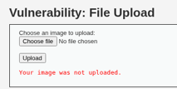

A direct upload attempt of shell.php was rejected. The intercepted request in Burp Suite showed the file part sent with Content-Type: application/x-php.
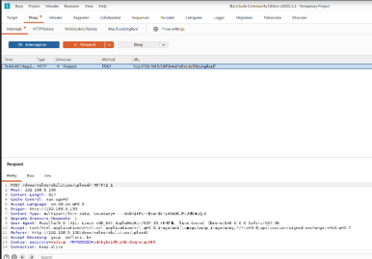

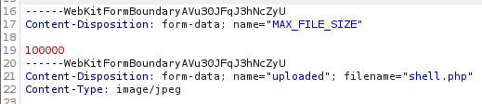

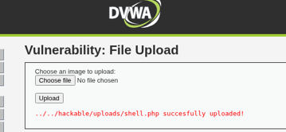

Changing only the Content-Type header value to image/jpeg in Burp Suite, then forwarding the request, resulted in a successful upload. This confirms Medium security level validates only the client-supplied Content-Type header - a value fully controlled by the attacker and never verified against the file's actual content.

High Security Level

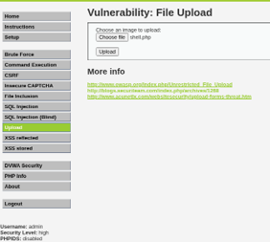



A direct upload attempt was blocked, as expected. The same Content-Type spoofing technique that succeeded at Medium level was attempted via Burp Suite and failed.

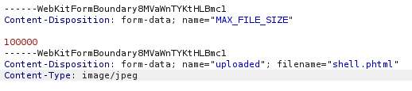



An extended bypass attempt was also made, combining a filename change (shell.php to shell.phtml) with the Content-Type spoof. This also failed, with the server again returning "Your image was not uploaded." This indicates High security level performs validation beyond headers and filenames - most likely inspecting actual file content or structure (e.g., verifying genuine image data), which cannot be bypassed through header or filename manipulation alone.

Exercise 4: Accessing the Uploaded Shell
Security level was reset to Low to test shell access. Browsing directly to http://192.168.5.130/dvwa/hackable/uploads/shell.php returned a blank page with no visible prompt - this is expected behavior for Weevely-generated shells, which only respond to specifically-crafted authenticated POST requests rather than showing an interactive password form in the browser.
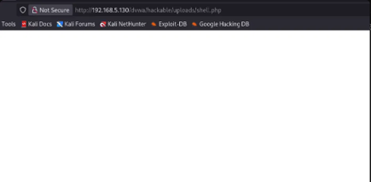

Connecting via the Weevely client directly established a session successfully:
weevely http://192.168.5.130/dvwa/hackable/uploads/shell.php YourPassword123
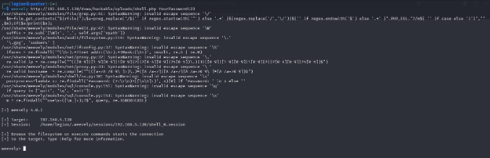

Command Execution Issue
Attempting basic commands (whoami, :system_info) at the weevely> prompt failed with HTTP 500 errors. Investigation via DVWA's PHP Info page revealed the target is running PHP 5.3.2-1ubuntu4.30 (released 2010). The disable_functions directive was confirmed empty, ruling out server-side function restrictions as the cause.
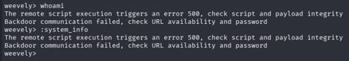

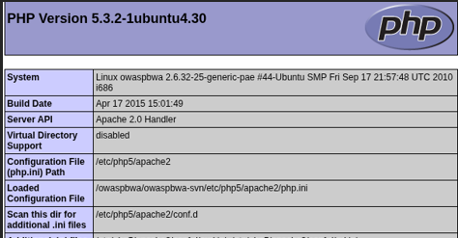

Root cause: Weevely 4.0.1 generates payloads targeting modern PHP syntax and behavior. Executed against PHP 5.3.2, the payload triggers a server-side error rather than completing command execution. This is a tooling/version compatibility issue rather than a defensive control - it illustrates that exploit tooling must match the target software stack, and legacy backends can break modern offensive tools even when the initial file upload vulnerability is fully exploitable.

Exercise 5: Understanding Security Measures

Summary of Outcomes Across Security Levels
Security Level | Direct Upload | Content-Type Spoof (Burp) | Extension + Content-Type Spoof (Burp)
Low | Allowed | N/A - not needed | N/A
Medium | Blocked | Bypassed | N/A - not needed
High | Blocked | Blocked | Blocked

How Burp Suite Was Utilized
Burp Suite's Proxy Intercept feature captured the raw multipart upload request before it reached the server, allowing direct inline editing of the Content-Type header and filename field within the request body - values that are normally set automatically by the browser and not editable through the DVWA form itself. This demonstrated that any client-supplied header or filename is inherently untrustworthy from the server's perspective, since Burp shows how trivially these values can be rewritten in transit.

Reflection: Effectiveness of Security Measures
Low security level performed no validation at all, making full compromise trivial. Medium security level validated only the client-supplied Content-Type header, which is easily spoofed since it is attacker-controlled and never verified against the actual file content. High security level appears to validate genuine file content (likely checking for real image structure, such as through getimagesize() or magic byte inspection), which could not be bypassed through header or filename manipulation alone.
The overall lesson from this lab is that effective file upload security requires content-based validation - inspecting the actual bytes and structure of an uploaded file - combined with server-side extension whitelisting, storing uploads outside the web root or in non-executable directories, and randomizing or rejecting suspicious filenames. Relying solely on client-supplied metadata such as headers or filenames, as seen at the Medium level, provides only superficial protection that is trivially bypassed with tools like Burp Suite.

Conclusion
This lab demonstrated the practical exploitation of file upload vulnerabilities in DVWA across three security levels. At Low level, a malicious PHP shell was uploaded without restriction. At Medium level, Content-Type header validation was bypassed using Burp Suite by spoofing the header to image/jpeg. At High level, both header and filename-based bypass attempts failed, indicating deeper content validation. Weevely successfully generated an obfuscated PHP shell and established a session connection, though command execution was blocked by a PHP version incompatibility (target running PHP 5.3.2 from 2010) rather than a security control - a distinction worth noting when interpreting exploit tool failures in real engagements. This lab reinforced that layered, content-aware validation is essential to defending against file upload attacks, and that client-supplied metadata should never be trusted for security decisions.

