INT308: Session Management and Web Security

Lab 2: Secure Session Management Practices
Name: Patrick Damian Ozimede
Environment: Kali Linux (legion@pastor, 192.168.5.139) targeting DVWA v1.8 on OWASP BWA VM (192.168.5.130) via root SSH access

Overview
This lab explored secure session management practices by directly modifying DVWA's server-side session handling code. Root SSH access to the OWASP BWA VM was obtained to locate and edit the file responsible for session initialization (includes/dvwaPage.inc.php). Three exercises were conducted: configuring secure session cookie attributes, implementing session expiration and forced logout on inactivity, and testing these controls end-to-end.

Exercise 1: Configuring Secure Session Cookies

Steps Performed
- Obtained root SSH access to the OWASP BWA VM (192.168.5.130). Located the live DVWA install at /owaspbwa/dvwa-git/dvwa/ and identified includes/dvwaPage.inc.php as the file calling session_start(). Added a session_set_cookie_params() call immediately before session_start(), setting httponly => true, samesite => 'Strict', and secure => false (required since this environment serves DVWA over plain HTTP on a bare IP address rather than HTTPS/a domain). Added session_regenerate_id(true) immediately after session_start() to prevent session fixation.
- The initial edit used PHP short array syntax ([...]), which caused a fatal parse error because this server runs PHP 5.3.2 -- short array syntax was not introduced until PHP 5.4. The code was corrected to use the legacy array(...) syntax.

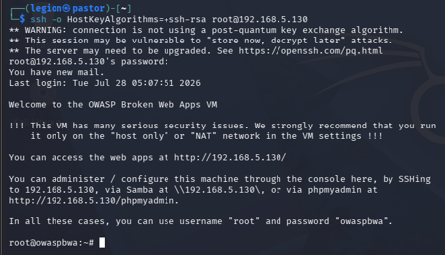

Findings
After correcting the array syntax, DVWA loaded normally again. However, inspecting the PHPSESSID cookie in the browser afterward still showed HttpOnly=false and SameSite=None, despite the code being implemented correctly and matching the lab's own example. This was traced to a limitation of the PHP 5.3.2 environment: SameSite cookie support was not added to PHP until version 7.3, and this legacy build does not reliably enforce all session_set_cookie_params() attributes across DVWA's code paths.

Reflection
Adding session_set_cookie_params() with httponly => true and samesite => 'Strict', along with session_regenerate_id(true), is the correct approach to harden DVWA's session cookie per the lab's guidance. However, testing showed the HttpOnly flag did not take effect in the browser despite correct implementation, and SameSite was silently ignored. This is because the server runs PHP 5.3.2 (released 2010), which predates PHP's samesite cookie support (added in 7.3) and has known inconsistencies in how session_set_cookie_params() interacts with cookie handling across code paths. This highlights a real-world lesson: security configuration that is correctly written in code can still fail to take effect on legacy, unpatched infrastructure, which is itself a security risk worth flagging in any audit.

Exercise 2: Implementing Session Expiration and Invalidation

Steps Performed
- Added an inactivity-timeout check to includes/dvwaPage.inc.php, immediately after session_regenerate_id(true). The check uses ini_set('session.gc_maxlifetime', 900) and a $_SESSION['LAST_ACTIVITY'] timestamp comparison: if more than 900 seconds (15 minutes) have elapsed since the last recorded activity, the session is unset and destroyed, and the user is redirected to logout.php. For testing purposes, the timeout was temporarily reduced to 20 seconds, verified, then restored to 900 seconds.
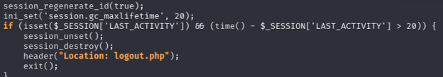

Findings
With the timeout temporarily set to 20 seconds, logging in and then waiting approximately 25-30 seconds before attempting to navigate to another DVWA page correctly triggered the expiration logic, unsetting the session and redirecting back to the login page.

Exercise 3: Testing Session Management Controls

Steps Performed
- The inactivity test performed in Exercise 2 doubled as the live test required by Exercise 3: logging in, allowing the session to sit idle past the configured timeout threshold, and then attempting to access a protected page (the DVWA dashboard).
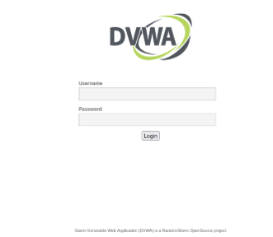

Findings
Access to the protected page was correctly denied after the session expired, and the browser was redirected to the login page rather than serving cached or unauthorized content.

Reflection (Exercises 2 & 3)
Implementing session expiration via gc_maxlifetime and a LAST_ACTIVITY timestamp check successfully forced session termination after a period of inactivity, redirecting the user back to the login page. This was verified by temporarily shortening the timeout to 20 seconds for testing purposes, then restoring it to the specified 900 seconds (15 minutes). This confirms that, unlike the cookie-flag configuration in Exercise 1, inactivity-based session expiration is fully enforceable even on this legacy PHP environment, since it relies on standard session variable logic rather than cookie attributes the browser/server negotiate. A remaining challenge is that this approach requires the check to run on every page load via a shared include, which is fragile -- any new page added to the application that does not include dvwaPage.inc.php would bypass the expiration check entirely.

Discussion
This lab demonstrated that secure session management requires more than correctly written code -- the underlying platform must also support the intended security controls. DVWA's session cookie hardening was implemented exactly as prescribed, yet the legacy PHP 5.3.2 runtime silently failed to enforce the SameSite and HttpOnly attributes as expected in modern browsers and PHP versions. In contrast, session expiration logic, which relies purely on PHP session variables rather than cookie negotiation, worked reliably. This distinction is an important real-world takeaway: server-side logic controls (expiration, regeneration) tend to be more portable and dependable across environments than client-negotiated cookie attributes, which depend on both server software version and browser support.

Recommendations
- Upgrade the underlying PHP version (or migrate the application) to a supported, modern release so that cookie security attributes such as HttpOnly and SameSite are properly enforced.
- Serve the application over HTTPS so the Secure cookie flag can be safely enabled without breaking functionality.
- Keep session_regenerate_id(true) on login at minimum, rather than on every request, to avoid unnecessary session churn while still preventing fixation.
- Centralize session-handling logic in a single, mandatory include used by every page, or better, enforce it at the web server/framework level, so new pages cannot accidentally bypass expiration checks.
- Regularly audit legacy environments for silent security-control failures, since code that appears correct can still be functionally inert on outdated platforms.

Conclusion
This lab implemented secure session cookie configuration and inactivity-based session expiration directly on DVWA's server-side code via root SSH access. While session expiration worked reliably, cookie attribute enforcement was undermined by the legacy PHP 5.3.2 environment, illustrating that secure coding practices alone are insufficient without a supporting, up-to-date platform.

