INT307: Web Application Security
Lab 1: Manual and Automated SQL Injection Testing

Student: Damian Ozimede Patrick
GitHub: github.com/damianozimede
Environment: Kali Linux (legion@pastor, 192.168.5.139) - OWASP BWA VM (192.168.5.130)
Date: July 2026

Objective
To understand and practice SQL injection techniques using both manual testing methods and automated tools (sqlmap) against a deliberately vulnerable web application (OWASP Mutillidae II), hosted on the OWASP Broken Web Applications (BWA) virtual machine.

Environment
Item | Value
Attacker machine | Kali Linux - legion@pastor (192.168.5.139)
Target VM | OWASP BWA - 192.168.5.130
Target application | OWASP Mutillidae II v2.6.24, Security Level 0 (Hosed)
Backend DBMS | MySQL 5.1.41-3ubuntu12.6-log
Web/App server | Apache 2.2.14 (Ubuntu), PHP 5.3.2-1ubuntu4.30
Target OS | Ubuntu 10.04 (Lucid Lynx)
Target database (Mutillidae) | nowasp

Exercise 1: Identify Vulnerable Parameters
Objective: Identify input fields that may be vulnerable to SQL injection.
The Mutillidae application was accessed at http://192.168.5.130/mutillidae/. Navigating to OWASP 2013 -> A1 Injection (SQL) -> SQLi - Extract Data -> User Info (SQL) led to the User Lookup (SQL) page.
Fields identified:
- Name (username) - text input
- Password - text input
Both fields are submitted via HTTP GET to user-info.php, meaning both parameters are visible directly in the URL. This makes the page a strong candidate for manual SQL injection testing, since payloads can be tested simply by editing the URL.
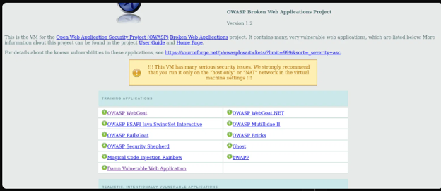
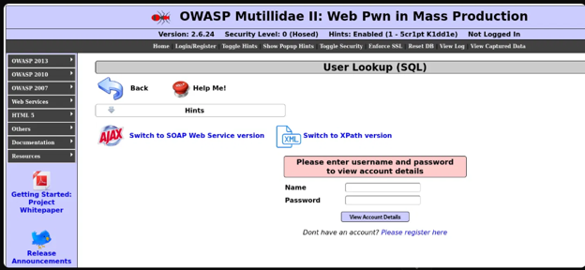

Exercise 2: Basic SQL Injection Testing
Objective: Perform basic SQL injection attacks to evaluate application response.
Payload 1:
' OR '1'='1
Result: "Authentication Error: Bad user name or password" - Results for "' OR '1'='1". 0 records found.
This payload did not succeed. Note: the lab's suggested payload syntax did not include a comment terminator, so the remainder of the original query (AND password='...') was likely left intact, breaking the intended logic without producing a usable true condition.
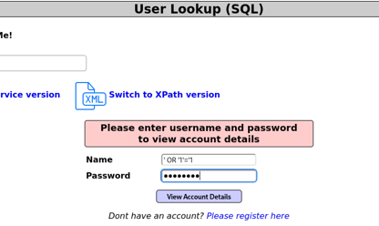

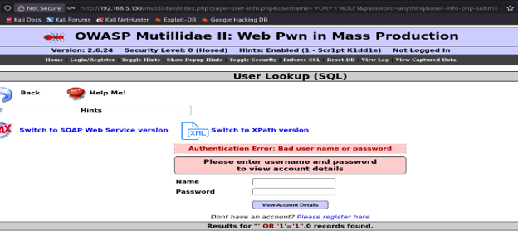
Payload 2 (adjusted):
' OR 1=1-- -
Result: 24 records found, returning full username/password/signature data for every account in the accounts table, including admin/admin.
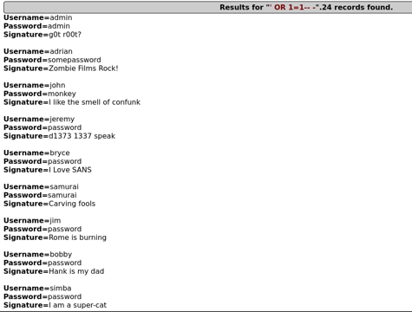
Finding: The Name field is vulnerable to SQL injection. The payload breaks out of the intended query logic, comments out the remainder of the original query, and forces the WHERE clause to always evaluate true, exposing the entire accounts table without valid credentials.

Exercise 3: Error-Based SQL Injection
Objective: Use error messages to extract database information.
Payload:
' AND 1=CONVERT(int, (SELECT @@version))-- -
Note: this payload uses Microsoft SQL Server syntax (CONVERT), while Mutillidae's backend is MySQL. The syntax mismatch itself triggered a verbose MySQL error.
Result: MySQL error 1064 (syntax error), which disclosed the full underlying query structure:
SELECT * FROM accounts WHERE username='' AND 1=CONVERT(int, (SELECT @@version))-- -' AND password=''
The error also revealed: MySQL version 5.1.73 (client library), the accounts table name, and internal server file paths (e.g. /owaspbwa/mutillidae-git/classes/MySQLHandler.php) along with a full PHP stack trace.
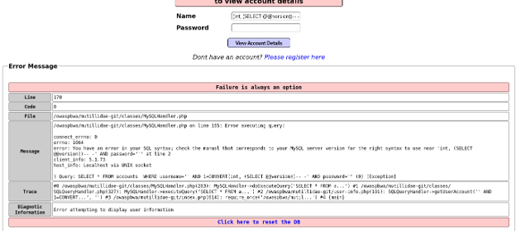
Finding: Error-based SQL injection confirmed. Verbose error handling discloses sensitive information about database structure and server internals, which an attacker can use to refine further attacks without needing valid data output.

Exercise 4: Boolean-Based SQL Injection
Objective: Manipulate queries to obtain true/false responses.
Initial attempts using AND-based payloads with a bare trailing space after -- (as suggested by the lab) behaved inconsistently, likely due to trailing whitespace being trimmed by the application before reaching the SQL query. The -- - comment format (used successfully in Exercise 2) was used instead to ensure reliable query termination.
Payload | Condition | Result
' OR 1=1-- - | TRUE | 24 records found
' OR 1=2-- - | FALSE | 0 records found, no error



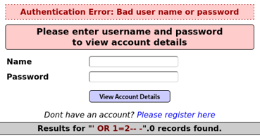

Finding: Boolean-based blind SQL injection confirmed. The application's response (record count / presence of an authentication error) reliably distinguishes TRUE from FALSE injected conditions, even without relying on verbose error messages. This technique remains viable in environments where detailed error output has been suppressed.

Exercise 5: Union-Based SQL Injection
Objective: Retrieve data from other tables using the UNION operator.
The lab's suggested 4-column payload failed with MySQL error 1222 ("different number of columns"). A 3-column retry also failed. Rather than guess further, the column count was determined systematically using the ORDER BY technique:
' ORDER BY 1-- - through ' ORDER BY 7-- - (succeeded)
' ORDER BY 8-- - (failed - column count error)
This confirmed the accounts table (accessed via SELECT *) has exactly 7 columns.
Final payload:
' UNION SELECT 1,user(),database(),version(),5,6,7-- -
Result: 1 record returned -
- Current DB user: mutillidae@localhost
- Current database: nowasp
- MySQL version: 5.1.41-3ubuntu12.6-log
Finding: Union-based SQL injection confirmed. Once the correct column count is established (via ORDER BY probing), arbitrary data - including data unrelated to the original query's table - can be retrieved by aligning it with the injected UNION SELECT's column positions.

Exercise 6: Retrieving Database Information
Objective: Extract tables and columns from the database.
Table enumeration payload:
' UNION SELECT 1,table_name,3,4,5,6,7 FROM information_schema.tables WHERE table_schema=database()-- -
Result: 12 tables found in the nowasp database:
- accounts, balloon_tips, blogs_table, captured_data, credit_cards, help_texts, hitlog, level_1_help_include_files, page_help, page_hints, pen_test_tools, youtubevideos
The credit_cards table stood out as a high-value target for further testing.
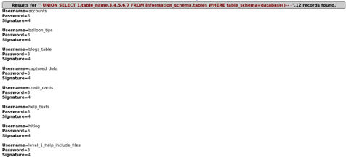

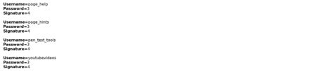

Column enumeration payload (accounts table):
' UNION SELECT 1,column_name,3,4,5,6,7 FROM information_schema.columns WHERE table_name='accounts'-- -
Result: 9 columns found - cid, username, password, mysignature, is_admin, firstname, lastname, userid, account.
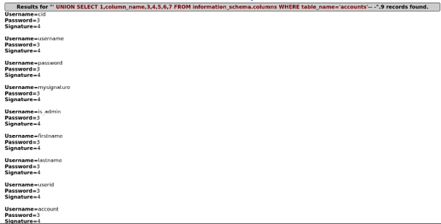
Finding: The presence of an is_admin column is significant - it is a privilege flag that could be targeted for further exploitation. Combined with the table enumeration, this demonstrates that UNION-based SQL injection can be used to map an entire database schema - every table and column - without any authenticated access.

Exercise 7: SQLMap Basic Commands
Objective: Use sqlmap to automatically confirm and characterize the vulnerability.
sqlmap -u "http://192.168.5.130/mutillidae/index.php?page=user-info.php&username=admin&password=admin&user-info-php-submit-button=View+Account+Details" -p username --batch --dbs
(The -p username flag scopes testing to the parameter already confirmed vulnerable manually, and --batch accepts sqlmap's default answers automatically, significantly reducing scan time.)
Result: sqlmap confirmed the username parameter injectable via four distinct techniques:
- Boolean-based blind (OR, WHERE/HAVING clause, MySQL comment)
- Error-based (EXTRACTVALUE, MySQL >= 5.1)
- Time-based blind (query SLEEP)
- UNION query (7 columns) - matching manual findings exactly
It also fingerprinted the backend: MySQL >= 5.1, Apache 2.2.14, PHP 5.3.2, Ubuntu 10.04 (Lucid Lynx) - and enumerated 34 databases present on the shared BWA server (hosting many vulnerable applications beyond Mutillidae, e.g. dvwa, joomla, wordpress).
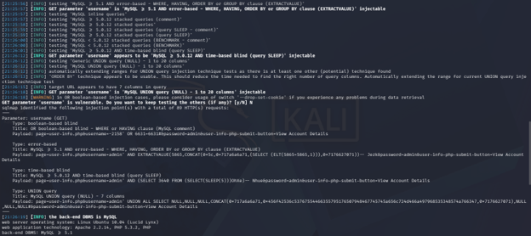
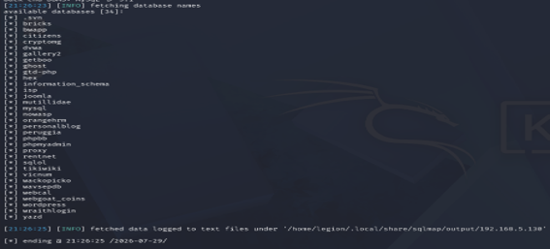
Finding: Automated tooling independently validated and extended manual findings within seconds, confirming multiple injection techniques and full server-level database enumeration.

Exercise 8: Enumerate Users and Passwords
Objective: Extract MySQL database management system user and password information.
sqlmap -u "..." -p username --batch -D nowasp --users --passwords
Result: 38 MySQL DBMS user accounts enumerated, including root@127.0.0.1, root@localhost, and root@brokenwebapps. sqlmap then retrieved password hashes for all accounts and performed a dictionary-based cracking attack, successfully cracking the majority of passwords - notably, one of the root account's password hashes was cracked to the clear-text password "user".
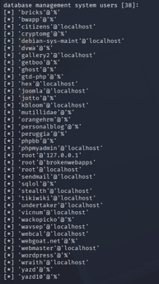

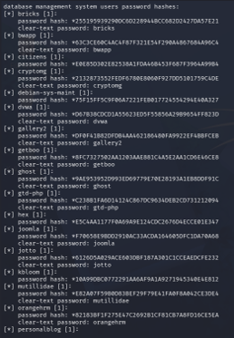
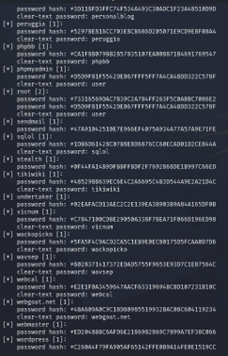

Finding: Weak, dictionary-crackable passwords on privileged database accounts can be fully compromised via automated SQL injection tooling, potentially granting an attacker full control over the MySQL server and every database it hosts.

Exercise 9: Dumping Data
Objective: Retrieve all entries from a specific table.
sqlmap -u "..." -p username --batch -D nowasp -T accounts --dump
Result: All 24 rows and 7 columns of the accounts table were extracted automatically in a single command, producing a clean formatted table and a CSV export. This dump confirmed the actual values of the is_admin column: three accounts (admin, adrian, ABaker) are flagged as administrators.
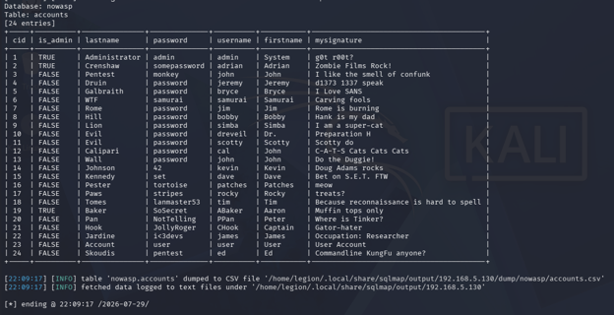
Finding: Automated dumping drastically speeds up full data exfiltration compared to manual, column-by-column UNION queries, and can reveal information (such as which specific accounts hold admin privileges) that manual extraction had not yet fully surfaced.

Exercise 10: Specify Columns and Tables
Objective: Enumerate columns in a specific table and extract only the data of interest.
sqlmap -u "..." -p username --batch -D nowasp -T credit_cards --columns
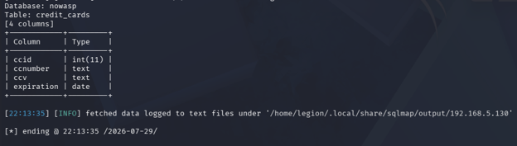
Result: 4 columns identified in the credit_cards table - ccid (int), ccnumber (text), ccv (text), expiration (date).
sqlmap -u "..." -p username --batch -D nowasp -T credit_cards -C ccnumber,ccv,expiration --dump
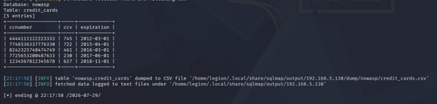
Result: 5 complete credit card records extracted - full card numbers, CVV codes, and expiration dates.
Finding: An attacker does not need to dump entire tables; SQL injection allows surgical extraction of exactly the data of interest by specifying table and column names directly, making attacks faster and harder to detect. Full payment card data extractable via a single unauthenticated web form field represents the most severe risk identified in this lab.

Additional Exercise: Bypassing Authentication
Objective: Log in as an admin user without knowing the password.
On the Mutillidae Login page (not User Lookup), the following payload was submitted in the username field, with the password field left blank:
admin' -- -
Result: Successfully authenticated as the admin user. The application header confirmed: "Logged In Admin: admin (g0t r00t?)" - matching the exact signature seen in earlier data dumps for that account.
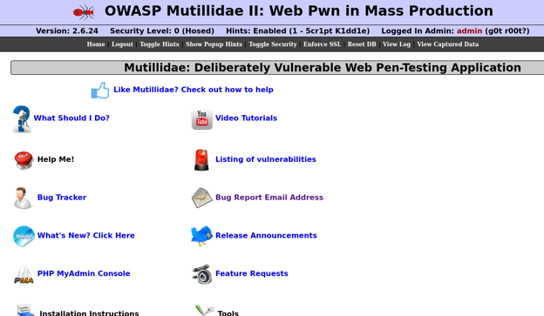
Finding: The trailing -- - comments out the password validation portion of the backend query, so the query effectively becomes a lookup by username only. This demonstrates that SQL injection can be used not just to extract data, but to gain full authenticated access to privileged accounts without any valid credentials.

Additional Exercise: Log Injection Testing
Objective: Determine whether application logs can be manipulated via SQL injection input.
The Mutillidae View Log page was reviewed after SQL injection testing. The raw payloads used during testing - including the authentication bypass payload and complex sqlmap UNION strings - appeared in the log verbatim and unsanitized, e.g.:
User ' OR 1=1-- - attempting to authenticate
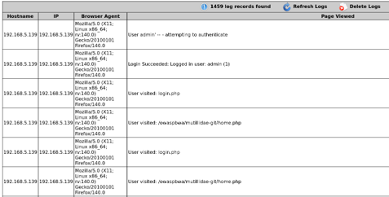

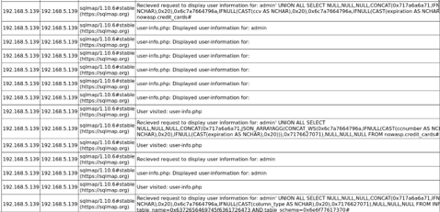

Finding: User-supplied input is logged without sanitization or encoding. This confirms a log injection vulnerability: an attacker could inject falsified log entries, characters that break log-parsing tools, or (if the log viewer renders entries unsafely) script content, creating a secondary XSS risk. It also means application logs cannot be fully trusted as an audit trail, since their content is directly attacker-influenced.

Additional Exercise: Using Burp Suite for Manual Testing
Objective: Intercept and modify an HTTP request to Mutillidae using Burp Suite.
Burp Suite's Proxy tool was used to intercept a live GET request to user-info.php. The username parameter was manually edited within Burp's request editor, from a normal value to the injection payload:
' OR 1=1 -- -
The modified request was forwarded to the server. Burp's "Edited request" view confirmed the payload was correctly URL-encoded and included in the outgoing request, and the server responded with HTTP 200 OK.
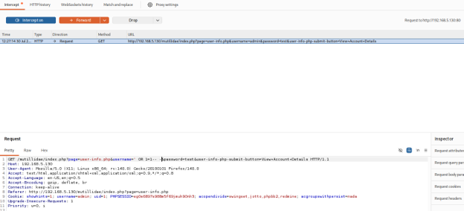
Finding: SQL injection testing does not require browser input at all. Using an intercepting proxy, an attacker can directly manipulate any request parameter in-flight, bypassing any client-side validation (such as JavaScript length or character checks) entirely. (Note: this particular test was performed while an authenticated admin session was already active from the prior exercise, so the results table did not render identically to the earlier manual test; logging out before testing would be expected to restore the full 24-record output seen previously.)

Conclusion
This lab provided hands-on experience with both manual and automated SQL injection techniques against OWASP Mutillidae II. Manual testing confirmed the User Lookup (SQL) page is vulnerable to basic, error-based, boolean-based, and union-based SQL injection, allowing full enumeration of the application's database schema (12 tables, including a sensitive credit_cards table) without authentication. The Login page was also shown to be vulnerable to authentication bypass, allowing admin-level access without valid credentials.
Automated testing with sqlmap independently confirmed all manual findings, additionally revealing the underlying MySQL server hosts 34 databases and 38 database user accounts, many with weak, dictionary-crackable passwords - including the root account. sqlmap was also used to perform full and targeted data extraction, culminating in the recovery of complete, unencrypted credit card records (card number, CVV, and expiration date) directly from the database.
Additional testing showed that the application logs user input verbatim without sanitization (a log injection risk), and that request parameters can be manipulated directly via an intercepting proxy such as Burp Suite, independent of any client-side input restrictions.
Key recommendations:
- Use parameterized queries / prepared statements for all database access - never concatenate user input directly into SQL strings.
- Disable verbose database error messages in production; log them server-side only.
- Enforce strong, unique passwords for all database accounts, especially privileged accounts such as root.
- Sanitize or encode all user input before writing it to application logs.
- Apply the principle of least privilege to database accounts used by web applications.
Ethical note: all testing in this lab was performed against a deliberately vulnerable, isolated training environment (OWASP BWA VM) with no real user data, for educational purposes only.

