|  |
| --- |
|  |
| **Investigation of Cold Stamping of Polycarbonate and Other Engineering Resins in an Injection Molded Part** |
|  |
|  |
| **By** |
| **Lisa L. D’Amico** |

Dissertation Supervisor: Stephen Driscoll,

Professor, Department of Plastics Engineering

ABSTRACT OF A DISSERTATION SUBMITTED TO THE FACULTY OF THE

DEPARTMENT OF PLASTICS ENGINEERING

IN PARTIAL FULFILLMENT OF THE REQUIREMENTS

FOR THE DEGREE OF

UNIVERSITY OF MASSACHUSETTS LOWELL

2016

**Abstract**

Typically polycarbonate is injection molded, but not cold formed. In this paper we look at injection molding polycarbonate, cooling the parts to room temperature, and then cold forming these same parts to function under load. Various grades of polycarbonate are investigated along with other engineering resins alloys. This includes impact, dimensional stability, structural integrity and heat testing. Once these parts are cold formed using polycarbonate other materials were investigated to see how they compare in this same scenario.

**Acknowledgements**

No table of contents entries found.

**List of Tables**

No table of figures entries found.

**List of Illustrations**

1. **Introduction**

Cold forming is a common term used for the production of working sheet steel into goods. The use of cold-formed steel construction materials has increased since first introduced in 1946. The manufacturing of cold-formed steel products occurs at room temperature using rolling or pressing. Cold forming was first introduced in construction in the 1920’s. As plastics were introduced into the industry, most were heated and formed, however, some were cold formed using a brake. These were typically high density polyethylene (HDPE), or ABS; not polycarbonate. The process of stamping was then introduced. Initially gaskets were made from various materials including polycarbonate, acetals etc. at room temperatures, however, cold forming has evolved to have a slightly different meaning in the process of stamping of plastic materials. While the plastics is being shaped without adding additional heat there is no study showing reshaping the product after the part has been injection molded into a useable shape. This is something I wanted to investigate.

I began my researched for information on the web, through SPE and SPI, in various magazines, and in text books. I was not able to find any information on the subject of cold forming of polycarbonate after the product had been injection molded. There is no data available on cold forming of Polycarbonate at all in any areas of plastics that I have

searched worldwide. I was able to find a few articles through Society of Plastic Engineers on acetals and ABS materials that were cold formed since 1968. Typically these articles included studies done by Makrolon, GE and Borg-Warner who at the time were investigating cold stamping extruded sheet grades of ABS. The reason for this type of process is that the tooling is inexpensive. Articles were available from 1968-1972. The oldest article that had any real relevance was published in 1960 in Modern Plastics that discusses cold forming of polycarbonate in three different processes. The first is through stamping of a sheet to obtain a flat circular part, the second is sheet rolling which may add shape to the flat plate, through continuous movement. The third and final way is a spinning process, this uses sheet that spin while pressure is applied to change the shape in areas of the sheet. Again, each of these uses sheets, and the article goes on the discuss the various properties after each process; including impact, flexural properties, and environmental stress cracking. There is also a discussion about the distortion of the final shape when cold forming is applied. Since I am not looking at sheets this is not an issue. In the Kunststoffe Journal on line an article on polyurethanes was found, that included a small comment about decorating on film through stamping but nothing specific to polycarbonate. This was published in 2011.

In 2014 there were articles in Munich Germany in a journal that discussed experimental polycarbonate file and measuring the optical properties but nothing specific to cold forming or stamping. I discovered an article on deep drawing of thermoplastics in polymer engineering & science but even this had no mention of polycarbonate. This study only included ABS and PP.

I have gone to material suppliers in the US, in Germany and in China asking for aid in this study only to be told that this can not be done with polycarbonate, or that it should not be done. I have received confirmation from Sabic, Styron and Bayer that they do not know of any other customer cold forming polycarbonate materials. I have had conversations with Ed Flaherty of Sonitek, a cold forming company, about cold forming polycarbonate, and he discussed with me that it is not done due to stress concentration issues. The only other information I was able to locate on cold stamping and forging was from a plastics conference in 1977.

Some plastics such as plexiglass sheets have been cold formed into a smooth arc shape and held to a radius by forcing the material into a curved channel support. Metals can be done similar to gutters. Most plastics are only formed with the addition of heat, similar to thermoforming. In the application investigated here, the stamping is actually being done at room temperature, and at very high speeds. ****What are the various polycarbonate materials and how they differ when used in the same way or in the same application. What properties have the greatest influence on the outcome, and what additives affect the plastics for this application. For example, melt flow index, colorant, impact modifier, geometry of the part, flame retardant etc.

In the examples studied the plastics are reshaped around a metal insert which is then held in place, after being injection molded into a specific shape. Therefore, not only is it important that the plastics can retain its original shape, but it must conform to the new stamped shape and still maintain the integrity of the material.

Experiments have shown that (1) the glass transition temperature of the polymer should be above the ambient temperature and above the temperature of forming, (2) tensile elongation at break should equal or exceed 30%, however, cold forming is typically only done on sheets. There is no data showing how best to handle a part that has been injection molded previously. There is data supporting cold forming of PMMA sheets however, this is typically done to bend sheets. In rare cases if polycarbonate were to be bent or reshaped after extruded into sheets, it is typically heated and then reshaped or bent. In this process no actual heat is introduced. The parts are injection molded, cooled to room temperature, prior to stamping these parts a metal strip is inserted into the part itself. The part then undergoes a process where it is stamped by a metal plunger with a square tip. This leaves an indent on the outside of the part forcing the plastics inward. The plastics then form around the metal piece holding it in place. Initially I started to look at reducing the cost of the overall product and looking at different materials that might be able to work for this application. I determined that polycarbonate is the best and least expensive materials available.

Next I began to look at the various polycarbonate materials that are available on the market and see how they perform differently in this application. How does the MFR change performance? What other factors change performance?

I compared other materials to see how they perform in this application such as polybutylene terephthalate (pbt), Ultem, and acrylonitrile butadiene styrene (abs). These material are not able to perform in this application as well as they are too brittle and crack or too soft and do not hold upon impact.

At Anderson Power Products a staking process to contain metal inside plastics parts is used. To do this, the parts are cold formed using the molded part after they are cooled to room temperature. This is done using a square tip plunger. Different size and shape plungers are used for different size parts, however, the same process is used for all. Once the parts are stamped the shape on the outside is measured. This must be deep enough to hold the metal strip inside in place.

It is very important that over time this “trough” does not relax, because if it does then the metal piece will loosen and fall out. There is a stress on the metal piece when the part is in use, and this can also cause the part to relax; this must also be tested.

Finally, the part is used in a wide range of electrical applications. This could include heat rise applications, so we must consider that the part may see heat over time, and this could cause the part to relax, so test must be done to ensure that all of this will not change the “trough” depth/ strength

The initial test looked at different melt viscosity polycarbonates. Polycarbonates were chosen because they have been proven to work. Polycarbonate is a good thermoplastic engineering material that is available in a wide range of molecular weights, and can be easily modified. Polycarbonate is an amorphous engineering thermoplastic with good impact, dimensional stability, thermal resistance, and electrical properties, while still having some ductility.

1. **Methodology**

The first step was to find materials that had similar properties for the application. The materials were chosen because according to the datasheets the properties of the materials were all very similar other than the melt flow. They all had flame retardant,

V-0 at 1mm, similar impact and an RTI electrical above 110 deg. C. These ranged from 4 MFR to 18 MFR. I decided on polycarbonate materials, PBT materials, and Ultem. The materials were processed in two different injection molds. All were run on Nissei molding machines. One in a 40 ton press and the other in a 180 ton press.

The parts were molded using the same molding machines, and the same molds.

The process conditions were adjusted per recommendations from technicians from each of the various material suppliers to ensure that the conditions were appropriate for the material being used. The parts were all measured for dimensional stability, and left to sit overnight. For each of the materials two machines and molds were sampled and tested. This was done to compare size a large and small size part. The small part weight is .0021 lbs. the larger part weight is 0.2026 lbs. Each process was run for 4 hours to ensure a stable process before parts were collected.

All of the materials molded in the two different molds without any issues. The cycle times were all similar for each of the molds. The smaller part was allowed to cool for 25 minutes; the parts were impact tested, using a Pass/Fail criteria. The parts all passed. The larger parts were allowed to cool for 30 minutes and then impact tested; again these all passed. The impact test run was a typical ASTM D3029 test done at 30 ft.lbs.



Figure 1 Impact Test

The next step was to leave them to sit overnight to allow them to cool to room temperature. The following morning, the parts where cold formed using the processes of forcing a plunger into the outside wall, but not through it. This causes an indent in the part. This step was done while holding a metal strip in place. Once this was completed, the depths were each measured.

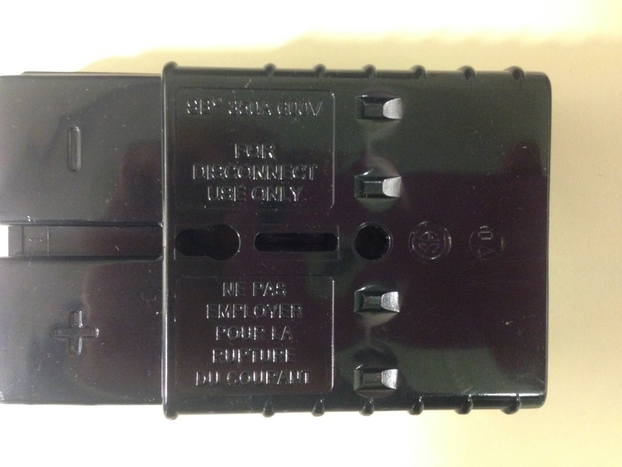

Figure 2: Cold forming shape

Shows plunger shape on part.

On the third morning the parts were tested for mold stress; this was a six hour heat test, at a temperature 10°F above the material’s RTI. This determines if they retain their strength, and dimensional properties with heat. The parts were remeasured, and the metal strips were verified if they were still in place.

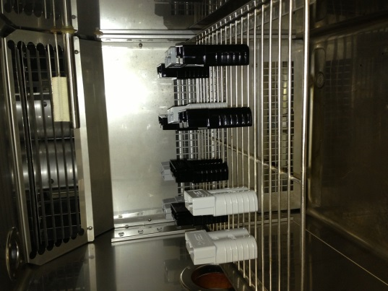

This shows how the parts are placed in the over on the shelf to allow for air to circulate.

Figure 3 : Oven Testing

The metal strips were also forced out to determine strength retention. Data was collected and compared for each of these materials, to determine how MFR affected cold forming, and the final properties.

Shows metal strip being held in place.

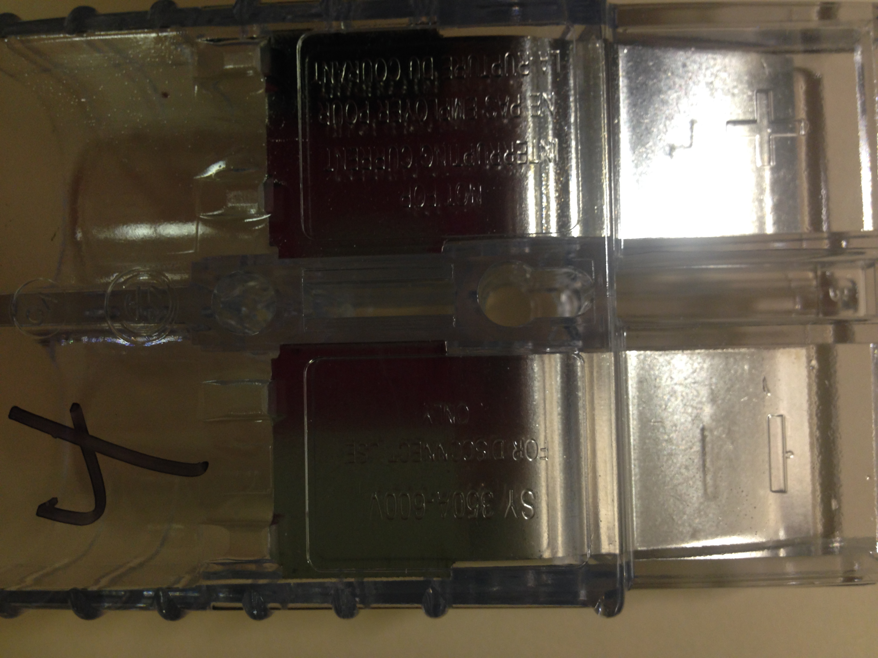

Figure 4: Shows metal after some testing

Following the polycarbonate testing, the next step was to determine what other materials could be used in these molds. The first material used was a Valox V3900WX, this material molded and staked according to previous process. Then this same process was completed for Valox 357. In the same fashion data was collected.

Data was collected on these parts using Noryl, and finally these parts were molded using a mix of polycarbonate and Pebax. In each case the large parts and smaller parts were molded collected, cooled, tested, staked, tested, and data was collected.

Additional testing was completed to determine how strong the cold forming was. This was done through a series of pull out tests before heating the parts and after heating the parts. The piece of equipment used was a cotillion

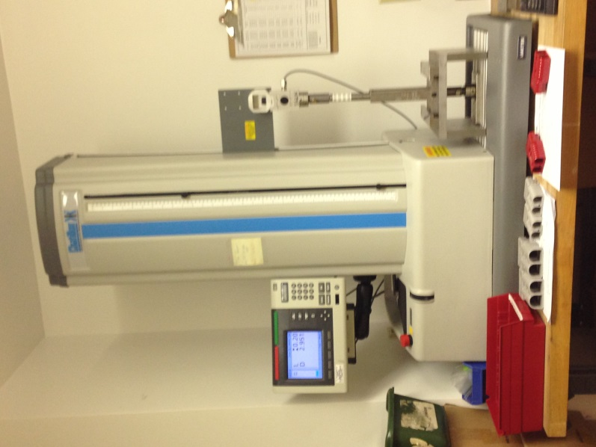

1. **Results**

**Recommendations**

In addition to MFR, other factors within the material that could affect the properties of the product will be investigated. This includes flame retardant additives and, more importantly, an impact modifier. The same process should be followed to ensure that all aspects are reviewed.