**University of Regina**

**CS207 Assignment 1**

**Roman Yushchyk**

**200368308**

**Part 1**

I choose my old remote control to be explored. I choose the way of a least resistance, it was already open and ready to be inspected.

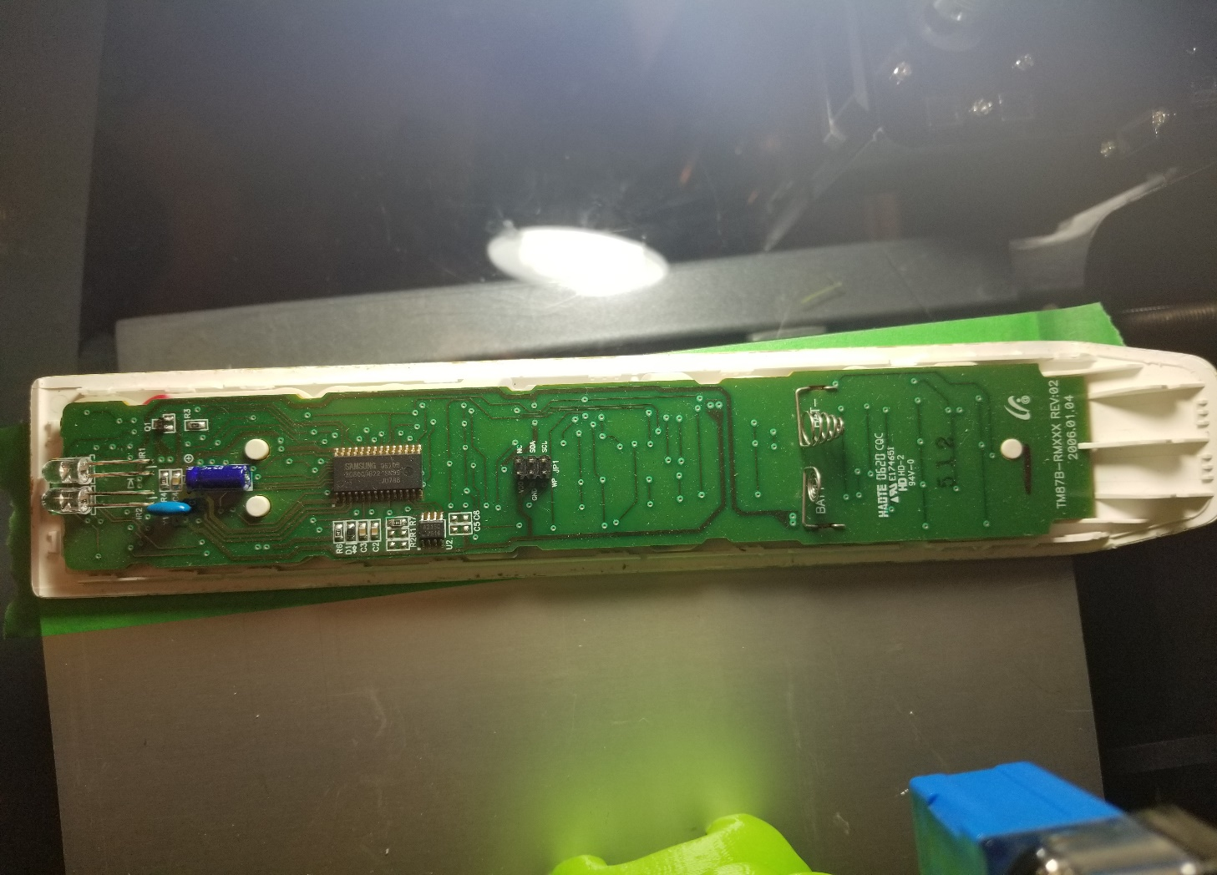

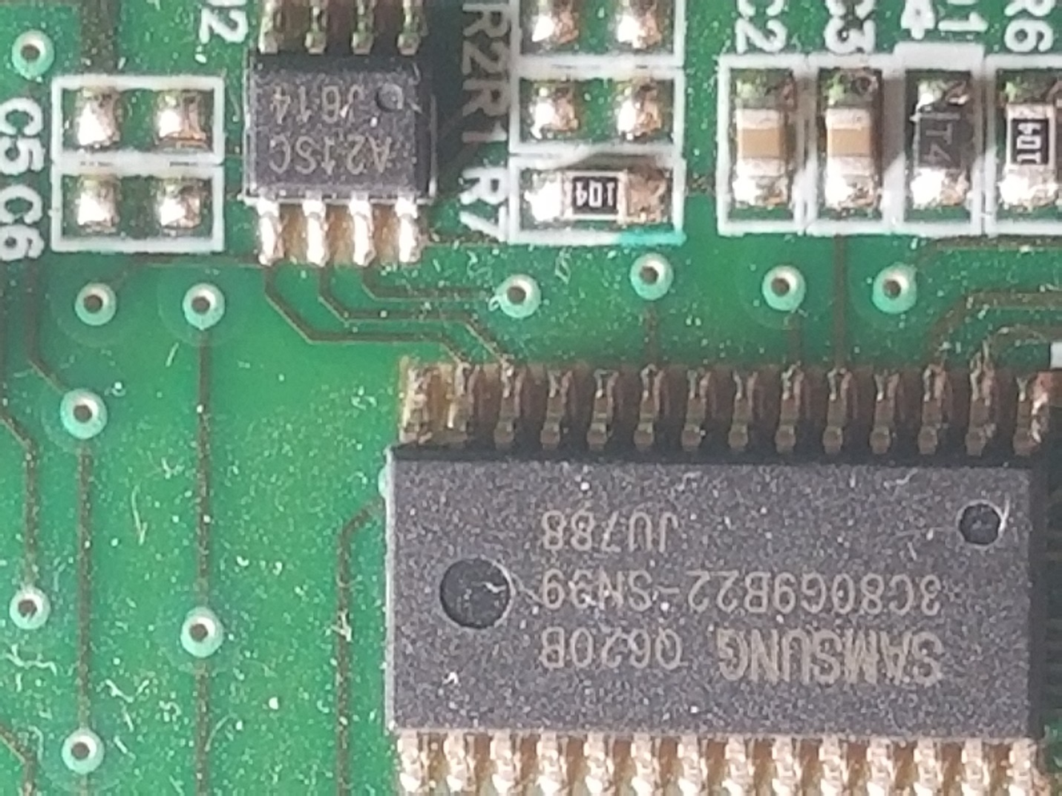

4

4

3

**2**

1

1. Surface mount resistor of nominal value 100kΩ
2. Microcontroller or a shift registers marked 3C80G9B22 and A21SCJ614 made by a Samsung.
3. Diode T4 is on the right side from number 1.
4. Next in line C2 and C3 which are surface mount capacitors.

**Part 2**

1. Battery source with nominal voltage rating of 3 Volts.
2. Red LED light bulb.
3. (Conductor wires)

Improvement notes for part 2:

It could be driven with a 3 Volts, but a typical Voltage for red LED is in between 1.5 and 3.5 V and an average current is 20mA. **Resistor ((3V – 1.5V)/20mA = 750 Ohms)** is needed to increase this circuit reliability and LED’s life span.

**Part 3**

* 1) Input from a sensor or WIFI connected controller.
* 2) Output for a Servo motor or LED control.
* 3) Processor is required to calculate possible next movement or a sum of previous motions.
* 4) Memory that is required to store instructions for the device operation or navigation algorithms.