Roman Yushchyk

200368308

CS207

Assignment 4

1. Draw a circuit diagram for an 8-button game controller (like the NES controller) with an Arduino.

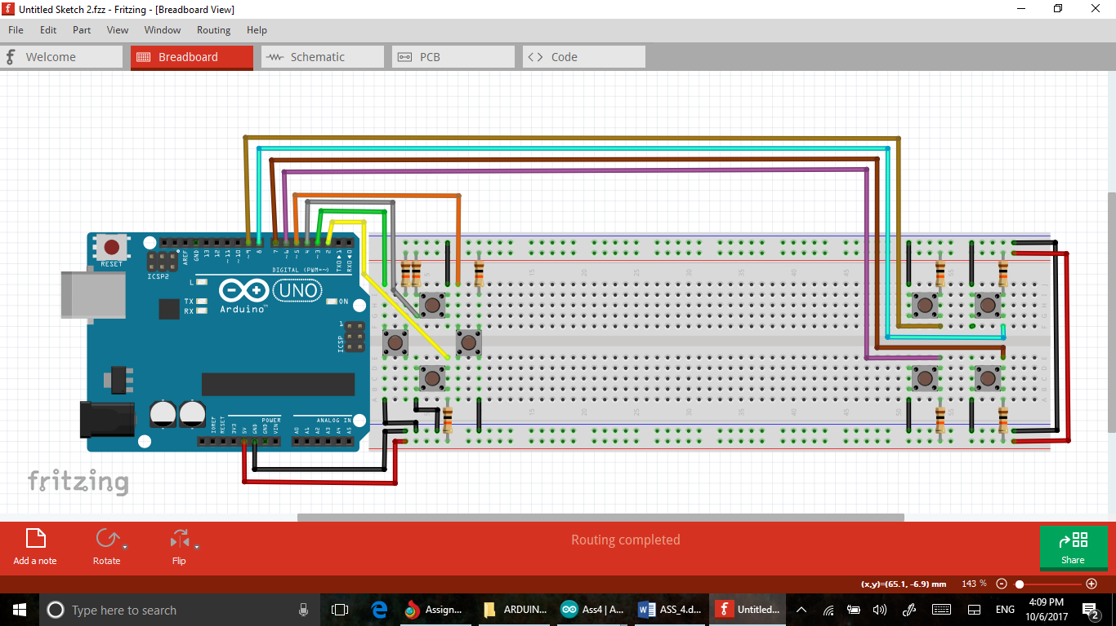

2. Write a program for your 8-button Arduino game controller that would send button presses over serial to your computer.

Link to a Google Drive file:

<https://drive.google.com/file/d/0B4R9QIEgtvCnaklmbTVkU1o5YU0/view?usp=sharing>

3. Research DRM in video games. A) What is it? B) How do you think it benefits or hinders the games industry?

***“Digital rights management (DRM) is a set of access control technologies for restricting the use of proprietary hardware and copyrighted works. DRM technologies try to control the use, modification, and distribution of copyrighted works (such as software and multimedia content), as well as systems within devices that enforce these policies. “***

Wiki link:

<https://en.wikipedia.org/wiki/Digital_rights_management>

1. It is a software and hardware security protocols design to prevent digital piracy.
2. DRM helps game developing companies to collect their profit trough making their product harder to use without a key. I think it benefits game industry overall because extra collected money could be used for a future new game development.

EXTRA CREDIT:

4. Build the 8-button game controller and download SuperTux or Freedoom-- take a selfie of you playing either of these with your home-made game controller.

I used a software named DataSnip Serial to Keyboard to establish windows link.

<http://www.priority1design.com.au/datasnip.html>

Game was downloaded from here:

<https://supertux.en.softonic.com/>

Video of me playing SuperTux:

<https://drive.google.com/file/d/0B4R9QIEgtvCnOGl5b0dwT3hvMnc/view?usp=sharing>