Roman Yushchyk

200368308

CS 207

**Assignment 6**

***1. The advent of home 3D printing has given rise to a number of ethical questions / legal issues. Name and discuss at least two of these issues and provide your opinion on them.***

Open source - denoting software for which the original source code is made freely available and may be redistributed and modified.

First of all is a concept of open source community imply that anyone can download a blueprint or a code and build his own copy of whatever that was. Many people see the opportunity and start monetizing on open source ideas. Is it ethical to use someone’s ideas to make profit? Perhaps it would be if money raised was dedicated to a new design concept that would be posted online as an open source development. Open source label is not simply a useful resource but a way to change this world by action and not a catchy phrase. When collaborative project reaches its goals its benefitting not only anyone who participate in it but also a whole world because it can access a new manufacturing means to produce goods they want or need or a new generation of 3D printers that can manufacture a whole electronic device in one piece.   
Second big problem is a legal side of open source question. Because of each source website offers their own set of terms and agreements that try to protect intellectual property, owners of which chose to monetize on their own product files or encouraging users of this website’s to give owners an appropriate citation when they using this source. But when it comes to enforcing punishment to those who bridge terms and conditions is hard to monitor them and it is even harder to punish them accordingly to their misconducts.

***2. What is a "dead reckoning" and why can it be very dangerous?***

In a navy world this term is used to describe a technique for plotting ships current position based on previous known positions and a general vector of speed. In a CNC milling machine or a 3D printer such a technique is used for guiding motors and is essentially the same as our NAVI using. Usually based on a stop switch position reading for each axel of motion. Then all of the manipulations is based on sum of all of the previous motions. It is more than typical way of tracking current position in any system of coordinates. But it has a build in flaw in its design, things are, that not every execution of move is exact as it was planned and over the time insignificant errors accumulates into a bigger more obvious error. Aside from this type of error it is completely possible for a machine to run into a solid obstacle like dropped filament spool that could jam free motion of motors. Such a scenario possibly could lead to a motor being scrapped and even a fire if electrical cables can’t handle access resistance while programming would have not a single clue about what is happening there in a real world. While we are dead reckoning our position we cannot react at all to a change in a physical world. Fighting an accumulative error is a little easier of a task. A stepper or a servo motor which would incorporate a motor itself and a hall effect sensor in one device to update current position with a feedback loop would solve accumulative error issue once and forever but not a safety concerns when it comes to dead reckoning few ounces of still at a high velocity. Perhaps adding a conductive sensor or thermal sensor to a moving parts would prevent a futile cases of interaction between us and a machines.

***3. Given this "H-Bridge" fill in the results for the following chart:***

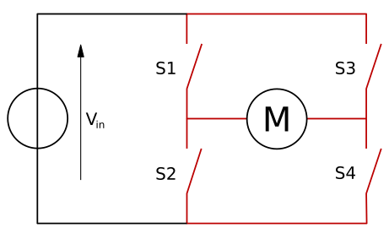

|  |  |  |  |  |
| --- | --- | --- | --- | --- |
| **S1** | **S2** | **S3** | **S4** | **Result** |
| 1 | 0 | 0 | 1 | Clockwise motion |
| 0 | 1 | 1 | 0 | Counter Clockwise motion |
| 0 | 0 | 0 | 0 | No motion (Open circuit) |
| 0 | 1 | 0 | 1 | No motion (Open circuit) |
| 1 | 0 | 1 | 0 | No motion (Open circuit) |
| 1 | 1 | 0 | 0 | **Short circuit** |
| 0 | 0 | 1 | 1 | **Short circuit** |
| 1 | 1 | 1 | 1 | **Short circuit** |