Roman Yushchyk

200368308

CS 207

Assignment 7

1. What is the use of a 595 Shift Register?

This particular shift register 74HC595 is design to control 8 pins at a time. Simple shift register can set any of its latch legs to turn a LED light on or to control a complex motion in robot arm. Idea I simply to reduce 8 pins output into a 3 pins output (Clock, Data and Latch). This is reducing number of pins that is utilized on Arduino board itself.

The 74HC595 is mainly used to extend default board functionality by adding extra digital pins.

2. What does a 555 timer do? Would it be useful in your project?

The LM555 timer is a chip that can be used to create pulses of various durations. A waveform of adjustable pulse width and frequency. And no to the second part of a question. I’m not using any of the LM555 timers but perhaps it could serve me a purpose if I run out of PWM pins.

3. Sketch a circuit to blink a led using only a 555, resistors, capacitors and led's.   
Compute the duty cycle of your circuit.

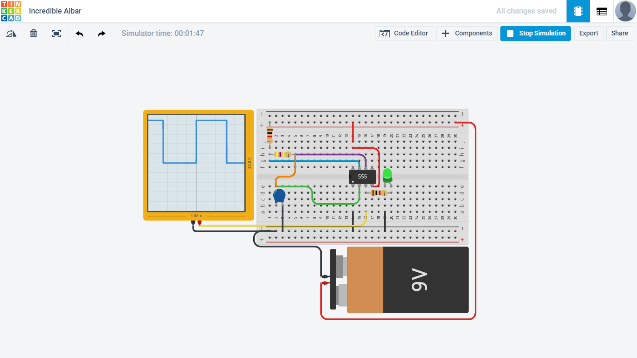

(Drop across Capacitor) = Vcc \* (1- e-t / (R\*C))

2/3\*Vcc = Vcc \* (1- e^-t / (R\*C))

2/3 = 1- e-t / (R\*C)

e-t / (R\*C) = 1/3

-t / (R\*C) = ln(1/3)

t = 1.1\*R\*C seconds

t =1.1\*470000\*0.000001

Period or a duty cycle = 0.517 Seconds