Are facial expressions the genuine display of individuals’ subjective feeling? A comparison of human and automatic recognition.

While it has been taken for granted in the development of several automatic facial expression recognition tools, the question of the link between subjective feelings and facial expressions is still a subject of debate. On one hand the behaviorist approach conceives emotions as genetically hardwired and therefore being genuinely displayed through facial expressions. On the other hand the constructivist approach conceives emotions are socially constructed and facial expression as social messages that are not related to emotions. In order to evaluate the link between the subjective feeling of emotions and their recognition based on facial expression, 232 videos of participants recruited to perform an emotion elicitation task were annotated by 1383 human observers as well as by an automatic facial expression classifier. The results show a low accuracy of human observers and of the automatic classifier to infer from the facial expression the subjective feeling of the participants recorded. Based on these results, the hypothesis of genetically hardwired emotion genuinely display is difficult to support whereas the idea of emotion socially constructed and facial expression as display of social messages appears to be more likely. Then, the way to infer emotional and mental state based on facial expressions should be questioned.

# Introduction

With the development of commercial automatic facial expression recognition tools (see Dupré et al. 2018 for a non-exhaustive list of available tools), industries and governments are gradually implementing this technology in order to track humans’ emotions in various scenarios (e.g., marketing, healthcare, automotive to name a few). Beside the ethical question of measuring human emotions, these tools are challenging psychological theories about inferring emotions from facial expressions. When automatic facial expression recognition tools are used to measure human emotions, they rest on the premise that facial expressions provide a direct access to expressers’ emotions. However the link between emotion felt and facial expressions is far from being established and still remain a hot topic in psychology research.

## The link between emotion and facial expression thought the behaviorist approach

Based on the behaviorist approach initiated by Darwin in *The Expression of the Emotions in Man and Animals* (Darwin 1872), facial expression are conceived as a genuine display of individuals inner emotional state. This hypothesis is used as a basis for the Basic Emotion Theory (BET) which states that a set of six or seven emotions are universally displayed and are genetically hardwired not only in humans (Ekman 1992) but also in different animal species (Waal 2019). According to this view, “when emotions are aroused by perception of a social event, a set of central commands produce patterned emotion-specific changes in multiple systems, including […] facial expressions.” (Ekman 2007, p49). Even if this theory obtained a popular support, it fails to explain how individuals can feel emotions without expressing them and how individuals can express emotions without feeling them.

## The link between emotion and facial expression thought the social constructivist approach

Detractors of the Basic Emotion Theory are perceiving emotion not as genetically hardwired but as a learnt association between a given situation and an appropriate response (Averill 1980, @barrett2017emotions). For the tenants of the constructivist approach, emotions are “concepts” based on past experiences and which are “a collection of embodied, whole brain representations that predict what is about to happen in the sensory environment, what the best action is to deal with impending events, and their consequences for allostasis” (Barrett 2017b, p12). Following this assumption, faces are used as tools to display signals in social interactions (Crivelli and Fridlund 2018). These signals can convey individuals’ motivations and readiness (Frijda and Tcherkassof 1997) or social messages (Fridlund and Rosenberg 1995).

This current paper investigates the link between the subjective feeling of emotions and their recognition from facial expressions. If emotions are hardwired, individuals emotional subjective feeling should be correlated to the recognition of facial expressions from both human observers and automatic classifiers whereas if emotions are social constructs, no correlation between subjective feeling and facial expression recognition should be observed.

# Method

To evaluate the link between subjective feeling of emotions and their recognition from facial expressions, participants were recruited to perform an emotion elicitation task while their facial expression was video recorded. Then, the videos was shown to human observer and analysed by an automatic classifier in order to identify which emotion was displayed.

## Emotion Elicitation

For the emotion elicitation experiment, 358 French participants (182 females, 176 males, *M*age = 47.9, *SD*age = 9.2) were recruited to perform one out of 11 emotions elicitation tasks designed to trigger a positive, negative or neutral emotional state (see Tcherkassof et al. 2013 for a description of tasks and procedure). Participants’ face were recorded using an hidden camera resulting 358 front facing 768x576 videos varying from 1s to 1479s.

After their emotion elicitation task the participants had to rate their emotional state during the task on a likert scale from 0 (“not at all”) to 5 (“strongly”) the six “basic” emotions (i.e., *anger*, *disgust*, *fear*, *happiness*, *surprise* and *sadness*) as well as six “non-basic” emotions (i.e., *pride*, *curiosity*, *boredom*, *shame*, *humiliation*, and *disappointment*).

Finally, a debriefing session was perform to ensure that participants were not durably affected by the emotion elicitation task. All the participants gave their agreement on their data and video to be processed for research purpose only.

## Human Facial Expression Recognition

For the human facial expression recognition method, 1383 student participants were recruited to annotate 232 out of the 358 video, therefore only the 232 annotated videos will be analysed in this paper. Each participants had to annotate between 1 and 177 videos resulting that each video was annotated 29 times on average (*SD* = 12).

The annotation of facial expressions was performed on-site using *Oudjat*, a software for designing video annotation experiments (Dupré et al. 2015). For each video, the annotation procedure hat two steps. First, the participants had to identify the emotional sequences by pressing the space bar of their keyboard to indicate the beginning and the end of the emotional sequences while watching the video. Second, the participants watched each emotional sequence previously identified and had to label the sequence using one of the 12 emotions proposed including six “basic” emotions (i.e., *anger*, *disgust*, *fear*, *happiness*, *surprise* and *sadness*) and six “non-basic” emotions (i.e., *pride*, *curiosity*, *boredom*, *shame*, *humiliation*, and *disappointment*). They also had the possibility to indicate that the sequence was not expressing one of the proposed emotion.

This annotation procedure results in a uni-dimensional time-series for each video per human observer identifying for each second of the video which emotion was recognized. Then time-series corresponding to the same video were aggregated to calculate the proportion of human observers for each second of the video per emotional label. The sum of each label proportion per second was used as a score to determine which labels corresponds to the overall video (i.e., the highest score). In case of more than one label having the maximum value, the emotion is described as undetermined.

## Automatic Facial Expression Recognition

The 232 annotated video were processed with Affdex (SDK v3.4.1). Affdex is an automatic facial expression recognition classifier developed and distributed by Affectiva is a spin-off company resulting from the research activities of MIT media lab created in 2009 (McDuff et al. 2016). Affdex’s algorithm uses Histogram of Oriented Gradient (HOG) features and Support Vector Machine (SVM) classifiers in order to recognize facial expressions. For each video frame, Affdex identify the probability of the face as expressing one of the six “basic” emotions (i.e., *anger*, *disgust*, *fear*, *happiness*, *surprise* and *sadness*) as well as additional psychological states such as *valence*, *engagement* or *contempt*, and facial features such as *cheek raise*, *eye widen* or *jaw drop*.

To determine which of the six “basic” emotion can be used to identify each video, the recognition probability for each label by frame was converted into odd ratio by frame (Dente et al. 2017). The highest sum of each odd ratio time-series defines the label recognized by the automatic classifier.

# Results

Whereas the self-reports, the human annotations and the automatic recognition include data on “non-basic” emotions and features, the analysis is performed using only the six “basic” emotions in order to compare them. The maximum score for self-reports, human annotations and automatic recognition is used to label the video. In case of more than one label obtaining the maximum value, the video is labeled as undetermined.

## Correlation between self-report and human facial expression recognition

Emotions self-reported as being characteristic of the elicitation are compared with the emotion recognized by the human observers in a confusion matrix (Figure 1).

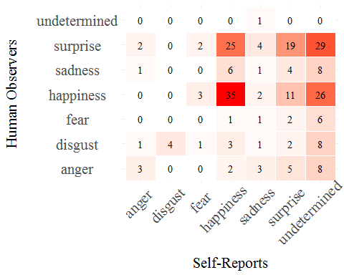

Figure 1: Confusion matrix of between the emotion self-reported as being characteristic of the elicitation with the emotion recognized by the human observers.

The result of the confusion matrix show a low agreement between emotion felt during the elicitation and emotion recognized by the human annotators (Accuracy = 0.27, 95%CI[0.21,0.33]; Kappa = 0.11) except for *happiness* (15.2%), *surprise* (8.26%) and *disgust* (1.74%). Sensitivity, specificity, precision and F1 score for each emotion can be found Table 1. Interestingly human annotators seem to recognize as *surprise* videos in which *happiness* was the highest self-reported emotion (10.9%), and in a lower instance *happiness* videos in which *surprise* was the highest self-reported emotion (4.78%).

*Table 1: Agreement accuracy metrics for each emotion.*

|  |  |  |  |  |
| --- | --- | --- | --- | --- |
| Emotion | Sensitivity | Specificity | Precision | F1 |
| anger | 0.43 | 0.92 | 0.14 | 0.21 |
| disgust | 1.00 | 0.93 | 0.20 | 0.33 |
| fear | 0.00 | 0.96 | 0.00 |  |
| happiness | 0.49 | 0.73 | 0.45 | 0.47 |
| sadness | 0.08 | 0.91 | 0.05 | 0.06 |
| surprise | 0.44 | 0.67 | 0.23 | 0.31 |
| undetermined | 0.00 | 0.99 | 0.00 |  |

However, the self-report show a very high proportion of undetermined emotional states which reveals not only the possibility of the emotion elicitation tasks to trigger more than one emotion but also the potential limit of using 6-points likert scales for which the participants can easily score to the maximum for more than one emotion.

## Correlation between self-report and automatic facial expression recognition

As in the previous analysis, emotions self-reported as being characteristic of the elicitation are compared with the emotion recognized by the automatic classifier in a confusion matrix (Figure 2).

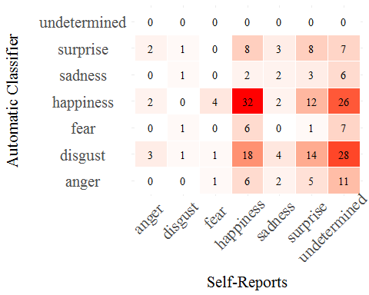

Figure 2: Confusion matrix of between the emotion self-reported as being characteristic of the elicitation with the emotion recognized by the automatic classifier.

Results obtained for the comparison between emotions self-reported and recognized by the automatic classifier are similar to the ones with human observers (Table 2). Overall there is a low agreement between emotion self-reported and emotion recognized by the automatic classifier (Accuracy = 0.19, 95%CI[0.14,0.24]; Kappa = 0.05) except for *happiness* (13.9%) and *surprise* (3.48%). Surprisingly the automatic classifier incorrectly recognized as *disgust* an important proportion of videos in which *happiness* was the highest self-reported emotion (7.83%). In parallel, the automatic classifier recognized as *happiness* and *disgust* videos in which *surprise* was the highest self-reported emotion (respectively 5.22% and 6.09%).

*Table 2: Agreement accuracy metrics for each emotion.*

|  |  |  |  |  |
| --- | --- | --- | --- | --- |
| Emotion | Sensitivity | Specificity | Precision | F1 |
| anger | 0.00 | 0.89 | 0 |  |
| disgust | 0.25 | 0.70 | 0.01 | 0.03 |
| fear | 0.00 | 0.93 | 0 |  |
| happiness | 0.44 | 0.71 | 0.41 | 0.43 |
| sadness | 0.15 | 0.94 | 0.14 | 0.15 |
| surprise | 0.19 | 0.89 | 0.28 | 0.22 |
| undetermined | 0.00 | 1.00 |  |  |

A comparable explanation can be provided as the level of undetermined emotion are very high for the self reports.

## Comparison between human and automatic recognition

As previously mentioned, the accuracy of humans observers and the automatic classifier have some similarities. In order to compare which recognition has the highest accuracy a Receiver Operating Characteristic (ROC) curve was calculated (Figure 3).

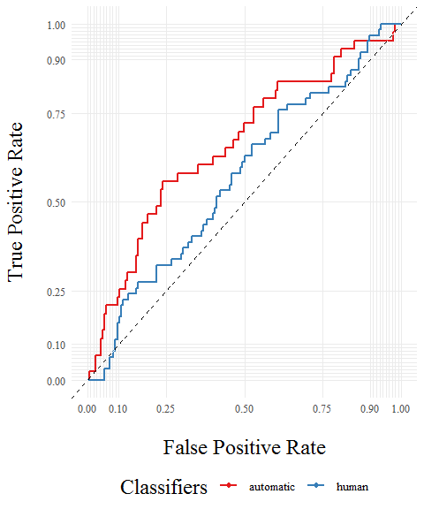

Figure 3: ROC curve comparing the accuracy in inferring subjective feelings from facial expressions by human observers and automatic recognition.

The ROC curve and its Area Under the Curve (AUC) values shows that the automatic classifier are more accurate than human observers in inferring subjective feeling from facial expressions (human AUC = 0.57 *vs.* automatic AUC = 0.66).

# Conclusion

Despite being one on the most investigated question in affective science, the link between emotion felt and facial expression is a hot topic and no clear evidence have been found to definitely answer it. However, with the growing interest of industries and government to monitor individual’s psychological states, evidences are showing that facial expressions are in reality not expressing emotions (McKeown 2013). This research aimed to provide some empirical data to the question. The subjective feeling of participants was compared with human recognition on one side and automatic recognition on the other side. The results reveals a low accuracy for both humans and automatic classifier to accurately identify the inner emotional states of these individuals based on their facial expressions.

Some limitations to this process should be stated over the use of self-reports to evaluate individual’s subjective feelings. Accessing to the inner subjective feeling can be biased if not impossible. Moreover the laboratory setting can trigger ambiguous and “non-basic” emotions which were not analysed in this research. The procedure use for human annotation can also be incriminated. Instead of asking the human annotators to provide an unique label, a more subtle approach was chosen to mimic results provided by the automatic classifier. In this regard, the results of the human annotation could have been more ambiguous because it is not the natural way that people are inferring human emotions. Finally, the automatic classifier algorithm can also be problematic. Based on training datasets which are most of the time using prototypical facial expression of the “basic” emotions, the algorithm to classify facial expressions can be held in check by the spontaneous facial expressions analysed.

Considering the above, the results provides an additional evidence that individuals’ subjective feeling can not be inferred from facial expressions and in our case invalidate the hypothesis of hardwired emotions. This result suggests that automatic facial expression recognition tools should be focused on evaluating facial morphology features such as action units rather than inferring potential emotional or affective states.

# Acknowledgment

The authors would like to thank Brigitte Meillon and Jean Michel Adam who developed the software used to collect and preprocess human observer annotations.

# References

Averill, James R. 1980. “A Constructivist View of Emotion.” In *Theories of Emotion*, 305–39. Elsevier.

Barrett, Lisa Feldman. 2017a. *How Emotions Are Made: The Secret Life of the Brain*. Houghton Mifflin Harcourt.

———. 2017b. “The Theory of Constructed Emotion: An Active Inference Account of Interoception and Categorization.” *Social Cognitive and Affective Neuroscience* 12 (1): 1–23.

Crivelli, Carlos, and Alan J Fridlund. 2018. “Facial Displays Are Tools for Social Influence.” *Trends in Cognitive Sciences* 22 (5): 388–99.

Darwin, Charles. 1872. *The Expression of the Emotions in Man and Animals*. London, UK: John Murray, London UK.

Dente, Pasquale, Dennis Küster, Lina Skora, and E Krumhuber. 2017. “Measures and Metrics for Automatic Emotion Classification via Facet.” In *Proceedings of the Conference on the Study of Artificial Intelligence and Simulation of Behaviour (Aisb)*, 160–63.

Dupré, Damien, Daniel Akpan, Elena Elias, Jean-Michel Adam, Brigitte Meillon, Nicolas Bonnefond, Michel Dubois, and Anna Tcherkassof. 2015. “Oudjat: A Configurable and Usable Annotation Tool for the Study of Facial Expressions of Emotion.” *International Journal of Human-Computer Studies* 83: 51–61.

Dupré, Damien, Nicole Andelic, Gawain Morrison, and Gary McKeown. 2018. “Accuracy of Three Commercial Automatic Emotion Recognition Systems Across Different Individuals and Their Facial Expressions.” In *2018 Ieee International Conference on Pervasive Computing and Communications Workshops (Percom Workshops)*, 627–32. IEEE.

Ekman, Paul. 1992. “An Argument for Basic Emotions.” *Cognition & Emotion* 6 (3-4): 169–200.

———. 2007. “The Directed Facial Action Task.” *Handbook of Emotion Elicitation and Assessment* 47: 53.

Fridlund, Alan J, and Erika L Rosenberg. 1995. “Human Facial Expression: An Evolutionary View.” *Nature* 373 (6515): 569–69.

Frijda, Nico H, and Anna Tcherkassof. 1997. “Facial Expressions as Modes of Action Readiness.” *The Psychology of Facial Expression*, 78–102.

McDuff, Daniel, Abdelrahman Mahmoud, Mohammad Mavadati, May Amr, Jay Turcot, and Rana el Kaliouby. 2016. “AFFDEX Sdk: A Cross-Platform Real-Time Multi-Face Expression Recognition Toolkit.” In *Proceedings of the 2016 Chi Conference Extended Abstracts on Human Factors in Computing Systems*, 3723–6. ACM.

McKeown, Gary J. 2013. “The Analogical Peacock Hypothesis: The Sexual Selection of Mind-Reading and Relational Cognition in Human Communication.” *Review of General Psychology* 17 (3): 267–87.

Tcherkassof, Anna, Damien Dupré, Brigitte Meillon, Nadine Mandran, Michel Dubois, and Jean-Michel Adam. 2013. “DynEmo: A Video Database of Natural Facial Expressions of Emotions.” *The International Journal of Multimedia & Its Applications* 5 (5): 61–80.

Waal, Frans de. 2019. *Mama’s Last Hug: Animal Emotions and What They Teach Us About Ourselves*. Granta Books.