The Titanic - A disaster reflecting social inequality

Damien Dupré

# Abstract

This document is an example of what can be done using Rmarkdown file to produce an academic/professional report. It focuses on the titanic dataset which is one of the most classic datasets to practice data analytic and data science. Indeed, the catastrophe of the titanic is not only interesting from a data point of view but also from a human point of view.

While the James Cameron movie did not focus too much on the influence of classes on the final outcome, it appears that passengers were not equals in age and gender. For these reasons, this report will investigate what are the influence of age and gender on passengers’ ticket fare.

# Literature Review

According to Saidatunnisa, Sili and Nasrullah (2019), the inequality issues towards women existed in one of the most outstanding movies of all times, Titanic. Titanic movie began with the 84 years old woman named Rose DeWitt Bukater who told about Titanic’s tragic story on its first and last voyage April 1912. Rose DeWitt Bukater was regardless of her status as the upper class, also a woman who experienced the inequality issues. Rose as a woman had to be obedient towards the male supremacy society she lived in.

In addition, researchers interested in inequalities in healthcare “are wont to quote data from the Titanic disaster” (Marmot 1999, p. 16). This ritual stems from Antonovsky (1967), who opened his classic paper with an illustration based on data from the Titanic, highlighting the higher survival rate of the first- and second-class passengers, versus the second- and third-class passengers, to demonstrate that social class influences mortality (Pearson, 2008).

* **Hypothesis 1:** The average tickets fare of female passengers is higher than the average ticket fare of male passengers.
* **Hypothesis 2:** Passengers’ tickets fare increases when their age increases.

# Method

The method section usually describes the participants where the data was collected, the material and the procedure used to collect the data, and the analysis performed to test the hypotheses.

## Participants

The data were collected from 1309 passengers known for having embarked on the Titanic. The average age of passengers was 29.9 years old (SD = 14.4) but the age from 263 passengers is unknown (Table 1).

|  |  |  |  |
| --- | --- | --- | --- |
| n | missing | m_age | sd_age |
| 1309 | 263 | 29.88114 | 14.41349 |

Table 1. Passengers’ demographics.

From them, 466 where female passengers and 843 were male passengers (Table 2).

|  |  |
| --- | --- |
| Sex | n |
| female | 466 |
| male | 843 |

Table 2. Distribution of passenger gender.

## Material

Little is know over how these data were collected but it lists the passengers name, age, gender, ticket class, number of siblings / spouses aboard the Titanic, number of parents / children aboard the Titanic, ticket number, passenger fare, cabin number, port of Embarkation (C = Cherbourg, Q = Queenstown, S = Southampton) and ultimately their survival (0 = No, 1 = Yes).

## Procedure

This section usually describes how the data were collected but here they were found online on the Kaggle website <https://www.kaggle.com/c/titanic/data>.

## Data Analyses

To test these hypotheses, the following linear regression model will be used:

$$Fare=β_{0}+β_{1}Gender+β_{2}Age+ϵ$$

This model uses Fare as a continuous outcome variable. Age is a continuous predictor and Gender a categorical predictor with two categories (i.e., female and male). Age and Gender are tested in the model as a main effect as indicated in Figure 1.

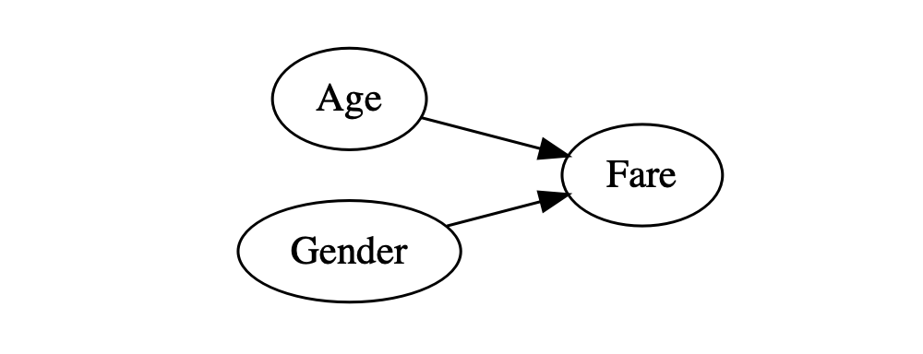

Figure 1. Representation of the model tested.

# Results

The average fare for female passengers is slightly higher than the average fare for male passengers (£46.2 for female passengers vs. £26.2 for male passengers) as show by the Figure 2.

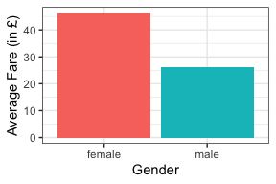

Figure 2. Average ticket fare for female and for male passengers.

It also appears that the ticket fare increases when age increases as well as shown in Figure 3.

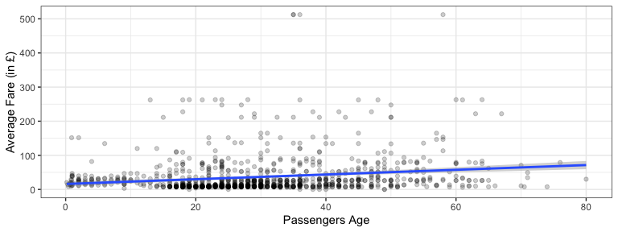

Figure 3. Relationship between passenger’s age and ticket fare.

The model tested is statistically significant in term of prediction of passengers fare (R2 = 0.07, F(2, 1042) = 40.26, p < .001). The effect of Age is statistically significant (b = 0.74, 95% CI [0.51, 0.97], t(1042) = 6.39, p < .001). The effect of Sex is statistically significant as well (b = -23.04, 95% CI [-29.81, -16.27], t(1042) = -6.68, p < .001).

# Discussion and Conclusion

An obvious reason why age of passengers influenced their ticket fare is due to negotiated rates for children being cheaper than adults. There is also the fact that older passengers prefer more comfortable cabins and therefore will pay a higher price. However, the reason why female passengers paid a higher price on average is still a mystery. Probably, male passengers were satisfied with more simple cabins. However, female passengers were usually travelling with their children and therefore required a larger cabin. This explanation provide supports for a latent gender inequality in western society. Female have much more side expenses than males, this phenomenon is known as pink tax (Lafferty, 2019) or tampon tax (Bennett, 2017).

# References

Antonovsky, A. (1967). Social class, life expectancy, and overall mortality. Milbank Quarterly, 45(2), 31–73.

Bennett, J. (2017). The tampon tax: Sales tax, menstrual hygiene products, and necessity exemptions. Business Entrepreneurship & Tax Law Review, 1, 183.

Lafferty, M. (2019). The pink tax: The persistence of gender price disparity. Midwest Journal of Undergrad Research, 11, 56-72.

Marmot, M. G. (1999). Epidemiology of socioeconomic status and health: Are determinants within countries the same as between countries? Annals of the New York Academy of Sciences, 896, 16–29.

Pearson, J. A. (2008). Can’t buy me whiteness: New lessons from the Titanic on race, ethnicity, and health. Du Bois Review: Social Science Research on Race, 5(1), 27-47.

Saidatunnisa, N. E., Sili, S., & Nasrullah, N. (2019). The inequality issues of male supremacy towards rose character in titanic movie. Ilmu Budaya: Jurnal Bahasa, Sastra, Seni dan Budaya, 3(4), 393-403.