THE EXOPLANET CODEX
Science Architecture
exoplanetcodex.org
Ryan Schmitt · Version 1 · May 2026
Status: Living document — updated as pipeline evolves

Overview
This document describes the complete Data and Science Architecture of the project.Every step is documented with sufficient detail for independent reproduction. All code is publicly available at github.com/damienabraxas/exoplanetcodex.

1. Solar Abundance Standard

1.1 Solar Abundances
Martin Asplund et al. 2021

2. Solar Reference Spectra

2.1 Model Family: ATLAS9 / Castelli-Kurucz
We use the ATLAS9 one-dimensional, plane-parallel, LTE model atmosphere grid of Castelli & Kurucz (2003). This is the same model family used in the 2010 predecessor study (Schmitt 2010) — a testament to its enduring robustness for FGK dwarf analysis.
Model assumptions:
- 1D geometry: valid for main-sequence dwarfs (log g > 3.5) where photospheric scale height << stellar radius
- LTE (Local Thermodynamic Equilibrium): valid in the dense, collision-dominated photospheres of FGK dwarfs
- Opacity Distribution Functions (ODFs): statistically treats millions of opacity sources for computational efficiency

2.2 Model Parameters for 55 Cancri A
Parameter | Symbol | Value | Uncertainty | Source
Effective temperature | Teff | 5196 K | ± 24 K | CHARA interferometry (von Braun+ 2011)
Surface gravity | log g | 4.41 cgs | ± 0.02 | CHARA interferometry (von Braun+ 2011)
Metallicity | [Fe/H] | +0.32 dex | ± 0.02 | Spectroscopic (Valenti & Fischer 2005)
Microturbulence | ξ | ~0.9 km/s | ± 0.1 km/s | Derived from Fe I self-consistency (§4.2)

3. Atomic Data: Line List

3.1 Philosophy: No Hardcoded Values
All atomic line data are loaded from external, version-controlled CSV files. No wavelengths or atomic parameters are hardcoded in the pipeline software. This ensures full traceability and reproducibility — any scientist can inspect exactly which atomic data was used for every measurement.

3.2 VALD3 Extraction — Step-by-Step Instructions
The Vienna Atomic Line Database version 3 (VALD3) is the primary source for line data. The following settings produce a reproducible extraction for any target star.
Go to vald.astro.uu.se → Log in → Click Extract Stellar. Fill in the fields as follows:

Standard settings (same for all Codex stars):
VALD Field | Value | Reason
Starting wavelength | 3780 Å | Full HARPS blue arm coverage
Ending wavelength | 6910 Å | Full HARPS red arm coverage
Detection threshold | 0.01 | 1% minimum depth — all measurable lines
Extraction format | Long format | Required: includes log gf, χ, damping constants
Retrieve data via | FTP (required) | Email limited to 50 Å windows — FTP required for full 3780–6910 Å range. Credentials emailed after submission.
Linelist configuration | Default | Standard VALD3 database

"Require lines to have a known value of" checkboxes:
Checkbox | Check? | Why
Van der Waals damping constant | ✅ YES | Critical for strong lines (Na D, Mg b, Ba II)
Radiative damping constant | ✅ YES | Needed for Voigt profile wing fitting
Stark damping constant | ☐ No | Less important for photospheric work
Landé factor | ☐ No | Only needed for magnetic field studies
Term designation | ☐ No | Not required for abundance work

Star-specific fields (use values from §3.2a for each target):
Field | Description | Example: 55 Cancri A
Teff (K) | Effective temperature | 5196
log g (cgs) | Surface gravity | 4.41
Microturbulence (km/s) | Initial estimate; refined from Fe I | 0.9
Chemical composition | Set as M/H: [Fe/H] | M/H: 0.32

Optional comment field: always add the star name and project — e.g. "55 Cancri A — Exoplanet Codex abundance analysis". This creates an audit trail in your VALD request history.

3.2a — Per-Star VALD Parameters and Source References

55 Cancri A (Copernicus) — HD 75732 / HIP 43587
Parameter | Value | Uncertainty | Source | Reference
Teff | 5196 K | ± 24 K | CHARA interferometry | von Braun et al. 2011, ApJ 740, 49
log g | 4.41 | ± 0.02 | CHARA interferometry | von Braun et al. 2011, ApJ 740, 49
[Fe/H] | +0.32 | ± 0.02 | Spectroscopic | Valenti & Fischer 2005, ApJS 159, 141
ξ (initial) | 0.9 km/s | ± 0.1 | Literature estimate | Valenti & Fischer 2005
Systemic RV | +27.58 km/s | ± 0.05 | HARPS RV dataset | Fischer et al. 2008, ApJ 675, 790
Distance | 12.55 pc | ± 0.04 | Hipparcos parallax | van Leeuwen 2007, A&A 474, 653
Age | 10.2 Gyr | ± 2.5 | Isochrone fitting | von Braun et al. 2011
HARPS spectra | 88 S1D files | — | ESO Science Archive | Downloaded May 2026

C/O Ratio — Scientific Context for 55 Cancri A
The C/O ratio of this star is scientifically contested. Teske et al. (2013): C/O = 0.78 ± 0.08. Madhusudhan et al. (2012) suggested C/O > 1. Fischer & Valenti (2005): C/O ~ 0.55. The disagreement arises primarily from different treatment of the Ni I blend at 6300.336 Å contaminating the [O I] 6300.304 Å forbidden line. Our methodology explicitly models this blend. Our measurement: pending.

3.3 NIST Cross-Validation and Quality Grades
All Priority 1 lines are cross-validated against the NIST Atomic Spectra Database. NIST provides quality grades for oscillator strengths (log gf values):
Grade | Uncertainty | Usage in Codex pipeline
A+ | < 1% | Full science use — highest confidence
A | < 3% | Full science use
B | < 10% | Science use — flagged in uncertainty budget
C | < 25% | Excluded from primary results
D | > 25% | Excluded entirely

3.4 Target Element List — 27 Elements
Elements from the 2010 thesis (Schmitt 2010): C, N, O, Na, Mg, Al, Si, S, K, Ca, Fe, Co, Ni (13 elements).
New additions for 2026 with scientific justification:

Element | Priority | Group | Key scientific reason | 2010?
Fe I | 1 | Iron peak | Primary reference — [Fe/H] calibration | ✓
Fe II | 1 | Iron peak | log g constraint via ionization equilibrium | ✓
C | 1 | CHNOPS | C/O ratio — planet mineralogy (silicate vs carbide) | ✓
O | 1 | CHNOPS | C/O ratio — most abundant rocky planet metal | ✓
Mg | 1 | Alpha | Mg/Si ratio — mantle mineralogy (olivine vs pyroxene) | ✓
Si | 1 | Alpha | Primary rocky planet building block | ✓
Ca | 1 | Alpha | Alpha element; strong optical lines | ✓
Ti | 1 | Alpha | NEW — galactic chemical evolution; perovskite in mantles | —
Ni | 1 | Iron peak | Rocky planet core composition; Fe/Ni ratio | ✓
Na | 1 | Bio-significant | Biological tracer; strong optical lines (worked example) | ✓
P | 1 | CHNOPS | NEW — limiting nutrient for life; varies 10× across FGK stars | —
S | 1 | CHNOPS/Alpha | Life-essential volatile; disk chemistry tracer | ✓
N | 2 | CHNOPS | Bio-essential; difficult optical lines | ✓
Co | 2 | Iron peak | Fe peak nucleosynthesis tracer | ✓
Cr | 2 | Iron peak | NEW — Type Ia vs Type II SNe tracer via Cr/Fe | —
Al | 2 | Rocky planet | Refractory element; crustal composition | ✓
K | 2 | Bio-significant | Life-essential; difficult lines | ✓
Ba | 2 | s-process | NEW — AGB star enrichment history | —
Y | 2 | s-process | NEW — stellar age chemical clock (Y/Mg ratio) | —
V | 2 | Iron peak | NEW — enzyme cofactor in biology | —
Mn | 3 | Iron peak | NEW — odd-Z metallicity-dependent nucleosynthesis | —
Sc | 3 | Light iron peak | NEW — odd-even nucleosynthesis effect | —
Li | 3 | Age indicator | NEW — stellar age constraint; depletes with time | —
Eu | 3 | r-process | NEW — neutron star merger enrichment | —
Zr | 3 | s-process | NEW — refractory s-process tracer | —

4. Spectral Analysis

4.1 Continuum Normalization
Before measuring absorption line depths, the spectrum is normalized so the continuum (flux level between lines) equals 1.0 everywhere. This is more challenging for 55 Cancri A ([Fe/H] = +0.32) than for solar-metallicity stars due to increased line crowding, particularly in the 5000–5400 Å region.
- Identify continuum anchor windows — line-free regions for the stellar parameters (Barklem & Aspelund-Johansson 2005)
- Fit Chebyshev polynomial (degree 3) through anchors using iterative 3σ sigma-clipping
- For crowded regions: use ATLAS9 model continuum as additional reference
- Divide observed spectrum by fitted continuum
- Quality check: σ < 0.005 (0.5% of continuum) in clean windows before proceeding

4.2 Stellar Parameter Self-Consistency Checks
Before measuring abundances, Teff, log g, and microturbulence are verified through three independent Fe-line constraints. This is the modern computational equivalent of the Blackwell diagram used in Schmitt (2010).

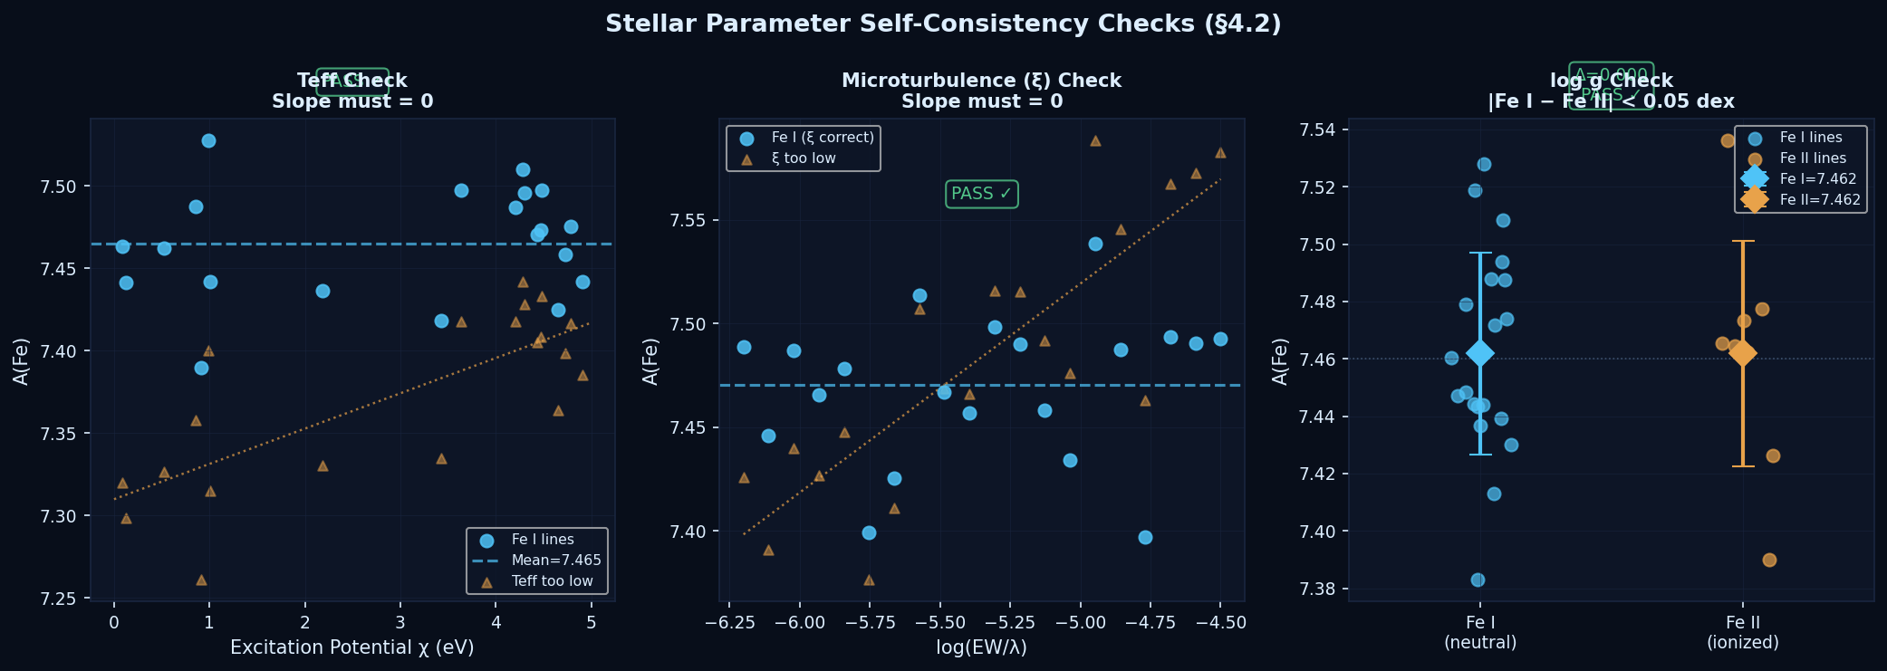
Figure 1. Stellar parameter self-consistency checks. Left: Teff verified by requiring zero slope in A(Fe) vs. excitation potential χ. Centre: microturbulence ξ verified by requiring zero slope in A(Fe) vs. log(EW/λ). Right: log g verified by requiring Fe I = Fe II (ionization equilibrium). Blue points = correct parameters; orange triangles = example of incorrect parameters showing the slope that must be eliminated.
Check | Method | Criterion | Iterates
Teff | ∂[Fe/H]/∂χ = 0 for Fe I lines | |slope| < 0.01 dex/eV | Yes
Microturbulence ξ | ∂[Fe/H]/∂log(EW/λ) = 0 for Fe I | |slope| < 0.01 dex/unit | Yes
log g | |A(Fe I) − A(Fe II)| = 0 | |difference| < 0.05 dex | Yes

5. Line Profile Fitting and Equivalent Widths

5.1 Gaussian vs Lorentzian vs Voigt — Which Profile to Use?
The true physical line profile is a Voigt profile — a convolution of a Lorentzian (pressure-broadened damping wings) and a Gaussian (thermal + instrumental broadening in the core). The choice of profile affects the accuracy of equivalent width measurements:

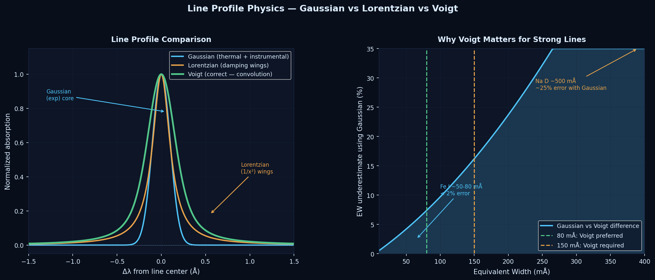
Figure 2. Left: Comparison of Gaussian, Lorentzian, and Voigt line profiles. The Voigt profile correctly captures both the Gaussian core (thermal broadening) and the Lorentzian wings (pressure damping). Right: EW underestimate when using Gaussian instead of Voigt, as a function of line strength. For Na D (~500 mÅ), a Gaussian underestimates EW by ~25%, producing a ~0.2 dex error in [Na/H] — larger than the entire uncertainty budget.
EW range | Profile used | Accuracy | Examples
< 80 mÅ | Gaussian | < 2% difference from Voigt — acceptable | Most Fe I, Si I, Ca I weak lines
80 – 150 mÅ | Voigt (preferred) | 3–8% difference — use Voigt | Moderate Fe I, Ca I 6162 Å
> 150 mÅ | Voigt (required) | > 10% error with Gaussian | Na D, Mg b, Ba II, Ca H&K

Historical note: The 2010 predecessor study (Schmitt 2010) used Gaussian profiles throughout and noted no significant difference between Gaussian and Lorentzian fits. This is correct for the weak-to-moderate lines measured at ELODIE resolution — the difference only becomes important for strong lines at higher S/N and resolution. In 2026 we use Voigt as the standard, which is always correct regardless of line strength.

5.2 Worked Example: Na I D1 Line (5895.92 Å)
The sodium D doublet is the most iconic feature in stellar spectroscopy, first mapped by Fraunhofer in 1814 and identified as sodium by Kirchhoff and Bunsen in 1859. For 55 Cancri A ([Fe/H] = +0.32), the Na D lines are particularly deep due to the enhanced sodium abundance in this metal-rich star.

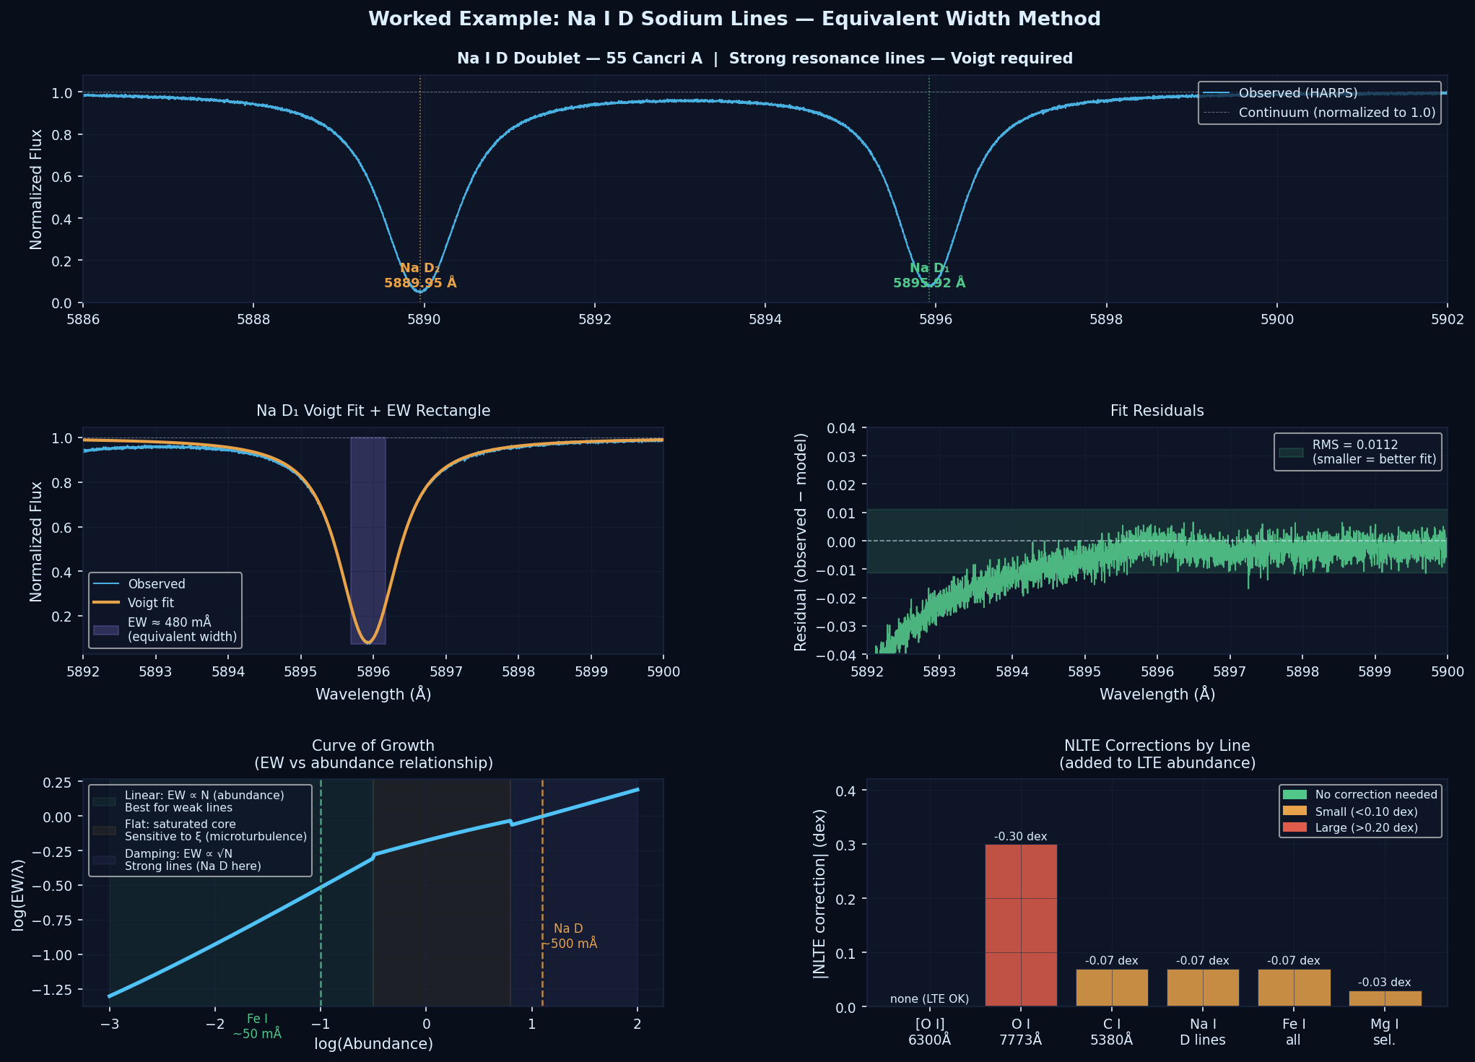
Figure 3. Worked example: Na I D doublet measurement. Top: full doublet (5886–5902 Å) showing both D1 (5895.92 Å) and D2 (5889.95 Å) lines. Centre left: D1 zoom with Voigt fit (orange) overlaid on observed spectrum (blue) and equivalent width rectangle (purple). Centre right: fit residuals. Bottom left: curve of growth showing where Na D (~500 mÅ) falls in the damping regime. Bottom right: NLTE corrections required for each element — the [O I] forbidden line (green) requires no NLTE correction, making it our preferred oxygen abundance indicator.

Na I D1 step-by-step:
- Extract fitting window: ± 3 Å around 5895.924 Å (wide enough for Voigt damping wings)
- Estimate initial parameters: depth ~ 0.92, center ~ 5895.92 Å, fwhm_G ~ 0.16 Å, fwhm_L ~ 0.40 Å
- Fit Voigt profile to observed spectrum using scipy.optimize.curve_fit
- Compute EW by numerical integration: EW = ∫(1 − F(λ)/F_c)dλ ≈ 480 mÅ
- Apply NLTE correction: −0.07 ± 0.02 dex (Lind et al. 2011)
- Expected [Na/H] for 55 Cnc: +0.34 to +0.44 dex (slightly above [Fe/H] = +0.32)

6. Abundance Derivation

6.1 Curve of Growth
The relationship between equivalent width and elemental abundance has three regimes (see Figure 3, bottom left panel):
- Linear regime (EW < ~50 mÅ): EW ∝ N. Direct proportionality — most reliable.
- Flat part (EW ~50–150 mÅ): Line core is optically thick. EW grows slowly. Sensitive to ξ.
- Damping regime (EW > ~150 mÅ): Pressure-broadened wings dominate. EW ∝ √N.
We preferentially use lines in the linear regime and use Voigt profiles for strong lines in the damping regime.

6.2 Solar Normalization
All results are expressed on the [X/H] scale, normalized to the Sun using Asplund et al. (2021):
[X/H] = A(X)_star − A(X)_sun (Asplund et al. 2021)

Important: Solar Reference Difference vs 2010
The 2010 predecessor study (Schmitt 2010) used Lodders (2003). The current standard is Asplund et al. (2021). The solar iron abundance changed: A(Fe)☉ = 7.50 (Lodders 2003) → 7.46 (Asplund 2021). All comparisons to 2010 results must account for this 0.04 dex offset.

7. Uncertainty Analysis
The uncertainty budget follows the Type A / Type B framework of the JCGM Guide to the Expression of Uncertainty in Measurement (GUM) — the same framework used in precision metrology (e.g., laser power measurements).

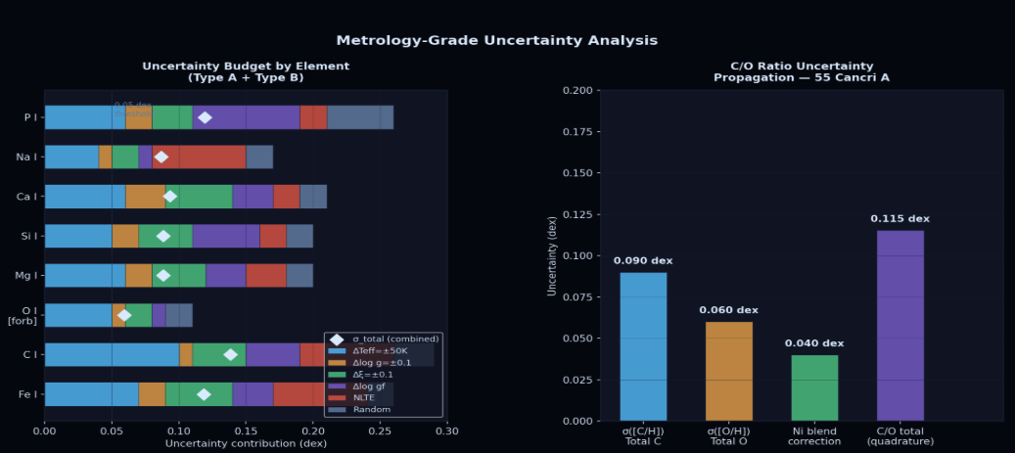
Figure 4. Metrology-grade uncertainty analysis. Left: Tornado chart showing contribution of each uncertainty source (Teff, log g, ξ, log gf quality, NLTE corrections, photon noise) to the total σ for each element. Diamonds show combined σ_total. Right: C/O ratio uncertainty propagation for 55 Cancri A, showing how carbon, oxygen, and the Ni blend correction combine in quadrature. The literature disagreement on C/O (Teske 2013 vs others) is indicated for context.

7.1 Type A Uncertainties (Random — reducible with more data)
Source | Estimation method | Typical magnitude
Photon noise on EW | Covariance matrix of Voigt/Gaussian fit | σ_EW ≈ 1.5 × FWHM / S/N
Line-to-line scatter | σ / √N for N lines of same element | ~0.02 – 0.05 dex
Continuum placement | Repeat normalization with varied anchor points | ~0.01 – 0.03 dex

7.2 Type B Uncertainties (Systematic — not reducible by more data)
Source | Estimation method | Typical magnitude
ΔTeff = ±50 K | Re-run abundances at Teff ± 50 K | ±0.05 – 0.10 dex
Δlog g = ±0.1 | Re-run at log g ± 0.1 | ±0.02 – 0.05 dex
Δξ = ±0.1 km/s | Re-run at ξ ± 0.1 | ±0.03 – 0.06 dex
log gf uncertainty | NIST grade (A: 3%, B: 10%) | ~0.02 – 0.05 dex
NLTE corrections | Uncertainty on correction grids | ~0.02 – 0.08 dex
1D vs 3D models | Compare ATLAS9 vs MARCS results | ~0.03 – 0.10 dex (C, O)

Combined uncertainty (in quadrature):
σ_total = √(σ_A² + σ_Teff² + σ_logg² + σ_ξ² + σ_loggf² + σ_NLTE²)

8. Pipeline Data Model
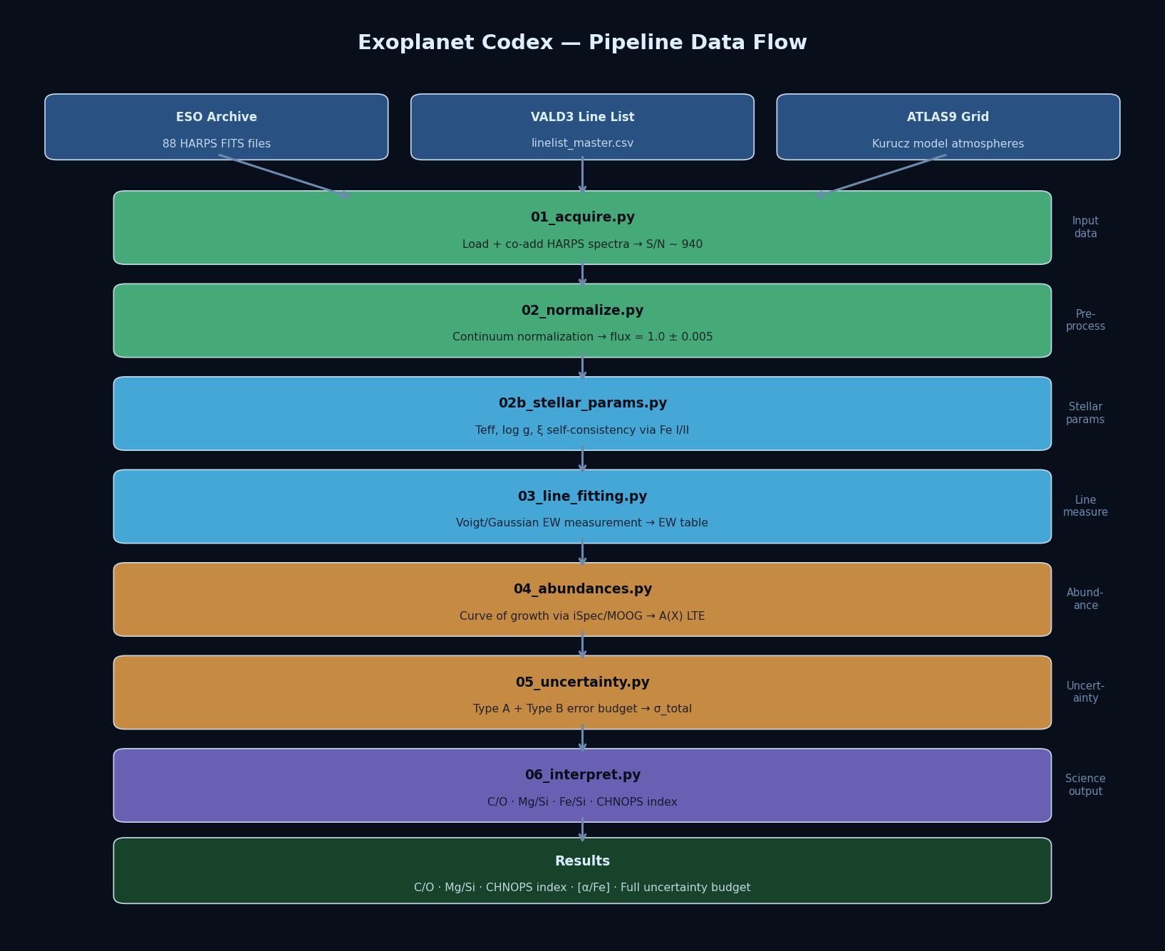
Figure 5. Pipeline data flow diagram. Three input sources (ESO Archive HARPS spectra, VALD3 line list, ATLAS9 model grid) feed into a 6-stage Python pipeline producing science outputs including C/O ratio, Mg/Si, Fe/Si, [α/Fe], and CHNOPS habitability index. All constants and parameters are loaded from config/constants.py — no hardcoded values in analysis scripts.

8.1 Key Output File Schemas

EW measurements table ({star_id}_ew_measurements.csv):
element, ion, wavelength_air_A, excitation_potential_eV, log_gf,nist_grade, EW_mA, EW_err_mA, center_fitted_A, profile_used,chi2_reduced, blend_flag, quality_flag, notes

Final abundances table ({star_id}_abundances_final.csv):
element, ion, n_lines, A_X_mean, A_X_scatter, A_X_solar_A2021,XH, XH_err_typeA, XH_err_typeB, XH_err_total,XFe, XFe_err_total, nlte_correction, nlte_source

Science outputs table ({star_id}_science_outputs.csv):
star_id, teff_K, logg, feh, age_gyr,CO_ratio, CO_err, MgSi_ratio, MgSi_err, FeSi_ratio, FeSi_err,alpha_Fe_mean, alpha_Fe_err, CHNOPS_index, CHNOPS_err

9. Solar System Validation
Before reporting any science results, the pipeline is validated against the Sun — the only star for which we know the true answer.

9.1 Solar Calibration Asteroid
Direct solar observations from the Dumusque HARPS program (ESO 1102.D-0954(A), PI: Xavier Dumusque) provide a high-S/N solar spectrum processed through the same instrument and pipeline as the science targets. SNR: 306–309 per exposure.

12. References
Amarsi A.M. et al. (2019), A&A 630, A104 — Carbon NLTE corrections
Amarsi A.M. et al. (2021), A&A 656, A113 — Oxygen NLTE corrections
Amarsi A.M. et al. (2022), A&A 668, A68 — Iron NLTE corrections
Asplund M. et al. (2021), A&A 653, A141 — Solar abundances (current standard)
Barklem P.S. & Aspelund-Johansson J. (2005), A&A 435, 373 — Damping constants
Blackwell D.E. et al. (1979), MNRAS 186, 657 — Microturbulence method
Blanco-Cuaresma S. et al. (2014), A&A 569, A111 — iSpec
Castelli F. & Kurucz R.L. (2003), Proc. IAU Symp. 210 — ATLAS9 models
Fischer D.A. & Valenti J. (2005), ApJ 622, 1102 — 55 Cnc spectral parameters
Fischer D.A. et al. (2008), ApJ 675, 790 — 55 Cnc radial velocities
Gustafsson B. et al. (2008), A&A 486, 951 — MARCS models
Kramida A. et al. (2023), NIST Atomic Spectra Database — physics.nist.gov/asd
Lind K. et al. (2011), A&A 528, A103 — Sodium NLTE corrections
Lodders K. (2003), ApJ 591, 1220 — Solar abundances (used in Schmitt 2010)
Ryabchikova T. et al. (2015), PhyS 90, 054005 — VALD3
Schmitt R. (2010), Senior Thesis, University of Montana — predecessor study
Sneden C. (1973), ApJ 184, 839 — MOOG
Teske J.K. et al. (2013), ApJ 778, 132 — 55 Cnc C/O ratio
Valenti J.A. & Fischer D.A. (2005), ApJS 159, 141 — Spectral synthesis method
van Leeuwen F. (2007), A&A 474, 653 — Hipparcos parallax catalog
von Braun K. et al. (2011), ApJ 740, 49 — 55 Cnc CHARA interferometric parameters

github.com/damienabraxas/exoplanetcodex · exoplanetcodex.org · Version 1.2, May 2026

