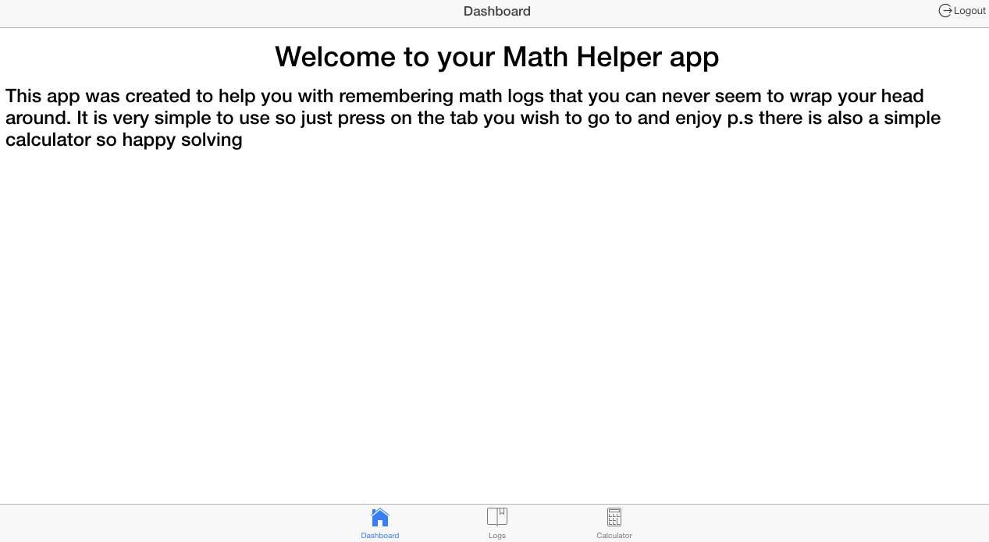

Math’s Helper App

Professional practice in IT

Damien Joyce | Computing and Software Development | 1st September 2017

# Introduction:

I completed this project as part of my studies at GMIT college Galway. This project was intended to show others my skills and what I have learned over the last three years while attending GMIT Galway. I had many different ideas on what kind of project I would use to best show off my skills as a developer. I thought of creating a java based project but I couldn’t think of any projects that would be complex enough to create. I decided to create a simple Math Helper App on ionic framework. I decided to use ionic version 1 because it was the version I previously used during my studies at GMIT Galway. This document will cover the topics that will explain my project in detail. The topics are shown below:

* Introduction
* How I wish to complete my project
* What is ionic
* Why was ionic created
* Conclusion
* References

# How I wish to complete my project:

I wish to create a simple to use ionic tabs app with a log in option using an API. I looked at many different online API’s I could use to handle the log in details for each user. I decided to use a firebase API to handle my log in details. It seemed like a simple and effective way to handle the users log in detail. I plan on using a google account log in as the option for the user to log into my app. I wish for a pop up log in option to open automatically when the user opens the app. I plan to use a SQLite database to store the math logs. I wish to use firebase to store the database details for each specific user, I believe that only one user can access their own database details at any time. Access must be restricted to make my app efficient and effective. I plan on using a simple but effective layout and that is why I chose the ionic framework. I wish to create this ionic app and run it on an IOS & android platform to test my app as a user. The technologies I wish to use are listed below:

* Ionic Framework version 1
* Firebase (API)
* IOS & Android
* Google
* GitHub

# What is ionic:

Ionic is a guide to building HTML5 mobile applications. It automatically created a base app which the developer can change and develop off. There are currently two versions of ionic which are ionic version 1 and ionic & angular 2. It is very simple to use at the begging and there is a lot of documentation detailing all the basics of creating your desired application. Ionic is a mobile application development framework targeted at building hybrid applications. A hybrid application is essentially small applications running in a browser in an application but they can also access the native platform layer of the device. The benefits of a hybrid applications over native applications are discussed below:

* Platform support
* Speed of development
* Access to third party code

Ionic is a front-end User Interface (UI) framework that handles the overall appearance of UI interactions to make a developer application more appealing. It is like bootstrap for native application development. Ionic differs from a responsive framework as it comes with a very native styles mobile UI elements and layouts, these options did not really exist previously to ionic. Ionic needs a native wrapper such as Cordova to run as a native application.

# Why was ionic created:

The creators of ionic strongly believed that HTML5 would rule on mobile applications over time like what happened to desktops. Once desktops became powerful enough and there was a huge leap in the advancement of browser technology. Most people who own a desktop spend the majority of their time surfing the internet, using social media or streaming shows this shows that most people who have a desktop spend it browsing the internet daily and can spend hours each day on the internet. Developers became overwhelmed with creating web applications. With recent developments in mobile technology such as smartphones and tablets which are now capable of running many of the web applications that were once only accessed through a desktop. The creatures of ionic wanted to build an HTML5 mobile application framework that was focused on native and hybrid applications instead of websites since there were was already so many great tools out there for website development, instead they wanted to create mobile applications that were for low level browsers such as IOS.

# Ionic Installation guide:

To install ionic version 1 on your device you must first have an up to date version of [Node.js](https://nodejs.org/en/). Then the you must open either the command window(windows) or terminal(Mac OS) and type in the following commands:

Windows: npm install -g cordova ionic

Mac: sudo npm install -g cordova ionic (depending on your devices .. configurations)

# How to run this project:

There is two possible ways of running this project. The simplest way is by running it on a web browser using the command line in Windows or as I have done using terminal using Mac OS. The commands are quite simple and are listed below:

* cd – to the folder where the project has been created
* ionic serve – this will run the ionic project and will post it on the default browser of the computer in use.

The second possible way of running this project is by using Xcode on Mac OS. When the IOS platform is added to the main project there is a platforms folder that has been created. In this folder, there is a file called FirebaseMathHelperApp.xcodeproj. Open this project and it will open in the Xcode platform. Then there is the option of running it on an IOS emulator or an IOS device once it is connected through a USB port. When running it all the user has to do is press the play button on the top left corner of the Xcode opening window. This will build and run the Ionic app.

# Conclusion:

Throughout this project, I discovered that some areas of creating this project will cause me much difficulty. These areas include implementing the API and creating the database. I discovered many good tutorials in how to create my desired Ionic application. I found that firebase was the most effective API to use to handle the authentication of this application. It was quite difficult to implement at the beginning and it took up much of my time but I eventually got it working. Throughout the project, I tried many different ways of creating a database and storing the data entered by the user but there are some bugs when using Cordova, these bugs are listed below:

* Will not create the database unless it is run on a device
* Will not create the database if an emulator is used
* The data entered by the user will only be entered in the database when using a device and not a web browser

My current project has the authentication API’s of both twitter and google browser working as well a simple calculator that does basic addition, subtraction, division and multiplication. I have tested this code many times with using both Firefox and Google Chrome web browsers to test my project. I found that I could not fully test my code due to some defects with creating a SQLite database with either browser. These issues are listed below:

* Uncaught TypeError: Cannot read property 'openDatabase' of undefined, this is due to Cordova being a platform specific plugin which means it will not work in the google web browser.
* TypeError: window.openDatabase is not a function this error arises simply because Firefox does not support a Web SQL database.

I have tested my project many times now and don’t seem to have any errors appearing in the developer mode in the Chrome web browser. I understand that the database isn’t working but from the amount of tests I have done and the errors that I have received it is my understanding that the web browser are a poor choice to use to test the this project as show above. This made it very difficult to produce a suffice project. I have ran both IOS emulators and web browsers to test this project to see would it be possible to fix the errors that I found in the developer tools of the web browser. I have researched many solutions to these errors and I have tried many of them as you can see from my [GitHub repository. I was able to fix some of the errors that arose but some of them I can’t seem to fix due most of the testing in the web browsers. After completing this project, I would recommend anyone interested in creating an Ionic project to make a separate copy of their project as I have had many issues with updating my project on my GitHub repository. This caused some unwanted files to be created as well as complications with the config.js file and also many other files with random text in each file that I had to then delete and change causing me to waste time on pointless tasks. If I were to do this project again I would not use SQLite as the database and I would use Ionic version three as it is the most up to date and it also has the most documentation that any other version of Ionic has had in the past. It also has the least amount of bugs and if I did my project in a newer version of Ionic I don’t believe that it would have given me as much difficulty as this project has. I have made an attempt on storing the data locally on the devices it is run on but I am still getting the same errors.](https://github.com/damienj252/MathHelperApp)

# Pictures of my application:

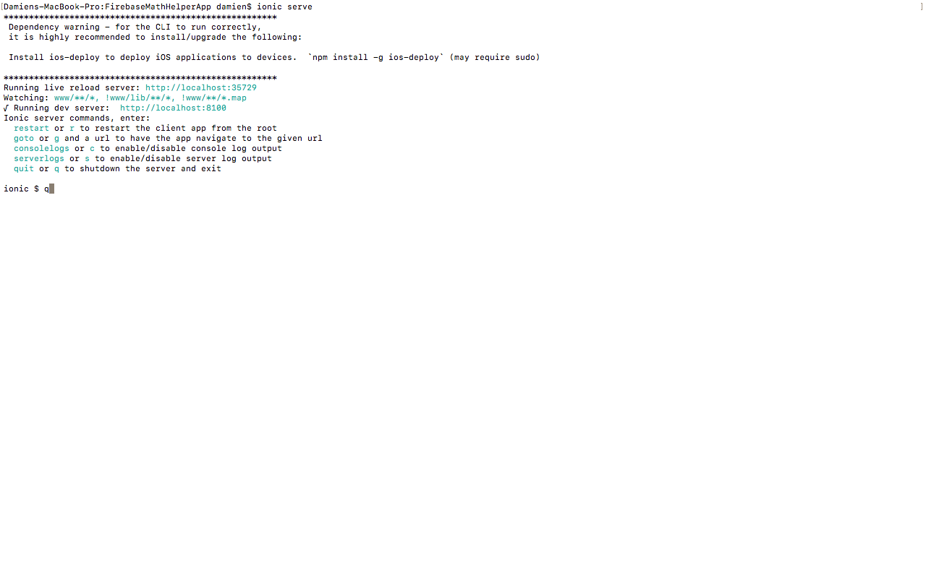

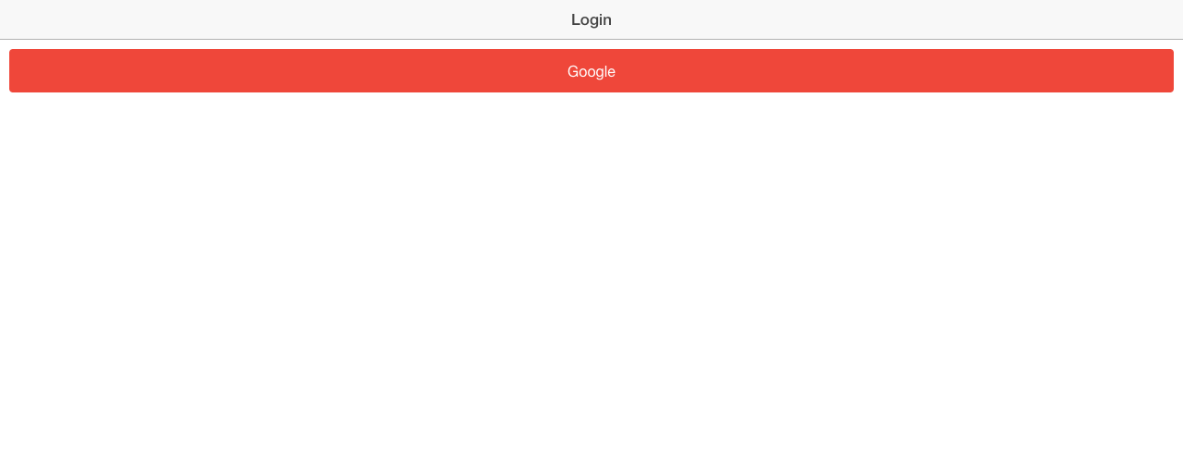



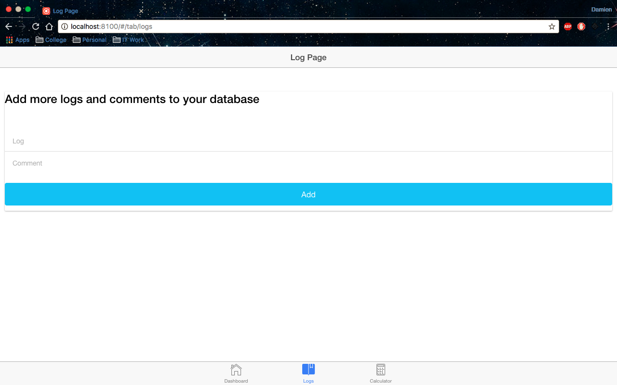

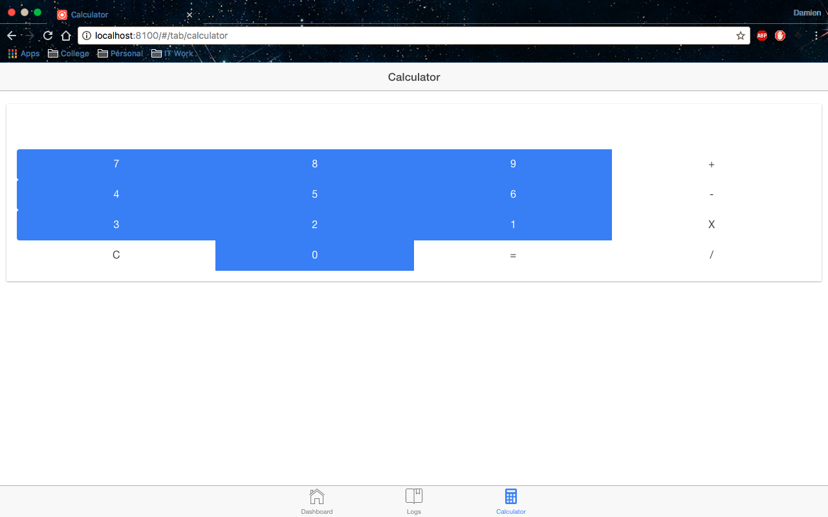

# Errors in web browsers:

