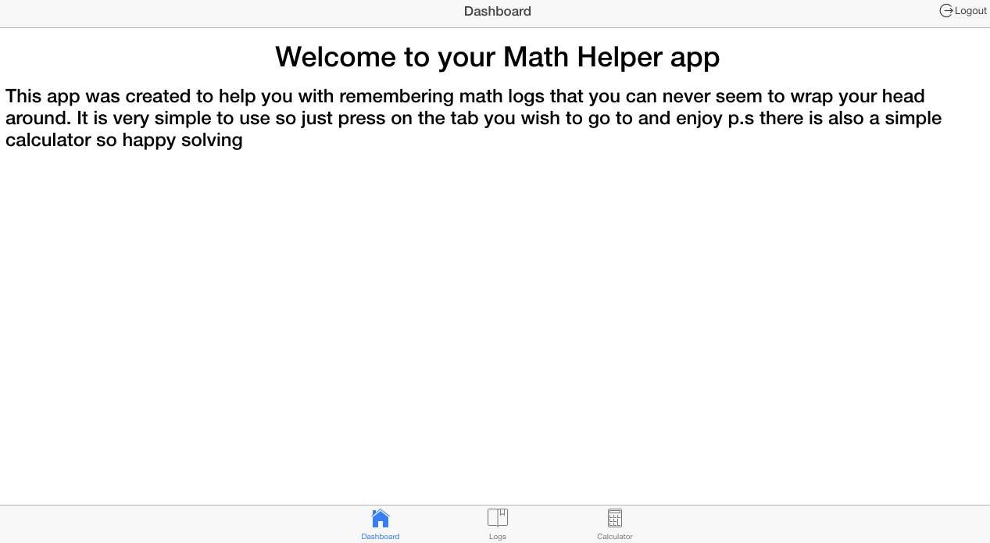

Math’s Helper App

Third year project

Damien Joyce | Computing and Software Development | 24th April 17

# Introduction:

I completed this project as part of my studies at GMIT college Galway. This project was intended to show others my skills and what I have learned over the last three years while attending GMIT Galway. I had many different ideas on what kind of project I would use to best show off my skills as a developer. I thought of creating a java based project but I couldn’t think of any projects that would be complex enough to create. I decided to create a simple Math Helper App on ionic framework. I decided to use ionic version 1 because it was the version I previously used during my studies at GMIT Galway. This document will cover the topics that will explain my project in detail. The topics are shown below:

* Introduction
* How I wish to complete my project
* What is ionic
* Why was ionic created
* Conclusion
* References

# How I wish to complete my project:

I wish to create a simple to use ionic tabs app with a log in option using an API. I looked at many different online API’s I could use to handle the log in details for each user. I decided to use a firebase API to handle my log in details. It seemed like a simple and effective way to handle the users log in detail. I plan on using a google account log in as the option for the user to log into my app. I wish for a pop up log in option to open automatically when the user opens the app. I plan to use a SQLite database to store the math logs. I wish to use firebase to store the database details for each specific user, I believe that only one user can access their own database details at any time. Access must be restricted to make my app efficient and effective. I plan on using a simple but effective layout and that is why I chose the ionic framework. I wish to create this ionic app and run it on an IOS & android platform to test my app as a user. The technologies I wish to use are listed below:

* Ionic Framework version 1
* Firebase (API)
* IOS & Android
* Google
* GitHub

# What is ionic:

Ionic is a guide to building HTML5 mobile applications. It automatically created a base app which the developer can change and develop off. There are currently two versions of ionic which are ionic version 1 and ionic & angular 2. It is very simple to use at the begging and there is a lot of documentation detailing all the basics of creating your desired application. Ionic is a mobile application development framework targeted at building hybrid applications. A hybrid application is essentially small applications running in a browser in an application but they can also access the native platform layer of the device. The benefits of a hybrid applications over native applications are discussed below:

* Platform support
* Speed of development
* Access to third party code

Ionic is a front-end User Interface (UI) framework that handles the overall appearance of UI interactions to make a developer application more appealing. It is like bootstrap for native application development. Ionic differs from a responsive framework as it comes with a very native styles mobile UI elements and layouts, these options did not really exist previously to ionic. Ionic needs a native wrapper such as Cordova to run as a native application.

# Why was ionic created:

The creators of ionic strongly believed that HTML5 would rule on mobile applications over time like what happened to desktops. Once desktops became powerful enough and there was a huge leap in the advancement of browser technology. Most people who own a desktop spend the majority of their time surfing the internet, using social media or streaming shows this shows that most people who have a desktop spend it browsing the internet daily and can spend hours each day on the internet. Developers became overwhelmed with creating web applications. With recent developments in mobile technology such as smartphones and tablets which are now capable of running many of the web applications that were once only accessed through a desktop. The creatures of ionic wanted to build an HTML5 mobile application framework that was focused on native and hybrid applications instead of websites since there were was already so many great tools out there for website development, instead they wanted to create mobile applications that were for low level browsers such as IOS.

# Conclusion:

Throughout this project, I discovered that some areas of creating this project will cause me much difficulty. These areas include implementing the API and creating the database. I discovered many good tutorials in how to create my desired Ionic application. I found that firebase was the most effective API to use to handle the authentication of this application. It was quite difficult to implement at the beginning and it took up much of my time but I eventually got it working. Throughout the project, I tried many different ways of creating a database and storing the data entered by the user but there are some bugs when using Cordova, these bugs are listed below:

* Will not create the database unless it is run on a device
* Will not create the database if an emulator is used
* The data entered by the user will only be entered in the database when using a device and not a web browser

I attempted to run my application on an IOS emulator and my IPhone but there were some bugs I could not fix. These bugs were connected to Cordova that was imported in my application. I researched these bugs and was unable to fix these but I believe it was because I was using Ionic version one as it is an older version of ionic and the latest version of Xcode which contains the IOS emulator I wished to use. This prevented me from being able to input data from the user into the database. If I had managed my time more effectively I believe I would have been able to get my application on the device running without any errors. My application is very straight forward and is simple to use. When the application is opened, a button appears which the user will press to allow them to log in using their google account if they do not have an account it allows them to create an account. After logging into my application is opened the dashboard page appears. At the bottom of the page there is three tabs which are labelled and have icons to make more apparent to the user. These tabs include a home page a logs page which should allow the user to add data to the database and finally there is a calculator that does simple math’s calculations and works perfectly. I was unable to get the logout button working as any attempt I attempted would crash my code.

# Pictures of my application:

