# nwkidsshow.com README

## Website Version 7

# Introduction

Django 1.4, upgraded to 1.5.

GAE

Cloud SQL, Cloud Storage

Users

Website layout

etc

# DB Schema

See also nwkidsshow-model.pdf

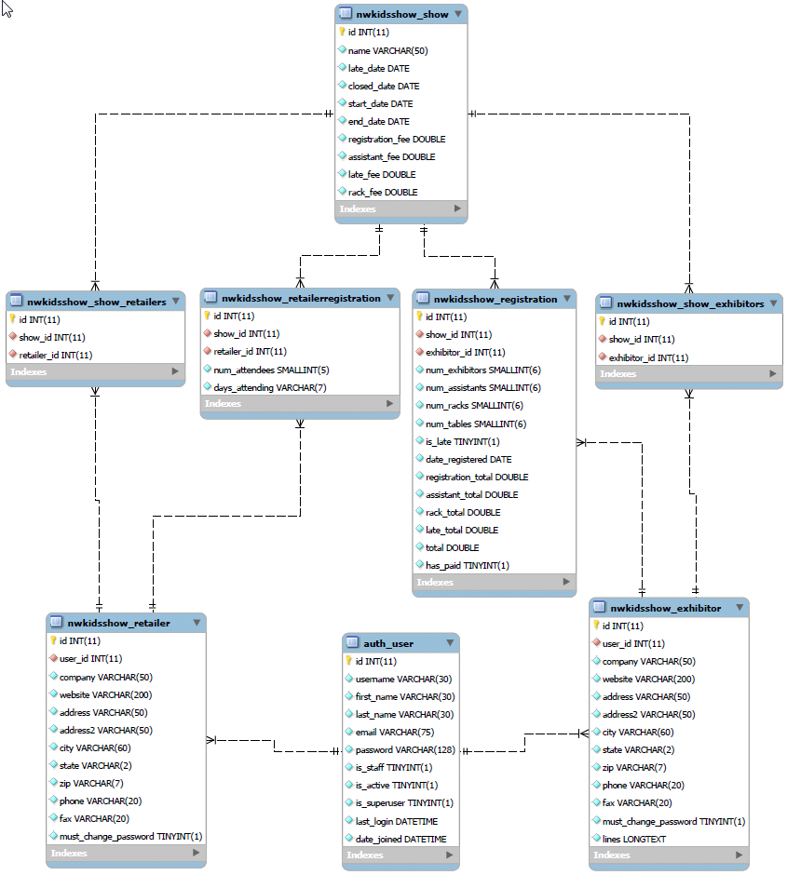

Note that nwkidsshow_show_retailers and nwkidsshow_show_exhibitors is an artifact created by django and not me. Regardless, it seems redundant with the other path from retailer to show. I don’t feel like fixing it though.

# DEV Environment

I use **PyCharm** because all of the Django and Google App Engine commands I use are built-in, not to mention Git Hub integration.

I also have **MySQL** installed for my local database (imported from PROD, see below) and use **MySQL Workbench** to manage the local db and run queries.

## manage.py commands

when you create a new database, you need to run “syncdb”. But since then, I have not used many manage.py commands. Others of interest might be: “reset”, but maybe dangerous.

# PROD Environment

Using Google App Engine with storage in Google Cloud SQL. See below for login and dashboard information.

## How to deploy

If you want to bump the website version number, you’ll have to:

1. edit app.yaml and change “version”. I am using just integers right now. Don’t confuse “version” with django version.
2. Use the GAE dashboard Version to make the new version the default (after you push it up).

In Pycharm (with the “upper” nwkidsshow project open) select Tools -> google App Engine -> Upload App Engine app… but the “…” is misleading because it does not open another dialog but just goes and does the push.

# ADMIN Dashboards

1. Google APIs console to watch Storage and Cloud-SQL:  
   <https://code.google.com/apis/console/b/0/?pli=1#project:729708433766:sql:instance:nwkidsshow.com:nwkidsshowdb:instance1> (login as [info@nwkidsshow.com](mailto:info@nwkidsshow.com)) and you should see the page below:  
   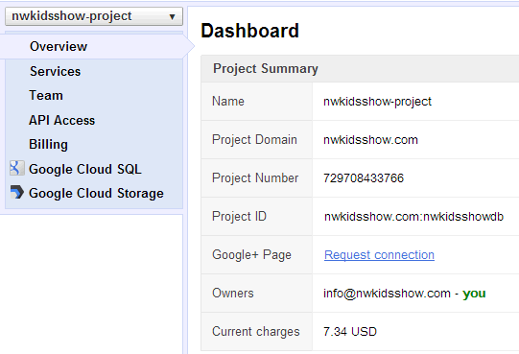
2. Cloud Storage Console is where the manual db exports get put.  
   <https://cloud.google.com/console#/c=cloudstorage&pid=729708433766&gcsh=nwkidsshow-backups/> (login as [info@nwkidsshow.com](mailto:info@nwkidsshow.com)). You can click on the file to download to your local machine and then import into MySQL via Workbench.  
   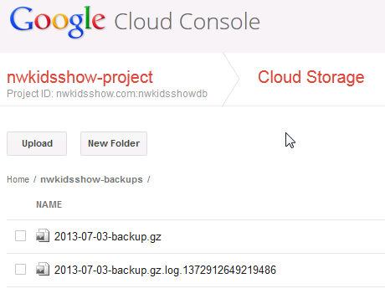
3. Google App Engine is where you manage running apps.  
   https://appengine.google.com/  
   login as [damien@macielinski.com](mailto:damien@macielinski.com)  
   and you’ll see two apps (I have not been using UAT yet)  
   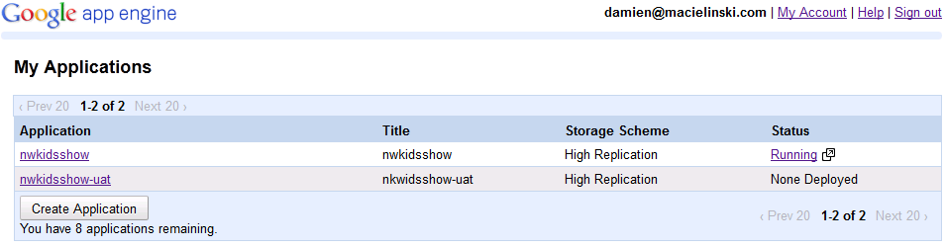  
   click on nwkidsshow to see a big dashboard with lots to do, like:  
   - Check Logs  
   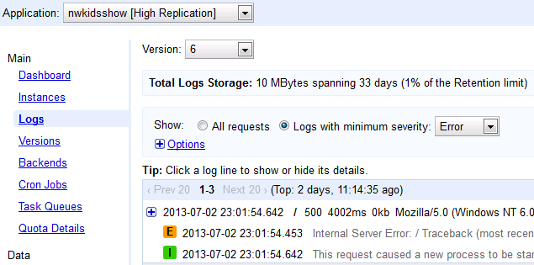  
   - change versions, or delete old versions not needed:  
   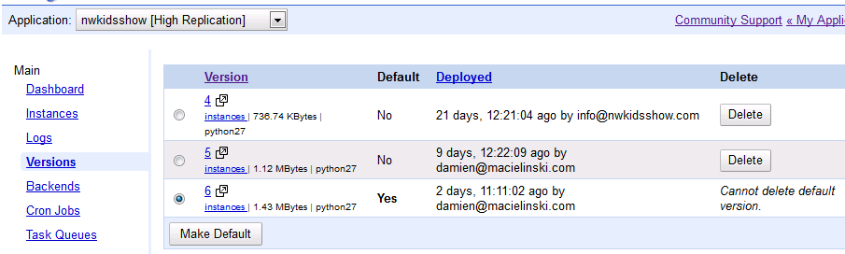  
   - Application settings is a big one with lots of things to configure, many of which I don’t even understand:
4. Github, I have two repositories, one for the “inner” app:  
   <https://github.com/damienmac/nwkidsshow>  
   and one for the outer website:  
   <https://github.com/damienmac/nwkidsshow2>  
   It is linked to PyCharm and all files updated before push or after successful test.
5. DNS is hosted by enom (<http://www.enomcentral.com> as “lmacielinski”)  
   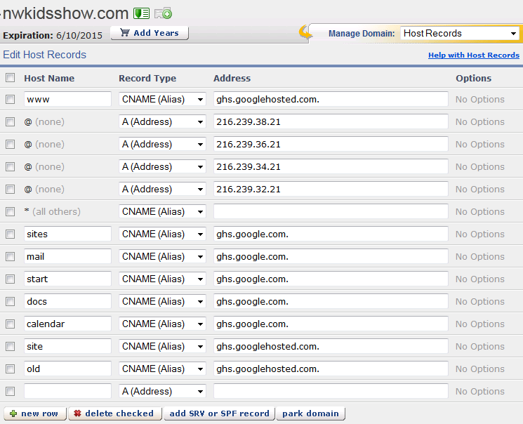

# Data from PROD to DEV

Login to Google APIs Dashboard (see above)

Select “Google Cloud SQL” and the nwkidsshow instance, currently:  
 [nwkidsshow.com:nwkidsshowdb:instance1](https://code.google.com/apis/console/b/0/?pli=1#project:729708433766:sql:instance:nwkidsshow.com:nwkidsshowdb:instance1)

In the Actions menu on upper RHS select Export Data

Fill out the dialog below using the Google Storage bucket name and a date in the filename like this for example:  
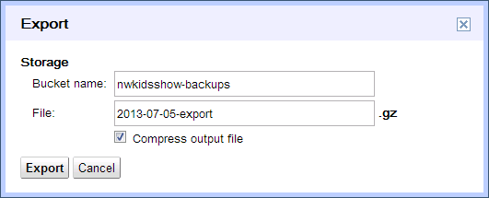

Click export and the message tells you where it is putting it: Exporting instance nwkidsshow.com:nwkidsshowdb:instance1 to gs://nwkidsshow-backups/2013-07-05-export.gz

Log in to the cloud console – cloud storage link above and download the exported gz file to your local machine (right-click, save-as)

Copy it to NW Kids Show directory and use 7zip to decompress to a new folder with that name.

Open MySQL Workbench -> Admin -> Data Import -> Import from Disk -> Import from Self-Contained File. (The file has a schema so don’t try and specify a default schema).  
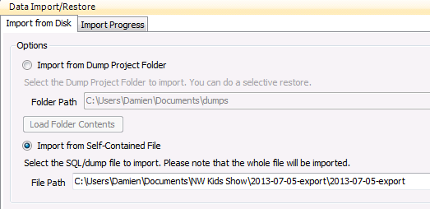

Start Import button (bottom right)

Root password for my local database is empty.

Output should indicate success:

22:06:08 Restoring C:\Users\Damien\Documents\NW Kids Show\2013-07-16-export\2013-07-16-exportRunning: mysql.exe --defaults-extra-file="c:\users\damien\appdata\local\temp\tmpb_jvnd.cnf" --host=localhost --user=root --port=3306 --default-character-set=utf8 --comments < "C:\\Users\\Damien\\Documents\\NW Kids Show\\2013-07-16-export\\2013-07-16-export"22:06:28 Import of C:\Users\Damien\Documents\NW Kids Show\2013-07-16-export\2013-07-16-export has finished

# Some useful SQL queries

select * from nwkidsshow_exhibitor

select * from auth_user

select * from nwkidsshow_exhibitor e, auth_user u  
where e.user_id = u.id and  
must_change_password = '1';

# How to add a column in PROD (simple changes)

(From the DJANGO book, chapter 10)

STEP 1: make the change in the models.py of the local dev environment.  
For example, in Registration model

booked_room = models.BooleanField()

STEP 2: run a manage.py sqlall on the local dev environment and see the new column details as they will be expected in the databse:

CREATE TABLE `nwkidsshow_registration` (  
…  
 `booked_room` bool NOT NULL,  
…  
}

STEP 3: create an ALTER command to add the column:

ALTER TABLE `nwkidsshow_registration` ADD COLUMN `booked_room` bool NOT NULL default false;

STEP 4: test it on the local dev environment by executing it on MySQL Workbench and examining the table, the new column, and its values. Try the admin console and make sure it comes up

STEP 5: make all the code changes - just in the local dev environment - DO NOT PUSH TO PROD. Test it good.

STEP 6: make a BACKUP or EXPORT of PROD database (see above).

STEP 7: execute the same ALTER statement on PROD.  
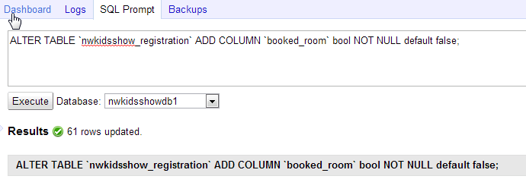

STEP 8: push the code changes to PROD. Test it good.

# ToDo

## Misc

[x] add more useful columns to the Registrations admin console

[x] add “booked_room” Boolean to registration object and add to admin console.

[x] DEBUG off (will I need error pages?)

[x]REPORT on LINEs at a show, make the NAME a link to the contact info for that exhibitor!

[x]Room Number for exhibitos for a show.

[x]Excel export of reports

[x] custom error pages? <https://docs.djangoproject.com/en/dev/topics/http/views/#customizing-error-views>

[ ] configure django in GAE to send email and enable ADMINS among other things.

[ ]After login, show a green success/advising bar at the top of the activities page, or next page (?)

[ ]After create a new user on /add-user/, take her back to that empty screen. Make an admin page with links to admin stuff?

[ ] robots.txt file?

[ ] Comments box from users (needs email first?)

[ ] enforce strong passwords

[ ] searchable directories of exhibitors and retailers?

[ ] what happens when you make a user not ACTIVE in Django? Test it out. Is this how we want to keep people off the system when no longer in NWKS?

## Online Payment

[ ] read the book, make a plan

[ ] https?

[ ] paypal

[ ] credit card

## Migration to 1.5

[x] Localflavor changes: <https://docs.djangoproject.com/en/dev/topics/localflavor/#localflavor-how-to-migrate>

1. Go to <https://github.com/django/> and find the package for your country.
2. from django.contrib.localflavor.fr.forms import FRPhoneNumberField  
   ...to this:  
   from django_localflavor_fr.forms import FRPhoneNumberField
3. WILL GOOGLE SUPPORT THIS? NO – so I copied it in locally and will try and push it up with my other content.

## FOOTER

[x] Copyright using template for year so don’t have to update in 2014 etc

[x] Logos: Python, Django, GAE

[x] website version #

# Privacy Policy

This website shares exhibitor contact information (provided by the exhibitor) with registered Northwest Kids Show retailers. This website shares retailer contact information (provided by the retailer) with registered Northwest Kids Show exhibitors. This website does not share your contact or personal information with any other parties.

This privacy policy is subject to change without notice and was last updated on July 01, 2013. If you have any questions feel free to contact me directly here: info@nwkidsshow.com.

Better? <http://www.freeprivacypolicy.com/free-privacy-policy.html>