CANBUS Man In The Middle V1

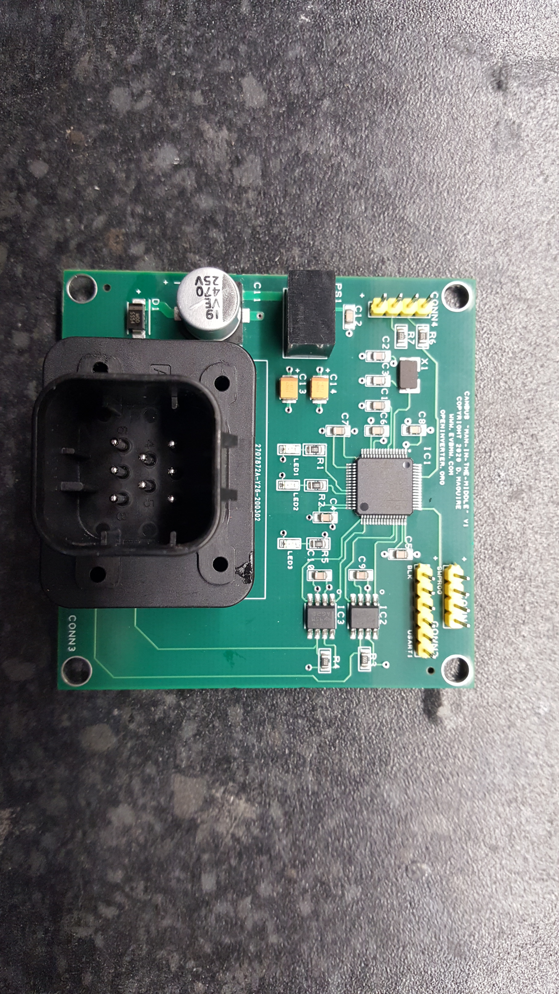

This board is designed to be inserted into a standard high speed can network and provide the ability to block, add or alter messages in a bidirectional manner. Based on the STM32F105 32bit microcontroller.

Connection is via an “Ampseal” 8 way connector part number : 776286-1.

Pinout :

1 - 12Volts input

2 - Can1 High

3 - Can2 High

4 - Gnd

5 - Gnd

6 - Gnd

7 - Can1 Low

8 - Can2 Low

Configuration menu may be accessed over 3.3v ttl serial at 19200,8,n,1 via the CONN2 header.

Pinout :

1 - Gnd

2 - NC

3 - Rx

4 - Tx

Recommend using an ftdi type 3.3v level usb to ttl serial cable and any terminal emulator program.

Software and hardware are fully open source and available on the github repo :

https://github.com/damienmaguire/CAN-BUS-Man-In-The-Middle

Software is compiled using ST CubeIDE :

https://www.st.com/en/development-tools/stm32cubeide.html

Uploading is via SWD (single wire debug) via the CONN1 header.

Pinout

1 - 3v3

2 - SWCLK

3 - SWDIO

4 - Gnd

Recommend using an STLink v2 type usb adapter cheaply available on ebay , amazon etc and the ST Link application :

https://www.st.com/content/st_com/en/products/development-tools/software-development-tools/stm32-software-development-tools/stm32-programmers/stsw-link004.html

Once connected over usart / terminal the menu may be accessed by sending the letter m.

CAN termination resistors are fitted to the board by default if purchased from the evbmw webshop. If they are not required , remove resistor R3 for CAN1 and/or resistor R4 for CAN2.

Software is still a work in progress so please do report any bugs on the repo and feel free to contribute.

