CHAdeMO controller V2

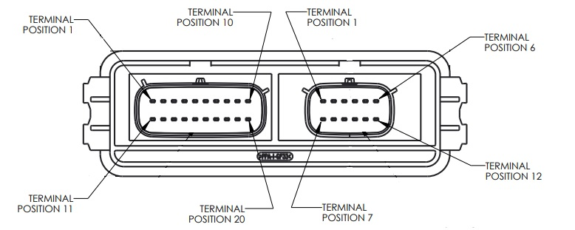

Plug A
1 – HV battery +, connect to High Voltage +(VBAT)
2 –
3 – HV battery - , connect to High Voltage - (GND2)
4 –
5 –
6 –
7 – VIN_SW, aux 12V output (VIN_SW)
8 – VIN, 12V input (VIN)
9 – HV-relay coils + (HVCON1)
10 – CANH

11 –
12 –
13 – SHUNT, connect to signal from SHUNT (SHUNT)
14 –
15 –
16 –
17 – Proximity, aux output (for AUX_PCB >0.6)
18 – HV-relay coils - (HVCON2/IN0)
19 – 12V GND (GND)
20 – CANL

Plug B (CHAdeMO)
1 – GND, connect to PIN1 (GND)
2 – Charge Start 1 , connect to PIN2 (IN1)
3 –
4 – Charge Enable, connect to PIN4 (OUT1)
5 –
6 –
7 – Proximity, connect to PIN7 (Proximity)
8 – CANH , connect to PIN8 (CANH)
9 – CANL , connect to PIN9 (CANL)
10 – Charge Start2, connect to PIN10 (IN0)
11 –
12 –

