**About This Document**

Purpose

**This document is a template.**

Scope

**Group PC Master Configuration on standard client.**

How to Use this Document

Revision History

|  |  |  |  |
| --- | --- | --- | --- |
| Version | Date | Reference / Author | Comments |
| 1.0 | 14/06/2016 | D.VANROBAEYS | Creation of the doc |
|  |  |  |  |
|  |  |  |  |

Reference Documents

|  |  |  |
| --- | --- | --- |
| Document | Date | Reference / Author |
|  |  |  |
|  |  |  |
|  |  |  |
|  |  |  |

**summary**

How to use Windows 10 Profile Generator 3

1 Introduction 4

2 How to use the tool ? 4

3 Where is located this profile ? 7

4 Profile in action 8

How to use Windows 10 Profile Generator



# Introduction

The Windows 10 Profile Generator allows you to generate a profile to pre-filled fields in the Windows 10 Deployment Wizards.

# How to use the tool ?

1. Run ***Windows 10 Profile Generator.exe***
2. Click on the ***Browse*** button and select your USB Key

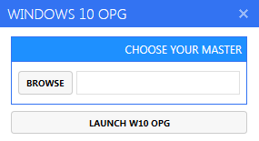

1. Click on ***Launch W10 OPG***. The tool below will be displayed:

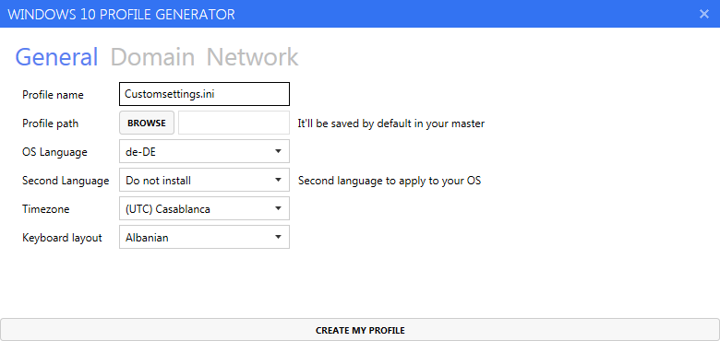

**General Tab**

* **Profile** **name**: By default “Customsettings.ini”.
* **OS** **Language** 🡺 Your first MUI to apply to your OS
* **Second** **language** 🡺 You can set a second language to apply
* **Timezone** 🡺 Choose your Timezone
* **Keyboard** **layout** 🡺 Choose your Keyboard layout

**Domain Tab**

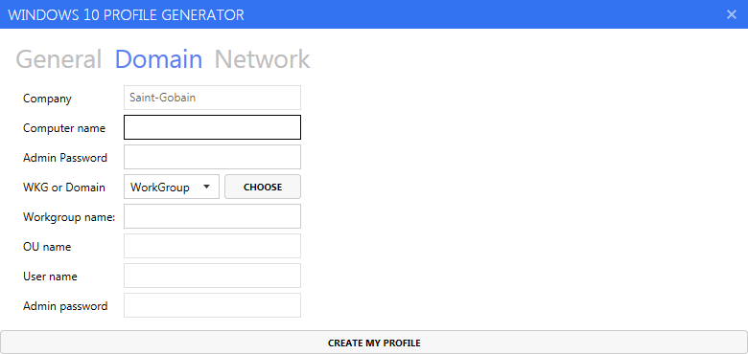

If you have selected WorkGroup, it’ll be as below:

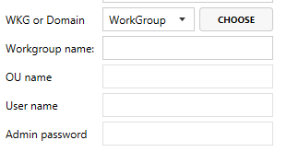

If you have selected Domain, it’ll be as below:

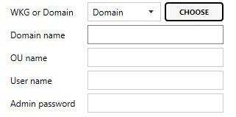

**Network Tab**

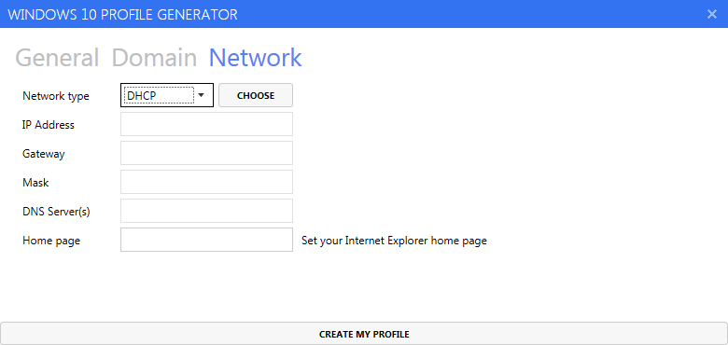

You can choose between two network types:

* DHCP
* Static

You can set your Internet explorer 11 home page

Once you have finished, click on the ***Create my profile*** button.

A customsettings.ini file will be created.

# Where is located this profile ?

The created profile will be located by default in the Deploy\Control folder from your USB Key.

**!!! Do not move or delete it, it should be located in this name with the same name: customsettings.ini**

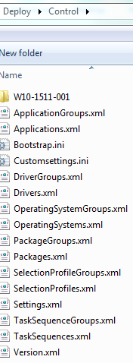

# Profile in action

Once you have created a profile, all fields will be automatically pre-filled in the Windows 10 Deployment Wizards.

See below, a profile created with the following informations:

* **Computer** **name**: Nothing (in this case a name will be generated)
* **WKG or Domain**: Workgroup
* **Workgroup name**: WorkGroup
* **First language pack**: French
* **Second language pack**: Spanish
* **Language to install**: French
* **Timezone**: Brussels, Copenhagen, Madrid, Paris
* **Keyboard** **layout**: French
* **Administrator** **password**: *******

