

**Department of Computer Science, Faculty of Science,  
University of Ibadan,  
Ibadan, Oyo State,  
Nigeria.**

**CSC 399: Industrial Training  
Industrial Training Report**

**Submitted by:** KOIKI DAMILARE SOLOMON

**Matriculation Number:** 185887

**Training Period:** 7thAugust, 2017 – 14th FEBRUARY 22, 2018

**Duration:** 6 Months

**Training Establishment**  
CLOUDWARE TECHNOLOGIES, TOP FLOOR ALBARKA COMPLEX, AWOLOWO JUNCTION, BODIJA IBADAN.

**IN PARTIAL FULFILMENT OF THE REQUIREMENT FOR THE AWARD OF A  
BACHELOR OF SCIENCE DEGREE IN COMPUTER SCIENCE   
(B.Sc. COMPUTER SCIENCE)**

**JUNE, 2018**

KOIKI DAMILARE SOLOMON.  
400 Level,  
Computer Science Department,  
Faculty of Science,  
University of Ibadan.  
JUNE, 2018.

The Director  
Industrial Training Coordinating Centre,  
University Of Ibadan,  
Ibadan.  
Dear Sir,

**Submission of Industrial Training Report**

I write to bring to your notice that I have successfully completed the 2016/2017 session, six months Student Industrial Work Experience Programme (SIWES) which started on the 7th August, 2017 and ended on the 14th February, 2018 at CloudWare Technologies.

As required for a successful completion of the CSC 399 programme, I hereby tender this submission letter alongside my industrial training report in partial fulfilment of the requirements of the S.I.W.E.S. programme.

I greatly appreciate your effort and the effort of the Industrial Training Coordinating Center (ITCC) towards making the student work experience programme a fulfilled reality.

Yours faithfully,  
KOIKI DAMILARE SOLOMON.

**ACKNOWLEDGEMENT**

With utmost joy and humility, I will like to use this opportunity to thank everybody who helped me in the successful completion of my Industrial Training program at CloudWare Technologies.

First and above all, I will like to give thanks to the most powerful and mighty God for giving me strength and diligence to carry this program out successfully. Gratitude goes to CTO of CloudWare Technologies, Mr. Akinmade Akintoye, the company executives, my industry based supervisor - Mr. Sanni Abiola Moshood, the CloudWare team and all members of staff for the patience, understanding, kindness, and love shown to me throughout my industrial training. And I would also like to appreciate the fore-mentioned people for the important lessons taught to me during the course of this program. The knowledge that was impacted into me shall never be taken for granted.

I also wish to thank my lecturers in the department whose teachings were of great importance during the course of the training.

Finally, I must express deep appreciation to my father, Mr. Koiki Segun for his moral and financial support during the course of this program. May the almighty God bless you all abundantly. Amen.

TABLE OF CONTENTS

Title Page 1

Submission Letter 2

Acknowledgement 3

Abstract 5

Chapter 1 – INTRODUCTION 7

Organisation Structure 7

Chapter 2 – CloudWare Tools Utilised 11

PHP 11

MySQL, Apache Webserver and XAMPP SERVER 12

JavaScript 15

POSTMAN 15

Chapter 3 - Training Experience and Work Done 16

Introduction 16

MediaPay 16

PactPay 26

Chapter 4 - Experience’s Relevance To Class Work 29

Chapter 5 - Summary, Conclusion And Recommendation30

Summary Of Work Report 30

Conclusion 30

Recommendation 31

Suggestion for the Improvement of the Scheme 32

**ABSTRACT**

In the quickly proliferating field of Technology, industrial training is a critical avenue of learning for every undergraduate student. It helps students to learn and acquire concrete skills in problem solving, research, reporting, interpersonal relationships, systems analysis and design and systems requirements analysis and many other important professional aspects. Industrial training also gives students much needed exposure to the technology industry. In addition, it gives students the necessary understanding to apply knowledge acquired throughout the academic program. The professional career of a students is also given a much needed head start.

The objectives of the industrial training program are to:

• Enhance the skills of students.

• To enrich the industrial knowledge of students by keeping them updated with the latest technologies.

Simply put: “Industrial training provides a bridge between theory and practice”.

Upon completion of the 1st Semester of 300 level, as an undergraduate student of Computer Science department, University of Ibadan, I was had the opportunity to carry out my Industrial training program at CloudWare Technologies. The company is located at Bodija in Ibadan.

I worked as a Web Developer intern at CloudWare Technologies for months starting from the 7th of August 2017. This report documents the knowledge and experiences I have gained through my Industrial Training program at CloudWare Technologies. It will contain four (4) main chapters. The chapters are broken down as follows:

• Chapter 1 (Introduction to the training organization): This chapter will be an introduction the establishment in which I interned. It will include information pertaining to the organization, its structure, technical background and its role in IT industry and our society.

* Chapter 2, 3 (Training Experience): These chapters will focus on the work I did and the experiences, that I acquired during the training program. The chapters will touch on topics such as work done, responsibilities handled, processes, technical exposure.
* Chapter 4 (Experience’ s relevance to class work)
* Summary, Conclusion, Recommendations: This final Section will be a summary of my internship experience. It is where I will briefly present my experience during the industrial training programme and discuss my personal goals achieved during the period. I will also discuss the importance of the internship program run by Cloudware Technologies and present any comments on program.

**Chapter One**

INTRODUCTION

My student’s industrial training program took place at CloudWare Technologies. Below is a summary of the organisation structure, company departments and their dynamics.

**1.1** **Location and History of Establishment:** CloudWare technologies is located at top floor, Albarka plaza between UBA bank and GTB, Awolowo junction, Bodija, Ibadan. CloudWare technologies have been experiencing growth by developing website and online applications, mobile applications, graphics design and web hosting. They develop customized software for clients but also produce generic software for enterprise and individual use.

CloudWare technologies is a company striving to become big and one of the evidences is that in the year 2013 they emerged as the leading innovative tech company in Nigeria

**1.2** **Organizational Structure:** The structure ranked from the Executive director through to the Managing partner, the human resources manager, software developer, other staffs and the training students.

**1.2.1 Company’s Organogram:**

Executive Director

Human Resources/ Finance Manager

Project Manager

Server Manager

Business Analyst

Software Development Leader

Graphics, UI/UX Development Leader

CMS Designer

Logo Designer

Mobile Developer

Web Developer

***Error! Reference source not found.***

**1.3 The Various Unit and their function in the Establishment:** There are basically two units namely;

* Graphics Design department (UI/UX design)
* Software development section
* HR Team
* Server Management Team

**1.3.1 Graphics Design Department**

User Interface (UI) Design focuses on anticipating what users might need to do and ensuring that the interface has elements that are easy to access, understand, and use to facilitate those actions. UI brings together concepts from [interaction design](https://www.usability.gov/what-and-why/interaction-design.html), [visual design](https://www.usability.gov/what-and-why/visual-design.html), and [information architecture](https://www.usability.gov/what-and-why/information-architecture.html).

## Choosing Interface Elements

Users have become familiar with [interface elements](https://www.usability.gov/how-to-and-tools/methods/user-interface-elements.html) acting in a certain way, so the graphics designers try to be consistent and predictable in your choices and their layout. Doing so will help with task completion, efficiency, and satisfaction.

Interface elements include but are not limited to:

* **Input Controls**: buttons, text fields, checkboxes, radio buttons, dropdown lists, list boxes, toggles, date field
* **Navigational Components**: breadcrumb, slider, search field, pagination, slider, tags, icons
* **Informational Components**: tooltips, icons, progress bar, notifications, message boxes, modal windows
* **Containers**: accordion

**1.3.2 Software development section**

In CloudWare technologies, software developers (or computer programmers) are the team that perform the design, installation, testing and maintenance of software systems.

They build whole systems by writing the code from scratch and also make use of frameworks and plugins. The development of the software is always based on the software specifications and requirements provided during software analysis.

They are also responsible for:

* Reviewing current systems
* Presenting ideas for system improvements, including cost proposals
* Working closely with analysts, designers and staff
* Producing detailed specifications and writing the program codes
* Testing the product in controlled, real situations before going live
* Preparation of training manuals for users
* Maintaining the systems once they are up and running

**Chapter Two**

CLOUDWARE TOOLS UTILISED

During the course of the training with CloudWare technologies, I worked on the backend and frontend programming of websites. Backend programming deals with database system and file system handling, while frontend programming deals with how the user and the website interact e.g. click of a button, movement of mouse, entering a text field etc.

The following tools were used:

1. PHP programming language
2. JavaScript programming language
3. MySQL, Apache Web Server and XAMPP Server (Local Server)
4. Online Server
5. Frameworks like JQuery
6. Plugins
7. POSTMAN

**2.1 PHP**

PHP is a general-purpose server-side scripting language originally designed for Web development to produce dynamic Web pages. It runs on the server to handle user data using different means like session, cookies, and requests (like post and the get requests), it can also be used to manipulate and upload files. Time and date manipulations and calculations are not left out of the many functions of PHP. PHP together with MySQL can be used to store data into database.

**Application in Organization**

PHP is the core server-side scripting language used at **CloudWare technologies** which is used as the backend of all the project I embarked on in the company. During my stay, I worked primarily with this language, and became more proficient in it.

**Uses, Merits and Demerits**  
PHP is a scripting language for backend programming and also to provide dynamism of web page content.

PHP is easy to learn because of its simple syntax, its popularity is an advantage to programmers who have knowledge of it as they can easily gain employment in the technology industry.  
However, compared to other languages like C# and Java, PHP is vulnerable to malicious attacks by hackers due to the fact that it is a loosely-typed language therefore giving room to easy manipulation of data and information.

**2.2 MySQL, Apache Web Server and XAMPP Server**

There is rarely any Information Technology outfit that does not interact with databases and servers. More so, many of these firms use MySQL as their relational database.

In a Database Management System (DBMS), there is the database, the languages for interacting with the database, and the users whereby the database stores the information. In today’s programming environment, it is the relational database that is largely in use. Examples of these include MySQL, Oracle, Microsoft SQL Server, PostgreSQL, Informix, and others. SQL, Structured Query Language, is a specialized type of programming language developed to work with relational databases.

MySQL offers a simple, free and open source relational database for various levels of web developers: individual developers, companies, and many more.

For a complete web development environment, a database and server are needed. A Server – a computer which houses your database and other server side resources, including your web pages—needs to be different from the client computer.

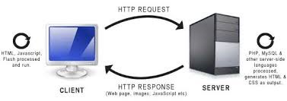

#### Figure 2.1: Client - Server Request Cycle

However, during development stages, you would need your local system to act as both the client system and the server. To allow this, you need a web server software. In this case, I used the Apache Web Server. The makers of the Apache webserver software enable your system to become a local server—commonly named local host—which can then house the MySQL database, as well as your web resources.

MySQL and Apache are a powerful duo; they are free, open source, easy to install and use, and have robust user support.

Nonetheless, to reap the benefits of their advantages, you would need to install them, and configure your computer environment. This is where the XAMPP Server comes in.

**Application in Organization**

In the organization I worked in, we used PDO, which is a variant of MySQL and MySQLi.

XAMPP Server was constantly running on my system. The equivalent of the PHP My Admin module of the XAMPP Server, which I used for accessing real remote servers.

**Uses, Merits and Demerits**

Apache, as of now, is the most widely used web server. This is a proof that it is accessible and easy to use. The most important advantage of Apache is that it is cross platform: It can work on Windows and Linux, as well as other Unix-based operating systems.

MySQL runs on many platforms, and is stable. The documentation for MySQL is excellent. It has a thorough Web site containing reference material, offers high quality support for their products, including a service that allows MySQL developers to log in to your server to correct problems and proactively help with optimization. XAMPP Server makes the process of interfacing with all the key actors easier. It eliminates the risk of wrong configurations or damages to one’s system, and also provides options for enabling and disabling different Apache and PHP modules/extensions.

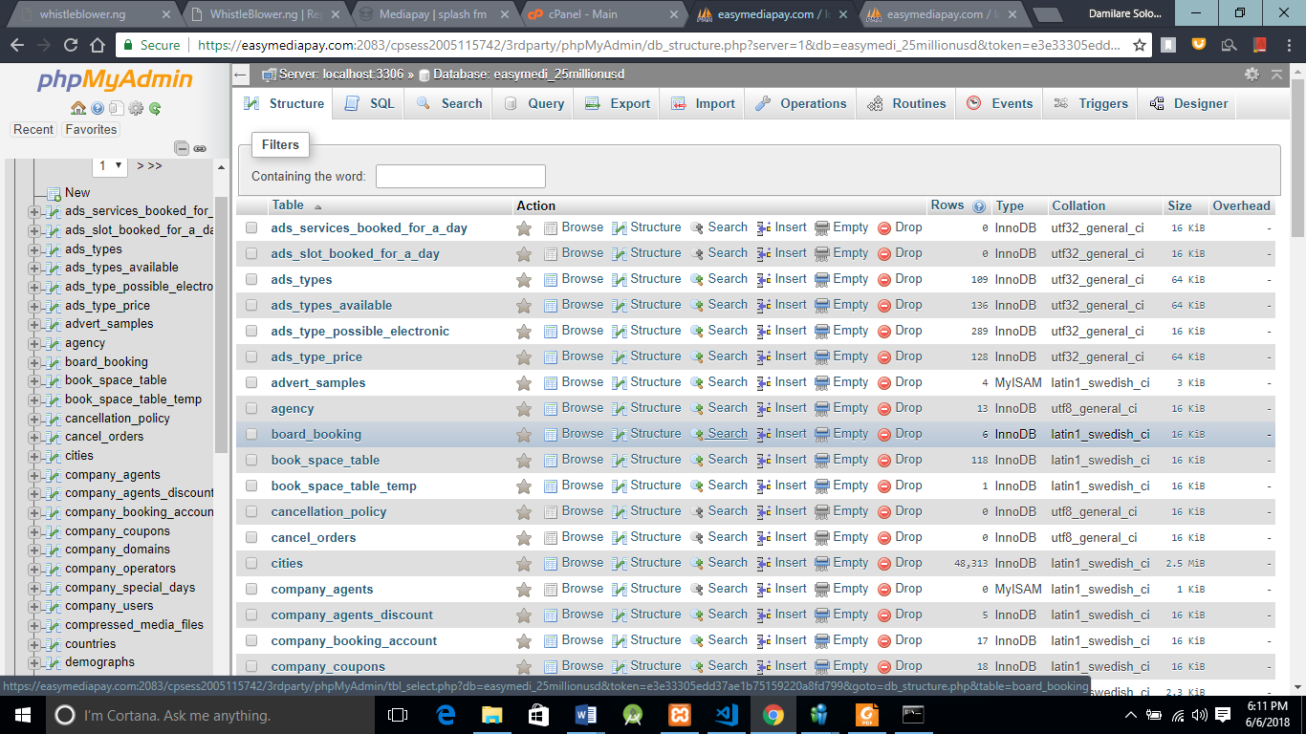

*Figure 2.2: XAMPP Server Admin Interface*

**2.2.1 MySQL Database**

MySQL Database is a database application for both web application and desktop application.

**2.2.2 MySQL database operations**

Major operations performed on a MySQL database are

* **C –** Create a data.
* **R –** Retrieve a data.
* **U –** Update a data.
* **D –** Delete a data.

**2.3 JAVASCRIPT**

Javascript often abbreviated as **JS**, is a high-level, interpreted programming language. It is a language which is also characterized as dynamic, weakly typed, prototype-based and multi-paradigm.

Alongside HTML and CSS, JavaScript is one of the three core technologies of the World Wide Web. JavaScript enables interactive web pages and thus is an essential part of web applications. The vast majority of websites use it, and all major web browsers have a dedicated JavaScript engine to execute it.

**2.4 POSTMAN**

****Postman is a powerful graphical user interface based platform that is used to  
make API development faster and easier. It is used in many instances: from  
building API requests through testing, documentation and sharing. It was  
designed to support all aspects of API (application programming  
interface) development. Postman's apps are built on a single underlying layer,  
thus ensuring consistent performance across numerous application  
environments.

**Chapter 3**

Training Experience And Work Done

## 3.1 Introduction:

The essence of The Student Industrial Work Experience Scheme I believe, is to give students an opportunity to learn, and exercise their already acquired skills through practical experience in the field. This then suggests, that this chapter, which explains the various practical projects that I undertook during the period of my Industrial Training, is the crux of this technical report.

In this chapter, I explain the projects and comprehensive view of projects undertaken at **CloudWare technologies**. I have selected major projects I undertook during my stay at the company. Some projects exposed me to all the areas I was interested in. However, for clarity sake, I have outlined the different aspects of such projects. This helped me in my personal evaluation as well.

When I resumed at **CloudWare technologies**, I had to get myself acquainted to and understand the style of programming used in the company by working along with the head of the web development team of the company. During this period, I got better understanding about Object Oriented Programming (OOP) concept.

## 3.2 Company Projects:

### 3.2.1 MediaPay:

**Overview of Project and Problem description**

MediaPay is a web service that create room for easy booking of adverts in media houses. The way adverts are booked in media houses today is usually strenuous and most times has to undergo many processes, and this does not even guarantee the chance of a successful booking. MediaPay is a web platform solution to media houses like (Print media houses, Display media house and Electronic Media house) to curb the challenges that might occur during the booking of adverts in a media house.

**Different Aspects of The Project.**

This project is a big project and it took us months to complete it. The project was built for three different major kinds of media houses which are Print media houses, Display media houses and Electronic Media houses. The different aspects of the project are:

1. Dashboard for the admins of Electronic Media houses
2. Subdomains for Electronic Media houses where end users book for their adverts
3. Dashboard for the admins of Display Media houses
4. Subdomains for Display Media houses where end users book for their adverts
5. Dashboard for the admins of Print Media houses
6. Subdomains for Print Media houses where end users book for their adverts

3.2.1.1 DASHBOARD FOR THE ADMINS OF ELECTRONIC MEDIA HOUSES

This is the dashboard for electronic media houses which include T.V stations, Radio stations etc. On their dashboard, they can add programs, advert type, additional services, coupons to give discount to end users etc.

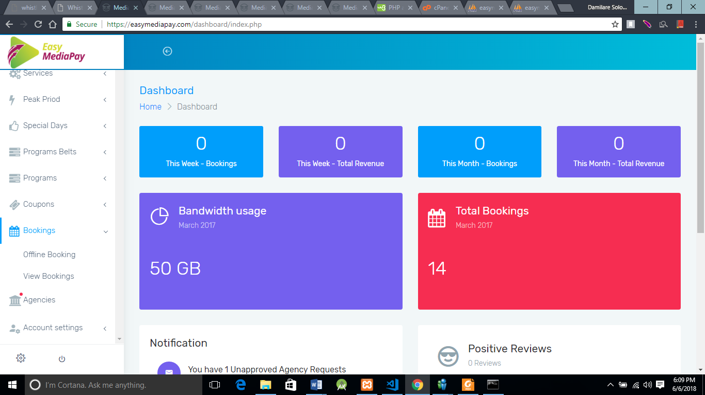

**ELECTRONIC MEDIA HOUSES HOME PAGE**

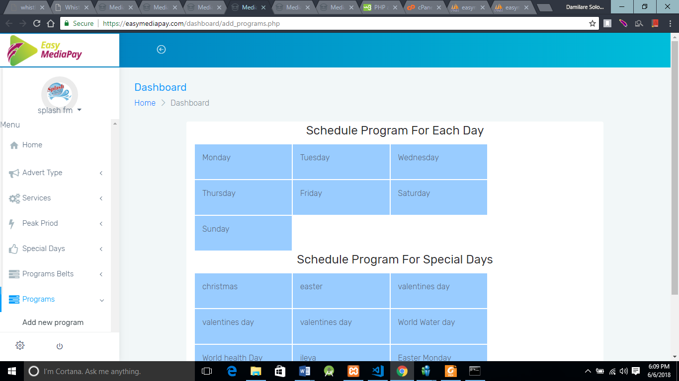

**ADD PROGRAM PAGE FOR ELECTRONIC MEDIA HOUSES**

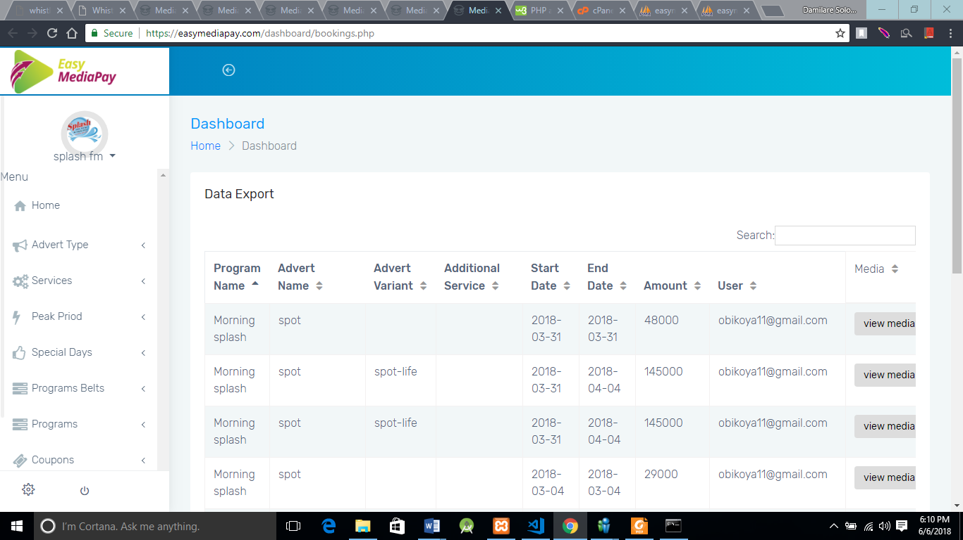

**PAGE SHOWING ADVERTS BOOKED IN AN ELECTRONIC MEDIA HOUSE**

3.2.1.2 SUBDOMAINS FOR ELECTRONIC MEDIA HOUSES

Their is only one page in this subdomain which is the schedule.php. On this page, end user books an adverts in any of the programmes available in the media house

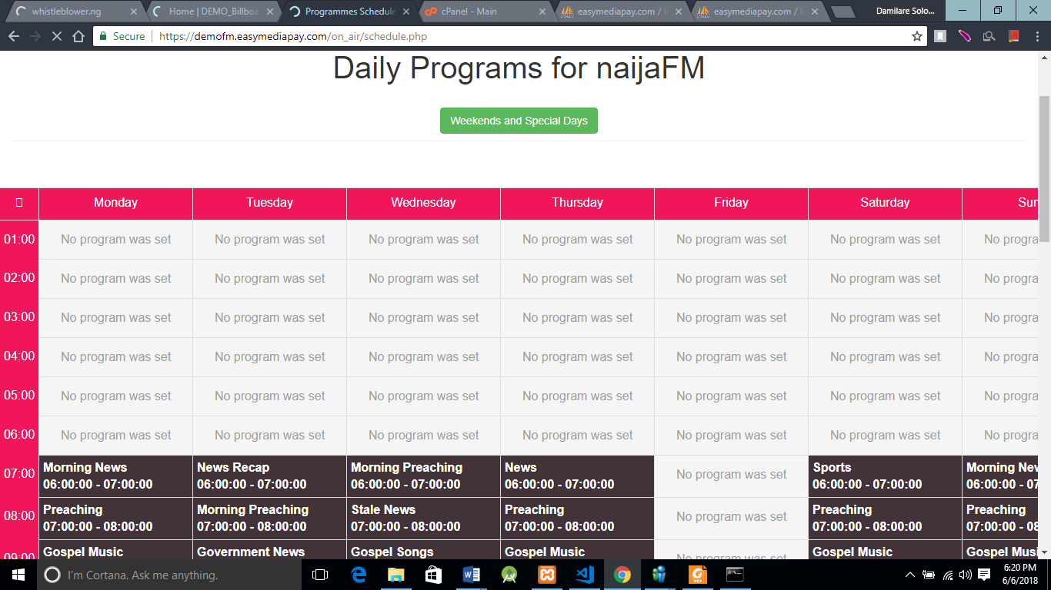

**END USER PAGE TO BOOK FOR AN ADVERT IN A PROGRAMME IN AN ELECTRONIC COMPANY**

3.2.1.3 DASHBOARD FOR THE ADMINS OF DISPLAY MEDIA HOUSES

This is the dashboard for display media houses. Display media houses are those companies that make use of display boards for adverts. On their dashboard, they can add boards, advert type, additional services, coupons to give discount to end users etc.



**DISPLAY MEDIA HOUSES HOME PAGE**

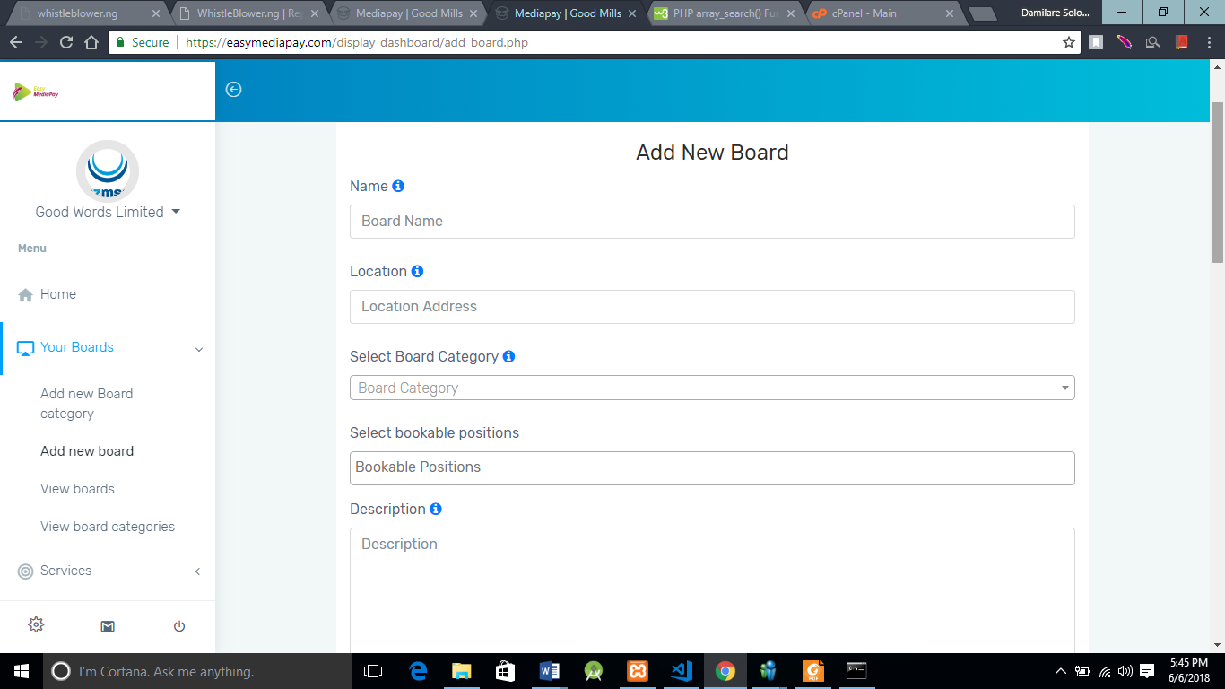

**PAGE TO ADD A NEW BOARD BY A DISPLAY COMPANY**

3.2.1.4 SUBDOMAINS FOR DISPLAY MEDIA HOUSES

This is an example of a subdomain created for a display company. Here end users can book one more positions on a board.

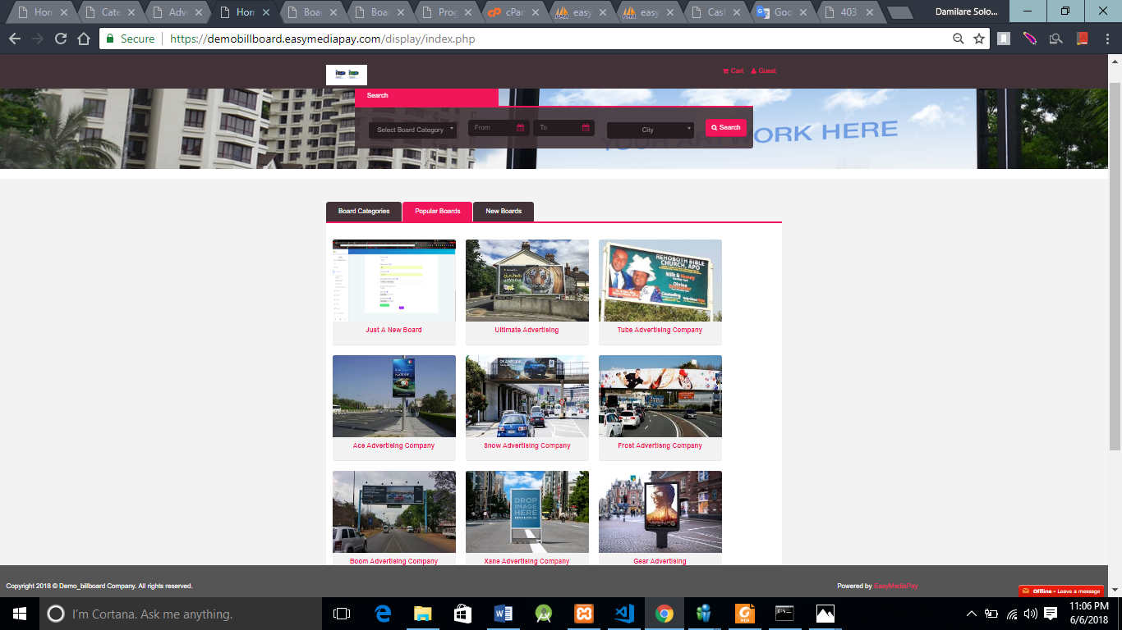

**DISPLAY ENDUSER LANDING PAGE**

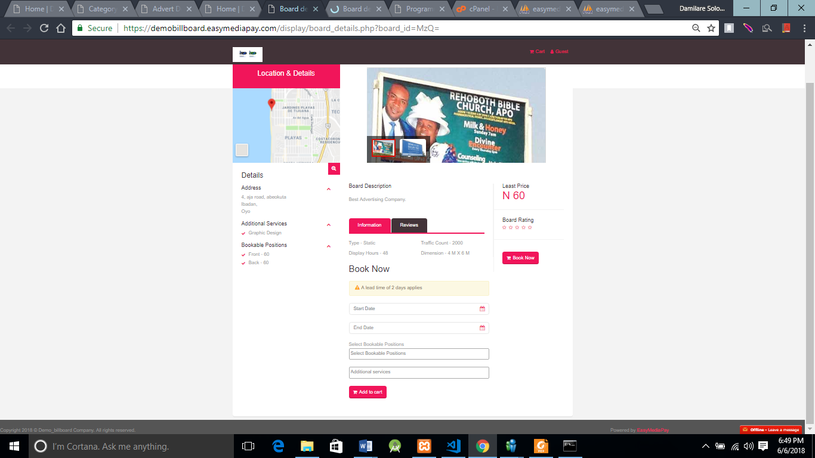

**DISPLAY ENDUSER BOARD BOOKING PAGE**

3.2.1.5 DASHBOARD FOR THE ADMINS OF PRINT MEDIA HOUSES

This is the dashboard for print media houses which include companies like newspaper companies, magazine companies and so on. On their dashboard, they can add, advert type, additional services, coupons to give discount to end users etc.

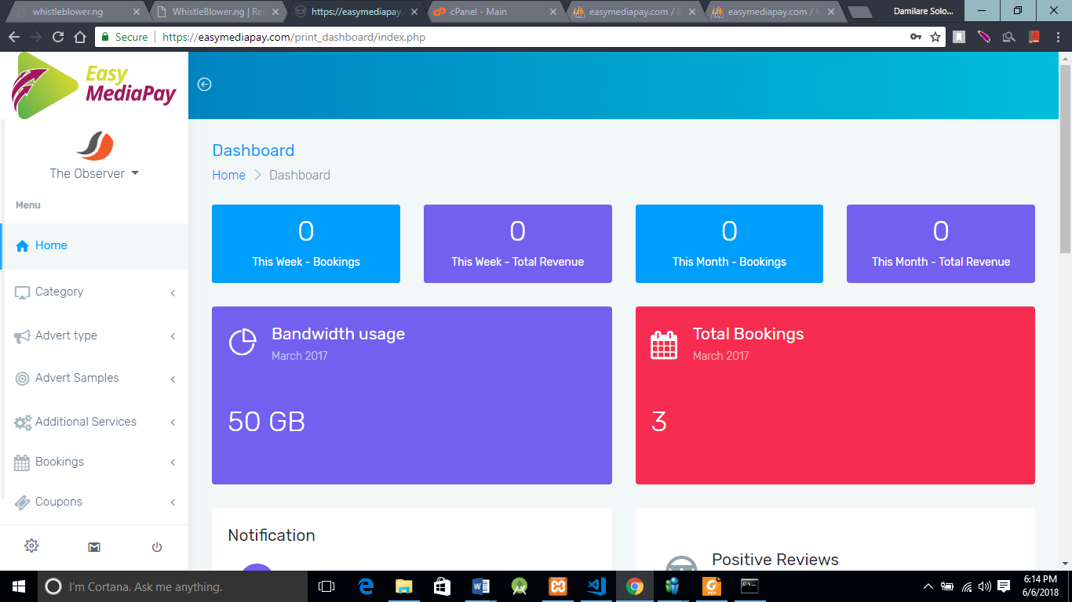

**PRINT MEDIA HOUSES HOME PAGE**

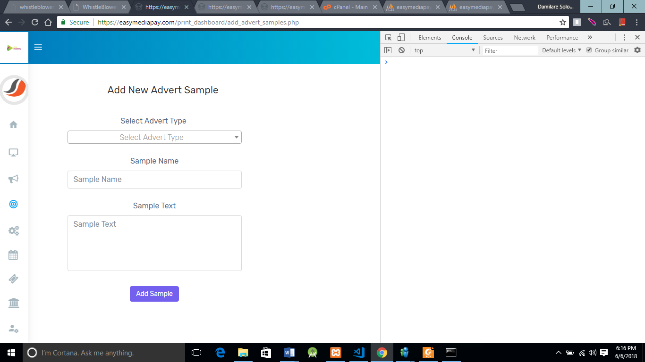

**PAGE FORPRINT MEDIA HOUSES TO ADD ADVERT SAMPLES**

3.2.1.6 SUBDOMAINS FOR PRINT MEDIA HOUSES

This is an example of a subdomain created for a print company. Here end users can book one more advert position.



**PRINT ENDUSER LANDING PAGE**

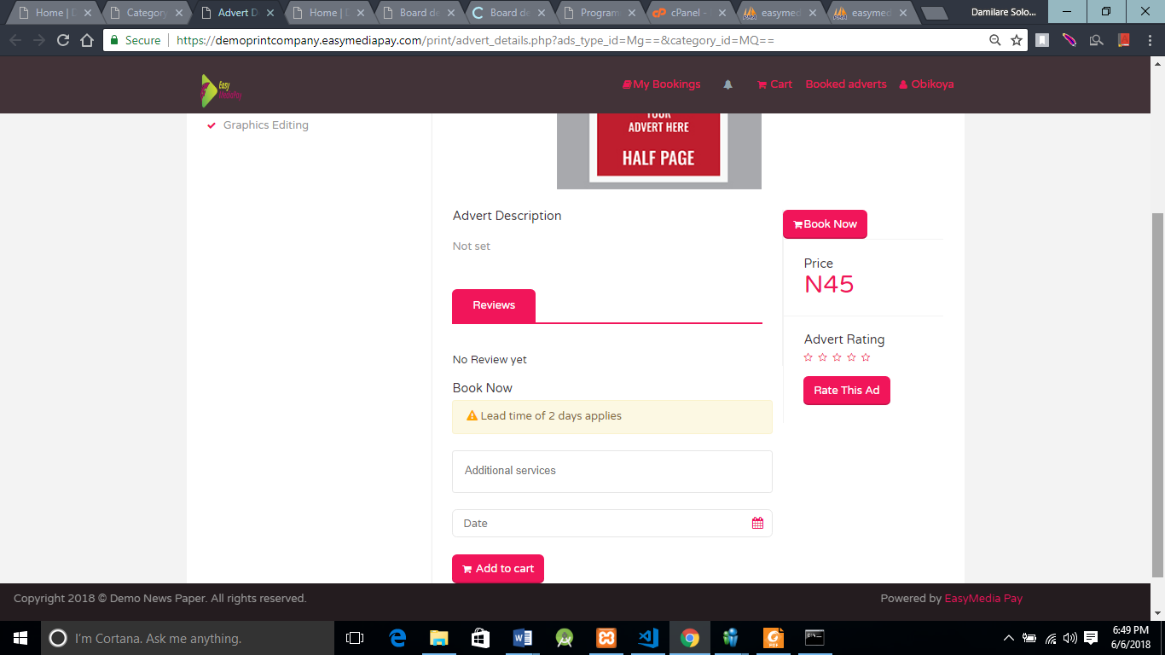

**PRINT ENDUSER ADVERT POSITION BOOKING PAGE**

**My Roles in the Project**  
I and my other colleague that had our Internship at the company with the assistance of the software development team leader took part in every part of the project. No one had a specific role per se, we worked as a team and were ready to assist one another in the project. Nevertheless, these are the roles that I took in the project:

1. Handled the submission of forms
2. Designed user interfaces for users
3. Created classes and functions in order to allow code reusability
4. Created database and tables where data will be stored
5. Created parsers to receive user data to API
6. Built subdomains for registered companies

**Technologies and tools Used with Functionalities**  
The project was built with core PHP and JavaScript programming languages. The markup language used was HTML which we styled with CSS (Cascaded Style Sheet). We also made use of plugins like (JQuery, Select2, Bootbox Js etc). APIs were built for the project to allow user data to be stored on a third party server.

**Experience Gained**

After this project, I gained a lot of experience. After this project my programing skill increased. I now understand and can also perform Object-oriented programming (a programming concept that allows code reusability). The project assisted me to be able to manipulate user data stored in an array. Also, I gained knowledge about UI (User Interface) designs using Bootstrap technology.

### 3.2.2 PactPay

PactPay is a safer, easier way to pay and get paid online. The service allows anyone to pay in any way they prefer, including through credit cards, bank accounts, PactPay connect account balances, without sharing financial information.



**PACTPAY LOGIN PAGE**

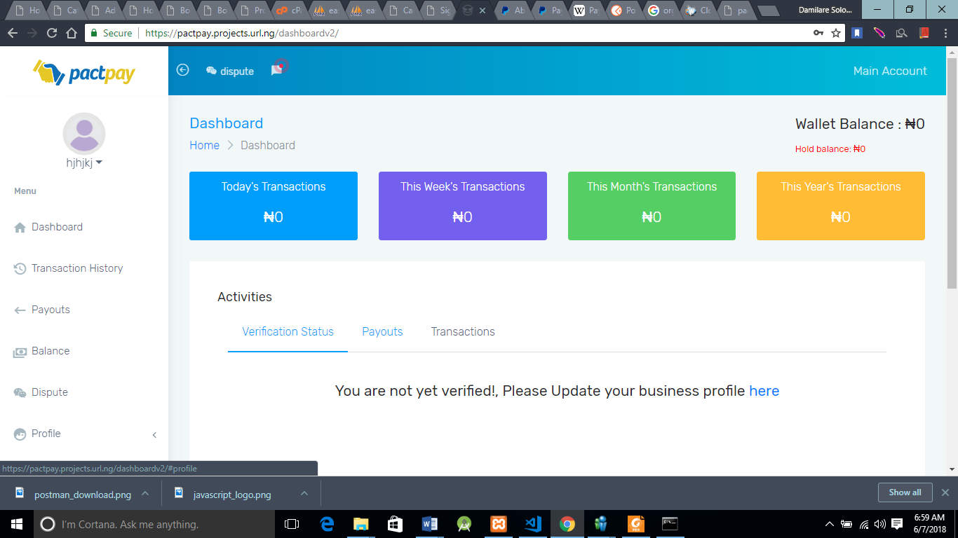

PACTPAY HOMEPAGE

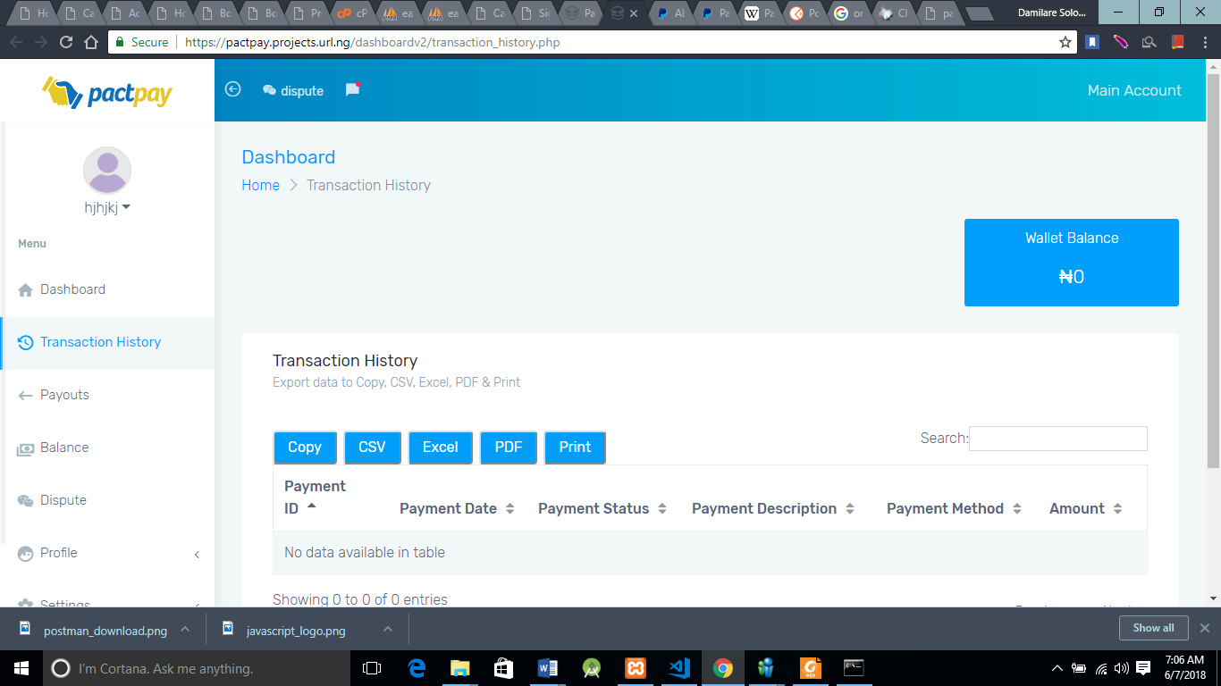

**TRANSACTION HISTORY PAGE**

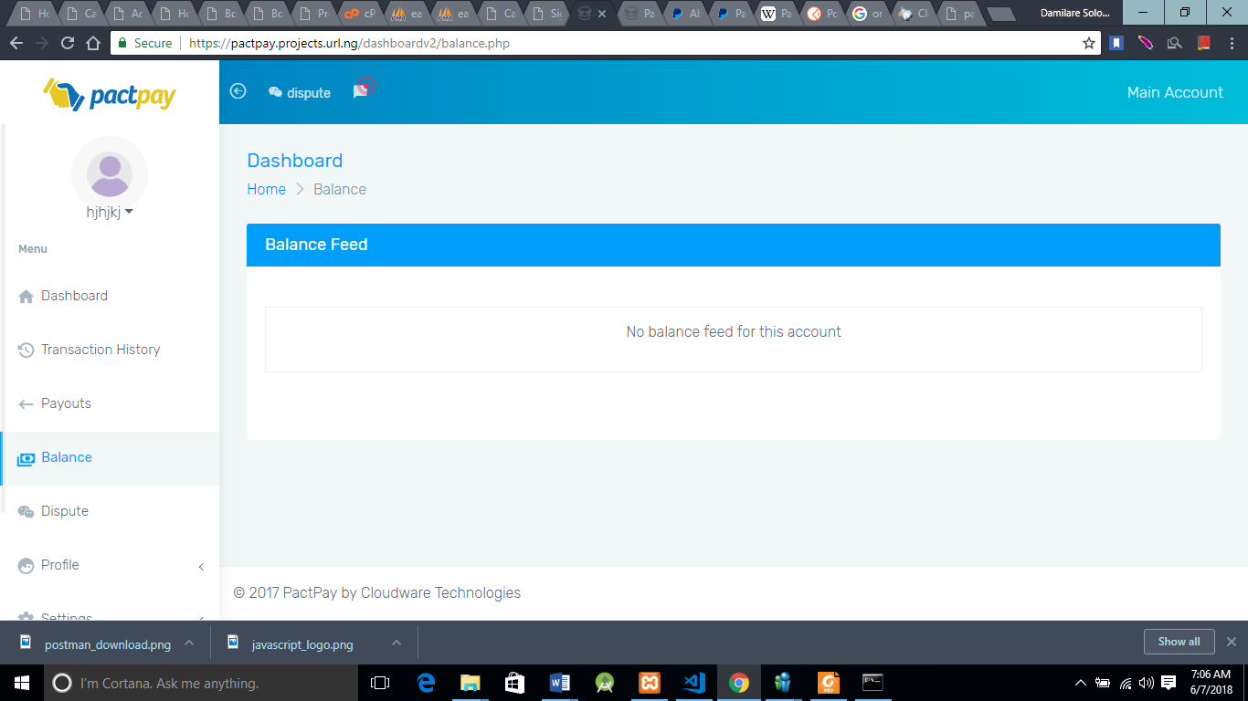

**PAGE SHOWING USER BALANCE**

**My Roles in the Project**  
These are the roles that I took in the project:

1. Handled user login
2. Fetched User notifications
3. Worked on the User Interface of the site

**Technologies and tools Used with Functionalities**  
The project was built with core PHP and JavaScript programming languages. The markup language used was HTML which we styled with CSS (Cascaded Style Sheet). We also made use of plugins like (JQuery, Select2, Bootbox Js etc). APIs were built for the project to allow user data to be stored on a third party server.

**Experience Gained**

After this project, I gained experience on how to fetch notifications, I gained knowledge on how to use a parser file. And mostly importantly, with the realization that I just concluded an online project I gained a little confidence.

**Chapter 4**

**EXPERIENCE’ S RELEVANCE TO CLASS WORK**

The emphasis of this chapter is to explain the relevance of the courses and lectures done  
while in school, to my Industrial Training exercise. I begin by thanking all my lecturers for  
their tutelage and support. The knowledge my lecturers impacted in me turned out to be my most invaluable asset during my industrial training. Thanks to the hours of lectures, tons of homework, practical classes and some personal research while in school, I was able to handle a handful of challenges at my workplace with relative ease. I conclude the chapter with some practical observations for some courses, which I feel may make it even more indispensable to a student with respect to industry experience.

5.1 Special Acknowledgement to My lecturers  
It may require another report as voluminous as this to express my heartfelt thanks to my lecturers for their teaching, patience and support. The period of the industrial training made me appreciate them even more. Without exception, I wish to say thank you to all the lecturers in the department of Computer Science that taught me before I went on Industrial Training without your individual drilling I might find it difficult to adapt to my workplace.  
5.2 Relevance of Classwork to Industry Experience  
The General Studies English Courses, **GES 101** which taught me some subtleties of the English language, helped me because I had to do a lot of documentation and write project proposal.  
**GES 301** is a course that should be encouraged, and if possible, made more practical. The same principle of business case studies, which was used in the textbook is the principle used by the Harvard Business School in teaching its students. I realized that most of the entrepreneurial skills we were taught came to play during my training.  
I was constantly putting to practice the lessons taught from my **CSC 302**—System Analysis and Design which really helped in my designs, **CSC 332**—Survey of Programming languages, and all the programming courses; especially **CSC 232** and **CSC 292**. My basic understanding of object-oriented languages with PHP in CSC292 helped me have a grasp of web Application developments has PHP the required language used. Also, the practical we had in school also enabled me to boast of tangible projects that I had to refer to my class works sometimes during work.

**Chapter Five**

**SUMMARY, CONCLUSION AND RECOMMENDATION**

**5.1 Summary of Work Report**

Here is the summary of my work report.

Some of the tools used at CloudWare Technologies are:

* PHP
* Javascript
* POSTMAN etc

The Departments at CloudWare Technologies are:

* Graphics design team
* Software development team
* Server management team
* HR department

After the completion of my IT at CloudWare Technologies, I can now boast of increase in my programming skills and also I gained experience about web user interface design (UI design)

**5.2 Conclusion:**

My Industrial experience at CloudWare Technologies gave me the much-needed exposure to real-life situations. It gave me the opportunity to develop and deploy applications to solving real-life problems, and in the process, developing my programming and analytical skills. I learned to be much more independent than I am, to make and follow budgets, to be accountable for all expenditure of both tangible and intangible resources, as well as to co-exist with ‘strangers’ in same vicinity. The working experience was also invaluable.

Also, I would encourage that the courses and practical courses which are given by our lecturers be taken seriously. At this juncture, I would like to pay special respect to one of my lecturers, Dr S.O Akinola, who always drilled us in practical programming exercises. At that point, it may seem stressful, but it will pay off if you follow diligently. Finally, make up your mind to learn during the SIWES experience. Even if you are an experienced developer, or an expert in networking, be ready to humble yourself and learn more.

### 5.3 Recommendations:

**The Industrial Training Coordinating Centre** really did very well in this SIWES especially by ensuring that every student actually got IT placements that pertained to their fields of study and by organizing a seminar to intimate us students on what is required of us in the industry. ITCC after putting in a lot of work, should not relent their efforts but go further to ensure that IT students’ welfare are taken care of by employers.

**The** **Department of Computer Science** should place emphasis on Database Management System and networking (Network Administration) as a course before students go for the SIWES training.

During my training, I observed that employers are interested not just in programming ability, but general level of intelligence, confidence and also accountability. Very key also is brainstorming sessions and quick decision making.  
To this regard, I recommend that the use of case study method should also be introduced to some CSC courses. Real-life scenarios, in which we are expected to brainstorm and make quick decisions should be organized. As stated earlier, GES 301 should be made more practical, and students should be grouped into smaller units. While taking the course, we were always too many, and as such never really practiced or discussed the case studies.

**5.4 Suggestions for the Improvement of the Scheme**

The followings are suggested points for the improvement of the SIWES programme/scheme:

* The school authority should be in affiliates with companies and organizations within the school locality. This will enhance proper supervision of the entire students and also solve the problem of no place of attachment.
* Proper package of funds should be made available for students during and after training. This will encourage full and effective participation of students in the training.
* The school authority must be responsible for posting students to a selected organization in affiliation with, just like the NYSC scheme.
* More companies should be established either by the Government or an individual. This will create more available space for students to be taken for the training and also provide job opportunity after graduation.