**VCL Reservation & CouchDB Installation**

**Reserve Windows 10 (64 bit base)**

**Login using the username and password provided**

**Go to the browser and enter this url:**  <http://couchdb.apache.org>

Download and Install the appropriate CouchDB for your operating system.

Once it’s finished, CouchDB will start up as a service.

**Go to**  <http://127.0.0.1:5984/_utils/> to access CouchDB’s GUI called Fauxton.

**Verification**

**The Verify tab is on the left side of the screen. Expand the tabs by clicking on the two way arrow.**

**Go to** the Verify tab and click on “Verify Installation” to ensure that we can perform CRUD operations.

**Cluster or Single Node**

Click on the setup tab and configure single node. Cluster has to do with multiple servers, so we only need single node for now. Create an admin user with password. (Please use the following username and password, so you don’t have to edit the script when doing the complex example

username : admin

Password: 12345

)

Don’t worry, you can change your settings and add more users using the admin tab.

**We will not replicate data just yet**. Ignore the question: Do you want to replicate data?

**Login as Admin**

If not logged in as admin, log out and login using the admin credentials yo just created.

**CRUD - CREATE, RETRIEVE, UPDATE, DELETE**

**CREATE** -

* Click on Databases tab
* Create database “mycompany”
* Note the url says: <http://127.0.0.1:5984/_utils/#database/my_company/_all_docs?limit=100> (The page shows up to 100 documents)

**Add Document to Database**

* Click on the plus sign close to All Documents
* Add new doc
* Notice that it already provides an id, so we’ll add other attributes to this id:

{

"_id": “………………………………..”,

"name":"Susan Doug",

"email":"sdoug@gmail.com",

"phone":"+1828373778",

"Address":{

"street":"1222, Chad ct",

"city":"Miami",

"State":"FL",

"Zip":"56787"

}

}

* Note, please use the _id value provided, simply add other attributes to the id as shown above. Don’t forget to add a comma after the _id value.
* Click “Create Document”
* You will now see a list of the documents you have created

Notice the _rev field under “value” column which means a revision. If we modify the database, it creates another revision

**Create another document using the following attributes:**

{

"_id": "......................................",

"name":"Leslie Adams",

"email":"ladamst@gmail.com",

"phone":"+1828972678",

"address":{

"street":"134, School str.",

"city":"Boston",

"State":"MA",

"Zip":"23378"

}

}

**RETRIEVE**

**Creating Views**

* Click on the plus sign on “All Documents” pane
* Create a new view - A view is simple queries and provides a customized response
* Views are created by a map-reduce function and reduce is optional so we’ll just use map.
* This emits a key-value pair
* _id is the key, the rest details are the documents.
* Make *View1* the Design name and *id* the index name
* Let’s say we want to select names of all customers in the database. We modify emit(doc._id, 1); as follows:  *emit(doc._id, {name:doc.name, email:doc.email, rev:doc._rev});*
* Click ‘Create Document and then Build Index’ button
* If we want to select the address or a bunch of objects, we use: *emit(doc._id, {name:doc.name, email:doc.email, address:doc.address, rev:doc._rev});*

**The url** where the view is stored can be accessed by clicking on the JSON tab. You give this url to developers as an API they can connect to avoid all the drama of drivers and Java SQL connectors.

Copy this API and save it somewhere, we’ll use it during the complex example. It shoudl look like this: <http://127.0.0.1:5984/mycompany/_design/View1/_view/id?include_docs=true>

**UPDATE -**

Click on the Edit icon on each document and make modifications. Note the additional attribute ‘revision’ _rev

**DELETE -**

Click on the delete icon on each document

**Complex Example -- Node js with CouchDB**

***(Note: commands are in blue ink)***

Download nodejs from [http://www.nodejs.or](http://www.nodejs.org)g

Recommended version: **8.11.1 LTS**

Set environment variables using the command:

* *setx nodejs “C:\Program Files\nodejs\ “ /M*
* Goto ‘control panel -> systems -> advanced system settings -> environment variables -> path’ to confirm that nodejs has been added

Using command prompt ‘cmd’, in the C drive create a project called ‘couchcompany’:

* *mkdir couchcompany*
* *cd couchcompany*

In couchcompany create a package.json file by running:

* *npm init*
* For name prompt, *click enter*
* For version, *click enter*
* For Description, add *Simple customer list*
* For entry point, *add app.js*
* Click enter through the rest prompt

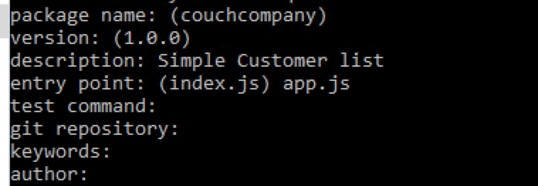

* Type *dir* and click enter to see the files in your couchcompany folder

This will create a package.json document which we’ll open with notepad

**Install Dependencies**

* In cmd navigate to couchcompany folder, and run the command:

*npm install express body-parser ejs node-couchdb --save*

* Create a text file and save it as app.js by running: echo const > app.js
* Run *notepad app.js* to edit the app.js file
* Make sure your app.js content looks like this:

*const express = require('express');*

*const bodyParser = require('body-parser');*

*const path = require('path');*

*const NodeCouchDb = require('node-couchdb');*

*const app = express();*

*app.set('view engine', 'ejs');*

*app.set('views', path.join(__dirname, 'views'));*

*app.use(bodyParser.json());*

*app.use(bodyParser.urlencoded({extended: false}));*

*app.get('/', function(req, res){*

*res.send('Working...');*

*});*

*app.listen(3000, function(){*

*console.log('Server Started On Port 3000');*

*});*

* Save your app.js document
* In couchcompany folder, run: *node app*
* Now we have created a nodejs application that uses couchdb as the backend
* When prompted click *Allow access*
* Goto <http://localhost:3000>
* Working… This shows we’ve set up correctly
* Now add your couchdb auth details to the app.js file
* Your apps.js should now look like this: (Note: use your own couchdb admin username and password)

*const express = require('express');*

*const bodyParser = require('body-parser');*

*const path = require('path');*

*const NodeCouchDb = require('node-couchdb');*

*const couch = new NodeCouchDb({*

*auth: {*

*User: 'admin',*

*password: '12345'*

*}*

*});*

*couch.listDatabases().then(function(dbs){*

*console.log(dbs);*

*});*

*const app = express();*

*app.set('view engine', 'ejs');*

*app.set('views', path.join(__dirname, 'views'));*

*app.use(bodyParser.json());*

*app.use(bodyParser.urlencoded({extended: false}));*

*app.get('/', function(req, res){*

*res.send('Working...');*

*});*

*app.listen(3000, function(){*

*console.log('Server Started On Port 3000');*

*});*

* Now, restart the server, do *Ctrl c*
* Run *node app*
* Note that, you’re now able to see ‘mycompany’ database in the terminal
* Leave the terminal running

**RETRIEVE documents**

* We want to query our couchdb database and have the results show up on the apps front end
* We’ll get all the documents from mycompany database and display on the homepage of our app
* Create a folder called **views** in couchcompany folder: open another command prompt and navigate to couchcompany folder
* *mkdir views*
* *cd views*
* Then create a file called **index.ejs** by running:

*echo dummydata > index.ejs*

* Paste the content below into your index.ejs. Your index.ejs file should look like this:

*<h3>MyCompany</h3>*

*<ul>*

*<% mycompany.forEach(function(mycompany){ %>*

*<li><%= mycompany.value.name %></li>*

*<% }); %>*

*</ul>*

Where ‘mycompany’ is the name of your couchdb

* Now in your app.js file, add the API you saved earlier. Your app.js file should look like this:

*const express = require('express');*

*const bodyParser = require('body-parser');*

*const path = require('path');*

*const NodeCouchDb = require('node-couchdb');*

*const couch = new NodeCouchDb({*

*auth: {*

*User: 'admin',*

*password: '12345'*

*}*

*});*

*const dbName = 'mycompany';*

*const viewUrl = '_design/View1/_view/id?include_docs=true';*

*couch.listDatabases().then(function(dbs){*

*console.log(dbs);*

*});*

*const app = express();*

*app.set('view engine', 'ejs');*

*app.set('views', path.join(__dirname, 'views'));*

*app.use(bodyParser.json());*

*app.use(bodyParser.urlencoded({extended: false}));*

*app.get('/', function(req, res){*

*couch.get(dbName, viewUrl).then(*

*function(data, headers,status ){*

*console.log(data.data.rows);*

*res.render('index',{*

*mycompany:data.data.rows*

*});*

*},*

*function(err){*

*res.send(err)*

*});*

*});*

*app.listen(3000, function(){*

*console.log('Server Started On Port 3000');*

*});*

* Remember to replace the username and password with your own
* Notice that we only included part of the url: _design/View1/_view/id?include_docs=true
* And not the full url: [http://127.0.0.1:5984/mycompany/_design/View1/_view/id?include_docs=true](http://127.0.0.1:5984/mycompany/_design/View1/_view/db?include_docs=true)
* Now restart the server
* Run *Ctrl c*
* Run *node app*

**INSERT a document**

* Modify your app.js to look like this: (Remember to change your username and password and use your own couchD API/url)

*const express = require('express');*

*const bodyParser = require('body-parser');*

*const path = require('path');*

*const NodeCouchDb = require('node-couchdb');*

*const couch = new NodeCouchDb({*

*auth: {*

*user:'admin',*

*password: '12345'*

*}*

*});*

*const dbName = 'mycompany';*

*const viewUrl = '_design/View1/_view/id?include_docs=true';*

*couch.listDatabases().then(function(dbs){*

*console.log(dbs);*

*});*

*const app = express();*

*app.set('view engine', 'ejs');*

*app.set('views', path.join(__dirname, 'views'));*

*app.use(bodyParser.json());*

*app.use(bodyParser.urlencoded({extended: false}));*

*app.get('/', function(req, res){*

*couch.get(dbName, viewUrl).then(*

*function(data, headers,status ){*

*console.log(data.data.rows);*

*res.render('index',{*

*mycompany:data.data.rows*

*});*

*},*

*function(err){*

*res.send(err);*

*});*

*});*

*app.post('/mycompany/add', function(req, res){*

*const name = req.body.name;*

*const email = req.body.email;*

*couch.uniqid().then(function(ids){*

*const id = ids[0];*

*couch.insert(dbName, {*

*_id: id,*

*name: name,*

*email: email*

*}).then(*

*function(data, headers, status){*

*res.redirect('/');*

*},*

*function(err){*

*res.send(err);*

*});*

*});*

*});*

*app.listen(3000, function(){*

*console.log('Server Started On Port 3000');*

*});*

* Modify your index.ejs to look like this:

*<h3>Add Customer </h3>*

*<form method="post" action="/mycompany/add">*

*<input type="text" name="name" placeholder="Add Name">*

*<input type="text" name="email" placeholder="Add Email">*

*<input type="submit" value="Submit">*

*</form>*

*<h3>MyCompany</h3>*

*<ul>*

*<% mycompany.forEach(function(mycompany){ %>*

*<li>*

*<h4><%= mycompany.value.name %></h4>*

*<%= mycompany.value.email %>*

*</li>*

*<% }); %>*

*</ul>*

* Now restart the server
* Run *Ctrl c*
* Run *node app*
* *Go to* [*http://localhost:3000/*](http://localhost:3000/)
* *You would see a view like this:*

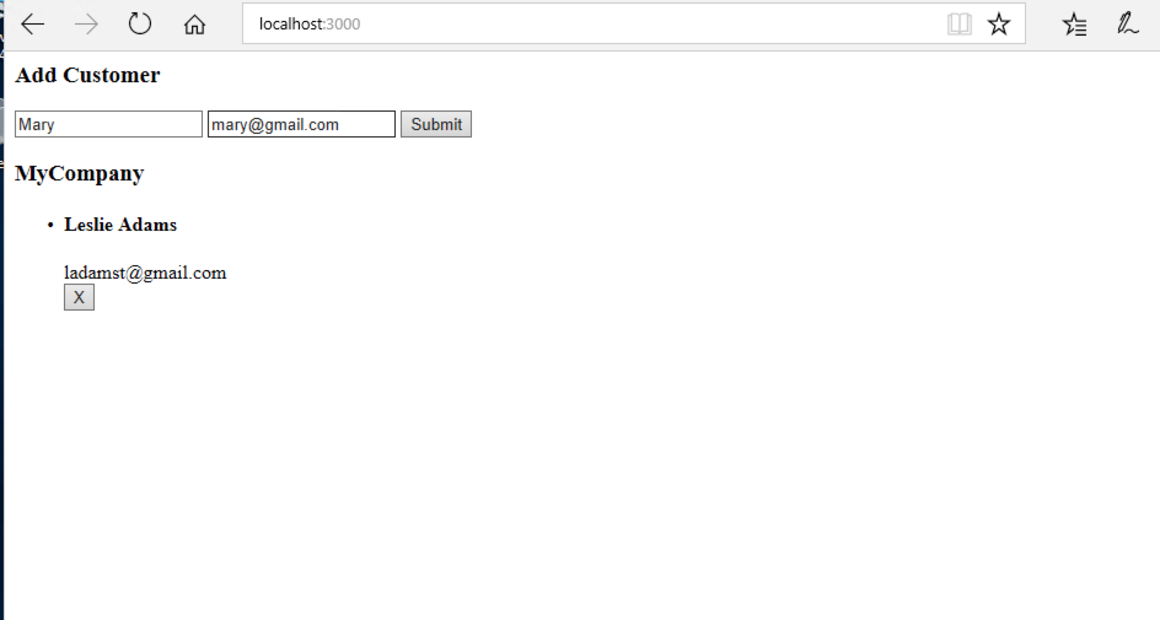

After inserting Mary and Sharon:

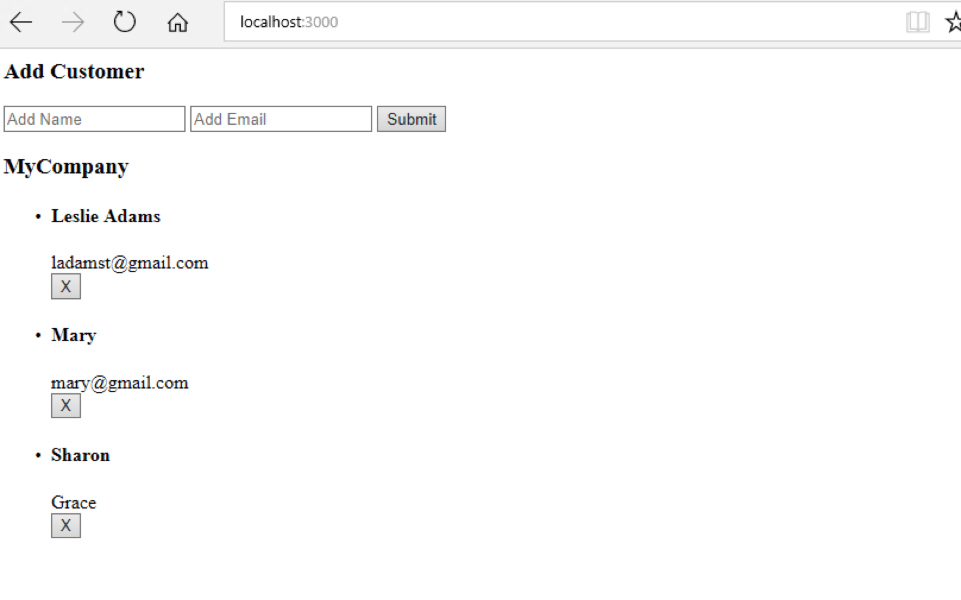

**DELETE a document**

* Modify your app.js to look like this: (Remember to change your username and password and use your own couchD API/url) (Read the script and note the modifications made)

*const express = require('express');*

*const bodyParser = require('body-parser');*

*const path = require('path');*

*const NodeCouchDb = require('node-couchdb');*

*const couch = new NodeCouchDb({*

*auth: {*

*user:'admin’,*

*password: '12345’*

*}*

*});*

*const dbName = 'mycompany';*

*const viewUrl = '_design/View1/_view/id?include_docs=true';*

*couch.listDatabases().then(function(dbs){*

*console.log(dbs);*

*});*

*const app = express();*

*app.set('view engine', 'ejs');*

*app.set('views', path.join(__dirname, 'views'));*

*app.use(bodyParser.json());*

*app.use(bodyParser.urlencoded({extended: false}));*

*app.get('/', function(req, res){*

*couch.get(dbName, viewUrl).then(*

*function(data, headers,status ){*

*console.log(data.data.rows);*

*res.render('index',{*

*mycompany:data.data.rows*

*});*

*},*

*function(err){*

*res.send(err);*

*});*

*});*

*app.post('/mycompany/add', function(req, res){*

*const name = req.body.name;*

*const email = req.body.email;*

*couch.uniqid().then(function(ids){*

*const id = ids[0];*

*couch.insert(dbName, {*

*_id: id,*

*name: name,*

*email: email*

*}).then(*

*function(data, headers, status){*

*res.redirect('/');*

*},*

*function(err){*

*res.send(err);*

*});*

*});*

*});*

*app.post('/mycompany/delete/:id', function(req, res){*

*const id= req.params.id;*

*const rev= req.body.rev;*

*couch.del(dbName, id, rev).then(*

*function(data, headers, status){*

*res.redirect('/');*

*},*

*function(err){*

*res.send(err);*

*});*

*});*

*app.listen(3000, function(){*

*console.log('Server Started On Port 3000');*

*});*

* Modify your index.ejs to look like this: (Read the script and note the modifications made)

*<h3>Add Customer </h3>*

*<form method="post" action="/mycompany/add">*

*<input type="text" name="name" placeholder="Add Name">*

*<input type="text" name="email" placeholder="Add Email">*

*<input type="submit" value="Submit">*

*</form>*

*<h3>MyCompany</h3>*

*<ul>*

*<% mycompany.forEach(function(mycompany){ %>*

*<li>*

*<h4><%= mycompany.value.name %></h4>*

*<%= mycompany.value.email %>*

*<form method="post" action="/mycompany/delete/<%= mycompany.key %>">*

*<input type="hidden" value="<%= mycompany.value.rev %>" name="rev">*

*<input type="submit" value="X">*

*</form>*

*</li>*

*<% }); %>*

*</ul>*

* Now restart the server
* Run *Ctrl c*
* Run *node app*
* *Go to* [*http://localhost:3000/*](http://localhost:3000/)
* *You would see a view like this. Click on the X close to Sharon to delete customer Sharon:*

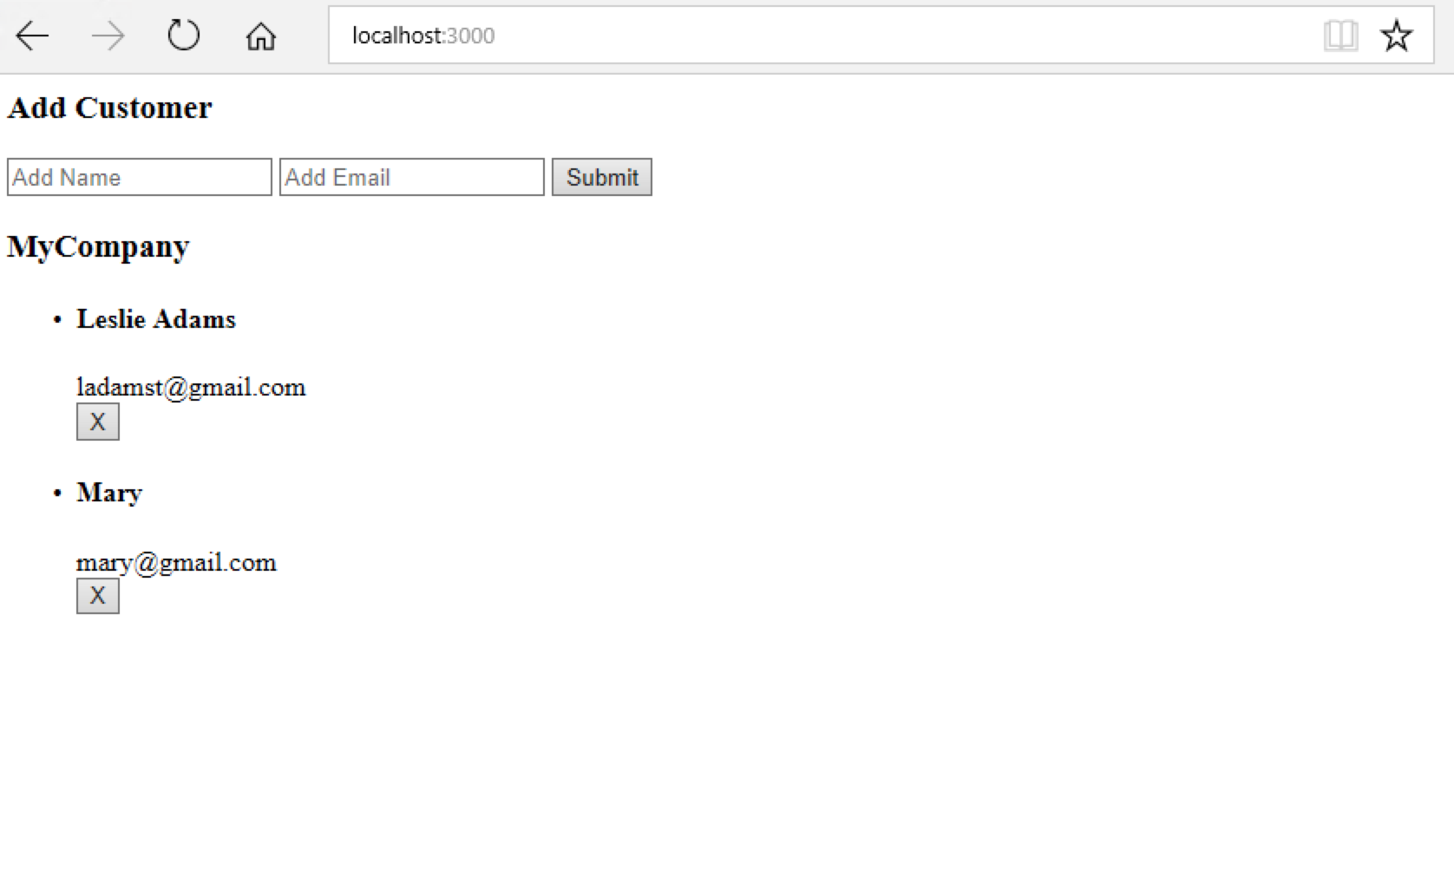

For more check this link:

*https://www.npmjs.com/package/node-couchdb*

*https://www.youtube.com/watch?v=R6LUMXrAoCE*