**HW3**

**Damin Xia**

**Results:**

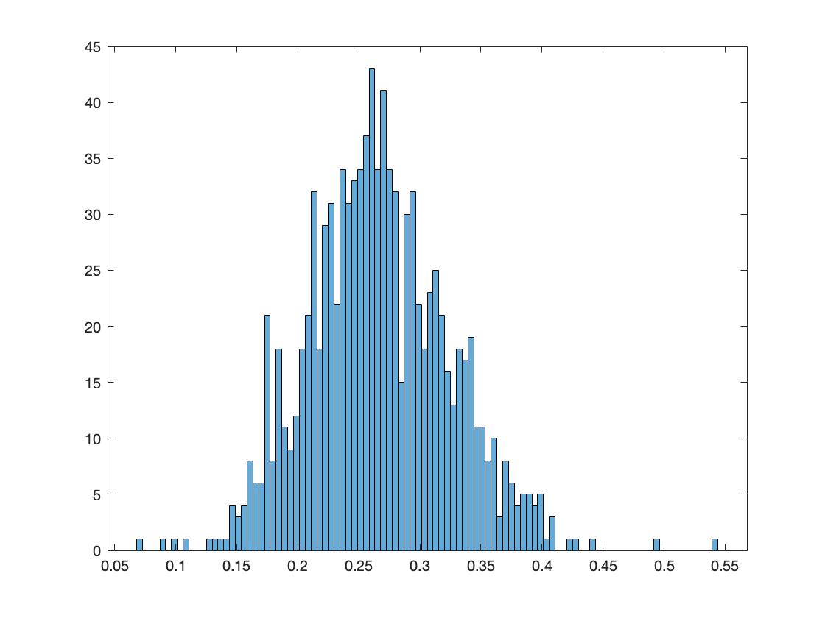**Original model:**

**Surrogate model:**

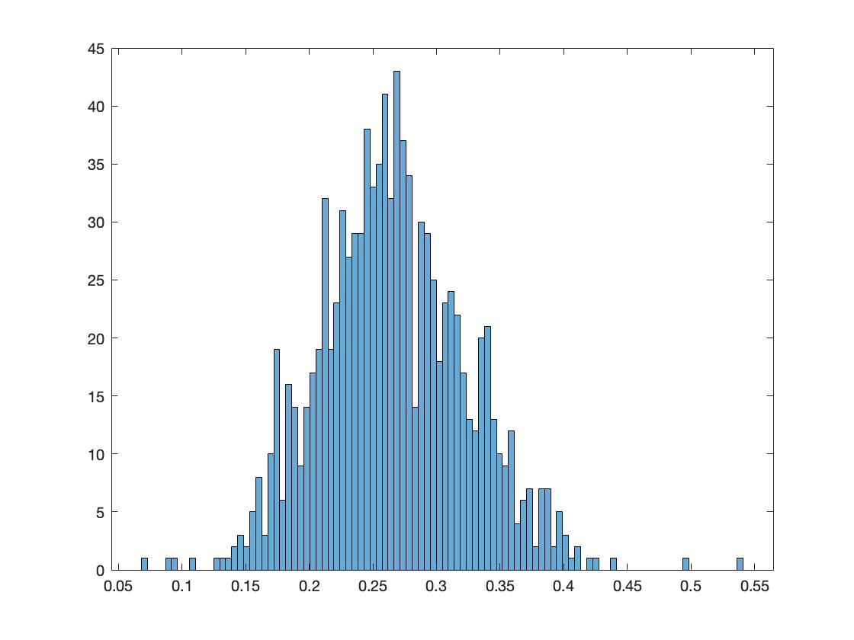

**Gaussian process model:**

**Comparison of statics of the three models:**

|  |  |  |  |
| --- | --- | --- | --- |
|  | Original Model | Surrogate Model | GP Model |
| Mean | 0.2662 | 0.2662 | 0.2662 |
| Standard deviation | 0.0574 | 0.074 | Not applicable |