**Dependency Management using Maven**

1. **Add a maven dependency and its related repository URL.**

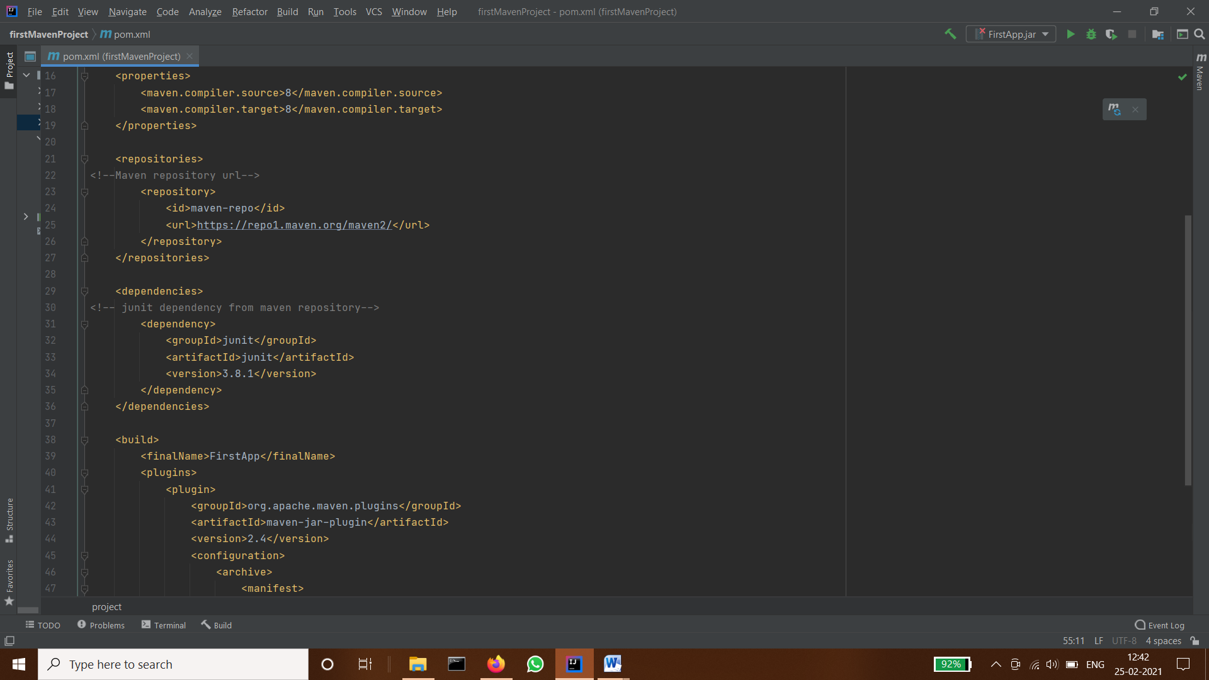

1. **Add a new repository in the pom.xml and use its dependencies.**

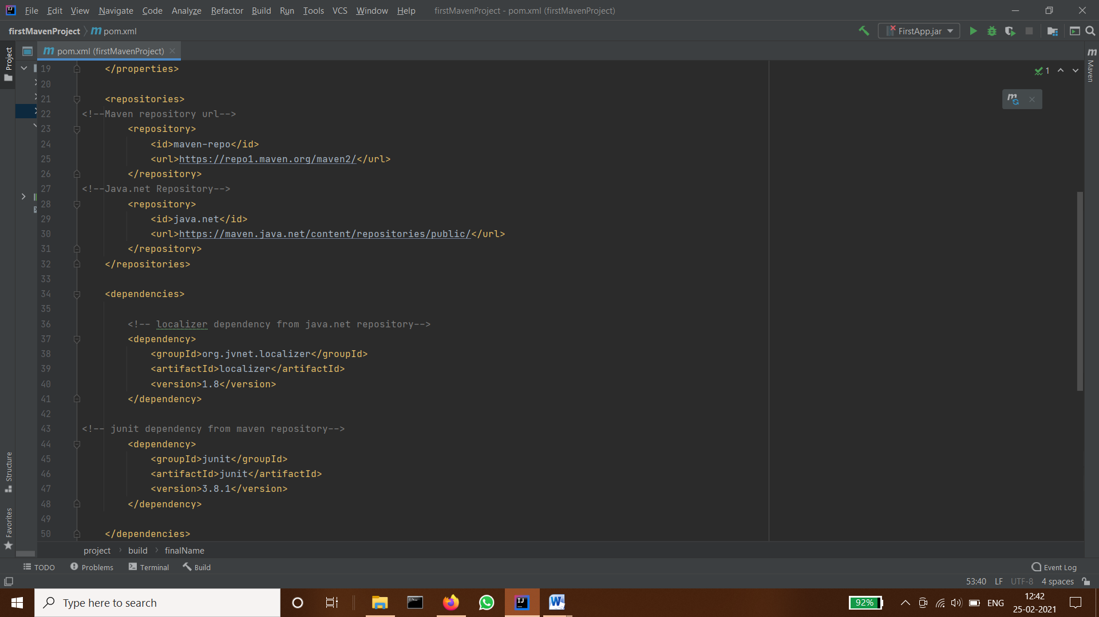

1. **Using JAR plugin, make changes in the pom.xml to make the jar executable. Using java -jar JAR_NAME, the output should be printed as "Hello World"**

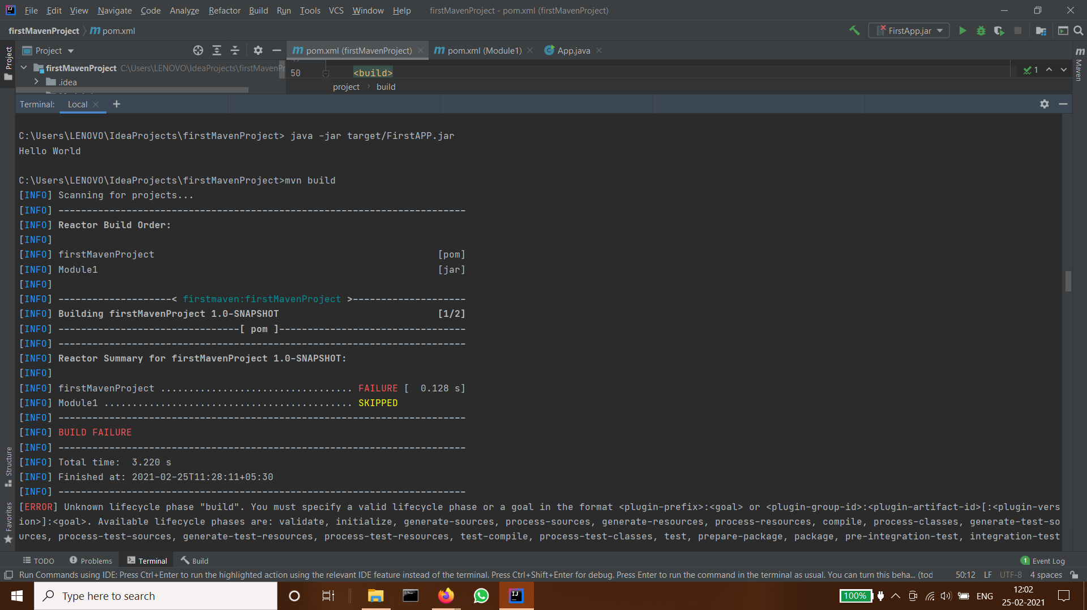

1. **Differentiate between the different dependency scopes: compile, runtime, test, provided using different dependencies being defined in your pom.xml.**

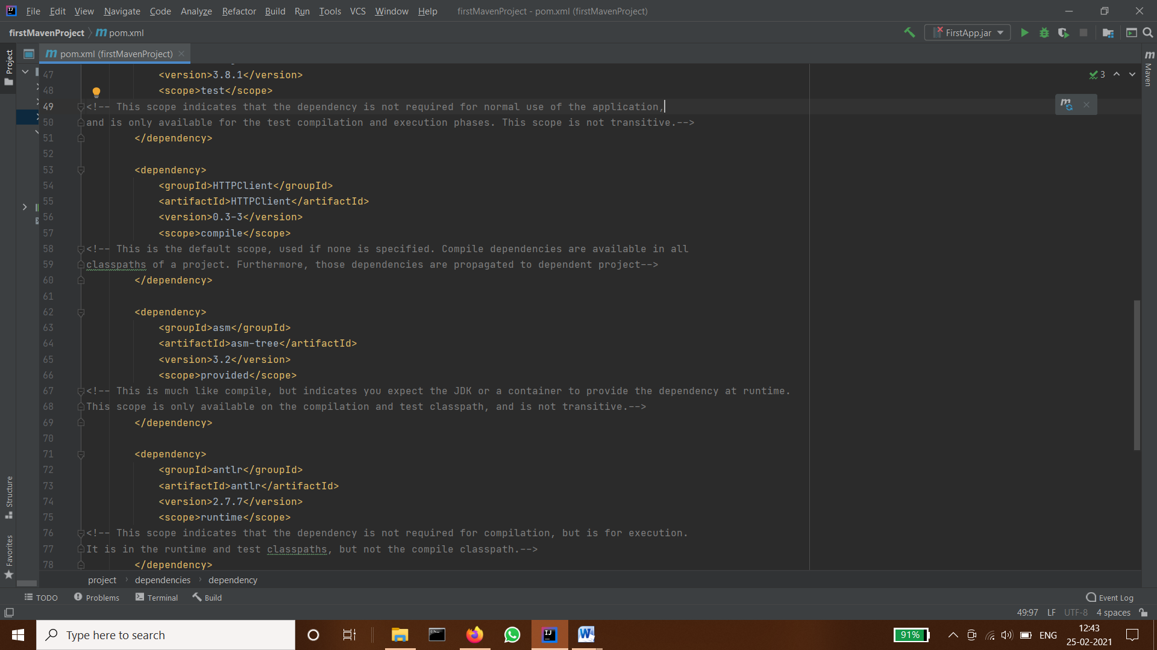

1. **Create a multi-module project. Run package command at the top level to make jar of every module.**

