Introduction to JavaScript

- Prompt for amount, interest rate and no. of years and calculate simple interest.
- took principal, rate of interest and years as input from user using prompt() method.
- Calculated the simple interest.
- Then printed it on the html page using the DOM. Set the value of <p> in javascript code by accessing it using its id with method getElementById()
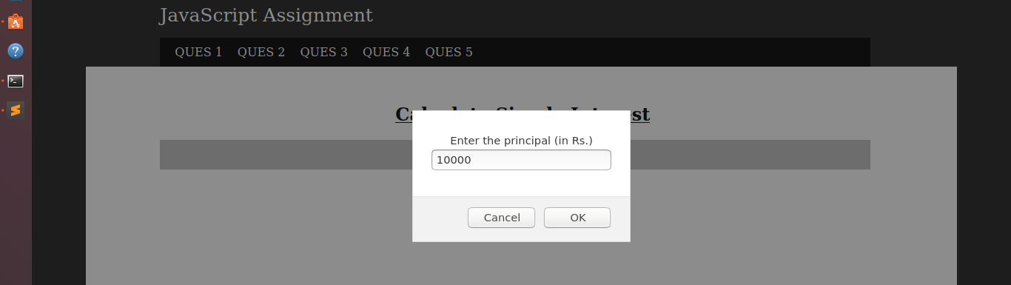

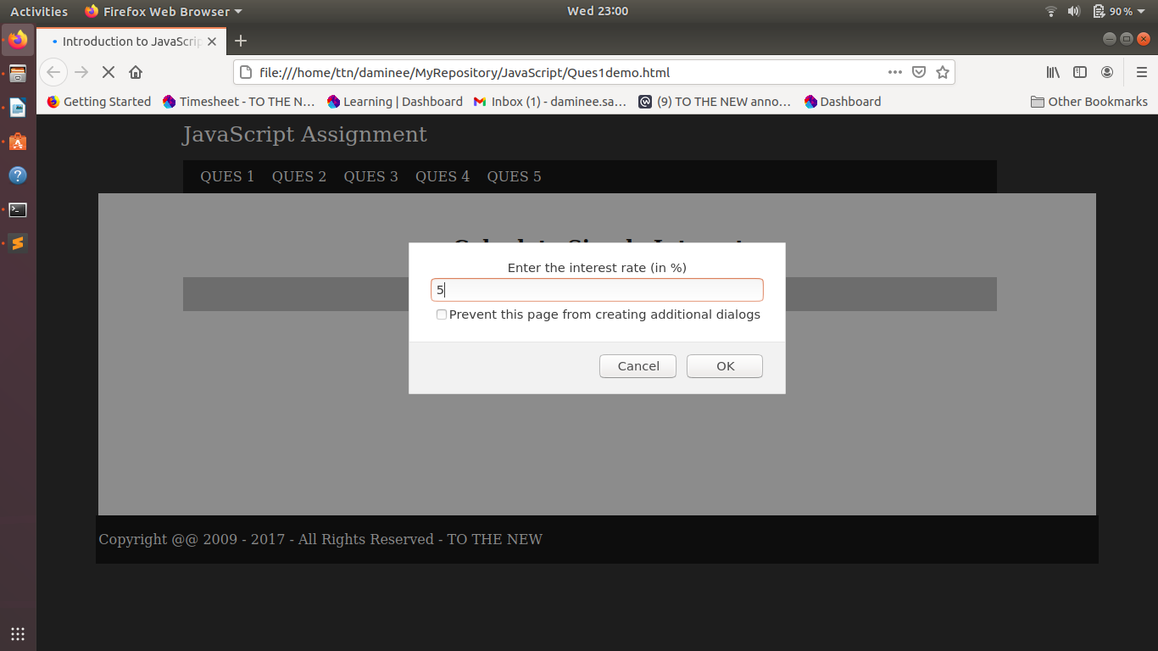
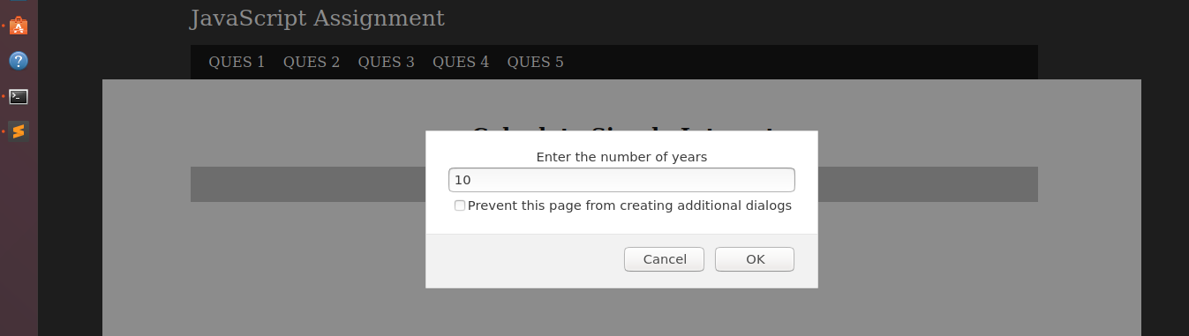
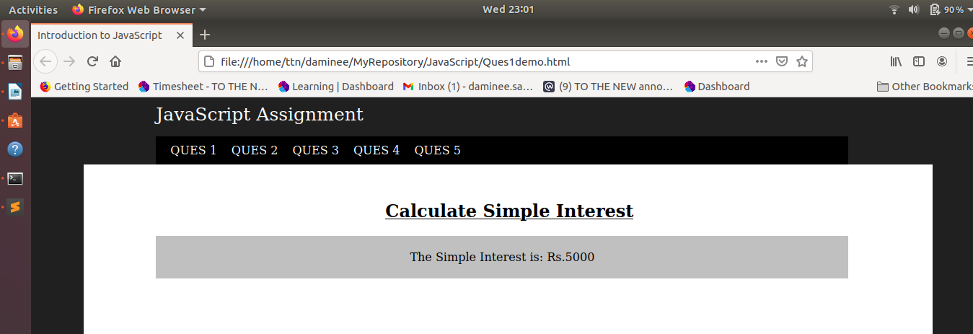
JavaScript Code Snippet
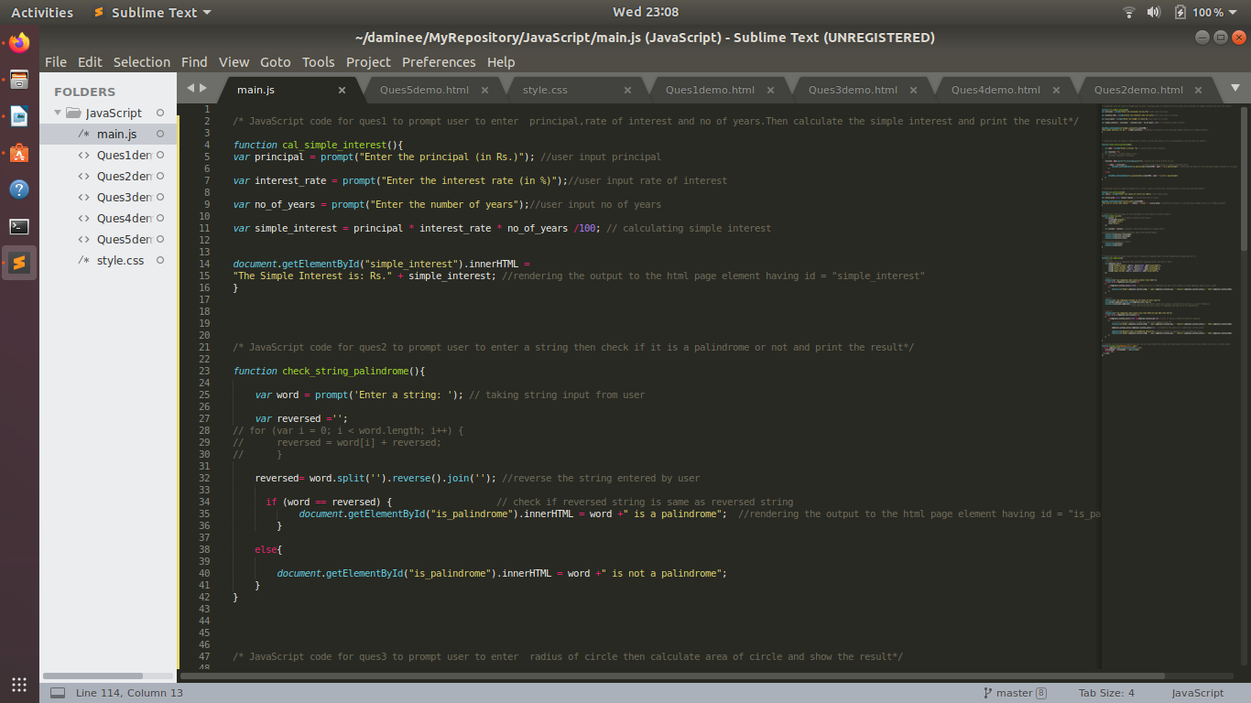

- is palindrome string
- took a string as an input from user using prompt() method.
- Checked if the string entered is palindro.
- Reverse the original string and storing into the another variable.
- Then compare both the strings is equal then the string is palindrome else its not
- Then printed it on the html page using the DOM. Set the value of <p> in javascript code by accessing it using its id with method getElementById()
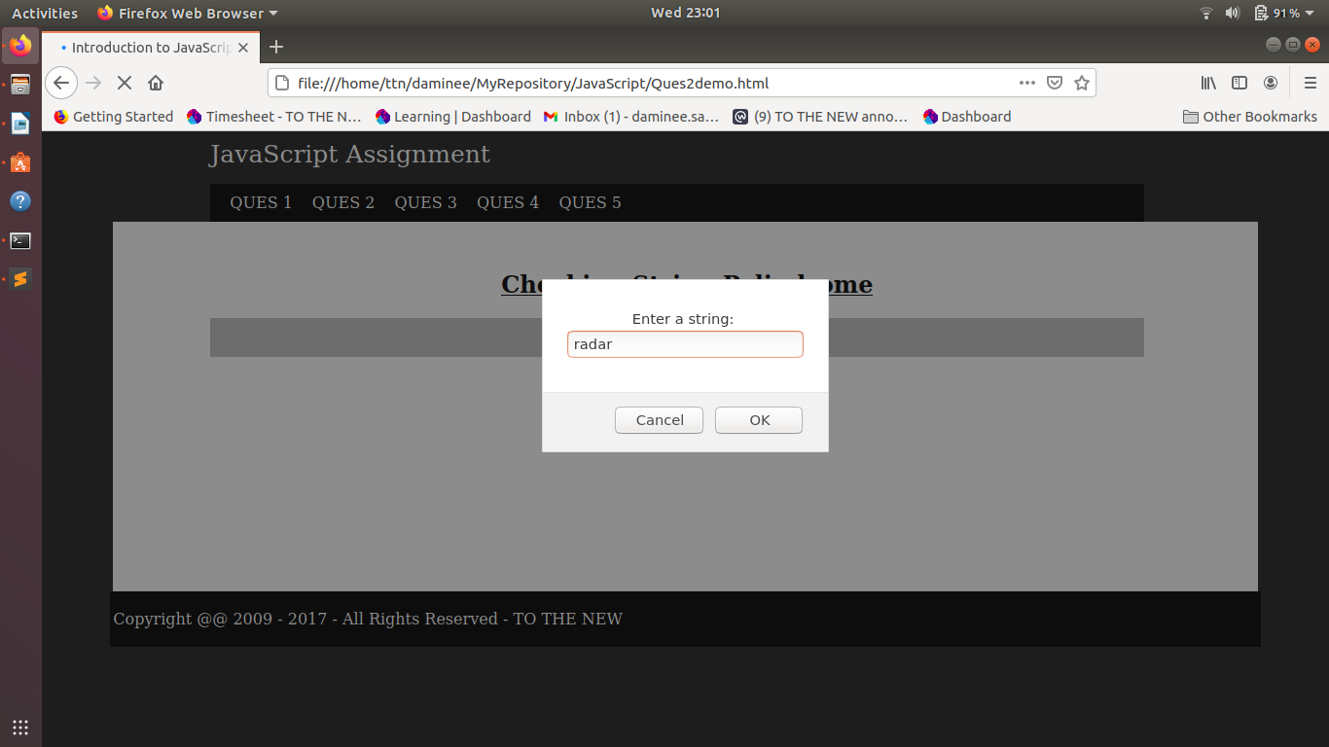

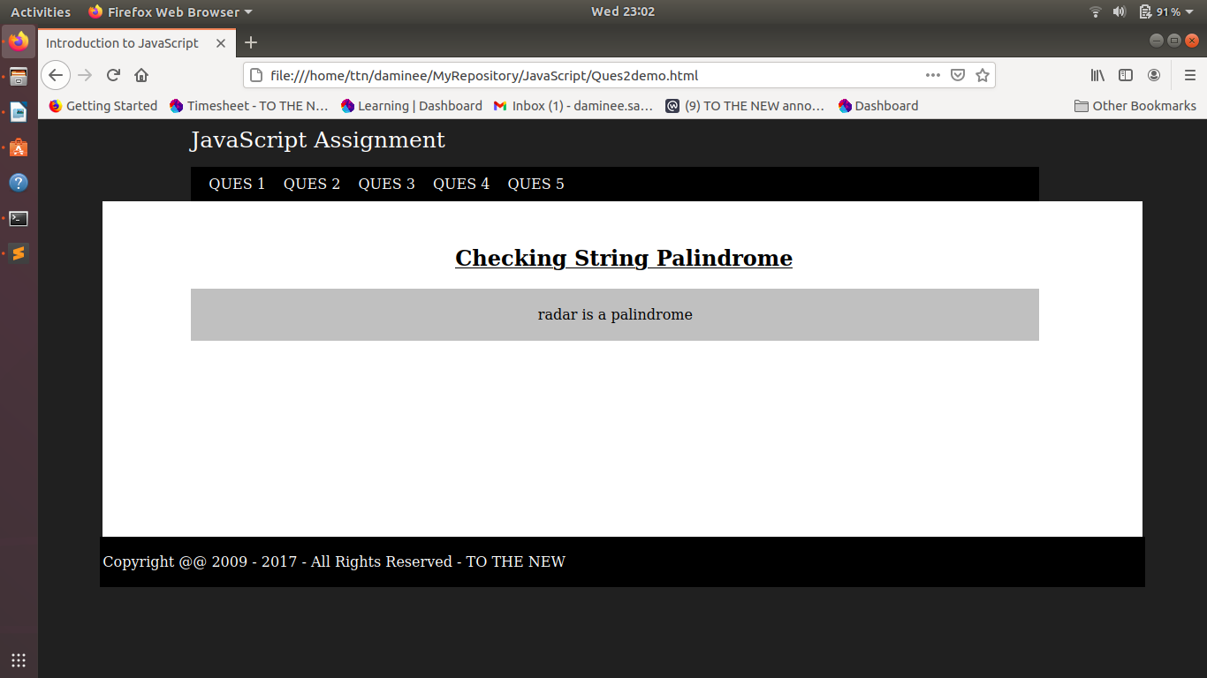
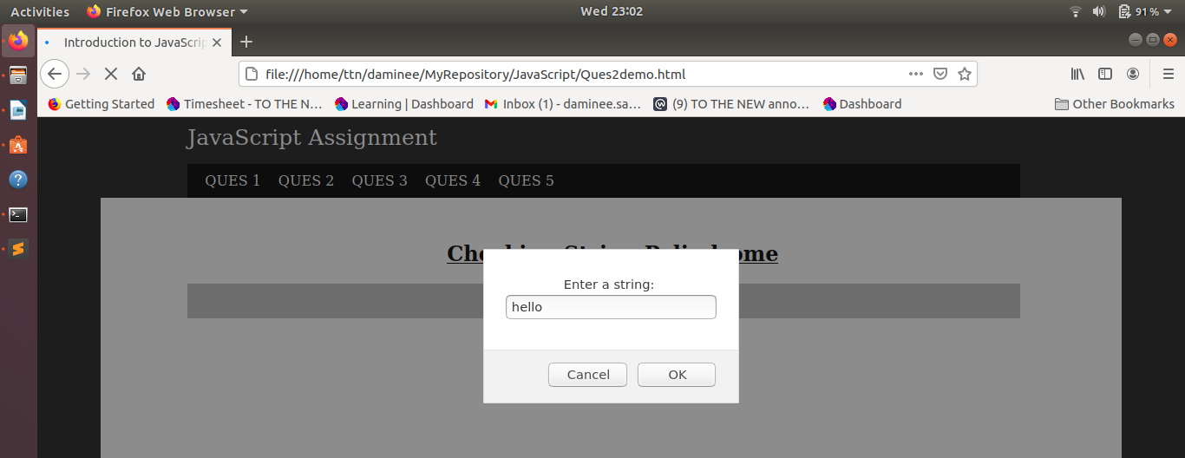
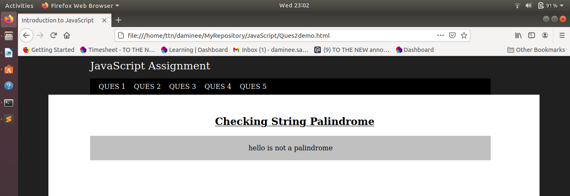
JavaScript Code Snippet
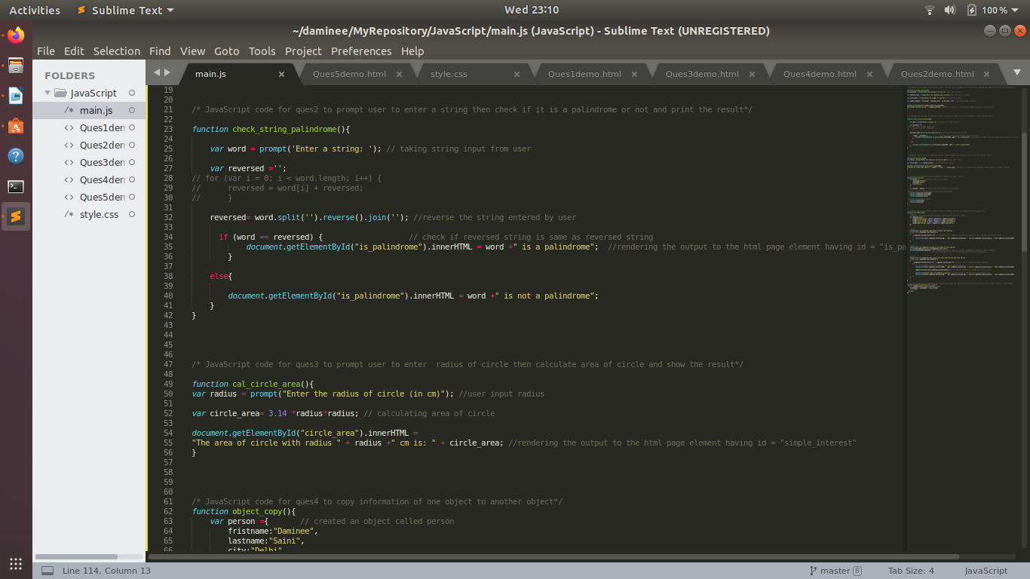
- Area of circle
- took value of radius as input from user using prompt() method.
- Calculated the area of circle.
- Then printed it on the html page using the DOM. Set the value of <p> in javascript code by accessing it using its id with method getElementById()
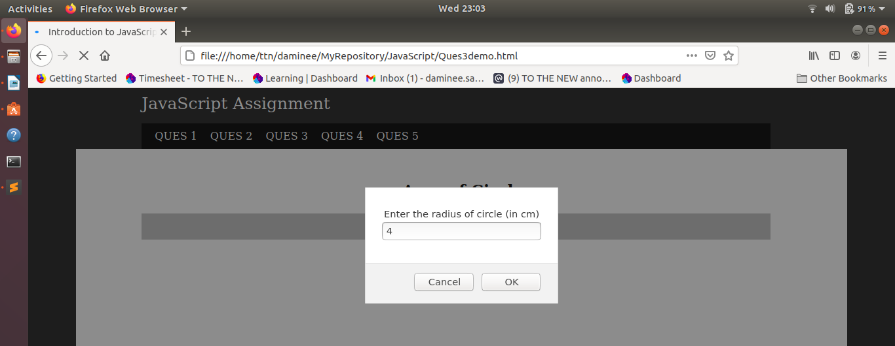
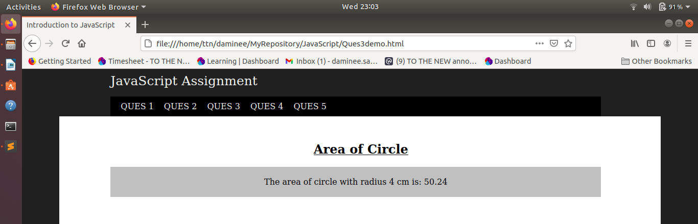
JavaScript Code Snippet
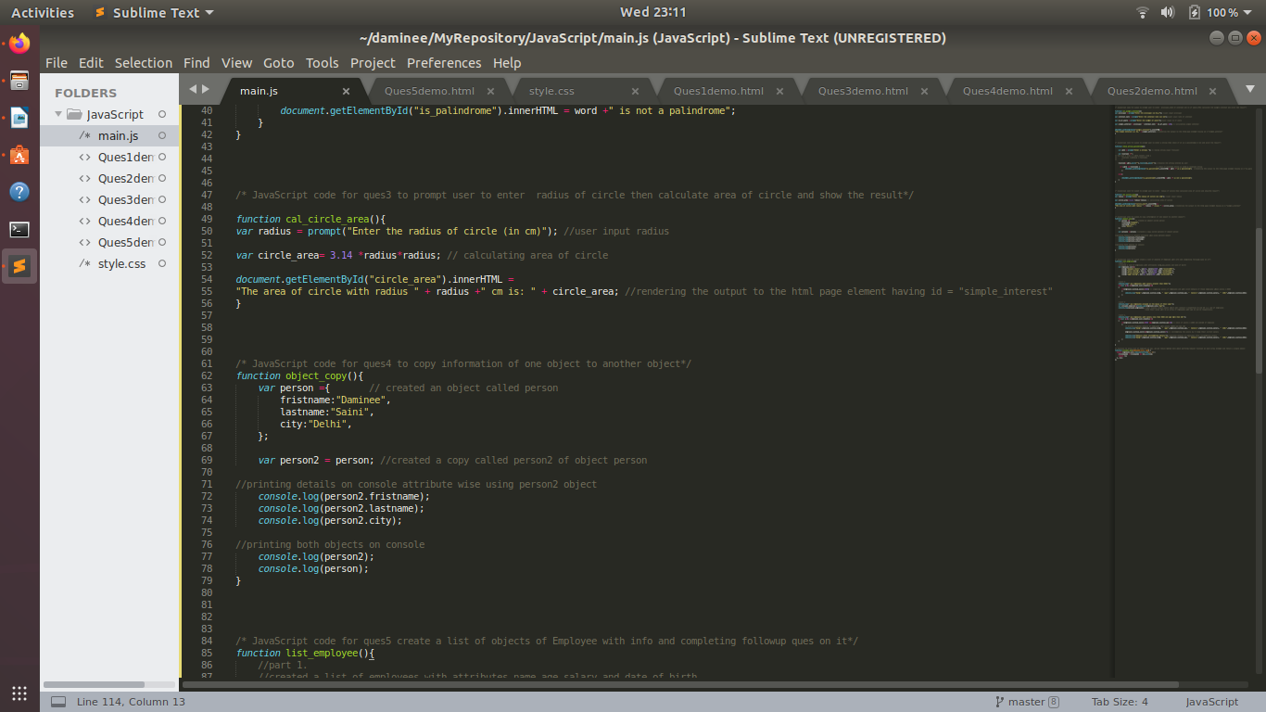

- Copy information of one object to another and log it to console.
- Created an object person with attributes {firstname, lastname, city}
- then created another object person2 and set it equal to object person.
- then printed the details of person2 on console.
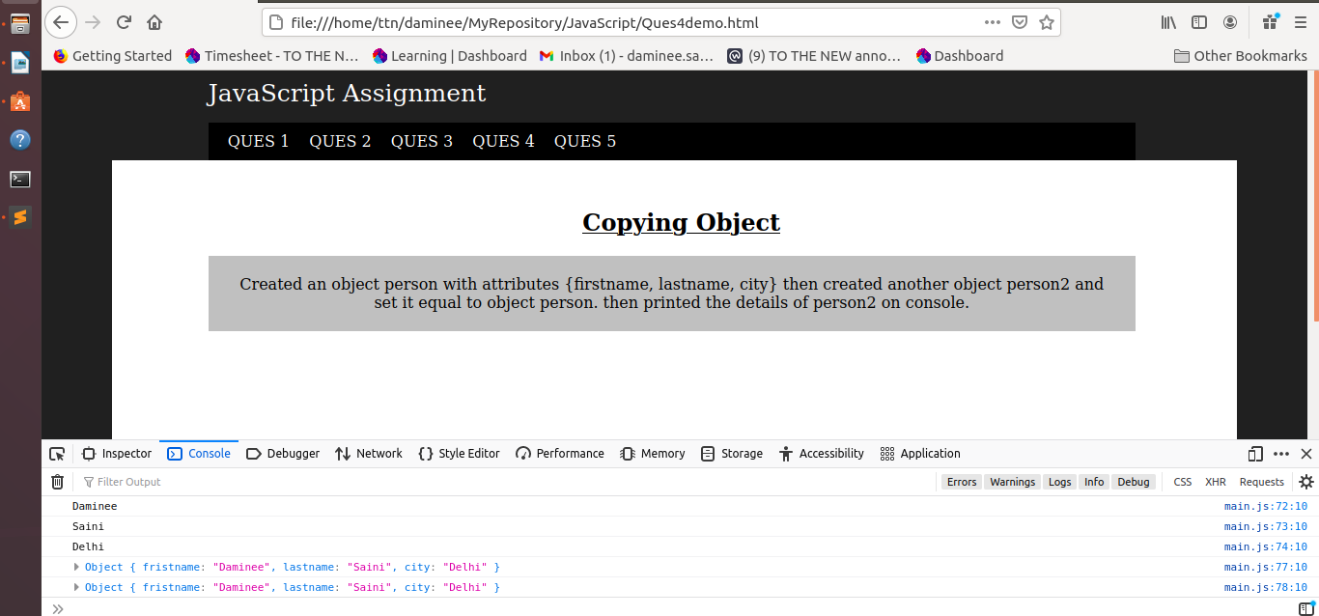
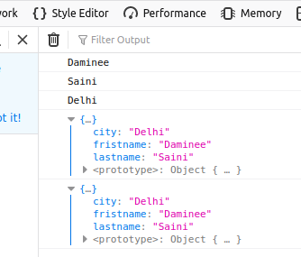

JavaScript Code Snippet
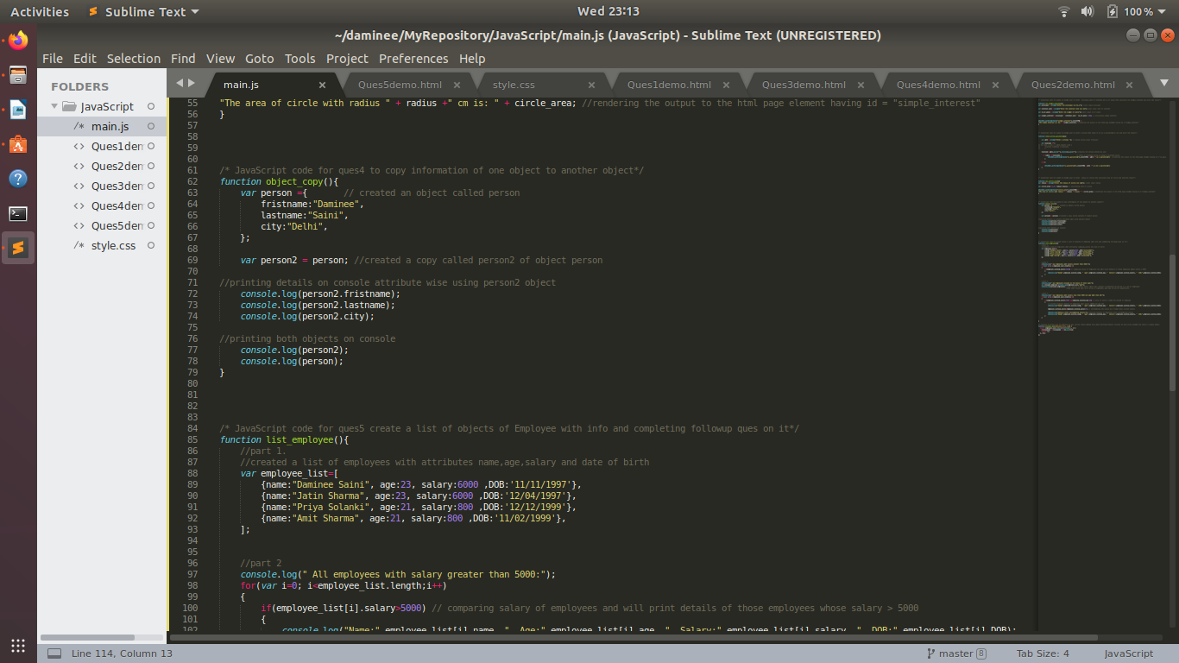

- create a list of objects of Employee with info as follow :
  - Name, age, salary ,DOB
  - filter all employees with salary greater than 5000
  - group employee on the basis of their age
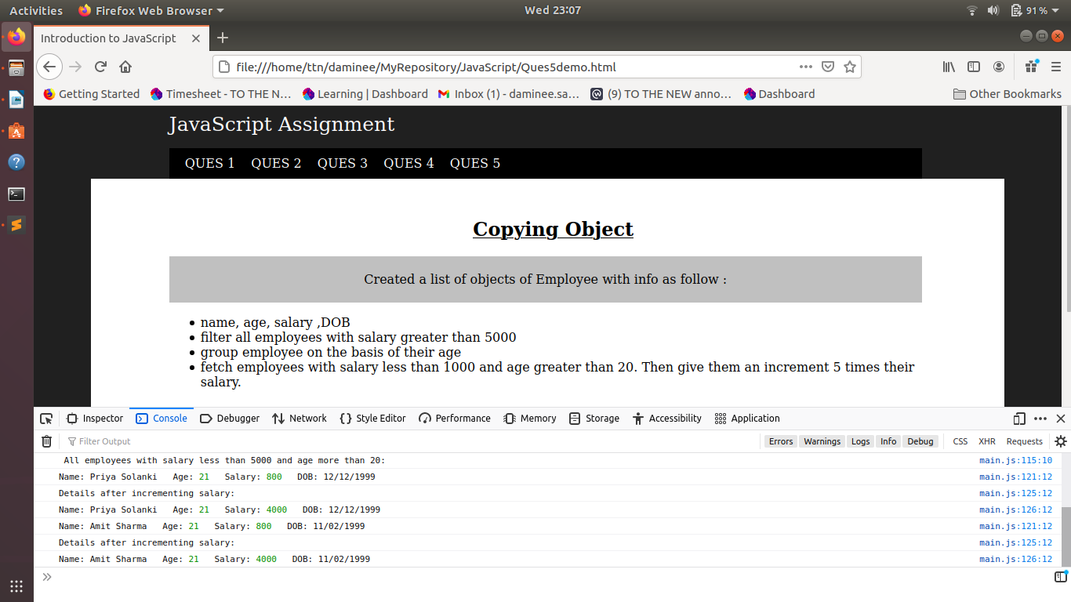
  - fetch employees with salary less than 1000 and age greater than 20. Then give them an increment 5 times their salary.

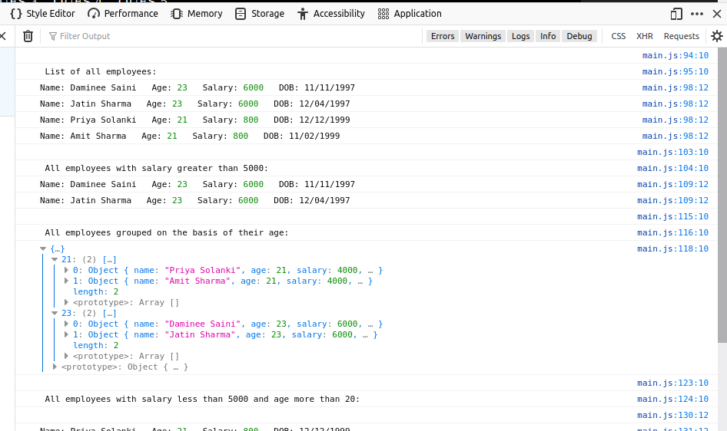

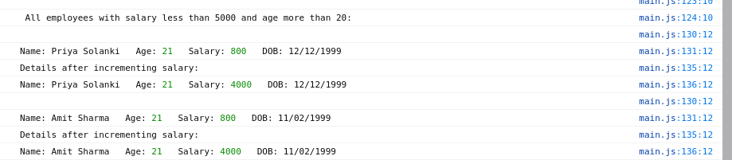
JavaScript Code Snippet
