1.How are inline and block elements different from each other?
There are two types of elements in HTML page – INLINE and BLOCK.
An inline element does not start on a new line and only takes up as much width as necessary.Therefore, no matter how you organize your inline-elements in the markup, they will always appear side-by-side.You can't put block elements inside inline elements.
This <span> element is an inline-level element.
A block-level element always starts on a new line and takes up the full width available.So, no matter how you organize your HTML, block-level elements always create a new line.
The <div> element is a block-level element.

<html>
<head>
<title>
Introduction to HTML and CSS
</title>
<link rel="stylesheet" href="style.css">
</head>
<body>
<div>
<h1>Inline and Block elements</h1>
<p>The following parahraph has an inline element.<span>This is an inline element.</span>
I have used span tag to show the inline element and its background color is different. And for block element I have used p tag (paragraph tag) and its content is underlined with a blue color.
</p>
</div>
</body>
</html>

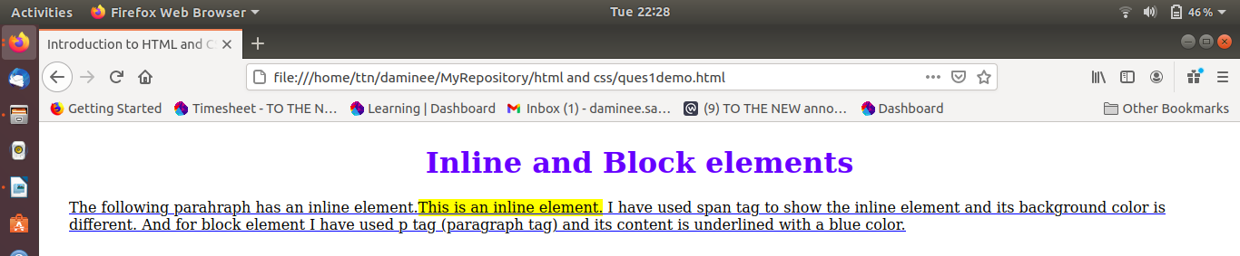

2.Explain the difference between visibility:hidden and display:none
- visibility:hidden - The tag with this property is not visible, but space is allocated for it on the page. The tag is rendered, it just not seen on the page.
- display:none – The tag with this property will not appear on the page at all. But one can still interact with it through the DOM (Document Object Model). There will be no space allocated for it between the other tags.

<html>
<head>
<title>
Introduction to HTML and CSS
</title>
<link rel="stylesheet" href="style.css">
</head>
<body>
<div>
<h1>Visible Property</h1>
In this example i am trying to show difference between Visible and Display.<span id="visibilityid"> lets set this tag property as Vissible:hidden </span>
The span element have property visible:hidden will not be shown but it will occupy space on page.
</div>
<div>
<h1>Display Property</h1>
In this example i am trying to show difference between Visible and Display.<span id="displayid"> lets set this tag property as display:none </span>
The span element have property display:none and will not be shown nor it will occupy space on page.
</div>
</body>
</html>
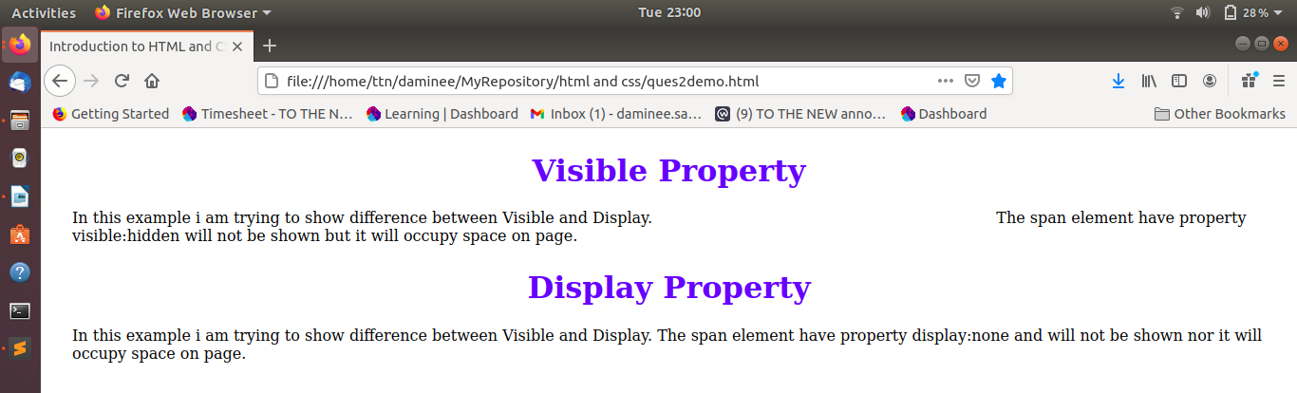

3. Explain the clear and float properties.
Float- This property is used for positioning and formatting content. It is generally used to wrap text around images.
The float property can have one of the following values:
- left - The element floats to the left of its container
- right - The element floats to the right of its container
- none - The element does not float. It will be displayed just where it occurs in the text. This is default
- inherit - The element inherits the float value of its parent

Clear- This property is used to specify what elements can float beside the cleared element and on which side.
The clear property can have one of the following values:
- none - Allows floating elements on both sides. This is default
- left - No floating elements allowed on the left side
- right- No floating elements allowed on the right side
- both - No floating elements allowed on either the left or the right side
- inherit - The element inherits the clear value of its parent
The most common way to use the clear property is after you have used a float property on an element.
<html>
<head>
<title>
Introduction to HTML and CSS
</title>
<link rel="stylesheet" href="style.css">
</head>
<body>
<h1> CLear and Float Property</h1>
<img src="hike-1836600_960_720-600x338.jpg" id="floatid">
<div id="clearid">
If you travel, you will not only learn about foreign cultures, but about your own as well. You will notice the cultural differences, and will find out what makes your culture unique. After retrurning from a long journey, you will see your country with new eyes.
</p>
</div>
</body>
</html>
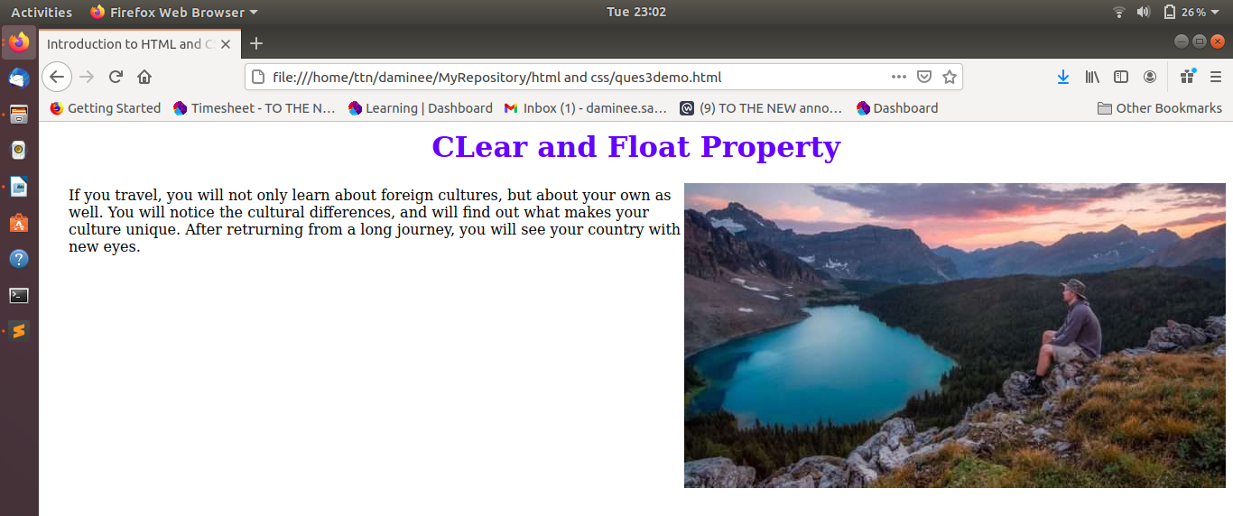
4. explain difference between absolute, relative,fixed and static.
- Absolute - An element with this property is positioned relative to the nearest positioned parent element.
- Relative - An element with this property is positioned relative to its normal position.
- Fixed - An element with this property will always stay in the same place even if the page is scrolled.
- Static - An element with this property is always positioned according to the normal flow of the page.
<html>
<head>
<title>
Introduction to HTML and CSS
</title>
<link rel="stylesheet" href="style.css">
</head>
<body>
<h1> Position Property</h1>
<div>
If you travel, you will not only learn about foreign cultures, but about your own as well. You will notice the cultural differences, and will find out what makes your culture unique. After retrurning from a long journey, you will see your country with new eyes.
<div id="static">
This div element has position: static;
<div id="relative">
This div element has position: relative;
</div>
<div id="absolute">
This div element has position: absolute;
</div>
</div>
<div id="fixed">
This div element has position: fixed;
</div>
</div>
</body>
</html>
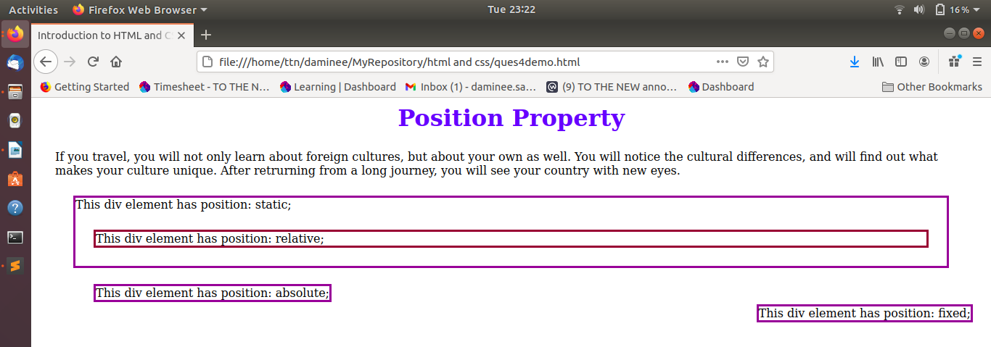
5. Write the HTML code to create a table in which there are 4 columns( ID , Employee Name, Designation, Department) and at least 6 rows. Also do some styling to it.
<!DOCTYPE html>
<html>
<head>
<title>
Introduction to HTML and CSS
</title>
<link rel="stylesheet" href="style.css">
</head>
<body>
<h1> Tables in HTML </h1>
<div>
<table id="customers">
<tr>
<th>ID</th>
<th>Employee Name</th>
<th>Designation</th>
<th>Department</th>
</tr>
<tr>
<td>001</td>
<td>Sidharth Sharma</td>
<td>Manager</td>
<td>Finance and Accounts</td>
</tr>
<tr>
<td>002</td>
<td>Megha SUndriyal</td>
<td>Assistant General Manager</td>
<td>Administration</td>
</tr>
<tr>
<td>003</td>
<td>Govind Singh</td>
<td>Deputy Manager</td>
<td>Marketing</td>
</tr>
<tr>
<td>004</td>
<td>Uday Sharma</td>
<td>Senior Office</td>
<td>VAT and Excise</td>
</tr>
<tr>
<td>005</td>
<td>Parth Shukla</td>
<td>Genral Manager</td>
<td>Marketing</td>
</tr>
<tr>
<td>006</td>
<td>Priya Singh</td>
<td>Assistant Manager</td>
<td>IT</td>
</tr>
</table>
</div>
</body>
</html>
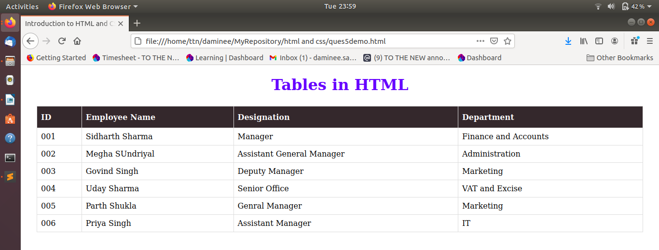
6. Why do we use meta tags?
The <meta> tag provides metadata about the HTML document. Metadata will not be displayed on the page, but will be machine parsable.
Meta elements are typically used to specify page description, keywords, author of the document, last modified, and other metadata. Also, it helps to improve the SEO( Search Engine Optimization) of a web page by using certain keywords related to the web page.
<meta> tags always go inside the <head> element.
7. Explain box model.
All HTML elements can be considered as boxes. In CSS, the term "box model" is used when talking about design and layout.
The CSS box model is essentially a box that wraps around every HTML element. It consists of: margins, borders, padding, and the actual content. The image below illustrates the box model:
Explanation of the different parts:
- Content - The content of the box, where text and images appear
- Padding - Clears an area around the content. The padding is transparent
- Border - A border that goes around the padding and content
- Margin - Clears an area outside the border. The margin is transparent
The box model allows us to add a border around elements, and to define space between elements.
<!DOCTYPE html>
<html>
<head>
<title>
Introduction to HTML and CSS
</title>
<link rel="stylesheet" href="style.css">
</head>
<body>

<h1> Box Model </h1>

<div class="boxmodel">
<table id="customers">
<tr>
<th>ID</th>
<th>Employee Name</th>
<th>Designation</th>
<th>Department</th>
</tr>
<tr>
<td>001</td>
<td>Sidharth Sharma</td>
<td>Manager</td>
<td>Finance and Accounts</td>
</tr>
<tr>
<td>002</td>
<td>Megha SUndriyal</td>
<td>Assistant General Manager</td>
<td>Administration</td>
</tr>
<tr>
<td>003</td>
<td>Govind Singh</td>
<td>Deputy Manager</td>
<td>Marketing</td>
</tr>
<tr>
<td>004</td>
<td>Uday Sharma</td>
<td>Senior Office</td>
<td>VAT and Excise</td>
</tr>
<tr>
<td>005</td>
<td>Parth Shukla</td>
<td>Genral Manager</td>
<td>Marketing</td>
</tr>
<tr>
<td>006</td>
<td>Priya Singh</td>
<td>Assistant Manager</td>
<td>IT</td>
</tr>
</table>
</div>
</body>
</html>
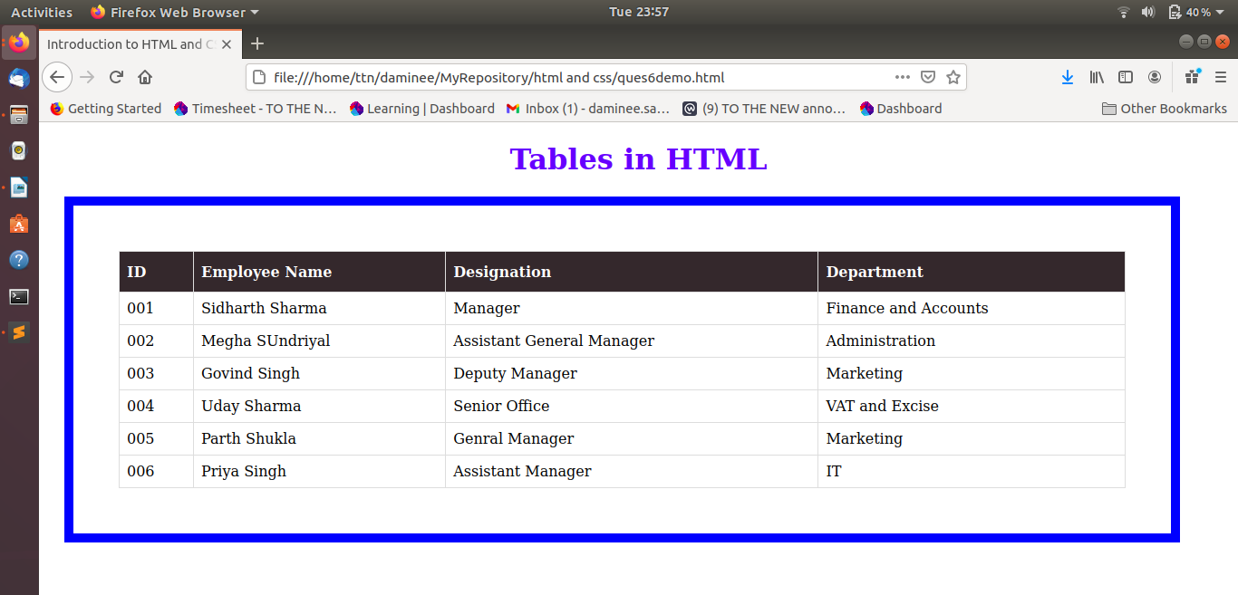

8. What are the different types of CSS Selectors?
A CSS selector is the first part of a CSS Rule. It is a pattern of elements and other terms that tell the browser which HTML elements should be selected to have the CSS property values inside the rule applied to them. The element or elements which are selected by the selector are referred to as the subject of the selector.
We can divide CSS selectors into five categories:
- Simple selectors - select elements based on name, id, class
- Combinator selectors - select elements based on a specific relationship between them
- Pseudo-class selectors - select elements based on a certain state
- Pseudo-element selectors - select and style a part of an element
- Attribute selectors - select elements based on an attribute or attribute value

9. Define Doctype.
All HTML documents must start with a <!DOCTYPE> declaration.
The declaration is not an HTML tag. It is an "information" to the browser about what document type to expect.
In HTML 5, the declaration is simple:
<!DOCTYPE html>
<html>
<head>
<title>Title of the document</title>
</head>
<body>
The content of the document......
</body>
</html>

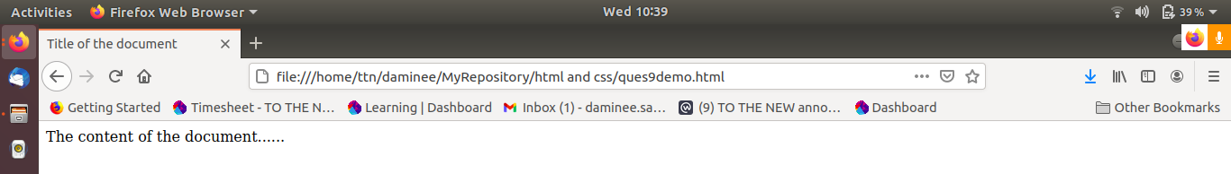

10. Explain 5 HTML5 semantic tags.
Semantic HTML elements are those that clearly describe their meaning in a human- and machine-readable way.
Elements such as <header>, <footer> and <article> are all considered semantic because they accurately describe the purpose of the element and the type of content that is inside them.
Some of the commonly used new tags of HTML5 are :
<article> - Defines an article in the document
<aside> - Defines content aside from the page content like sidebar.
<footer> - Defines a footer for the document or a section
<header> - Defines a header for the document or a section
<nav> - Defines navigation links in the document
<section> - Defines a section in the document

11. Create HTML for web-page.jpg (check resources, highest weightage for answers)
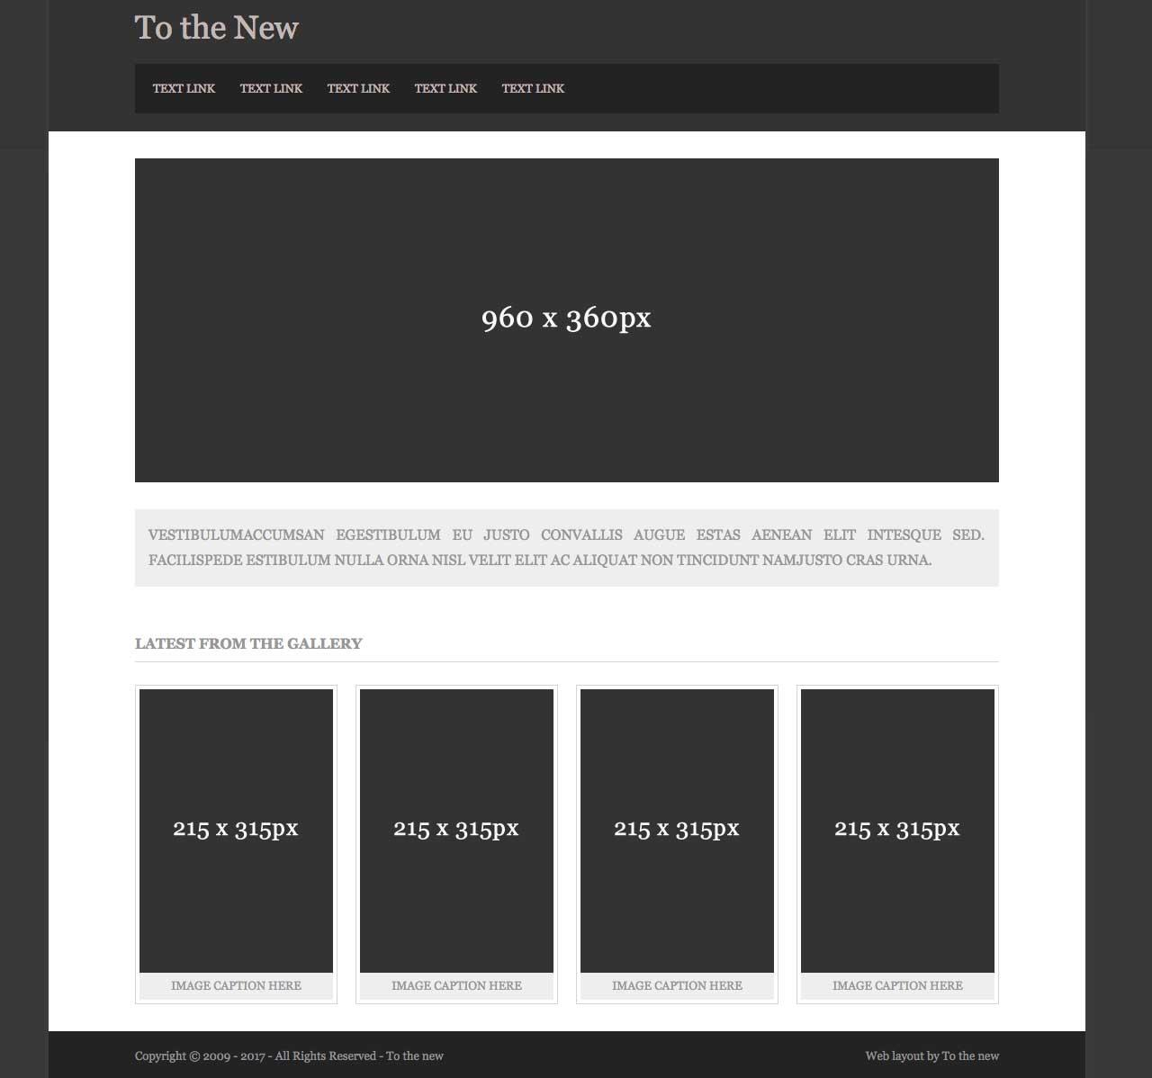

Files used – ques11demo.html and style2.css
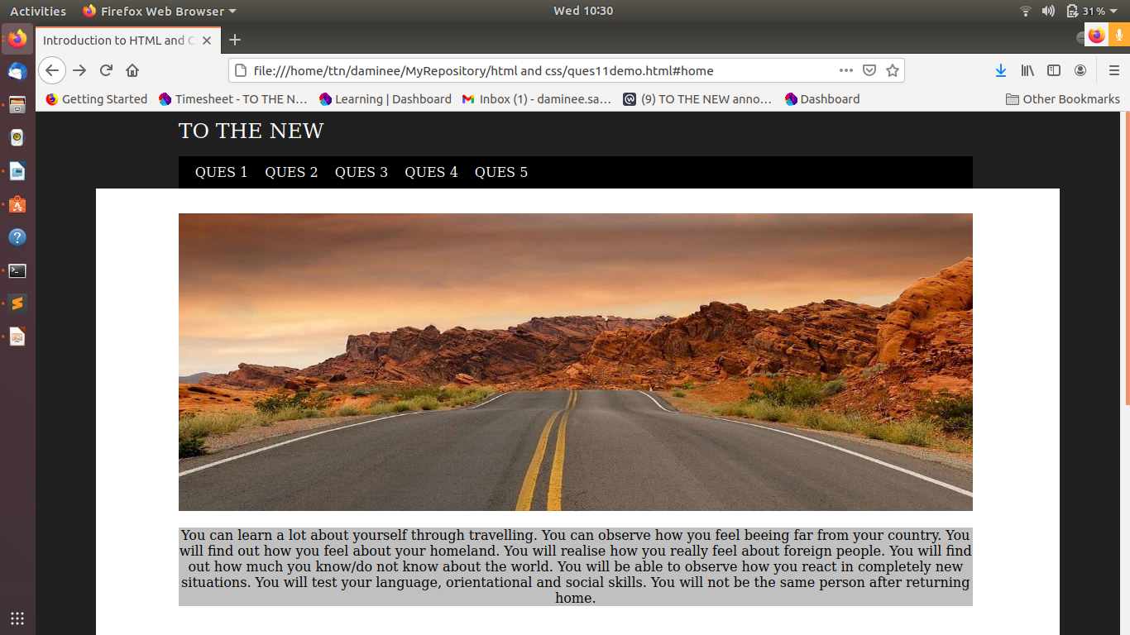
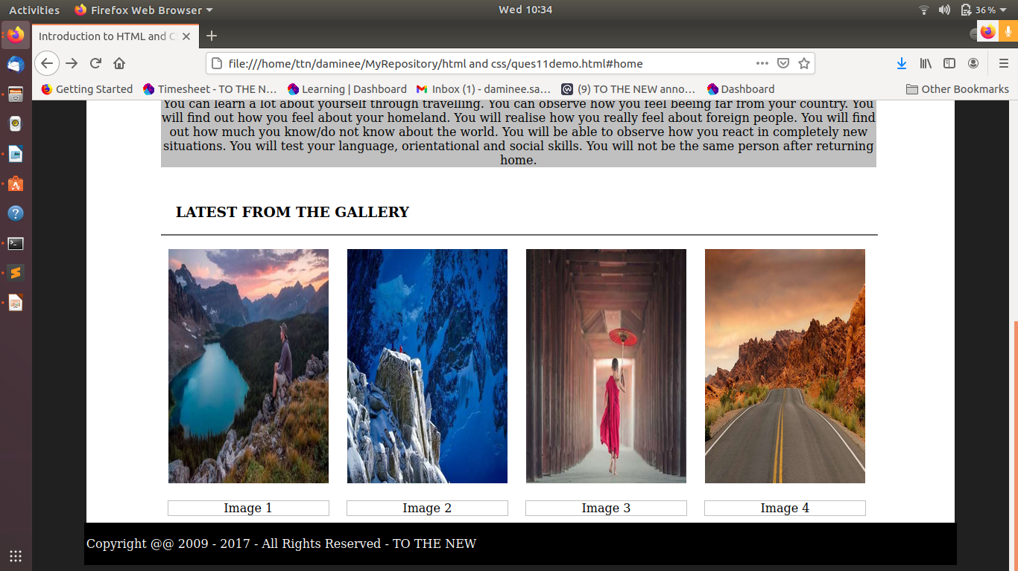

12. Create HTML for form.png (check resources, highest weightage for answers)
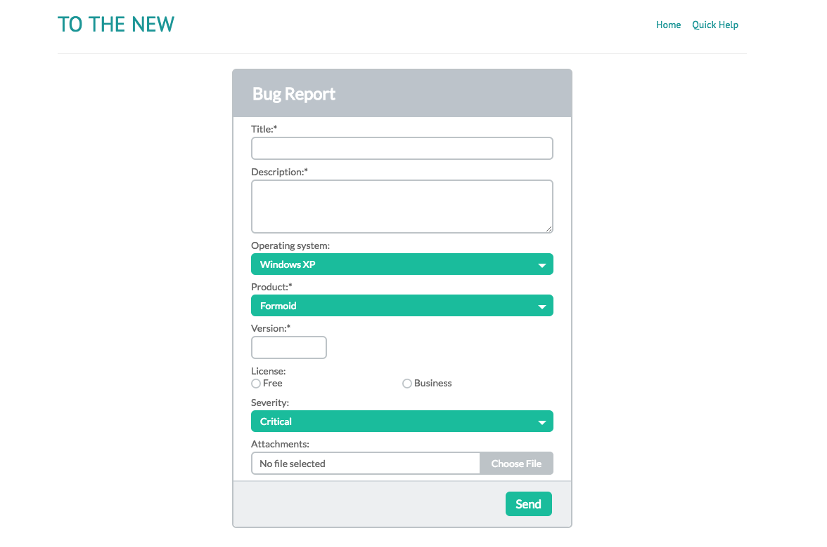

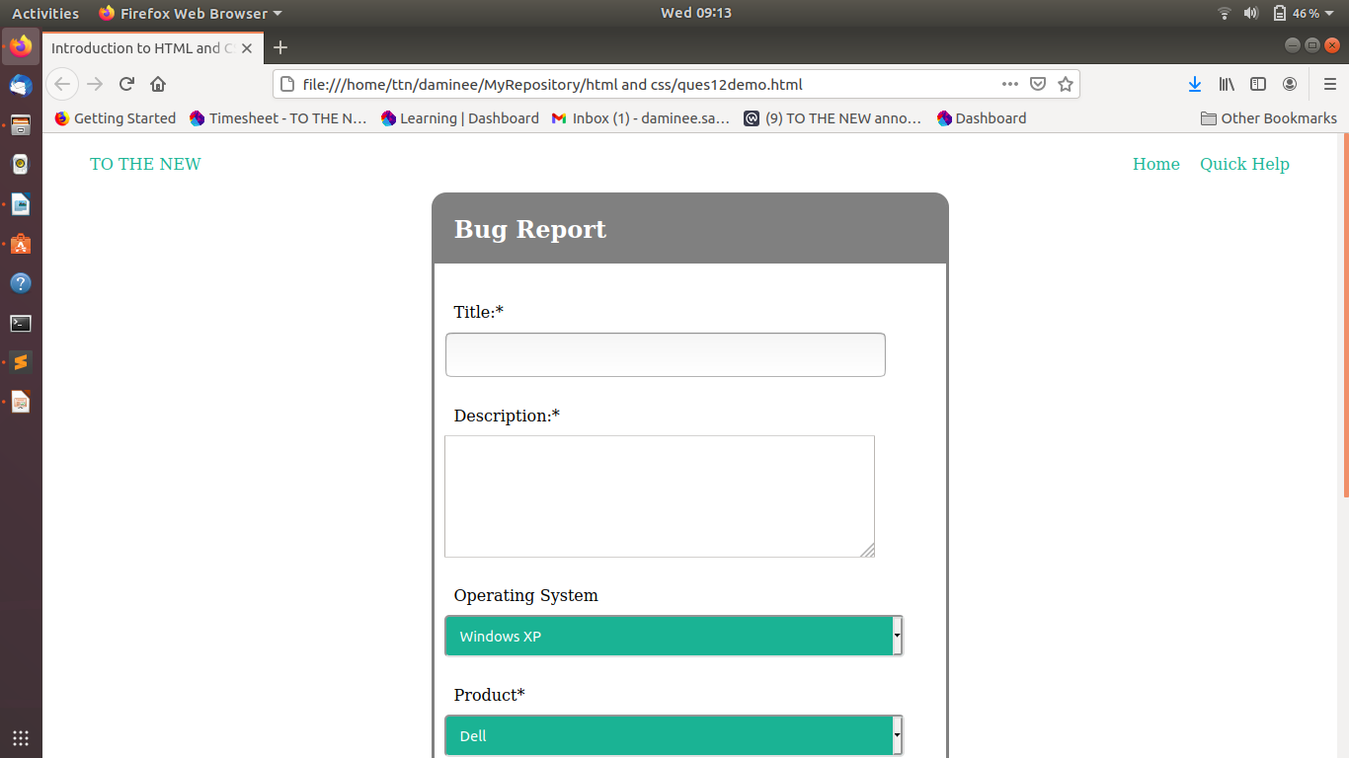

Files names are- ques12demo.html and mystyle.css

