COLLECTIONS

- Write Java code to define List . Insert 5 floating point numbers in List, and using an iterator, find the sum of the numbers in List.
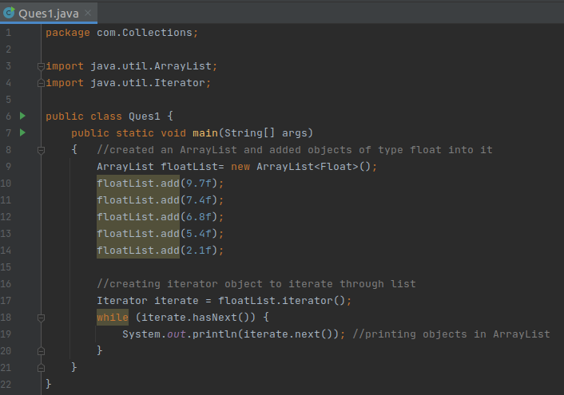

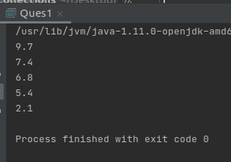
- Write a method that takes a string and returns the number of unique characters in the string.
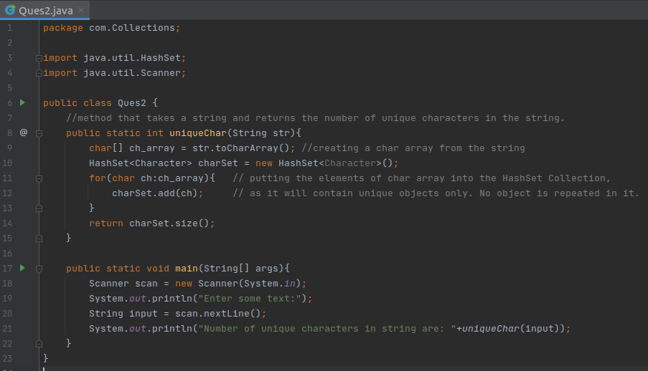
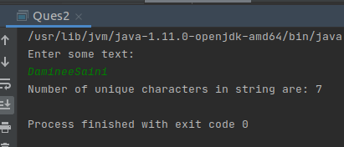

- Write a method that takes a string and print the number of occurrence of each character characters in the string.
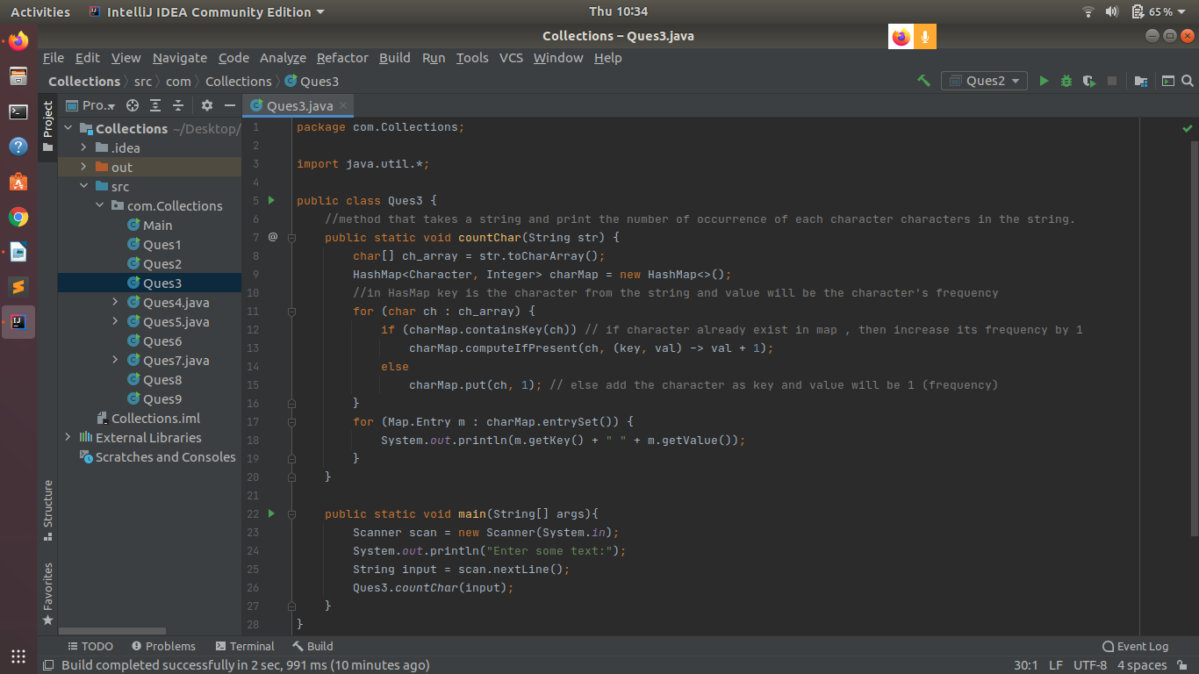
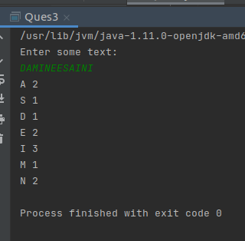

- Write a program to sort Employee objects based on highest salary using Comparator. Employee class{ Double Age; Double Salary; String Name
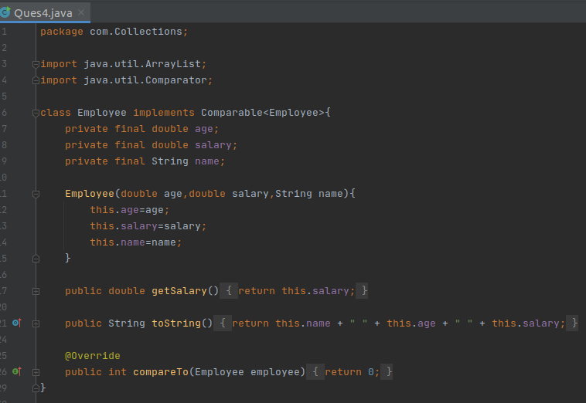
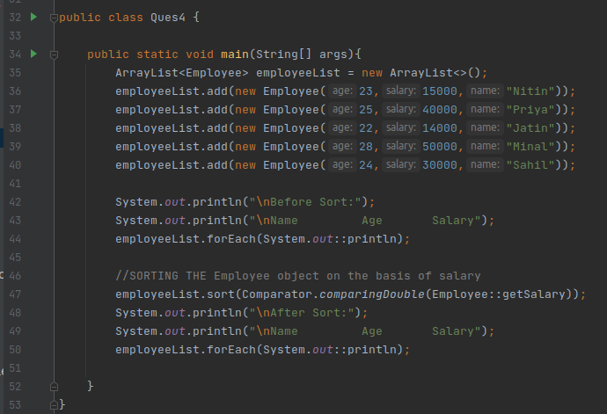

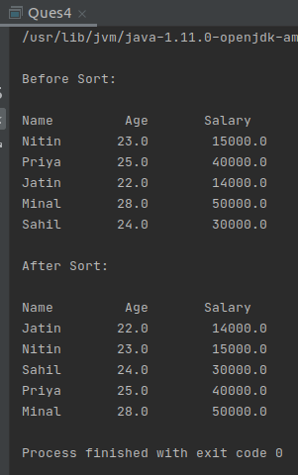

- Write a program to sort the Student objects based on Score , if the score are same then sort on First Name . Class Student{ String Name; Double Score; Double Age
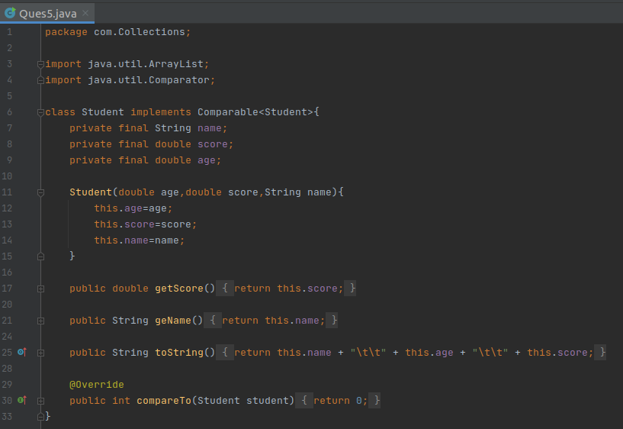
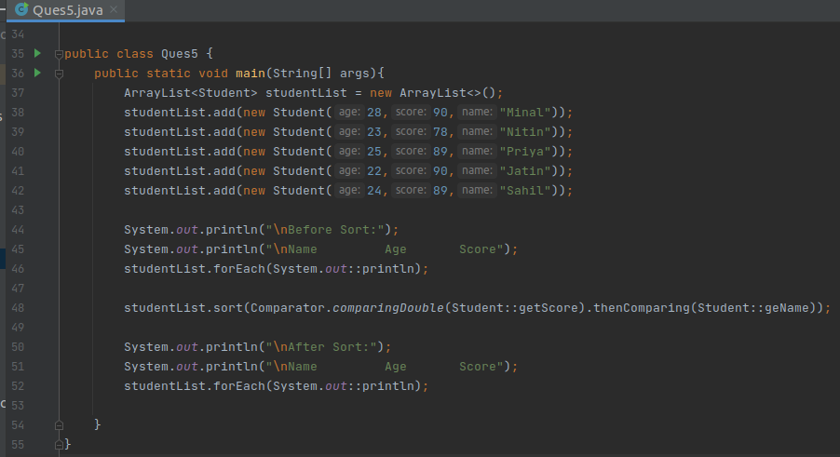

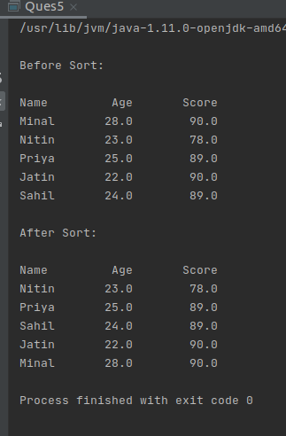

- Print the elements of an array in the decreasing frequency if 2 numbers have same frequency then print the one which came first.
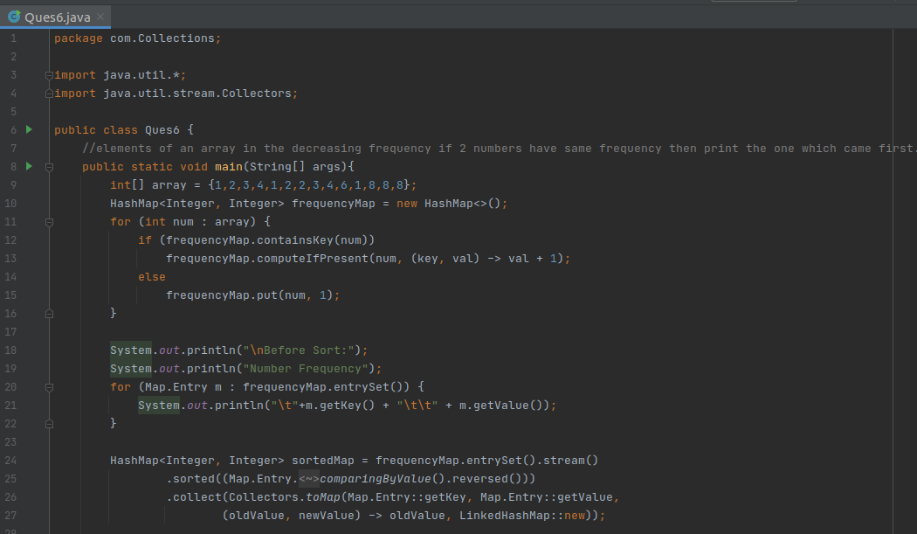
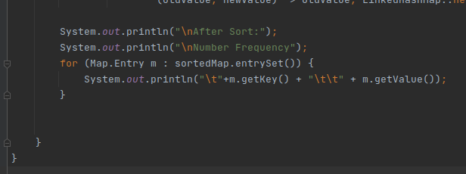

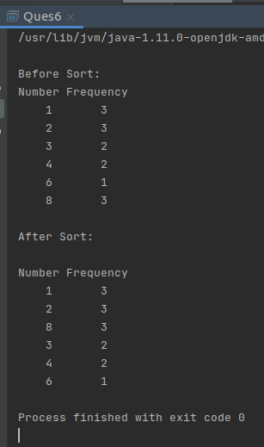

- Design a Data Structure SpecialStack that supports all the stack operations like push(), pop(), isEmpty(), isFull() and an additional operation getMin() which should return minimum element from the SpecialStack. (Expected complexity O(1))

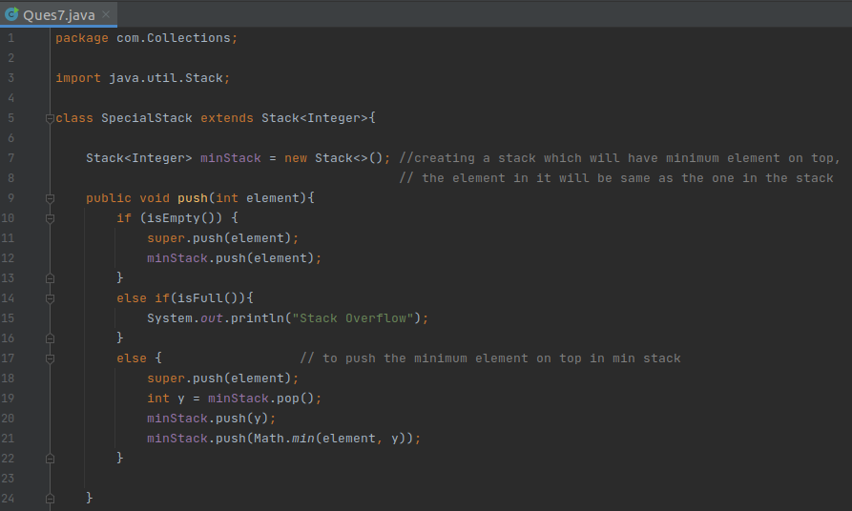
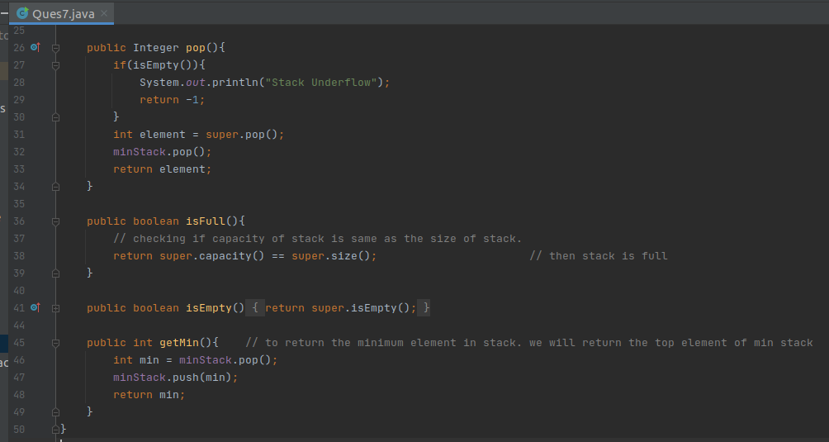

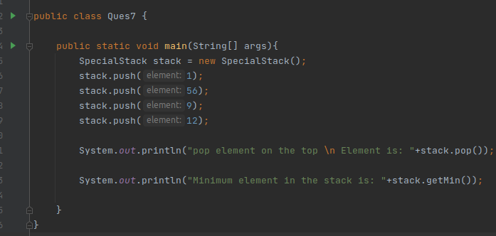
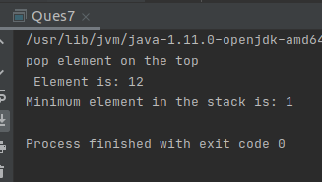

- Write a program to format date as example "21-March-2016"
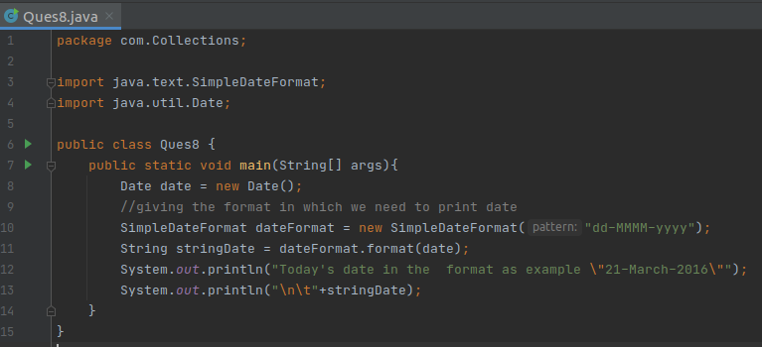
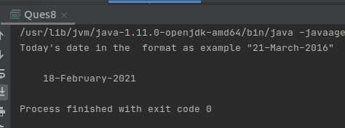

- Write a program to display times in different country format.
