**WEEK 6**

**React Hands-On Exercises**

**1. ReactJS-HOL**

**Steps done:**

1. npm install -g create-react-app
2. npx create-react-app myfirstreact
3. cd myfirstreact
4. code .

App.js

import React from 'react';

function App() {

  return (

    <div>

      <h1>Welcome to the first session of React</h1>

    </div>

  );

}

export default App;

**Output**

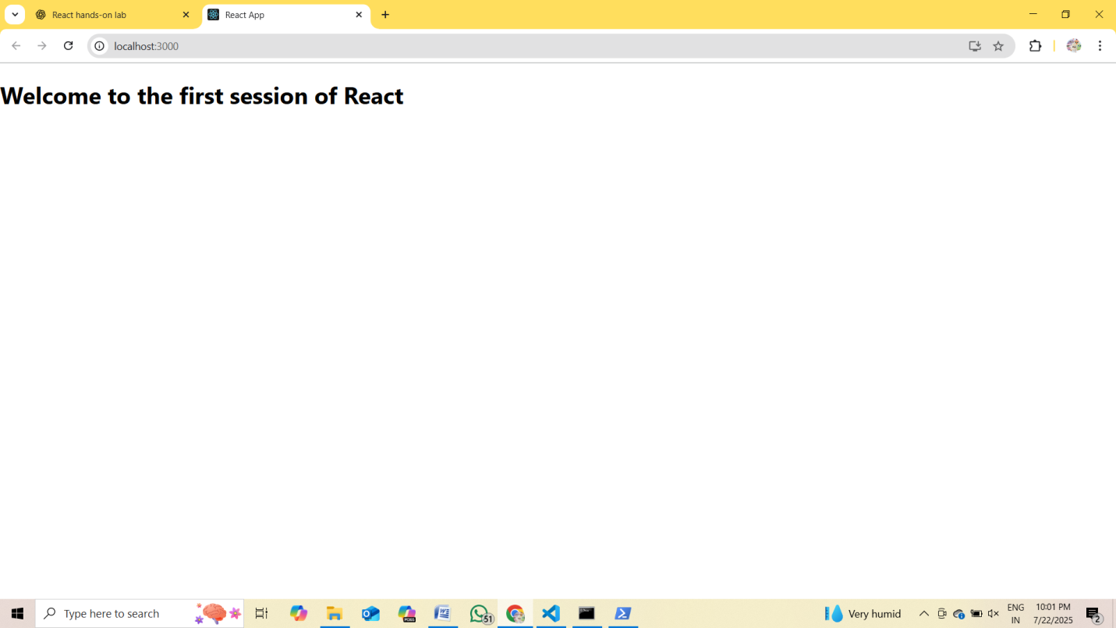

**2. ReactJS-HOL**

Home.js

import React, { Component } from 'react';

class Home extends Component {

  constructor() {

    super();

    this.state = {};

  }

  render() {

    return (

      <div>

        <h2>Welcome to the Home page of Student Management Portal</h2>

      </div>

    );

  }

}

export default Home;

About.js

import React, { Component } from 'react';

class About extends Component {

  constructor() {

    super();

    this.state = {};

  }

  render() {

    return (

      <div>

        <h2>Welcome to the About page of the Student Management Portal</h2>

      </div>

    );

  }

}

export default About;

Contact.js

import React, { Component } from 'react';

class Contact extends Component {

  constructor() {

    super();

    this.state = {};

  }

  render() {

    return (

      <div>

        <h2>Welcome to the Contact page of the Student Management Portal</h2>

      </div>

    );

  }

}

export default Contact;

App.js

import React from 'react';

import './App.css';

import Home from './Components/Home';

import About from './Components/About';

import Contact from './Components/Contact';

function App() {

  return (

    <div className="App">

      <Home />

      <About />

      <Contact />

    </div>

  );

}

export default App;

**Output**

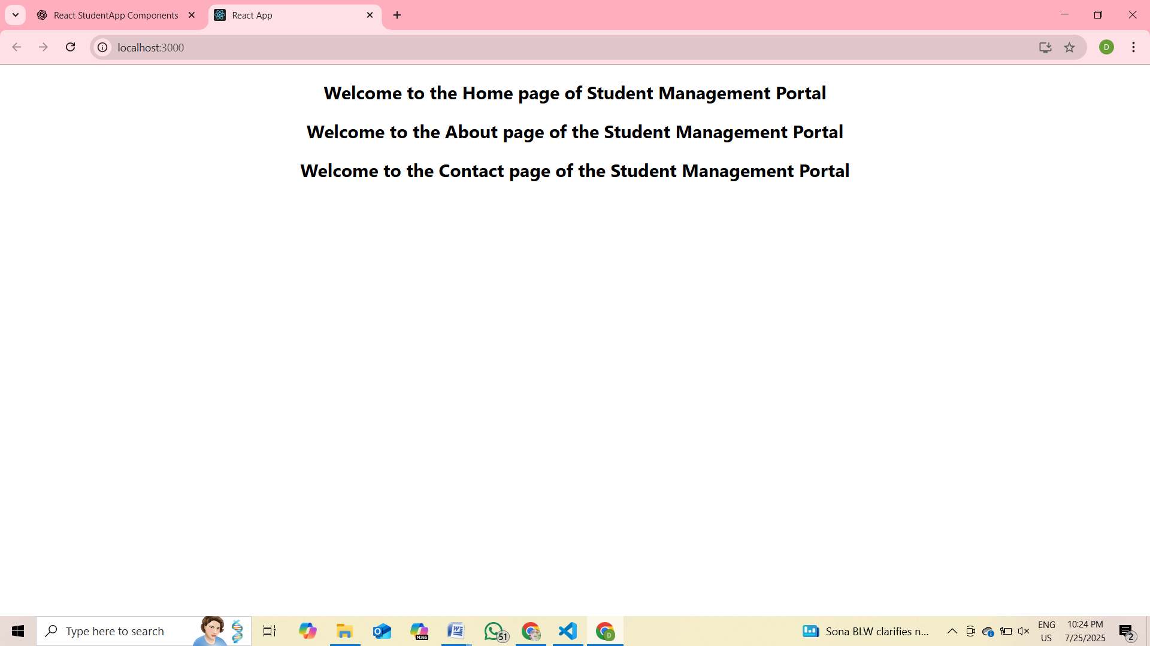

**3. ReactJS-HOL**

CalculateScore.js

import React from 'react';

import '../Stylesheets/mystyle.css';

function CalculateScore(props) {

  const { name, school, total, goal } = props;

  const average = total / goal;

  return (

    <div className="score-container">

      <h2>Student Score Report</h2>

      <p><strong>Name:</strong> {name}</p>

      <p><strong>School:</strong> {school}</p>

      <p><strong>Total Marks:</strong> {total}</p>

      <p><strong>Goal Subjects:</strong> {goal}</p>

      <p className="average"><strong>Average Score:</strong> {average.toFixed(2)}</p>

    </div>

  );

}

export default CalculateScore;

mystyle.css

.score-container {

  background-color: #f9f9f9;

  border: 2px solid #4CAF50;

  padding: 20px;

  margin: 20px auto;

  width: 60%;

  border-radius: 10px;

  font-family: Arial, sans-serif;

  text-align: left;

  box-shadow: 0 0 10px rgba(0, 0, 0, 0.1);

}

.score-container h2 {

  color: #4CAF50;

  text-align: center;

}

.score-container p {

  font-size: 16px;

  margin: 5px 0;

}

.average {

  font-size: 18px;

  font-weight: bold;

  color: #d9534f;

}

App.js

import React from 'react';

import './App.css';

import CalculateScore from './Components/CalculateScore';

function App() {

  return (

    <div className="App">

      <CalculateScore name="John Doe" school="ABC High School" total={430} goal={5} />

    </div>

  );

}

export default App;

**Output**

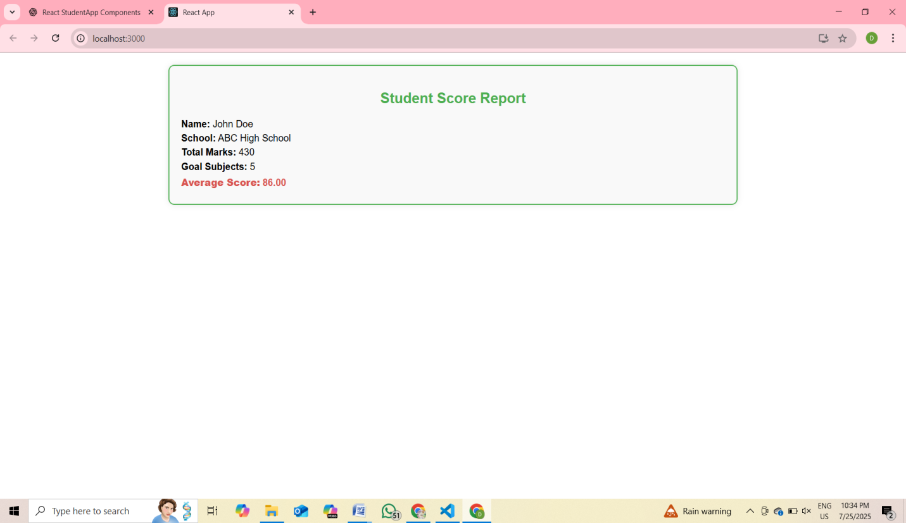

**4. ReactJS-HOL**

**Steps done:**

npx create-react-app blogapp

cd blogapp

code .

**Post.js**

// src/Post.js

import React from 'react';

class Post extends React.Component {

  render() {

    const { title, body } = this.props;

    return (

      <div style={{ borderBottom: '1px solid #ccc', marginBottom: '20px' }}>

        <h2>{title}</h2>

        <p>{body}</p>

      </div>

    );

  }

}

export default Post;

**Posts.js**

// src/Posts.js

import React from 'react';

import Post from './Post';

class Posts extends React.Component {

  constructor(props) {

    super(props);

    this.state = {

      posts: [],

    };

  }

  // Fetch data using Fetch API

  loadPosts = () => {

    fetch('https://jsonplaceholder.typicode.com/posts')

      .then((response) => {

        if (!response.ok) throw new Error('Failed to fetch posts');

        return response.json();

      })

      .then((data) => {

        this.setState({ posts: data });

      })

      .catch((error) => {

        throw error; // Let componentDidCatch handle this

      });

  };

  // Lifecycle method to load posts after component mounts

  componentDidMount() {

    this.loadPosts();

  }

  // Error handling lifecycle method

  componentDidCatch(error, info) {

    alert('An error occurred: ' + error.message);

    console.error('Error info:', info);

  }

  render() {

    return (

      <div style={{ padding: '20px' }}>

        <h1>Blog Posts</h1>

        {this.state.posts.map((post) => (

          <Post key={post.id} title={post.title} body={post.body} />

        ))}

      </div>

    );

  }

}

export default Posts;

**App.js**

import React from 'react';

import Posts from './Posts';

function App() {

  return (

    <div className="App">

      <Posts />

    </div>

  );

}

export default App;

**OUTPUT**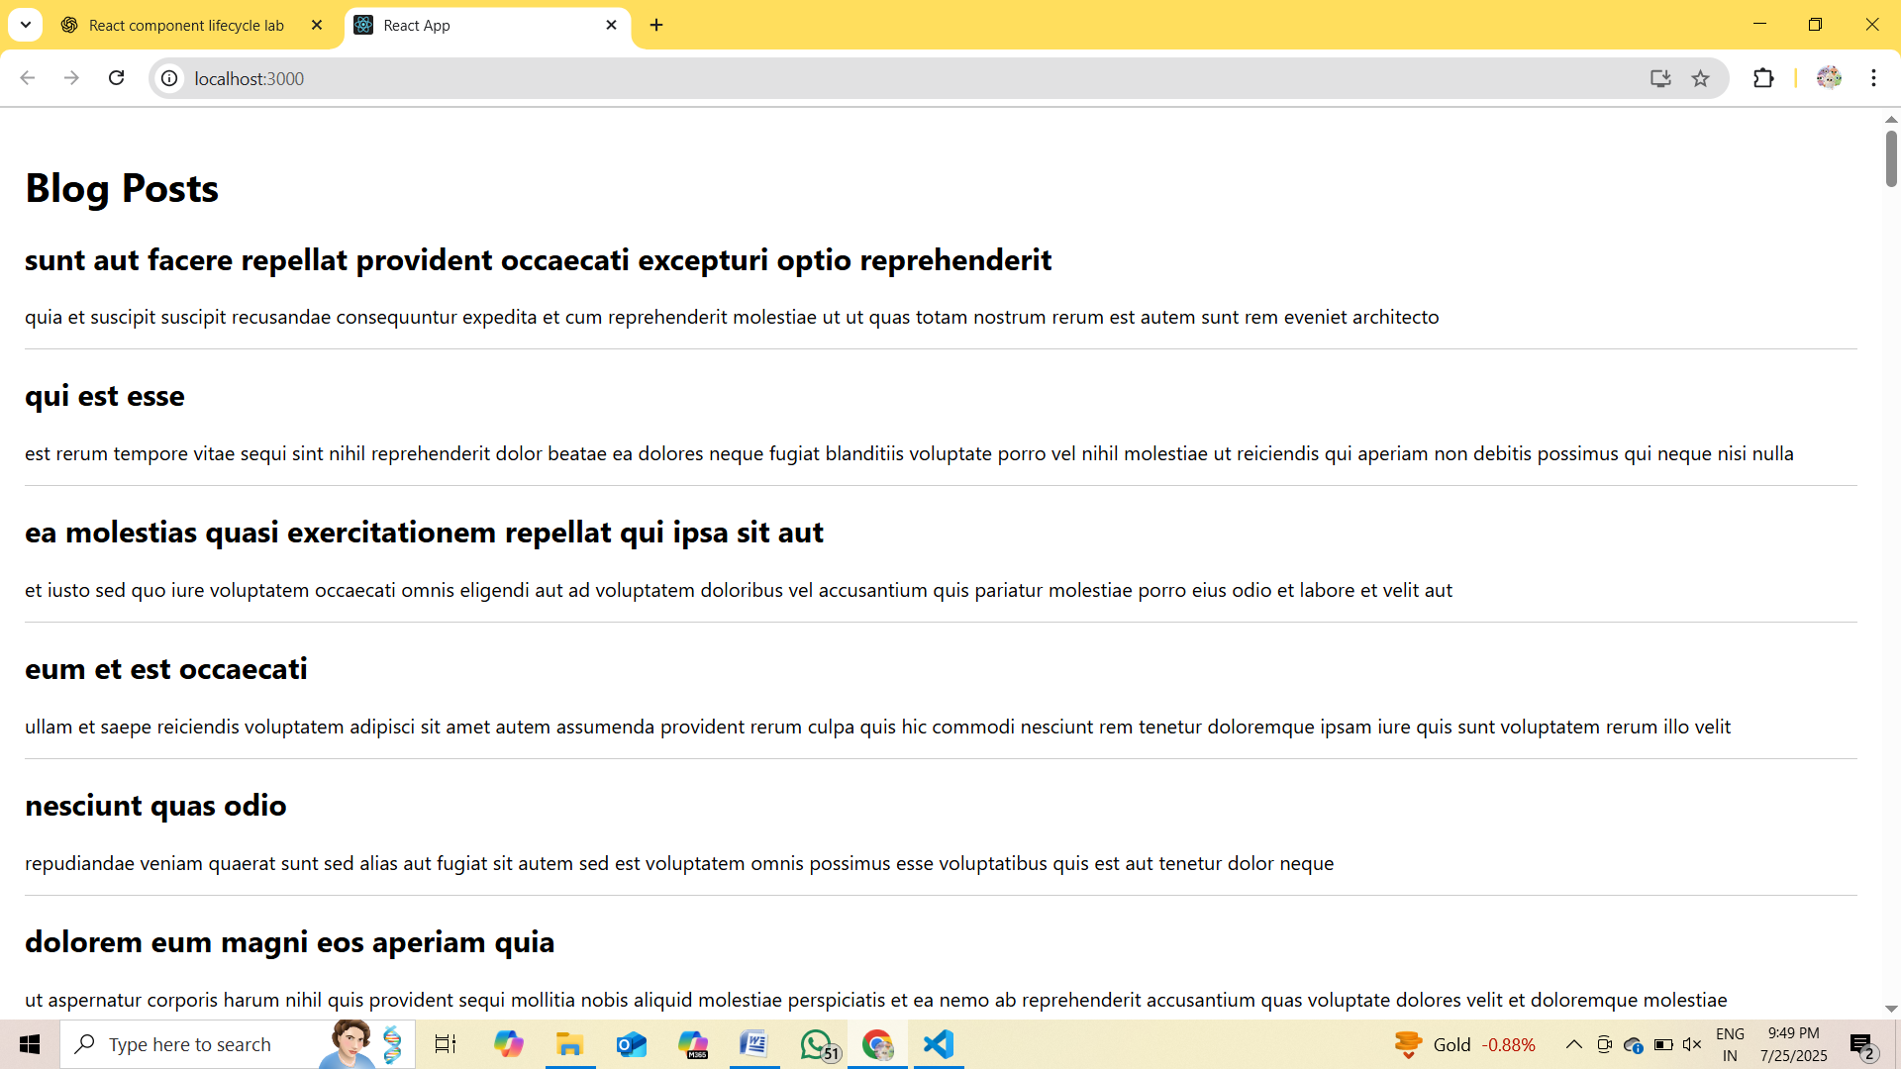

**5. ReactJS-HOL**

CohortDetails.js

import React from 'react';

import styles from './CohortDetails.module.css';

function CohortDetails({ code, title, startDate, status, coach, trainer }) {

  const isOngoing = status.toLowerCase() === 'ongoing';

  const titleStyle = {

    color: isOngoing ? 'green' : 'blue',

    fontWeight: 'bold',

    marginBottom: '8px',

  };

  return (

    <div className={styles.box}>

      <h4 style={titleStyle}>{code} - {title}</h4>

      <dl>

        <dt>Started On</dt>

        <dd>{startDate}</dd>

        <dt>Current Status</dt>

        <dd>{status}</dd>

        <dt>Coach</dt>

        <dd>{coach}</dd>

        <dt>Trainer</dt>

        <dd>{trainer}</dd>

      </dl>

    </div>

  );

}

export default CohortDetails;

CohortDetails.module.css

.box {

  width: 300px;

  display: inline-block;

  margin: 10px;

  padding: 10px 20px;

  border: 1px solid black;

  border-radius: 10px;

  vertical-align: top;

}

dt {

  font-weight: 500;

}

App.js

import React from 'react';

import CohortDetails from './Components/CohortDetails';

function App() {

  return (

    <div style={{ padding: '20px', fontFamily: 'Arial' }}>

      <h2 style={{ marginBottom: '20px' }}>Cohorts Details</h2>

      <CohortDetails

        code="INTADMDF10"

        title=".NET FSD"

        startDate="22-Feb-2022"

        status="Scheduled"

        coach="Aathma"

        trainer="Jojo Jose"

      />

      <CohortDetails

        code="ADM21JF014"

        title="Java FSD"

        startDate="10-Sep-2021"

        status="Ongoing"

        coach="Apoorv"

        trainer="Elisa Smith"

      />

      <CohortDetails

        code="CDBEJf21025"

        title="Java FSD"

        startDate="24-Dec-2021"

        status="Ongoing"

        coach="Aathma"

        trainer="John Doe"

      />

    </div>

  );

}

export default App;

**OUTPUT**

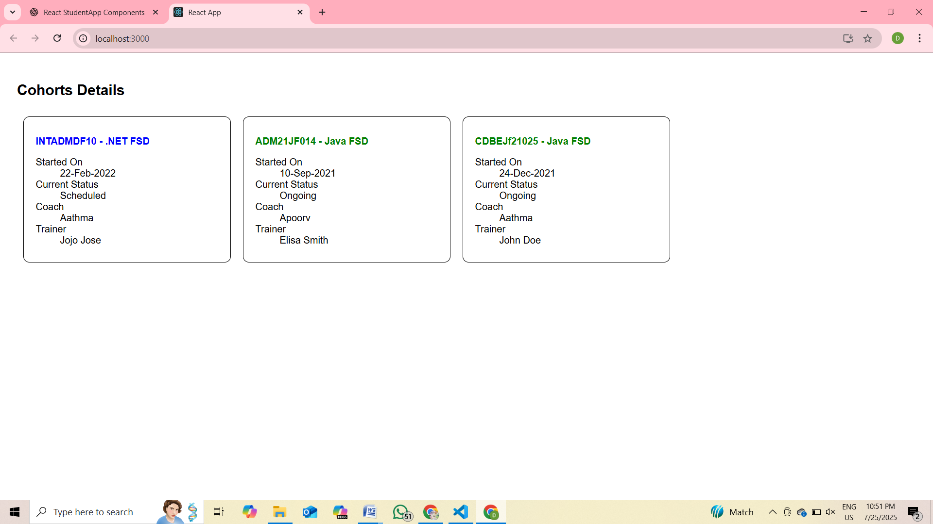

**Additional hands on**

**6. ReactJS-HOL**

Trainer.js

class Trainer {

  constructor(id, name, email, phone, technology, skills) {

    this.trainerId = id;

    this.name = name;

    this.email = email;

    this.phone = phone;

    this.technology = technology;

    this.skills = skills;

  }

}

export default Trainer;

TrainersMock.js

import Trainer from './Trainer';

const trainers = [

  new Trainer(1, "John Doe", "john@example.com", "1234567890", "Java", ["Spring", "Hibernate"]),

  new Trainer(2, "Jane Smith", "jane@example.com", "2345678901", "React", ["Hooks", "Redux"]),

  new Trainer(3, "Mike Lee", "mike@example.com", "3456789012", "Python", ["Flask", "Django"])

];

export default trainers;

Home.js

import React from 'react';

function Home() {

  return (

    <div>

      <h2>Welcome to Cognizant Academy Trainer Portal</h2>

      <p>This portal helps you manage trainer data efficiently.</p>

    </div>

  );

}

export default Home;

TrainerList.js

import React from 'react';

import { Link } from 'react-router-dom';

function TrainerList({ trainers }) {

  return (

    <div>

      <h2>Trainer List</h2>

      <ul>

        {trainers.map((trainer) => (

          <li key={trainer.trainerId}>

            <Link to={`/trainers/${trainer.trainerId}`}>{trainer.name}</Link>

          </li>

        ))}

      </ul>

    </div>

  );

}

export default TrainerList;

TrainerDetails.js

import React from 'react';

import { useParams } from 'react-router-dom';

import trainers from './TrainersMock';

function TrainerDetails() {

  const { id } = useParams();

  const trainer = trainers.find(t => t.trainerId === parseInt(id));

  if (!trainer) {

    return <p>Trainer not found.</p>;

  }

  return (

    <div>

      <h2>{trainer.name}</h2>

      <p><strong>Email:</strong> {trainer.email}</p>

      <p><strong>Phone:</strong> {trainer.phone}</p>

      <p><strong>Technology:</strong> {trainer.technology}</p>

      <p><strong>Skills:</strong> {trainer.skills.join(', ')}</p>

    </div>

  );

}

export default TrainerDetails;

App.js

import React from 'react';

import { BrowserRouter, Routes, Route, Link } from 'react-router-dom';

import Home from './Home';

import TrainerList from './TrainerList';

import TrainerDetails from './TrainerDetails';

import trainers from './TrainersMock';

function App() {

  return (

    <BrowserRouter>

      <div style={{ padding: '20px', fontFamily: 'Arial' }}>

        <nav>

          <Link to="/" style={{ marginRight: '15px' }}>Home</Link>

          <Link to="/trainers">Trainers</Link>

        </nav>

        <hr />

        <Routes>

          <Route path="/" element={<Home />} />

          <Route path="/trainers" element={<TrainerList trainers={trainers} />} />

          <Route path="/trainers/:id" element={<TrainerDetails />} />

        </Routes>

      </div>

    </BrowserRouter>

  );

}

export default App;

**OUTPUT**

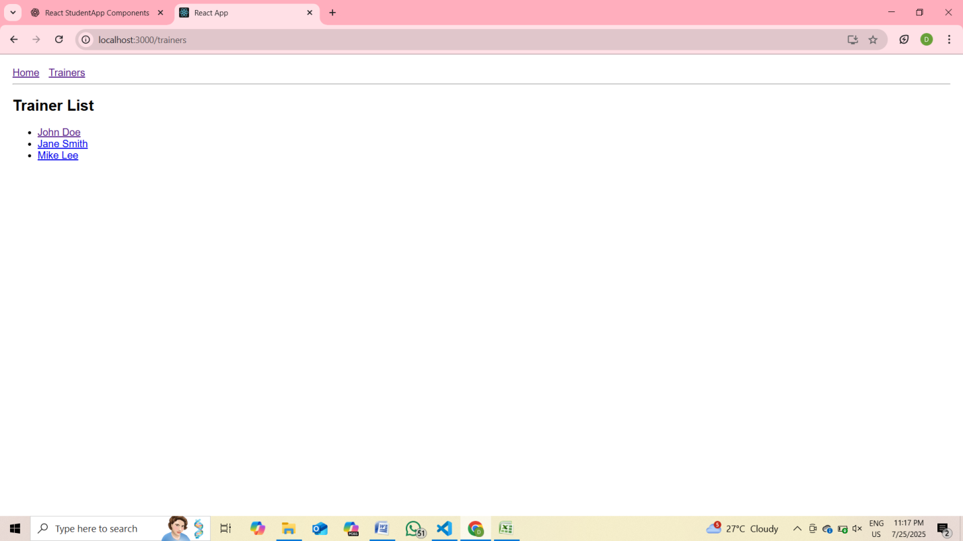

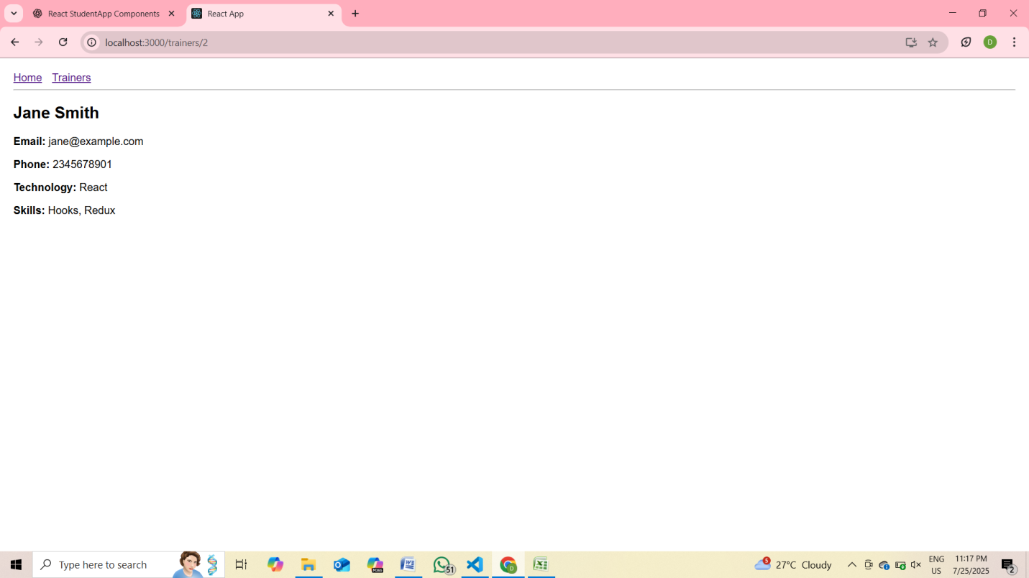

**7. ReactJS-HOL**

Cart.js

import React, { Component } from 'react';

class Cart extends Component {

  render() {

    return (

      <div style={{ border: '1px solid #ccc', padding: '10px', margin: '10px' }}>

        <h3>Item: {this.props.itemname}</h3>

        <p>Price: ₹{this.props.price}</p>

      </div>

    );

  }

}

// ✅ Default Props

Cart.defaultProps = {

  itemname: "Unknown Item",

  price: 0

};

export default Cart;

OnlineShopping.js

import React, { Component } from 'react';

import Cart from './Cart';

class OnlineShopping extends Component {

  render() {

    // ✅ Create array of cart items

    const items = [

      { itemname: "T-shirt", price: 500 },

      { itemname: "Shoes", price: 1200 },

      { itemname: "Watch", price: 1500 },

      { itemname: "Headphones", price: 800 },

      { itemname: "Backpack", price: 1000 }

    ];

    return (

      <div style={{ padding: '20px' }}>

        <h2>🛒 Online Shopping Cart</h2>

        {/* ✅ Loop through and render Cart components */}

        {items.map((item, index) => (

          <Cart key={index} itemname={item.itemname} price={item.price} />

        ))}

      </div>

    );

  }

index.js

import React from 'react';

import ReactDOM from 'react-dom/client';

import OnlineShopping from './OnlineShopping';

// ✅ ReactDOM.render() alternative in React 18+

const root = ReactDOM.createRoot(document.getElementById('root'));

root.render(<OnlineShopping />);

**OUTPUT**

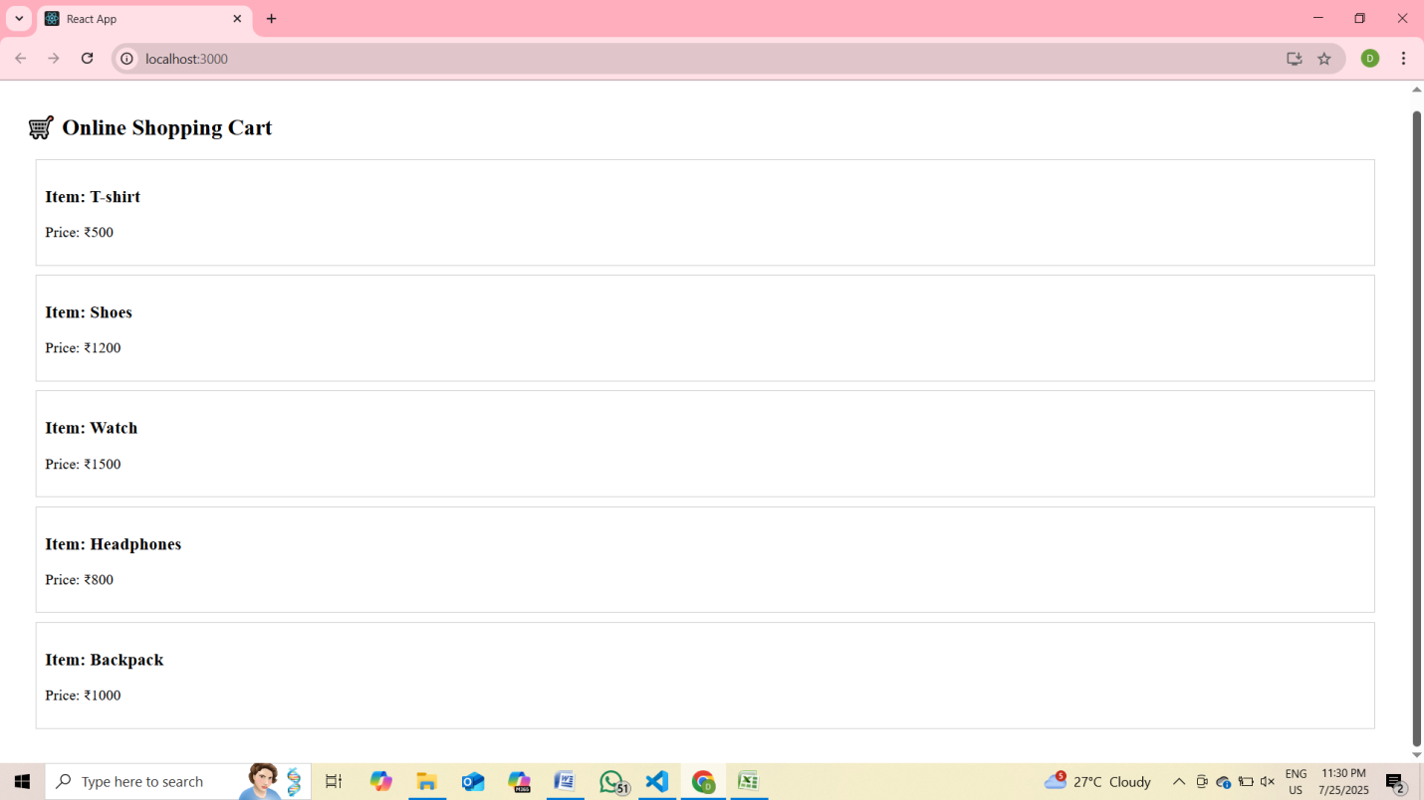

**8. ReactJS-HOL**

CountPeople.js

import React, { Component } from 'react';

class CountPeople extends Component {

  constructor(props) {

    super(props);

    // ✅ Initialize state

    this.state = {

      entryCount: 0,

      exitCount: 0

    };

  }

  // ✅ Method to increment entry count

  UpdateEntry = () => {

    this.setState((prevState) => ({

      entryCount: prevState.entryCount + 1

    }));

  };

  // ✅ Method to increment exit count

  UpdateExit = () => {

    this.setState((prevState) => ({

      exitCount: prevState.exitCount + 1

    }));

  };

  render() {

    return (

      <div style={{ padding: '20px', textAlign: 'center' }}>

        <h2>🏢 Mall People Counter</h2>

        <p><strong>People Entered:</strong> {this.state.entryCount}</p>

        <p><strong>People Exited:</strong> {this.state.exitCount}</p>

        <button onClick={this.UpdateEntry} style={{ marginRight: '10px' }}>

          Login

        </button>

        <button onClick={this.UpdateExit}>

          Exit

        </button>

      </div>

    );

  }

}

export default CountPeople;

index.js

import React from 'react';

import ReactDOM from 'react-dom/client';

import CountPeople from './CountPeople';

// ✅ Use ReactDOM.createRoot (React 18+)

const root = ReactDOM.createRoot(document.getElementById('root'));

root.render(<CountPeople />);

**OUTPUT**

