**WEEK 7**

**React Hands-On Exercises**

**9. ReactJS-HOL**

**Steps done:**

npx create-react-app cricketapp

cd cricketapp

ListofPlayers.js

import React from 'react';

function ListofPlayers() {

  const players = [

    { name: 'Virat Kohli', score: 82 },

    { name: 'Rohit Sharma', score: 45 },

    { name: 'KL Rahul', score: 91 },

    { name: 'Shubman Gill', score: 68 },

    { name: 'Hardik Pandya', score: 88 },

    { name: 'Ravindra Jadeja', score: 65 },

    { name: 'MS Dhoni', score: 78 },

    { name: 'Rishabh Pant', score: 52 },

    { name: 'Jasprit Bumrah', score: 72 },

    { name: 'Mohammed Shami', score: 60 },

    { name: 'Yuzvendra Chahal', score: 55 }

  ];

  // ✅ Filter players with score < 70

  const lowScorers = players.filter(player => player.score < 70);

  return (

    <div>

      <h2>🏏 List of All Players with Scores</h2>

      <ul>

        {players.map((p, index) => (

          <li key={index}>{p.name} - {p.score}</li>

        ))}

      </ul>

      <h3>⬇️ Players with Score Below 70</h3>

      <ul>

        {lowScorers.map((p, index) => (

          <li key={index}>{p.name} - {p.score}</li>

        ))}

      </ul>

    </div>

  );

}

export default ListofPlayers;

IndianPlayers.js

import React from 'react';

function IndianPlayers() {

  const players = ['Sachin', 'Sourav', 'Dravid', 'Kumble', 'Zaheer', 'Sehwag'];

  // ✅ Destructure into odd and even team

  const oddTeam = players.filter((_, index) => index % 2 !== 0);

  const evenTeam = players.filter((_, index) => index % 2 === 0);

  // ✅ Declare two separate arrays

  const T20Players = ['Raina', 'Dhoni', 'Kohli'];

  const RanjiPlayers = ['Wasim Jaffer', 'Pujara', 'Rahane'];

  // ✅ Merge using spread operator

  const mergedPlayers = [...T20Players, ...RanjiPlayers];

  return (

    <div>

      <h2>🧢 Odd Team Players</h2>

      <ul>

        {oddTeam.map((p, index) => <li key={index}>{p}</li>)}

      </ul>

      <h2>🧢 Even Team Players</h2>

      <ul>

        {evenTeam.map((p, index) => <li key={index}>{p}</li>)}

      </ul>

      <h2>🔁 Merged Players (T20 + Ranji)</h2>

      <ul>

        {mergedPlayers.map((p, index) => <li key={index}>{p}</li>)}

      </ul>

    </div>

  );

}

export default IndianPlayers;

App.js

import React from 'react';

import ListofPlayers from './ListofPlayers';

import IndianPlayers from './IndianPlayers';

function App() {

  const flag = true; // change to false to show IndianPlayers instead

  return (

    <div style={{ padding: '20px', textAlign: 'center' }}>

      <h1>🏏 Cricket App</h1>

      {

        flag ? <ListofPlayers /> : <IndianPlayers />

      }

    </div>

  );

}

export default App;

**Output**

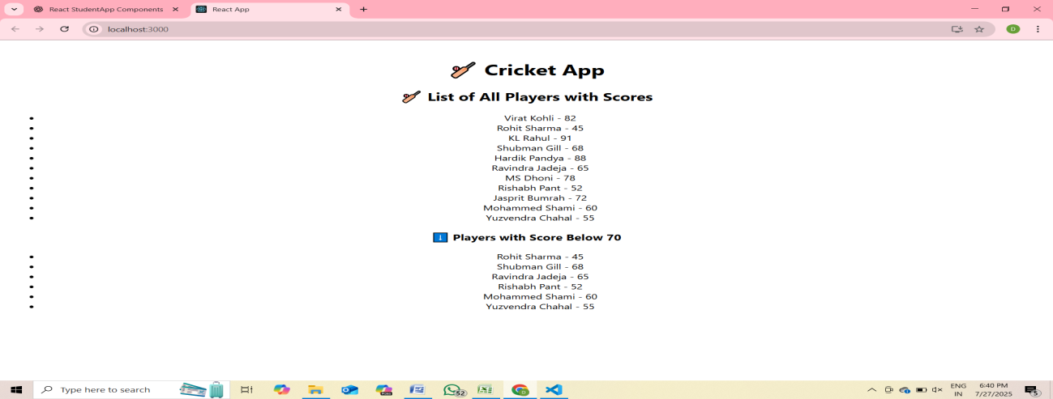

**10. ReactJS-HOL**

App.js

import React from 'react';

function App() {

  const officeList = [

  {

    name: 'DBS',

    rent: 50000,

    address: 'Chennai',

    image: 'https://images.unsplash.com/photo-1593444288880-c44c30c34548?auto=format&fit=crop&w=600&q=60'

  },

  {

    name: 'WeWork',

    rent: 65000,

    address: 'Bangalore',

    image: 'https://images.unsplash.com/photo-1629909613654-d0d4b226d6b0?auto=format&fit=crop&w=600&q=60'

  },

  {

    name: 'Regus',

    rent: 40000,

    address: 'Hyderabad',

    image: 'https://images.unsplash.com/photo-1527689368864-3a821dbccc34?auto=format&fit=crop&w=600&q=60'

  }

];

  return (

    <div style={{ backgroundColor: 'black', color: 'white', textAlign: 'center', padding: '20px' }}>

      <h1>Office Space , at Affordable Range</h1>

      {officeList.map((item, index) => {

        const rentStyle = {

          color: item.rent <= 60000 ? 'red' : 'green',

          fontWeight: 'bold'

        };

        return (

          <div key={index} style={{ marginBottom: '30px' }}>

            <img src={item.image} alt={item.name} style={{ width: '300px', height: '200px', borderRadius: '10px' }} />

            <h2>Name: {item.name}</h2>

            <p style={rentStyle}>Rent: Rs. {item.rent}</p>

            <p>Address: {item.address}</p>

          </div>

        );

      })}

    </div>

  );

}

export default App;

**Output**

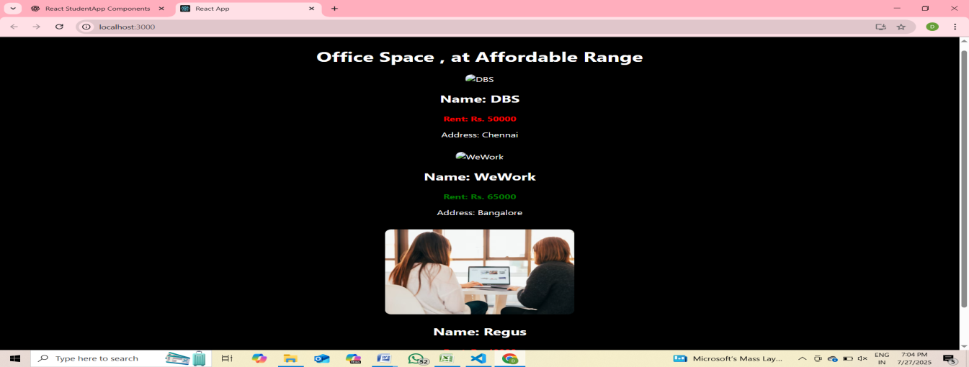

**11. ReactJS-HOL**

npx create-react-app eventexamplesapp

cd eventexamplesapp

npm start

eventexamplesapp/

├── src/

│ ├── components/

│ │ └── CurrencyConvertor.js

│ ├── App.js

│ └── index.js

CurrencyConvertor.js

// src/components/CurrencyConvertor.js

import React, { useState } from 'react';

const CurrencyConvertor = () => {

  const [rupees, setRupees] = useState('');

  const [euros, setEuros] = useState('');

  const handleSubmit = (e) => {

    e.preventDefault();

    const converted = (parseFloat(rupees) / 90).toFixed(2); // Assuming 1 Euro = 90 INR

    setEuros(converted);

  };

  return (

    <div>

      <h3>Currency Convertor</h3>

      <form onSubmit={handleSubmit}>

        <input

          type="number"

          placeholder="Enter INR"

          value={rupees}

          onChange={(e) => setRupees(e.target.value)}

        />

        <button type="submit">Convert</button>

      </form>

      {euros && <p>{rupees} INR = {euros} EUR</p>}

    </div>

  );

};

export default CurrencyConvertor;

App.js

// src/App.js

import React, { Component } from 'react';

import CurrencyConvertor from './components/CurrencyConvertor';

class App extends Component {

  constructor(props) {

    super(props);

    this.state = {

      counter: 0

    };

  }

  // Increment with multiple methods

  increment = () => {

    this.setState((prevState) => ({ counter: prevState.counter + 1 }));

    this.sayHello();

  };

  sayHello = () => {

    console.log('Hello! This is a static message.');

  };

  decrement = () => {

    this.setState((prevState) => ({ counter: prevState.counter - 1 }));

  };

  // Event with argument

  sayMessage = (message) => {

    alert(message);

  };

  // Synthetic Event

  handleClick = (e) => {

    alert('I was clicked');

    console.log(e); // SyntheticEvent

  };

  render() {

    return (

      <div style={{ textAlign: 'center', marginTop: 40 }}>

        <h1>React Event Handling</h1>

        <h2>Counter: {this.state.counter}</h2>

        <button onClick={this.increment}>Increment</button>{' '}

        <button onClick={this.decrement}>Decrement</button>

        <hr />

        <button onClick={() => this.sayMessage('Welcome!')}>Say Welcome</button>

        <hr />

        <button onClick={this.handleClick}>OnPress</button>

        <hr />

        <CurrencyConvertor />

      </div>

    );

  }

}

export default App;

**Output**

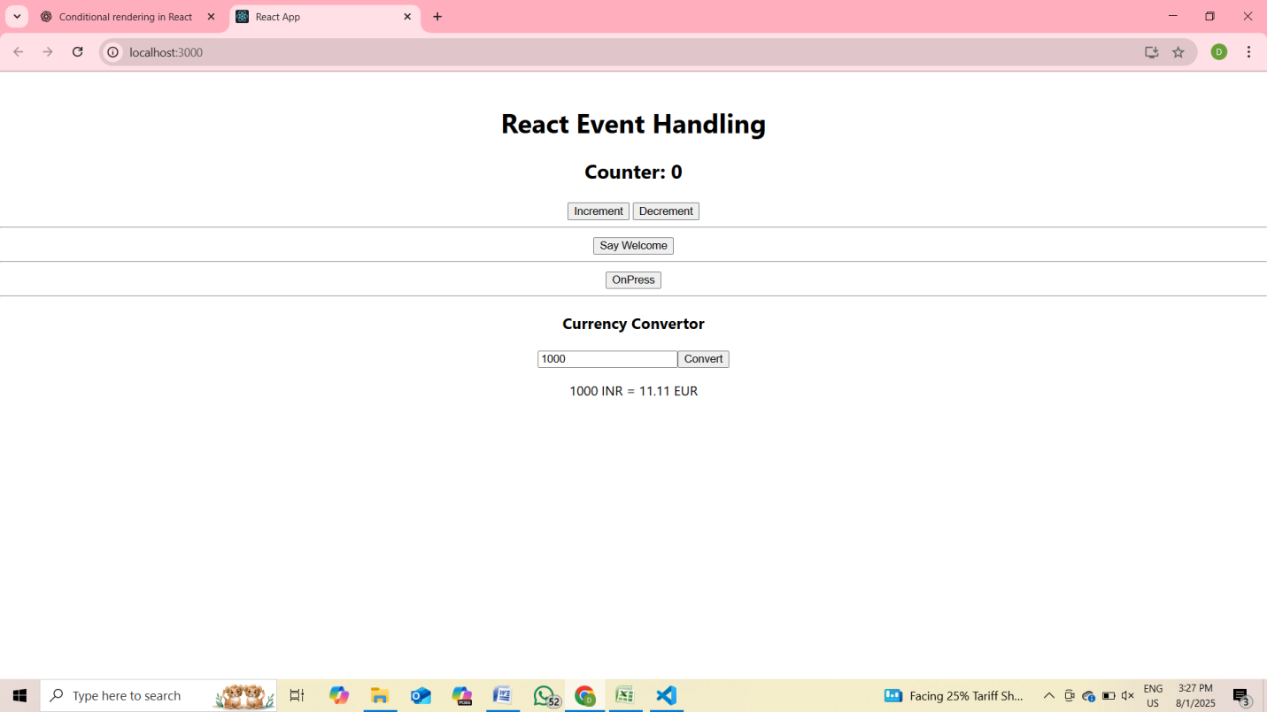

**12. ReactJS-HOL**

**Steps done:**

npx create-react-app ticketbookingapp

cd ticketbookingapp

npm start

ticketbookingapp/

├── src/

│ ├── components/

│ │ ├── GuestPage.js

│ │ ├── UserPage.js

│ │ └── FlightDetails.js

│ ├── App.js

│ └── index.js.

FlightDetails.js

// src/components/FlightDetails.js

import React from 'react';

const FlightDetails = () => {

  return (

    <div>

      <h2>Flight Details</h2>

      <ul>

        <li>Flight: AI-202 | From: Delhi | To: Mumbai | Time: 10:00 AM</li>

        <li>Flight: AI-203 | From: Mumbai | To: Bangalore | Time: 2:00 PM</li>

      </ul>

    </div>

  );

};

export default FlightDetails;

GuestPage.js

// src/components/GuestPage.js

import React from 'react';

import FlightDetails from './FlightDetails';

const GuestPage = () => {

  return (

    <div>

      <h1>Welcome, Guest!</h1>

      <p>Please log in to book your flight tickets.</p>

      <FlightDetails />

    </div>

  );

};

export default GuestPage;

UserPage.js

// src/components/UserPage.js

import React from 'react';

import FlightDetails from './FlightDetails';

const UserPage = () => {

  return (

    <div>

      <h1>Welcome, User!</h1>

      <FlightDetails />

      <button>Book Now</button>

    </div>

  );

};

export default UserPage;

**App.js**

// src/App.js

import React, { useState } from 'react';

import GuestPage from './components/GuestPage';

import UserPage from './components/UserPage';

function App() {

  const [isLoggedIn, setIsLoggedIn] = useState(false);

  const handleLogin = () => setIsLoggedIn(true);

  const handleLogout = () => setIsLoggedIn(false);

  // Element variable

  let page;

  if (isLoggedIn) {

    page = <UserPage />;

  } else {

    page = <GuestPage />;

  }

  return (

    <div style={{ textAlign: 'center' }}>

      <h1>Ticket Booking App</h1>

      {isLoggedIn ? (

        <button onClick={handleLogout}>Logout</button>

      ) : (

        <button onClick={handleLogin}>Login</button>

      )}

      <hr />

      {page}

    </div>

  );

}

export default App;

**OUTPUT**

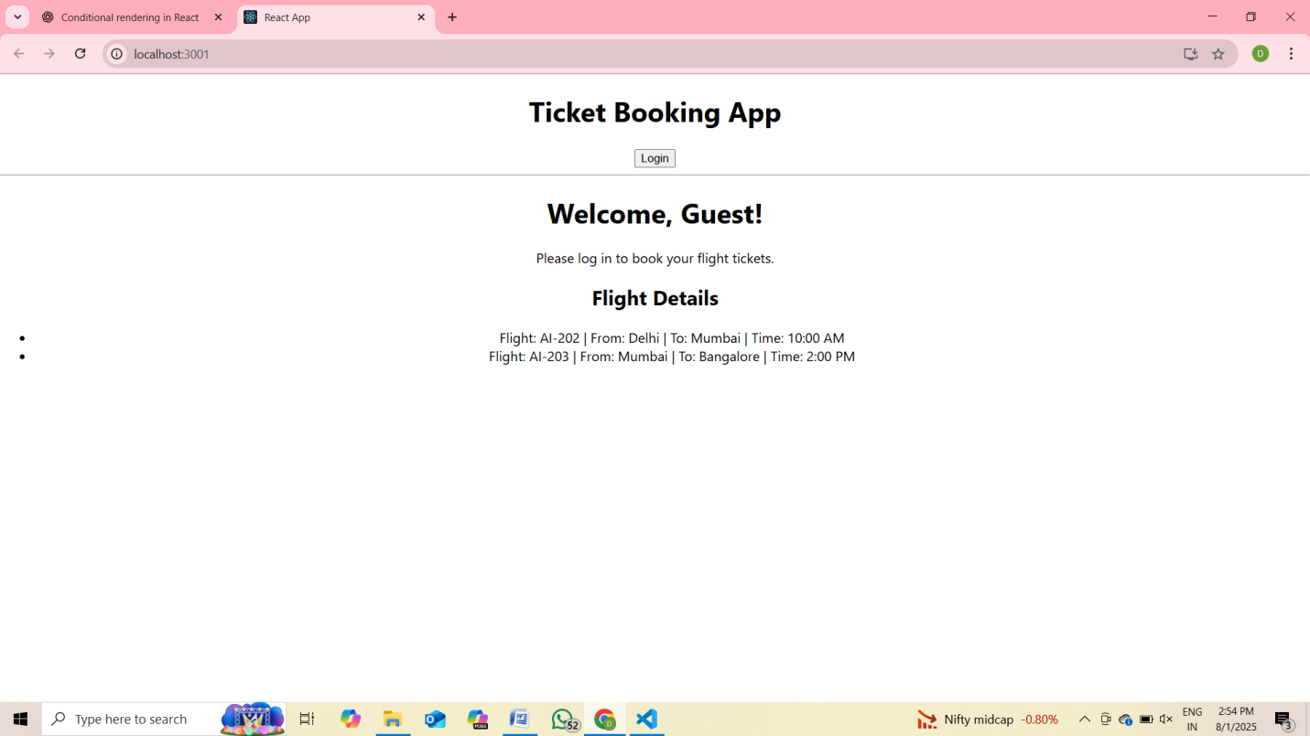

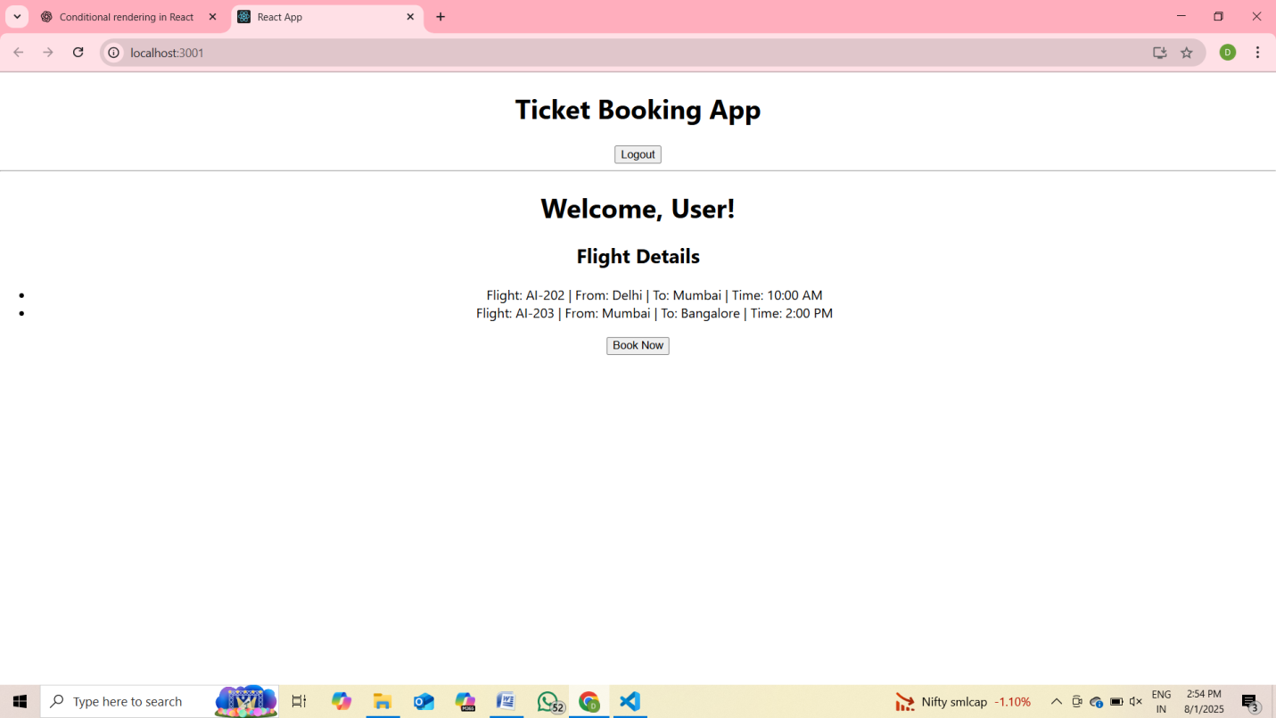

**13. ReactJS-HOL**

**Steps done:**

npx create-react-app bloggerapp

cd bloggerapp

npm start

bloggerapp/

├── src/

│ ├── components/

│ │ ├── BookDetails.js

│ │ ├── BlogDetails.js

│ │ └── CourseDetails.js

│ └── App.js

BookDetails.js

// src/components/BookDetails.js

import React from 'react';

const BookDetails = (props) => {

  const booklist = props.books.map((book) => (

    <div key={book.id}>

      <h3>{book.bname}</h3>

      <h4>{book.price}</h4>

    </div>

  ));

  return (

    <div>

      <h2>Book Details</h2>

      {booklist}

    </div>

  );

};

export default BookDetails;

BlogDetails.js

// src/components/BlogDetails.js

import React from 'react';

const BlogDetails = ({ blog }) => {

  return (

    <div>

      <h2>Blog Details</h2>

      <h3>{blog.title}</h3>

      <p>{blog.author}</p>

      <p>{blog.body}</p>

    </div>

  );

};

export default BlogDetails;

CourseDetails.js

// src/components/CourseDetails.js

import React from 'react';

const CourseDetails = ({ courses }) => {

  return (

    <div>

      <h2>Course Details</h2>

      {courses.map((course, index) => (

        <div key={index}>

          <h3>{course.name}</h3>

          <p>{course.date}</p>

        </div>

      ))}

    </div>

  );

};

export default CourseDetails;

App.js

// src/App.js

import React, { useState } from 'react';

import BookDetails from './components/BookDetails';

import BlogDetails from './components/BlogDetails';

import CourseDetails from './components/CourseDetails';

function App() {

  const [view, setView] = useState('course');

  const books = [

    { id: 1, bname: 'Master React', price: 670 },

    { id: 2, bname: 'Deep Dive into Angular 11', price: 800 },

    { id: 3, bname: 'Mongo Essentials', price: 450 },

  ];

  const blog = {

    title: 'React Learning',

    author: 'Stephen Biz',

    body: 'Welcome to learning React!',

  };

  const courses = [

    { name: 'Angular', date: '4/5/2021' },

    { name: 'React', date: '6/3/2021' },

  ];

  const renderComponent = () => {

    switch (view) {

      case 'book':

        return <BookDetails books={books} />;

      case 'blog':

        return <BlogDetails blog={blog} />;

      case 'course':

      default:

        return <CourseDetails courses={courses} />;

    }

  };

  return (

    <div style={{ textAlign: 'center' }}>

      <h1>Blogger App</h1>

      <div>

        <button onClick={() => setView('course')}>Course Details</button>

        <button onClick={() => setView('book')}>Book Details</button>

        <button onClick={() => setView('blog')}>Blog Details</button>

      </div>

      <hr />

      {renderComponent()}

    </div>

  );

}

export default App;

**OUTPUT**

