**Design Document - SEDA API for BI**

1. **Purpose:** The purpose of this document is to provide design specification for API used to provide SEDA data to BI application.
2. **API Design**

Returns json data of the signals created between a particular time interval in SEDA

**URL** - *<https://<dns>:<port>/signals/public/seda/api/v1/signals_bi>*

**Method** - POST

**Data Params - These are the parameters that should be send as the data in json format in POST request**

**{**

**“startDate” :**

**“endDate” :**

**}**

**\*\* startDate and endDate format should be day-month-year, ex 12-01-2020 .**

**\*\* Data params should be sent in the POST request in a json format.**

**Success Response (sample) -**

**Code : 200**

**Content :**

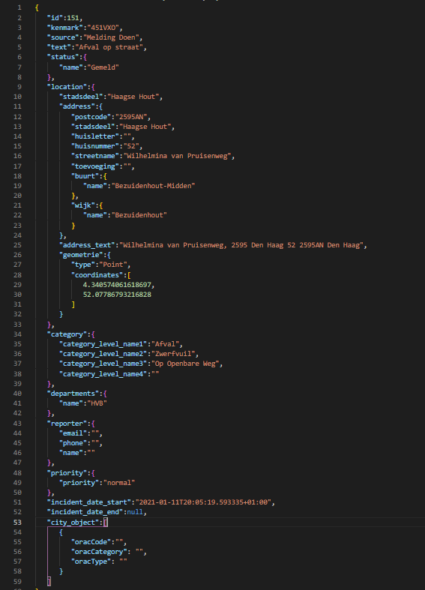

**Error Response ( sample ) -**

**Code : 422**

**Content: { error : “Invalid parameters” }**

**Code : 429**

**Content: { error : “Too many requests” }**

**Code: 401**

**Content: {error: “Unauthorized”}**

1. **API Field mapping with SEDA Database:**

|  |  |  |  |
| --- | --- | --- | --- |
| **BI Field** | **SEDA Table name** | **SEDA column name** |  |
|  |  |  |  |
| signal_id | **Signal** | **Id** |  |
| kenmark | **Signal** | **webform_kenmark** |  |
| category_level_name1 | **Category** | **category_level_name1** |  |
| category_level_name2 | **Category** | **category_level_name2** |  |
| category_level_name3 | **Category** | **category_level_name3** |  |
| category_level_name4 | **Category** | **category_level_name4** |  |
| stadsdeel | **Location** | **stadsdeel** |  |
| incident_start_date | **Signal** | **incident_start_date** |  |
| incident_end_date | **Signal** | **incident_end_date** |  |
| priority | **Priority** | **priority** |  |
| state | **Status** | **name** |  |
| housenumber | **Address** | **address** |  |
| houseletter | **Address** | **address** |  |
| wijk | **Wijk** | **name** |  |
| buurt | **Neighbourhood** | **name** |  |
| name | **Department** | **name** |  |
| X coordinate | **Location** | **X coordinate** |  |
| Y coordinate | **Location** | **Y coordinate** |  |
| geometrie | **Location** | **geometrie** |  |
| street | **Location** | **address** |  |
| source | **Signal** | **source** |  |
| text | **Signal** | **text** |  |
| reporter | **Reporter** |  |  |
| toevoeging | **Location** | **address** |  |
| forman_emp_name | **Signal** | forman_emp_name |  |
| plan_time | **Signal** | plan_time |  |
| updates | **Signal** | updates |  |
| Urgency | **Signal** | Urgency |  |
| report_days | **Signal** | report_days |  |
| oracCode | **Signal** | oracCode |  |
| oracCategory | **Signal** | oracCategory |  |
| oracType | **Signal** | oracType |  |

**Notes -**

1. **API will return all the signals between startDate and endDate, where startDate and endDate are inclusive**
2. **Throttle rate is 20/min and 1200/hour. If API requests exceed the maximum rate then** “**Rate Exceeded**” error **will be returned.**
3. **Questions**

**For security purposes -**

* **Do we have to create a specific user that can consume this API data ?**
* **Do we have to use token authentication (token will be generated using username and password) or we can use a static token (no username and password required) but static token is not as secure as dynamic token.**