**1)Creating report HMS-SEDA**

**URL** : <https://seda-dev.mycleancity.nl/hms_seda/api/>

Field Update:  
For creating signal in SEDA use **POST** request

Use this payload using postman.

**Payload Body**

{

"state" : "Gemeld",

"gemeente" : "Gemeente Den Haag",

"organisatie" : "HMS",

"signal_id" : "",

"incident_start_date" : "2021-02-02T19:25:03.456+01:00",

"postcode" : "2595 SJ",

"huisnummer" : 13,

"huisletter" : "D",

"huisnummertoevoeging" : "",

"fractie" : "Afval",

"type_inzamelmiddel" : "Verzamelcontainer",

"meldingcategorie" : "Plastic",

"meldingtekst" : "Vol",

"updated_at" : "2021-02-02T19:25:03.456+01:00",

"gps_x" : "52.768545",

"gps_y" : "4.825336",

"bijlagen_melding": [

{

"bijlage_melding_naam" : "",

"bijlage_melding_inhoud": ""

}

],

"bijlagen_afhandeling" : [

{

"bijlage_melding_naam" : "",

"bijlage_melding_inhoud": ""

}

]

}

**Expected Output:** 201_created  
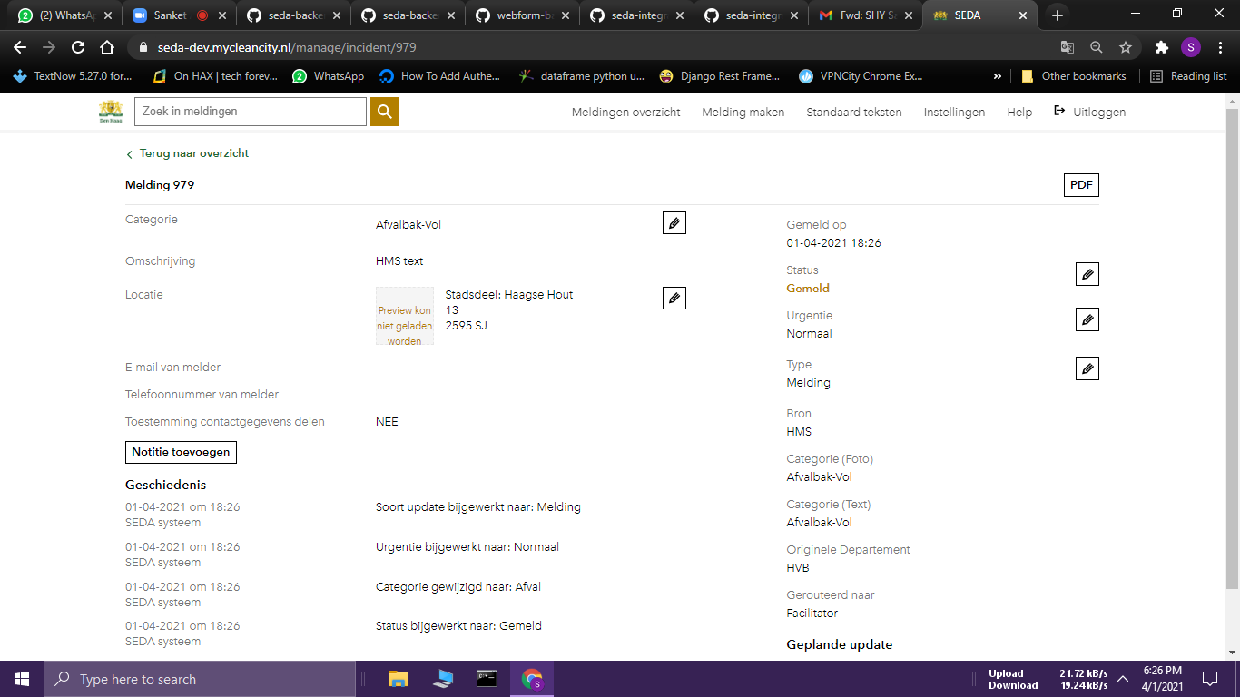

**2) Updating Report HMS-SEDA as “In behandeling”**

**URL** : <https://seda-dev.mycleancity.nl/hms_seda/api/>

For “in behandeling” use **PUT** request, make sure you use signal_id it should not be empty.

**Payload Body**

{

"state" : "In behandeling",

"gemeente" : "Gemeente Den Haag",

"organisatie" : "HMS",

"signal_id" : "541a6e89-04f1-4a54-88bc-1efe0b5076cc",

"incident_start_date" : "2021-02-02T19:25:03.456+01:00",

"postcode" : "2595 SJ",

"huisnummer" : 13,

"huisletter" : "D",

"huisnummertoevoeging" : "",

"fractie" : "Afval",

"type_inzamelmiddel" : "Verzamelcontainer",

"meldingcategorie" : "Plastic",

"meldingtekst" : "Vol",

"updated_at" : "2021-02-02T19:25:03.456+01:00",

"gps_x" : "52.768545",

"gps_y" : "4.825336",

"bijlagen_melding": [

{

"bijlage_melding_naam" : "",

"bijlage_melding_inhoud": ""

}

],

"bijlagen_afhandeling" : [

{

"bijlage_melding_naam" : "",

"bijlage_melding_inhoud": ""

}

]

}

**Expected Output:** 200_ok

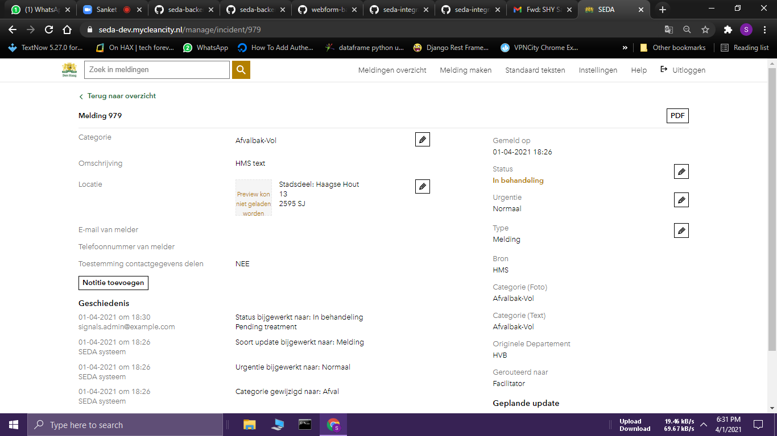

**3) Updating Report HMS-SEDA as “Afgehandeld”**

**URL** : <https://seda-dev.mycleancity.nl/hms_seda/api/>

For “Afgehandeld” use **PUT** request, make sure you use signal_id it should not be empty.

{

"state" : "Afgehandeld",

"gemeente" : "Gemeente Den Haag",

"organisatie" : "HMS",

"signal_id" : "541a6e89-04f1-4a54-88bc-1efe0b5076cc",

"incident_start_date" : "2021-02-02T19:25:03.456+01:00",

"postcode" : "2595 SJ",

"huisnummer" : 13,

"huisletter" : "D",

"huisnummertoevoeging" : "",

"fractie" : "Afval",

"type_inzamelmiddel" : "Verzamelcontainer",

"meldingcategorie" : "Plastic",

"meldingtekst" : "Vol",

"updated_at" : "2021-02-02T19:25:03.456+01:00",

"gps_x" : "52.768545",

"gps_y" : "4.825336",

"bijlagen_melding": [

{

"bijlage_melding_naam" : "",

"bijlage_melding_inhoud": ""

}

],

"bijlagen_afhandeling" : [

{

"bijlage_melding_naam" : "",

"bijlage_melding_inhoud": ""

}

]

}

**Expected Output:** 200_ok

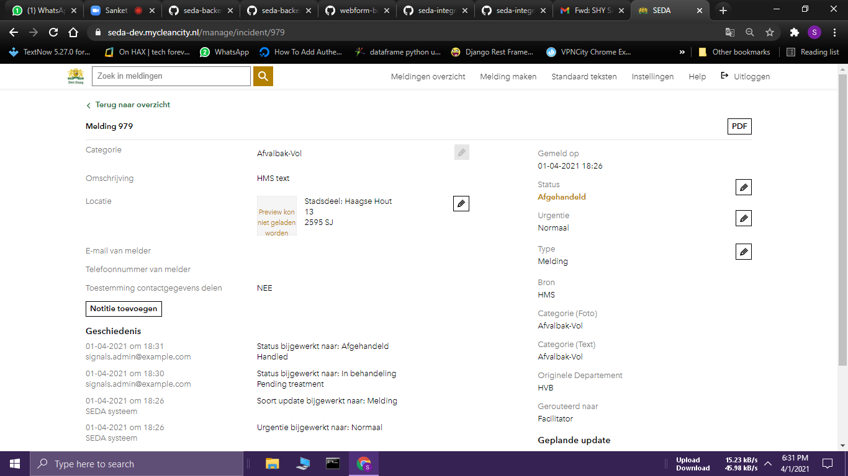

**4) Updating Report HMS-SEDA as “Afgewezen”**

**URL** : <https://seda-dev.mycleancity.nl/hms_seda/api/>

If the state is Afgewezen then the signal is routed to Mobile Beheerder.

For “Afgewezen” use **PUT** request, make sure you use signal_id it should not be empty.

{

"state" : "Afgewezen",

"gemeente" : "Gemeente Den Haag",

"organisatie" : "HMS",

"signal_id" : "541a6e89-04f1-4a54-88bc-1efe0b5076cc",

"incident_start_date" : "2021-02-02T19:25:03.456+01:00",

"postcode" : "2595 SJ",

"huisnummer" : 13,

"huisletter" : "D",

"huisnummertoevoeging" : "",

"fractie" : "Afval",

"type_inzamelmiddel" : "Verzamelcontainer",

"meldingcategorie" : "Plastic",

"meldingtekst" : "Vol",

"updated_at" : "2021-02-02T19:25:03.456+01:00",

"gps_x" : "52.768545",

"gps_y" : "4.825336",

"bijlagen_melding": [

{

"bijlage_melding_naam" : "",

"bijlage_melding_inhoud": ""

}

],

"bijlagen_afhandeling" : [

{

"bijlage_melding_naam" : "",

"bijlage_melding_inhoud": ""

}

]

}

**Expected Output:** 200_ok

