Architecture Design Document - MOA Valuation Assembly Procedure Automation

Document Version: 1.0

\

1. Executive Summary
The MOA Valuation Assembly Procedure Automation solution aims to eliminate manual effort involved in assembling valuation packages, validating plan information, generating compliance notices, updating logs, and creating required bookmarks.
The solution leverages an existing FastAPI-based application and PDF processing framework to automatically analyze valuation package PDFs, apply business rules, generate required outputs, and update operational tracking information. The automation will improve accuracy, reduce manual review effort, standardize processing, and accelerate valuation package preparation.
2. Business Objectives
Primary Objectives
- Automate valuation package review and assembly.
- Reduce manual effort and processing time.
- Standardize compliance notice generation.
- Improve accuracy through rule-based validations.
- Automate completion activities including bookmarks, email generation, and log updates.
- Minimize operational risk associated with manual document review.
3. Solution Scope
In Scope

Cover Page Validation | Action Required Classification | Notice Generation | Information Processing | Output Automation
Plan verification | Compliance Failure | ADP Failure Notice | Excess Summary handling | Bookmark generation
Company name validation | ADP/ACP Prior Method | ACP Failure Notice | Important Information page updates | Email subject generation
Company address validation | ADP/ACP Current Method | 402(g) Failure Notice |  | Valuation Assembly Log updates
Plan name validation | 12-Month Correction | 415 Failure Notice
Plan Year End validation | Variance Report | Sample Letter creation
Mutual of America reference validation | Top Heavy
 | No Action Required

Out of Scope
- OCR processing for scanned PDFs
- Manual review workflows
- Non-standard valuation package formats
- Changes to PDF assembly engine functionality already completed

4. High-Level Architecture
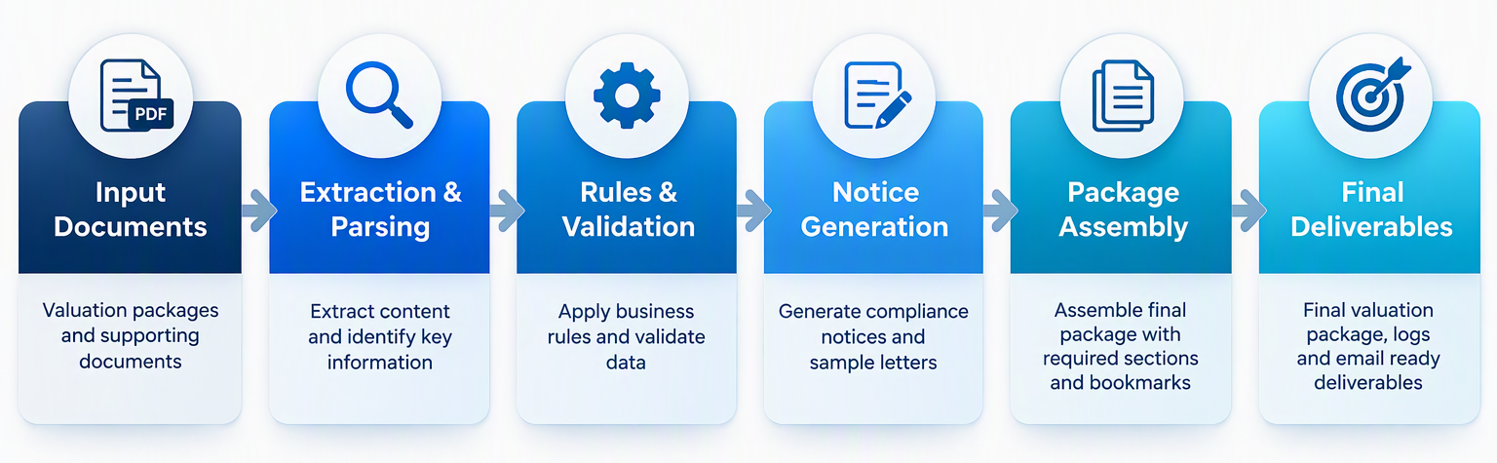

5. Logical Architecture Components
5.1 User Interface Layer
FastAPI Web Application
Responsibilities:
- Upload valuation package PDFs
- Trigger automation workflow
- Display processing results
- Present exception details
- Download finalized package

Technology:
- FastAPI
- HTML Front End

5.2 Document Processing Layer
PDF Extraction Service
Responsibilities:
- Read valuation package PDFs
- Extract text
- Extract page-level metadata
- Identify key sections
Technology:
- PyMuPDF
Inputs:
- Valuation Package PDF
Outputs:
- Structured extracted text
5.3 Metadata Parsing Engine
Responsibilities:
- Identify company information
- Extract plan data
- Extract testing results
- Locate compliance failures
- Locate refund amounts
- Locate QNEC information

Output Example:
{
"plan_name": "",
"company_name": "",
"plan_year_end": "",
"adp_result": "",
"acp_result": "",
"qnec_amount": "",
"refund_amount": ""
}

5.4 Business Rules Engine
Core decision layer responsible for all valuation package logic.
Rule Categories
Cover Page Rules
- Name matching
- Address matching
- MOA validation
Action Required Rules
- Top Heavy
- Variance Report
- Compliance Failure
- No Action Required
Notice Rules
- Current Method
- Prior Method
- ADP
- ACP
- 402(g)
- 415
Information Rules
- Sample Letter inclusion
- Important Information page updates
- Excess Summary handling

5.5 Notice Generation Service
Responsibilities
Automatically generate:
- ADP Failure Notice
- ACP Failure Notice
- Current Method Notice
- Prior Method Notice
- 402(g) Notice
- 415 Notice
- Sample Letter
Inputs:
- Parsed data
- Rule engine decision
Outputs:
- PDF-ready content

5.6 Package Assembly Engine
Responsibilities
- Merge required pages
- Exclude unnecessary sections
- Include mandatory notices
- Apply page ordering
- Generate bookmarks
Outputs:
- Final valuation package
5.7 Completion Services
Email Subject Generator
Example
MOA Valuation Package – ABC Company – Plan Year End 12/31/2025
Valuation Log Updater
Updates:
- Plan information
- Processing timestamp
- Status
- Exceptions
Target:
- Excel Log

6. Data Flow
Processing Workflow

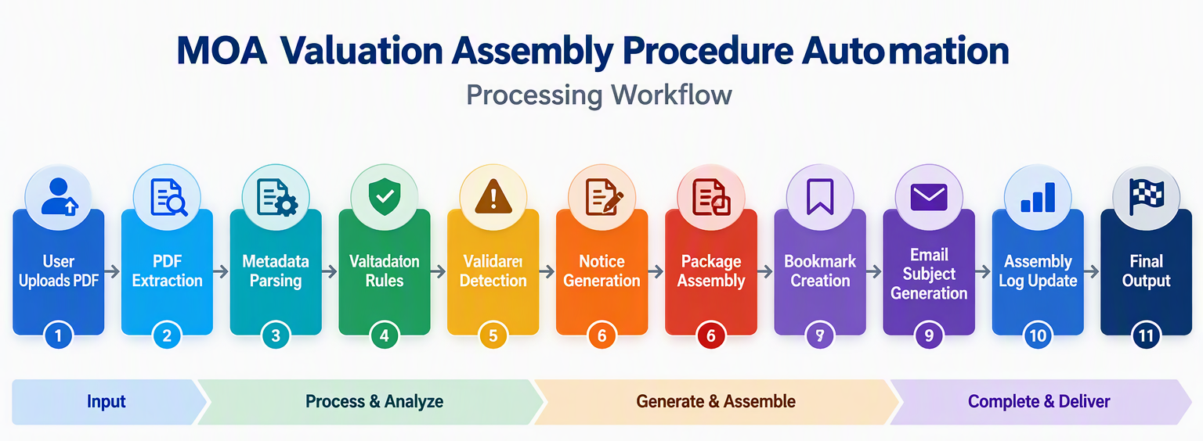

7. Deployment Architecture

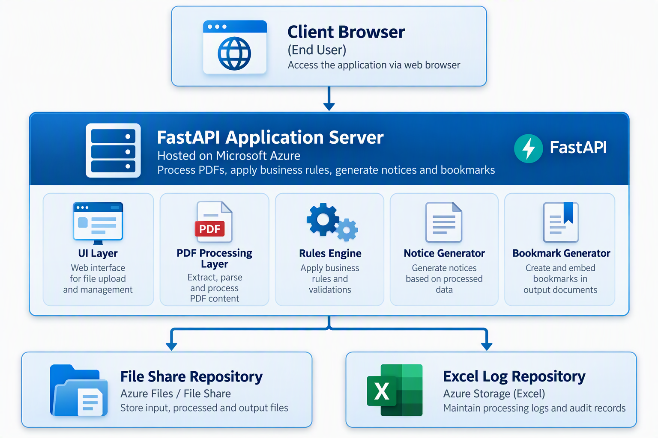
9. Risks & Mitigation
Risk | Impact | Mitigation
PDF layout variations | Extraction errors | Validate multiple historical packages
Incomplete business rules | Rework during UAT | SME walkthroughs
Dynamic wording changes | Logic updates required | Template-driven design
Missing source data | Incorrect notice generation | Validation checks
Off-calendar plans | Logic complexity | Dedicated SIT scenarios

10. Dependencies
Business Dependencies
- Valuation Package Process documentation
- Quick Review Checklist
- SME availability
- Automation decision matrix approval

Technical Dependencies
- Python runtime
- FastAPI framework
- PyMuPDF library
- Excel integration
- File share access

Test Data Dependencies
- Current Method Pass/Fail
- Prior Method Pass/Fail
- 402(g) failure packages
- 415 failure packages
- Top Heavy plans
- Variance Reports
- No Action Required scenarios
- Off Calendar plans

11. Proposed Technology Stack
Layer | Technology
Front End | HTML
API Layer | FastAPI
Backend Language | Python
PDF Processing | PyMuPDF
Business Rules | Python Rule Engine
Data Store | Excel/File Share
Logging | Python Logging Framework
Deployment | Windows/Linux Server

