Windows Server Deployment Guide
Document Processing POC

Architecture diagram
Browser traffic hits IIS on your domain (HTTPS). IIS serves the React build and reverse-proxies API routes to FastAPI on localhost port 8000.
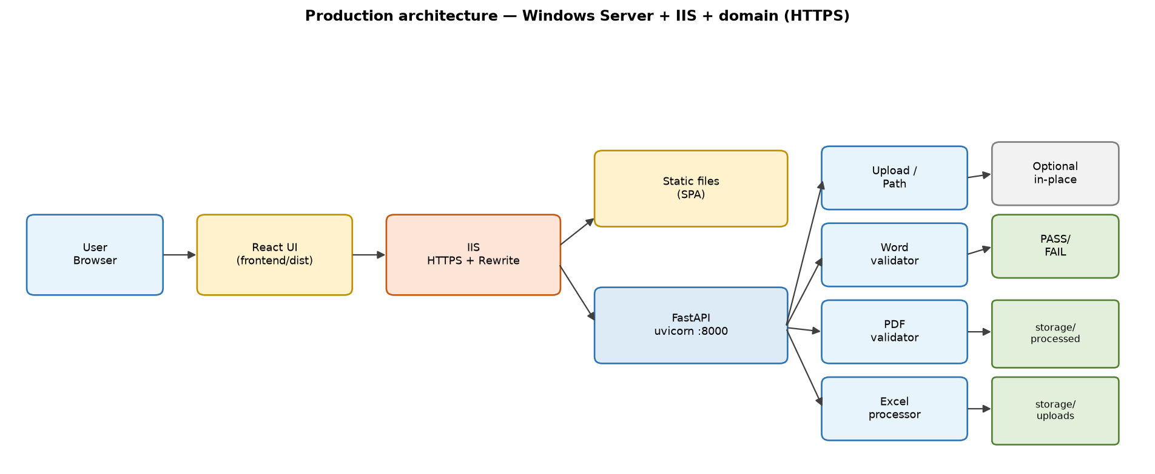

Figure 1 — Deployment architecture (single-domain layout)

This guide explains how to host the POC on a Windows Server and serve it on a custom domain (HTTPS). It matches the current repo layout: React (Vite) frontend + FastAPI backend.

1. What you are deploying
Component | Role | Production shape
Frontend | React UI | Static files (frontend/dist) served by IIS
Backend | FastAPI + uvicorn | Windows service on 127.0.0.1:8000 (not public)
Reverse proxy | IIS + URL Rewrite + ARR | Public HTTPS on your domain → API + static site
Storage | Uploads & processed Excel | backend/storage/uploads, backend/storage/processed
Logs | Backend logs | backend/logs/

Recommended URL layout (single domain, simplest for browsers):
- `https://docs.yourcompany.com/` → React app
- `https://docs.yourcompany.com/upload`, `/process/*`, `/download/*`, `/health` → proxied to FastAPI
With that layout, the browser sees one origin; you avoid most CORS issues.

2. Server prerequisites

Hardware / OS
- Windows Server 2019 or 2022 (or Windows 10/11 for a lab demo)
- Enough disk for uploads and processed files (plan for large Excel/PDF)

Software to install
- Python 3.11 or 3.12 (64-bit)
- [python.org](https://www.python.org/downloads/windows/) — check “Add python to PATH” during install
- Verify: `python --version`
- Node.js 20 LTS (64-bit) — only needed on the build machine (can be the same server)
- Verify: `node --version`, `npm --version`
- Git (optional) — to clone the repo on the server
- IIS (Internet Information Services)
- Server Manager → Add Roles → Web Server (IIS)
- Enable: Static Content, HTTP Redirection, Application Request Routing (install ARR separately if needed), URL Rewrite ([download URL Rewrite](https://www.iis.net/downloads/microsoft/url-rewrite))
- Visual C++ Redistributable — sometimes required for PyMuPDF wheels

Network / DNS
- A record (or CNAME): `docs.yourcompany.com` → public IP of the server
- Firewall: allow inbound TCP 443 (and 80 temporarily for certificate validation)

3. Deploy application files on the server
Example install path: `C:\Apps\POC-APP`

Option A — Git clone
cd C:\Apps
git clone <your-repo-url> POC-APP
cd POC-APP

Option B — Copy ZIP from your dev machine
Copy the project without `node_modules`, `.venv`, or large sample files you do not need.

4. Backend setup (Python)
cd C:\Apps\POC-APP\backend
python -m venv .venv
.\.venv\Scripts\Activate.ps1
python -m pip install --upgrade pip
pip install -r requirements.txt
Test manually:
cd C:\Apps\POC-APP\backend
.\.venv\Scripts\Activate.ps1
uvicorn app.main:app --host 127.0.0.1 --port 8000
In another window:
curl http://127.0.0.1:8000/health
Expect: `{"status":"ok"}`
Stop uvicorn (Ctrl+C) before configuring the service.

Folders created at runtime
On startup the API creates:
- `backend\storage\uploads`
- `backend\storage\processed`
- `backend\logs`
Ensure the Windows service account (see below) has Modify permission on `backend\storage` and `backend\logs`.

Environment variables (recommended on server)
Set these for the service account (System Properties → Environment Variables, or NSSM):
Variable | Purpose | Example (Windows)
ALLOWED_DOCUMENT_PATH_ROOTS | Extra roots for Server path upload | D:\SharedDocs;D:\OneDrive
(optional) | Path list uses ; on Windows

Paths for `/upload/path` must still be under allowed roots (project folder, user home, or `ALLOWED_DOCUMENT_PATH_ROOTS`).

In-place Excel path
If you use static in-place processing, edit `backend\app\services\excel\excel_config.py`:
- `STATIC_INPLACE_EXCEL_PATH` → Windows path, e.g. `D:\Data\2026helpwc 000006.xlsx`
- The file must be readable/writable by the service account
- Close Excel on the server when processing; OneDrive/sync locks can block saves

5. Frontend build (production)
Set the API base URL to your public site URL (same domain as the UI if using IIS reverse proxy):
cd C:\Apps\POC-APP\frontend
npm ci
$env:VITE_API_URL = "https://docs.yourcompany.com"
npm run build
Output: `frontend\dist\` (static HTML/JS/CSS)
Important: Rebuild whenever you change domains or API URL. `VITE_API_URL` is baked in at build time.

6. Production CORS (required if API and UI use different hostnames)
Today `backend/app/main.py` allows only localhost Vite ports. For production you must either:
A (recommended): Same domain via IIS proxy (no cross-origin calls) — still safe to add your domain to CORS for health checks.
B: API on `https://api.yourcompany.com` and UI on `https://docs.yourcompany.com` — add those origins to `CORSMiddleware` in `main.py` before go-live.
Example origins to add:
"https://docs.yourcompany.com",
"https://www.yourcompany.com",
Redeploy backend after changing CORS.

7. Run backend as a Windows service (NSSM)
Running uvicorn in a logged-in session is fine for demos; production should use a service.
- Download [NSSM](https://nssm.cc/download) and extract `nssm.exe` (e.g. to `C:\Tools\nssm`).
- Install service (run elevated Command Prompt or PowerShell):
C:\Tools\nssm\nssm.exe install POC-APP-API
Set in the NSSM GUI:
Field | Value
Path | C:\Apps\POC-APP\backend\.venv\Scripts\python.exe
Startup directory | C:\Apps\POC-APP\backend
Arguments | -m uvicorn app.main:app --host 127.0.0.1 --port 8000

Optional I/O tab: redirect stdout/stderr to `C:\Apps\POC-APP\backend\logs\uvicorn.log`.
- Start service:
C:\Tools\nssm\nssm.exe start POC-APP-API
Alternative: IIS can run HttpPlatformHandler with uvicorn; NSSM is simpler for this POC.

8. IIS — site, SSL, static frontend, API proxy

8.1 Create IIS site
- IIS Manager → Sites → Add Website
- Site name: `POC-APP`
- Physical path: `C:\Apps\POC-APP\frontend\dist`
- Binding: `https`, port `443`, hostname `docs.yourcompany.com`, select SSL certificate
- Application pool: No Managed Code, identity with read access to `dist` and (if needed) write nowhere for static site.

8.2 SSL certificate
- Corporate: Import PFX into Local Computer → Personal, bind in IIS.
- Public CA (Let’s Encrypt): Use [win-acme](https://www.win-acme.com/) on Windows to issue and auto-renew.

8.3 SPA routing (React Router)
For client-side routes (e.g. `/result`), add a `web.config` in `frontend\dist`:
<?xml version="1.0" encoding="UTF-8"?>
<configuration>
<system.webServer>
<rewrite>
<rules>
<rule name="SPA fallback" stopProcessing="true">
<match url=".*" />
<conditions logicalGrouping="MatchAll">
<add input="{REQUEST_FILENAME}" matchType="IsFile" negate="true" />
<add input="{REQUEST_FILENAME}" matchType="IsDirectory" negate="true" />
</conditions>
<action type="Rewrite" url="/index.html" />
</rule>
</rules>
</rewrite>
</system.webServer>
</configuration>
Rebuild/copy after `npm run build` if you add this file under `frontend/public/` so Vite copies it to `dist`.

8.4 Reverse proxy API to uvicorn
Enable ARR proxy: IIS → server node → Application Request Routing Cache → Server Proxy Settings → Enable proxy.
In the site’s `web.config` (merge with SPA rule carefully), add rules before SPA fallback for API paths:
<rule name="ReverseProxyToFastAPI" stopProcessing="true">
<match url="^(health|upload|process|download)(/.*)?$" />
<action type="Rewrite" url="http://127.0.0.1:8000/{R:0}" />
</rule>
Adjust the regex if you add more top-level API routes later.
Large uploads: In IIS → site → Configuration Editor → `system.webServer/serverRuntime` → increase `uploadReadAheadSize` and request limits as needed (e.g. 100MB+ for big Excel). Also consider `maxRequestBodySize` in ASP.NET settings if applicable.

9. Post-deploy verification checklist
Step | Action | Expected
1 | Browse https://docs.yourcompany.com | Home page loads
2 | https://docs.yourcompany.com/health | {"status":"ok"}
3 | Upload a small PDF/Excel | Result page runs processing
4 | Download processed Excel | File downloads
5 | Server path (if used) | Path under allowed roots works
6 | Check backend\logs\ | New log file on service start

10. Domain-only vs split API subdomain

Single domain (recommended)
- `VITE_API_URL=https://docs.yourcompany.com`
- IIS proxies API paths to `127.0.0.1:8000`
- Minimal CORS changes

Split subdomain
- UI: `https://docs.yourcompany.com`
- API: `https://api.yourcompany.com` → separate IIS site or binding, proxy all traffic to uvicorn
- `VITE_API_URL=https://api.yourcompany.com`
- Must update CORS in `main.py`

11. Security notes for production (beyond POC)
The POC is not production-hardened. Before exposing to the internet:
- Add **authentication** (Azure AD, IIS Windows Auth, or API keys)
- Restrict **Server path** feature to admins or disable on public deployments
- Review `STATIC_INPLACE_EXCEL_PATH` — do not point at sensitive shares without ACLs
- **HTTPS only**; redirect HTTP → HTTPS
- Patch Windows, Python, and Node regularly
- Antivirus scanning on upload folder (policy-dependent)
- Backup `storage` and document retention policy
- Rate limiting / max upload size at IIS and application layer

12. Updating the app
cd C:\Apps\POC-APP
git pull # or copy new files
cd backend
.\.venv\Scripts\Activate.ps1
pip install -r requirements.txt
# Restart POC-APP-API service
cd ..\frontend
npm ci
$env:VITE_API_URL = "https://docs.yourcompany.com"
npm run build
# IIS serves updated dist automatically
Restart IIS site or app pool only if you changed `web.config`.

13. Troubleshooting
Symptom | Likely cause | Fix
UI loads, API 404 | Proxy rule missing/wrong | Fix web.config rewrite; confirm ARR enabled
CORS error in browser | UI and API different origins | Same-domain proxy or update CORSMiddleware
502 Bad Gateway | uvicorn not running | Start NSSM service; check port 8000
Upload fails on large file | IIS/body size limit | Increase upload limits in IIS
Path upload rejected | Path outside allowed roots | Set ALLOWED_DOCUMENT_PATH_ROOTS or move file
In-place Excel fails | File locked or permissions | Close Excel; grant service account write access
.xls fails on server | Missing xlrd | pip install -r requirements.txt in venv

14. Quick reference — paths on server
Item | Path
App root | C:\Apps\POC-APP
Backend venv | C:\Apps\POC-APP\backend\.venv
Uploads | C:\Apps\POC-APP\backend\storage\uploads
Processed | C:\Apps\POC-APP\backend\storage\processed
Logs | C:\Apps\POC-APP\backend\logs
Frontend build | C:\Apps\POC-APP\frontend\dist

15. Optional: firewall lock-down
- Do not expose port 8000 on the public firewall.
- Only 443 (and 80 for redirect) should be open; IIS talks to uvicorn on localhost.
Replace `docs.yourcompany.com` with your real domain throughout. Adjust `C:\Apps\POC-APP` if you use a different install path.

