NXTWAVE OF INNOVATION IN ADVANCE TECHNOLOGY
Department of Computer Science and Engineering • Jaipur, Rajasthan
____________________________________________________
ACADEMIC INTERNSHIP REPORT
Web Development at Codec Technologies Pvt. Ltd.


1-Month AICTE & ICAC-Approved Industrial Training & Internship Program
Internship Period: 08 July 2026 – 13 August 2026 • Mode: Pan India (Hybrid)
Candidate Name: Damin Sahu | Host Organization: Codec Technologies Pvt. Ltd.
Degree: B.Tech in Computer Science & Engg. | Location: Chandivali IT Hub, Mumbai
Institution: NXTWAVE of Innovation in Advance Tech | Designation: Web Developer Intern
Location: Jaipur, Rajasthan | Industry Mentor: Dr. Anurag Shrivastava (Prog. Mgr.)
Roll Number: 25TEC2SE291 | Institutional Supervisor: Aparajita Negi (HOD, NIAT)
Academic Year: 2025–2029 | Submission Date: 22/10/2026
A formal technical report submitted in partial fulfillment of the requirements for the degree of
Bachelor of Technology in Computer Science and Engineering
NXTWAVE of Innovation in Advance Technology • 2026

Internship Certificate & Candidate Declaration
Official credential issued by Codec Technologies Pvt. Ltd. and student statement of integrity

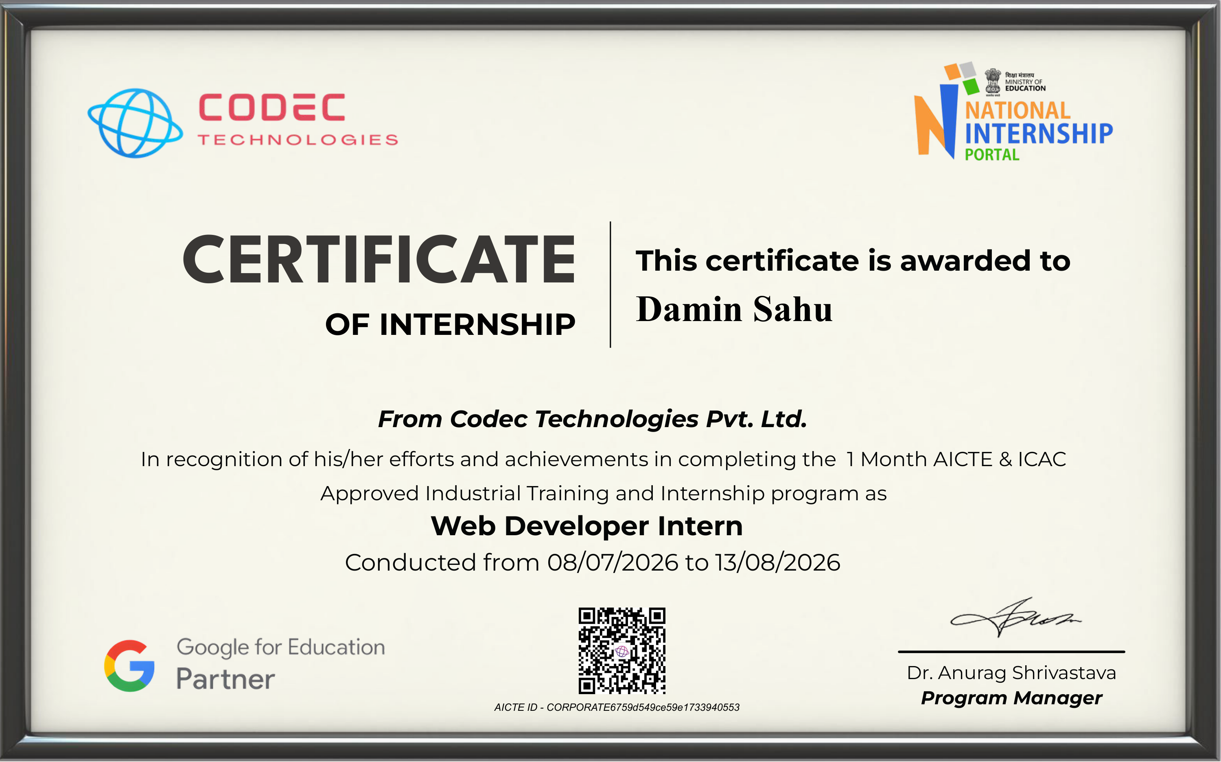

Candidate Declaration
I, Damin Sahu, student of B.Tech in Computer Science and Engineering at NXTWAVE of Innovation in Advance Technology, Jaipur, Rajasthan, hereby declare that the work presented in this internship report entitled "Web Development at Codec Technologies Pvt. Ltd." is an authentic record of my industrial training completed during the period from 08 July 2026 to 13 August 2026. The single web project discussed in this report, namely the Personal Portfolio Website, was engineered by me as part of the assigned technical curriculum under the guidance of Dr. Anurag Shrivastava, Program Manager, Codec Technologies Pvt. Ltd.
I further affirm that this report adheres to academic integrity standards and accurately reflects the verified technologies, codebase structure, and learning outcomes without unauthorized fabrication.
Date: 22/10/2026 _______________________________
Place: Jaipur, Rajasthan Damin Sahu
Signature of the Student
Roll No.: 25TEC2SE291

Executive Abstract & Acknowledgements
Overview of industrial internship achievements and formal academic recognitions

Executive Abstract
This report documents the one-month industrial training and internship completed by Damin Sahu (Roll No: 25TEC2SE291) at Codec Technologies Pvt. Ltd. in the capacity of Web Developer Intern, spanning from 08 July 2026 to 13 August 2026. Conducted in a hybrid work environment across Pan India under the AICTE & ICAC-Approved Industrial Training and Internship Program, the primary objective of this internship was to bridge theoretical computer science education with contemporary front-end web engineering practices.
The core technical deliverable discussed in this report is the design, implementation, and deployment of a responsive Personal Portfolio Website. The application was constructed using modern web engineering principles, leveraging semantic HTML5 for structure, modular CSS3 architecture with custom design tokens for responsive aesthetics, and TypeScript/JavaScript with React and Vite for component-driven UI architecture. Source code management and collaborative versioning were conducted through Git and GitHub (https://github.com/daminsahu697-debug/portfolio), culminating in a live public deployment on Vercel (https://damin-portfolio.vercel.app).
Key learning outcomes encompass modular UI design, interactive state and modal management, asset optimization for fast page loads, cross-device responsiveness, and continuous deployment workflows. The experience provided crucial insights into software development hygiene, industry-standard toolchains, and real-world problem-solving methodologies.

Acknowledgements
I express my profound gratitude to Codec Technologies Pvt. Ltd. for providing an intensive, structured, and immersive industrial internship platform. I am particularly indebted to Dr. Anurag Shrivastava, Program Manager and Talent Acquisition Manager, for his professional leadership, program organization, and constructive feedback throughout the internship tenure.
I extend sincere thanks to Aparajita Negi (Head of Department, NIAT) and the academic faculty at NXTWAVE of Innovation in Advance Technology, Jaipur, Rajasthan, for establishing foundational principles in computer science and software development that enabled me to execute industrial tasks with technical rigor.
Finally, I appreciate the collaborative spirit of fellow peers in the July 2026 cohort whose technical exchanges and shared problem-solving discussions enriched this industrial learning journey.
Accreditation: Verification Note: This internship was conducted under AICTE Corporate ID: CORPORATE6759d549ce59e1733940553 and National Career Service (NCS) ID: E19E86-0116588288923. All document dates (08/07/2026 to 13/08/2026) are preserved exactly as stated in official records.

Table of Contents
Document organization and section index
Section | Chapter & Topic Description | Page
— | Cover Page (Submission details, student profile, institutional header) | Page 1
— | Internship Certificate & Candidate Declaration (Official credentials) | Page 2
— | Executive Abstract & Acknowledgements (Industrial scope & recognitions) | Page 3
Chapter 1 | Introduction to Codec Technologies Pvt. Ltd. (Background & accreditations) | Page 4
Chapter 2 | Internship Work Profile & Methodology (Objectives & workflow) | Page 5
Chapter 2 (Cont.) | Personal Portfolio Website Project (Architecture & verification) | Page 6
Chapter 3 | Implementation Details & Learning Outcomes (Engineering & testing) | Page 7
Chapter 4 | Technical Challenges, Conclusion & Suggestions (Problem solving) | Page 8
Annexures | Official Offer Letter & Document References (High-res offer letter) | Page 9

Chapter 1: Introduction to Codec Technologies

1.1 Organizational Profile
Codec Technologies Pvt. Ltd. is an established IT and business consultancy organization headquartered at Chandivali IT Hub, Mumbai, India, with an operational footprint spanning across 27+ countries. As stated in official institutional correspondence, Codec Technologies operates as a global platform committed to empowering emerging technical learners and connecting talent with industry opportunities through structured training programs. The organization trades online via its official portal (www.codectechnologies.in).

1.2 Corporate Credentials & Accreditations
• Quality Certification: ISO 9001:2015 certified organization, ensuring standardized operational quality.
• Industry Partnerships: Recognized Google for Education Partner, aligning training with industry-standard development ecosystems.
• AICTE & ICAC Approval: Operating under AICTE Corporate ID: CORPORATE6759d549ce59e1733940553.
• National Career Service Registration: Verified NCS ID: E19E86-0116588288923.

1.3 Mentorship & Evaluation Framework
The industrial internship program is administered under the leadership of Dr. Anurag Shrivastava, Program Manager and Talent Acquisition Head. The cohort framework incorporates milestone reviews, structured engineering tasks, and evaluation criteria designed to simulate agile development practices.

Chapter 2: Internship Work Profile & Methodology
Internship objectives, role definition, and professional web engineering methodology

2.1 Internship Objectives
The primary purpose of the internship at Codec Technologies was to provide structured industrial exposure to contemporary web development paradigms. Key objectives included:
• Translating academic computer science foundations (algorithms, object-oriented concepts, database structures) into functional client-side web software.
• Developing a production-ready web application adhering to semantic conventions, responsive UI/UX principles, and accessibility standards.
• Mastering version control workflows using Git and GitHub for code traceability and team collaboration.
• Understanding continuous deployment, static hosting mechanics, and production build pipelines.

2.2 Role Definition & Operating Mode
The candidate served in the formal capacity of Web Developer Intern within the July 2026 cohort (duration: 08 July 2026 to 13 August 2026). Operating in a Pan India, Hybrid Mode, tasks were completed through remote development cycles, online repository submissions, and virtual technical coordination.

2.3 Professional Engineering Lifecycle
The technical workflow followed during the internship reflected established industry practices, structured into five progressive phases:
Workflow Phase | Key Engineering Activities & Deliverables
1. Requirement Analysis | Deconstructing technical requirements, user stories, content hierarchies, and asset catalogs.
2. Interface Architecture | Designing modular layout skeletons, typography systems, color tokens, and responsive breakpoints.
3. Component Development | Implementing modular React/TypeScript components, interactive state hooks, and DOM event listeners.
4. Responsive Testing | Validating cross-device viewport behavior, checking touch interactions, and auditing console logs.
5. Deployment & Release | Configuring build optimizations in Vite, committing clean git trees, and publishing to Vercel hosting.

2.4 Source Code Management Standards
A critical component of the industrial workflow was rigorous version control. Code changes were tracked using atomic Git commits with clear imperative messages, branch management, and remote repository synchronization on GitHub. Sensitive configuration files such as environment credentials (.env) and build caches were systematically excluded using a comprehensive .gitignore configuration.

Chapter 2 (Cont.): Personal Portfolio Website Project
Comprehensive technical overview of the primary industrial project deliverable

2.5 Project Overview & Purpose
The primary software deliverable completed during the internship was the Personal Portfolio Website. The objective was to design and deploy a personal web platform that professionally showcases the developer's academic profile, technical skill inventory, featured projects, extracurricular achievements, and verified contact channels.
Project Verification: GitHub Repository: https://github.com/daminsahu697-debug/portfolio
Live Production URL: https://damin-portfolio.vercel.app
Developer Role: Frontend Developer • Status: Production Verified (0 Errors)

2.6 System Architecture & Component Hierarchy
The website is structured as a component-driven Single Page Application (SPA) with a clean separation of concerns between data definitions, visual components, and styling:
[App Shell] -> [Navbar, ThemeContext, ThemeCustomizer]
-> [Hero Section (Bio, Portrait Headshot, Quick CTAs)]
-> [Education Timeline (B.Tech at NXTWAVE, Class X, Class XII)]
-> [Projects Showcase (SecureChain DMS, Portfolio)]
-> [Skills Inventory (6 distinct categories)]
-> [Resume Hub Modal (PDF Preview & Download)]
-> [Contact Section & Footer (Direct Mail/Phone/Social)]
Data Layer: Decoupled centralized configuration in src/data/portfolio.ts

2.7 Core Functional Sections Implemented
• Hero Introduction: Features personal positioning ('Building Practical Software Solutions Across Web, AI & IoT'), embedded circular portrait, and quick CTA buttons.
• Education Timeline: Details B.Tech CSE at NXTWAVE of Innovation in Advance Technology (CGPA: 9.33, 2025–2029), Class XII (82.8%), and Class X (97%).
• Categorized Technical Skills: 6 organized clusters covering Programming Languages, Web Technologies, AI & CV, Embedded IoT, Backend & Databases, and Core CS Concepts.
• Verified Projects Showcase: Displays project role, technologies, and verified repository links for SecureChain DMS and the Portfolio Website.
• Integrated Resume Hub: Modal viewer enabling inline PDF inspection and one-click downloading of Damin_Sahu_Resume.pdf.
• Theme Customizer & Accessibility: Persistent light/dark toggles and multi-hue accent selections respecting system reduced-motion preferences.

Chapter 3: Implementation Details & Learning Outcomes
Engineering execution, verification testing, and technical competencies acquired

3.1 Frontend Implementation Process
• Semantic Structure: Developed using HTML5 semantic elements (<header>, <nav>, <main>, <section>, <article>, <footer>) to guarantee accessible document outlining and optimal search indexing.
• Modular Vanilla CSS Design System: Constructed entirely in index.css utilizing CSS Custom Properties (CSS variables) for design tokens (colors, font scales, radius, shadows). This eliminated heavy CSS frameworks while granting full styling flexibility.
• Component Architecture in React 19 & TypeScript: Strict TypeScript interfaces were defined for all entities (Project, EducationItem, ResumeConfig), guaranteeing type safety and eliminating runtime null reference bugs.
• Centralized Content Decoupling: All website copy, credentials, project descriptions, and links are isolated in src/data/portfolio.ts, separating content from UI presentation.

3.2 Testing, Verification & Quality Assurance
Testing Dimension | Verification Methodology & Observed Outcome
Viewport Responsiveness | Tested across desktop (1920x1080), laptop (1366x768), tablet (768x1024), and mobile viewports (375x667). Confirmed fluid reflow without horizontal scrolling.
Static Asset Delivery | Verified HTTP 200 responses for static image assets (profile.jpg: 169.8 KB) and downloadable resume (resume.pdf: 76.5 KB) via production CDN.
Build & Compilation | Executed tsc -b and vite build. Produced production bundle of 281.9 KB JS and 39.3 KB CSS transformed across 1,950 modules with 0 errors.

3.3 Key Learning Outcomes & Professional Growth
• Technical Competency: Solidified mastery of modern JavaScript/TypeScript, React component design, Vite bundler optimization, and CSS layout algorithms (Flexbox, CSS Grid).
• Software Hygiene: Developed an appreciation for strict git hygiene, atomic commit messages, and automated deployment pipelines.
• Problem-Solving Maturity: Gained capability in debugging layout anomalies, managing modal escape keys and focus states, and implementing seamless theme persistence using localStorage.

Chapter 4: Technical Challenges, Conclusion & Suggestions
Engineering hurdles resolved, academic synthesis, and recommendations for future cohorts

4.1 Engineering Challenges & Solutions
• Challenge 1: Cross-Device Responsive Layout Stability — Ensuring that complex cards with varying text lengths, badges, and image portrait containers aligned evenly across both narrow mobile viewports and wide displays.
Resolution: Implemented fluid CSS Grid with minmax() functions, combined with CSS clamp() for responsive typography, preventing layout breakage without excessive media query rules.
• Challenge 2: Multi-Theme Contrast & Modal Accessibility — Maintaining high-contrast text readability across light, dark, and colored accent themes while ensuring the PDF viewer modal was fully accessible.
Resolution: Formulated a centralized semantic color token palette with WCAG AA compliance checks and implemented backdrop overlay click listeners and keyboard dismiss handlers.
• Challenge 3: Production Build Asset Resolution — Ensuring that static PDF documents and image headshots loaded seamlessly on both local development servers and public cloud hosting without path mismatches.
Resolution: Standardized asset routing under the Vite public/ directory and verified deployment HTTP headers using production curl requests.

4.2 Conclusion & Curriculum Alignment
The industrial training completed at Codec Technologies Pvt. Ltd. served as an invaluable bridge between academic theory and real-world software engineering. Concepts introduced during the B.Tech Computer Science and Engineering program at NXTWAVE of Innovation in Advance Technology — such as software development lifecycles, structured programming, and modular design — were directly put into practice. The resulting portfolio website stands as an active, verified testament to the front-end competencies, design sensibilities, and deployment capabilities acquired during this program.

4.3 Constructive Suggestions for the Internship Program
• Structured Collaborative Review: Incorporating mandatory peer pull-request reviews would expose interns to team code critique and merge conflict resolution.
• Extended Timeline: While the 1-month duration is intensive and focused, expanding the window to 6–8 weeks would permit deeper integration of backend microservices and database persistence.
• Automated CI/CD Workshops: Introducing hands-on sessions on GitHub Actions for automated linting and unit testing would further elevate industry readiness.

Annexures & Document References
Official internship offer letter, institutional verification IDs, and public repository links

Annexure I: Official Internship Offer Letter

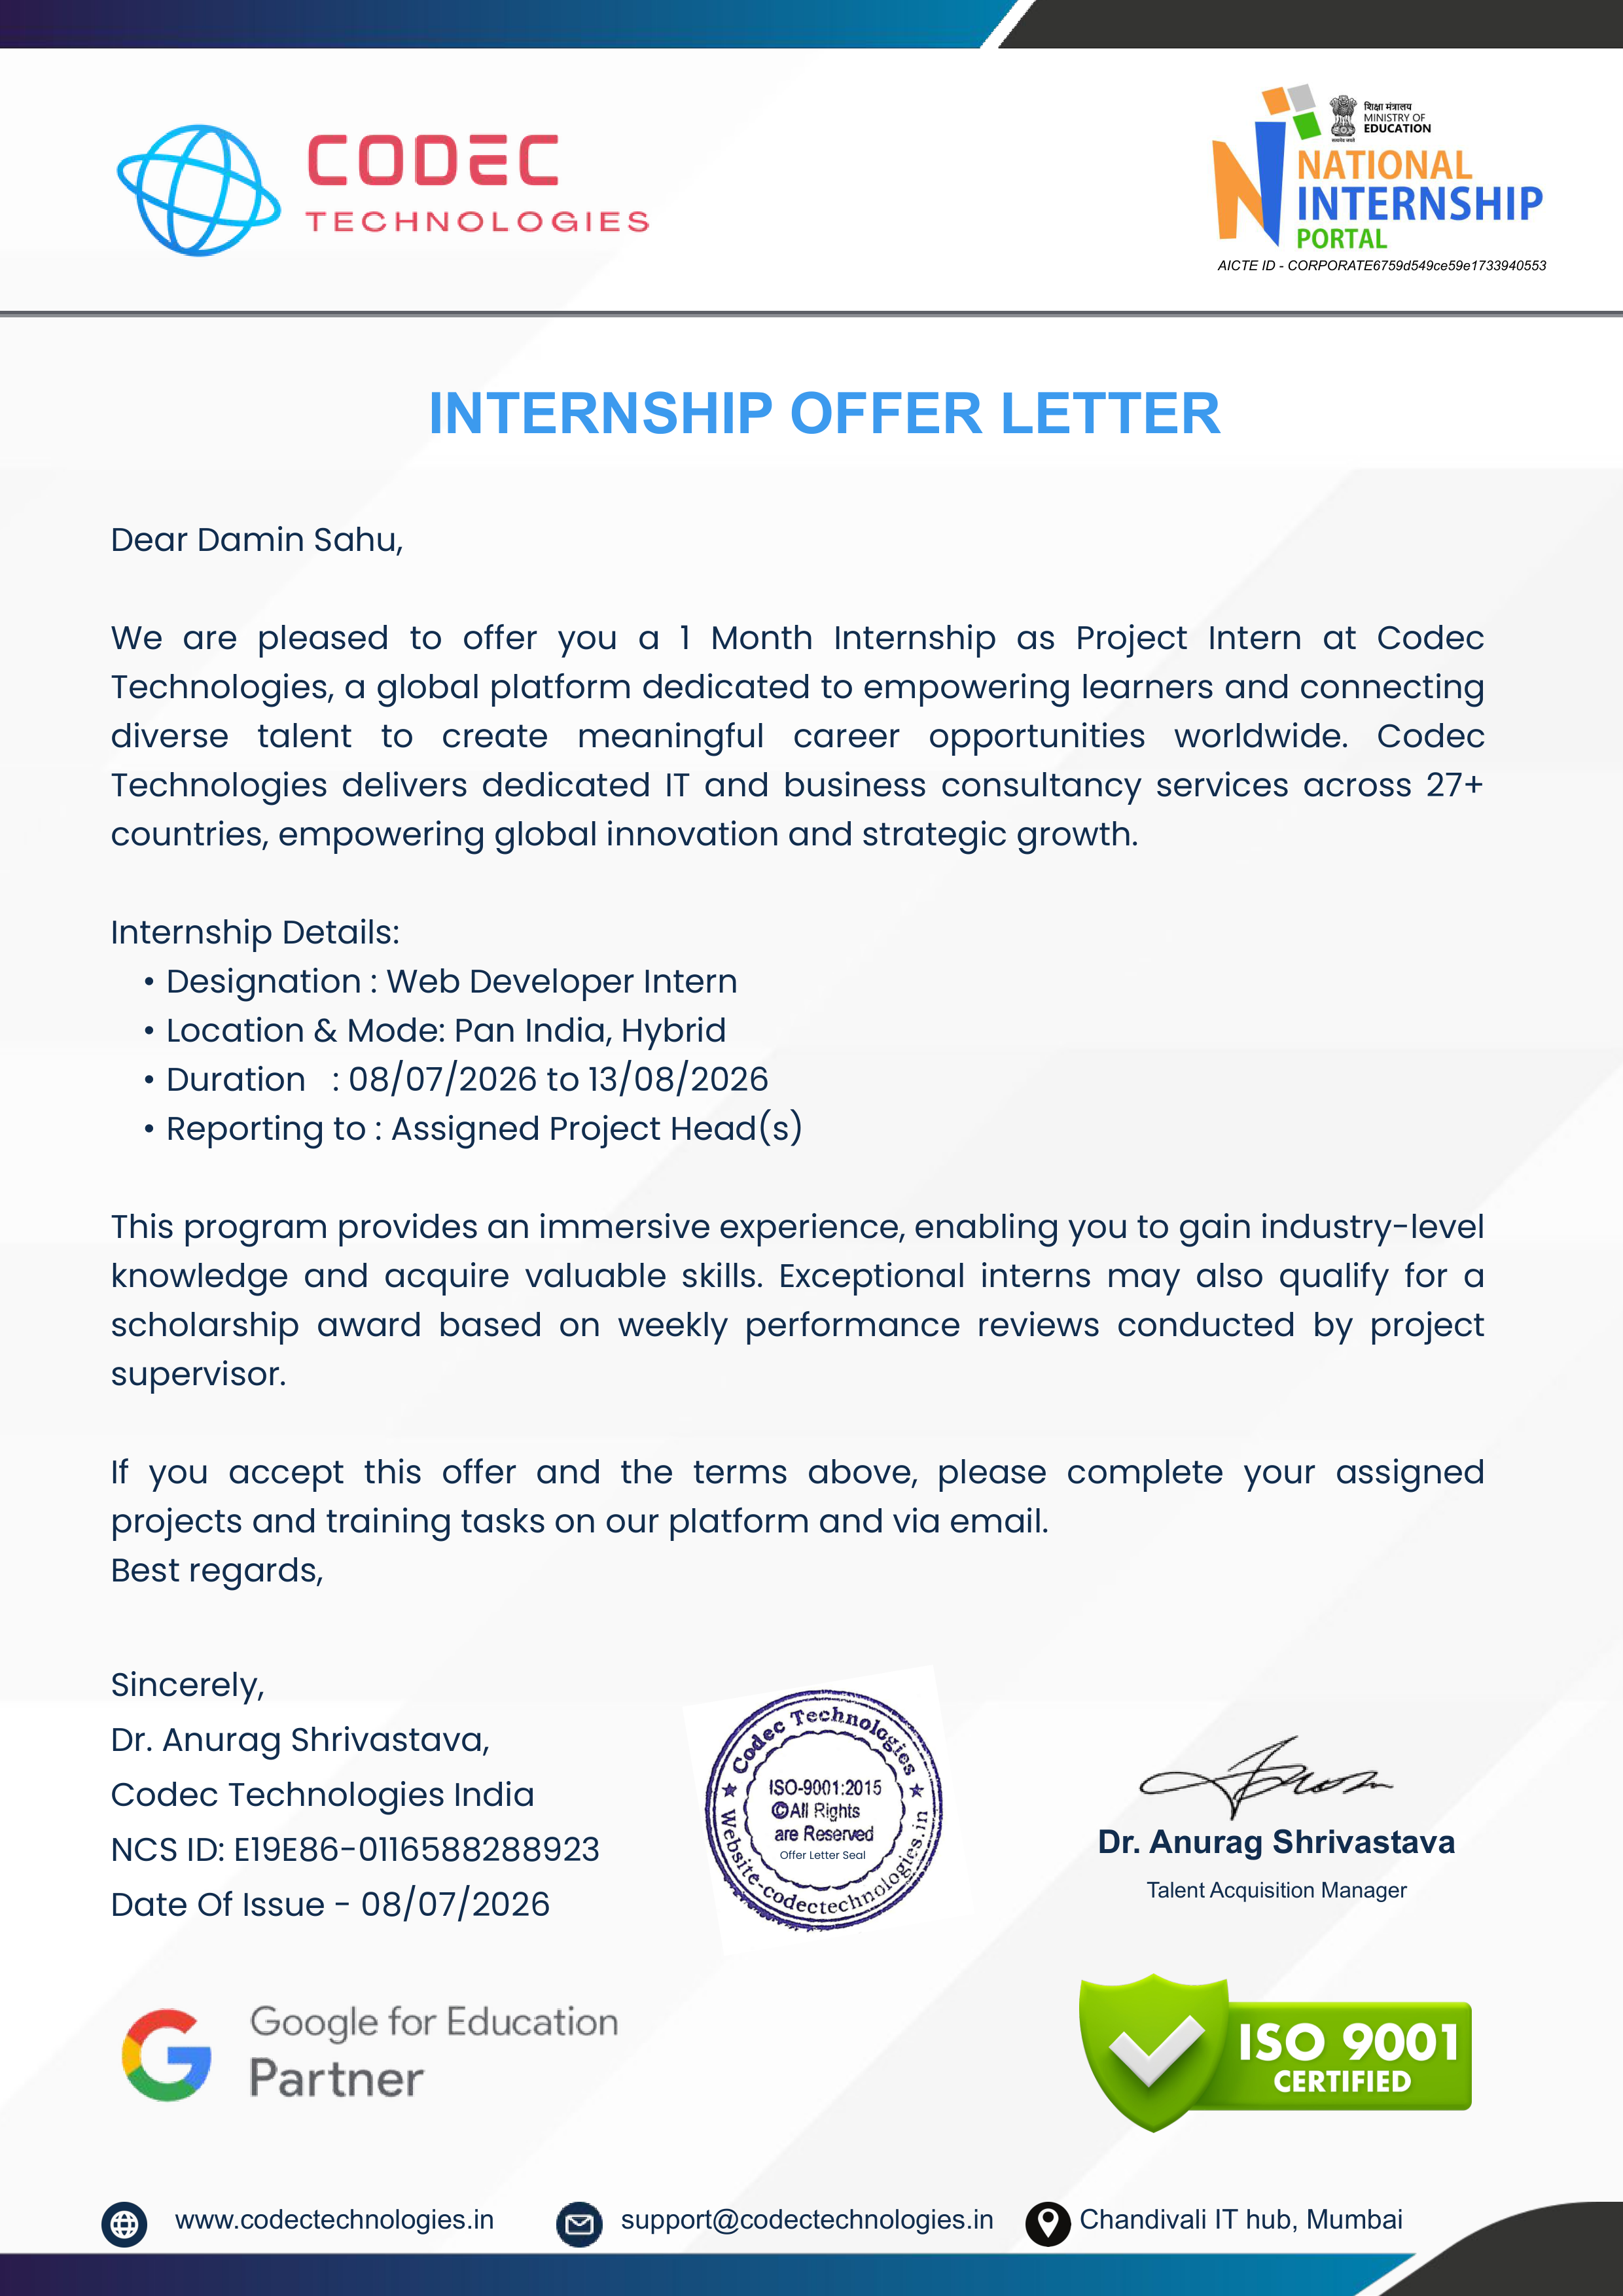

Annexure II: Official References & Verified Project Links
Reference Item | Verification Details & Official Resource URL
Host Organization | Codec Technologies Pvt. Ltd. • Portal: https://www.codectechnologies.in
National Career Service | Official NCS ID: E19E86-0116588288923 • Ministry of Labour & Employment, Govt. of India
AICTE Corporate ID | Approved Corporate Registration ID: CORPORATE6759d549ce59e1733940553
GitHub Repository | Portfolio Source Code: https://github.com/daminsahu697-debug/portfolio
Live Production Website | Public Portfolio URL: https://damin-portfolio.vercel.app

