Name: Damion Lowers
ID:620024494
project 2

1. Generate a pair of keys. Export your public key into a .asc file.
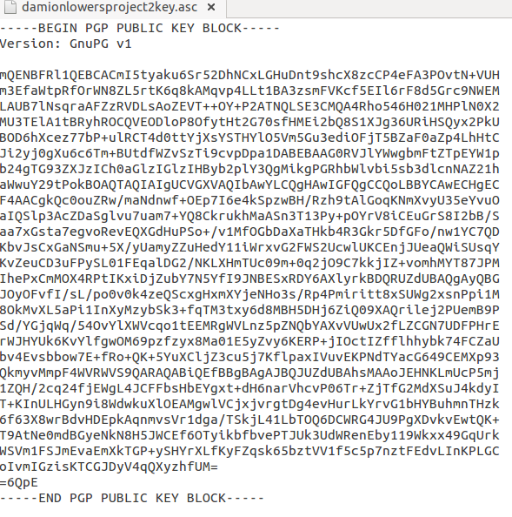

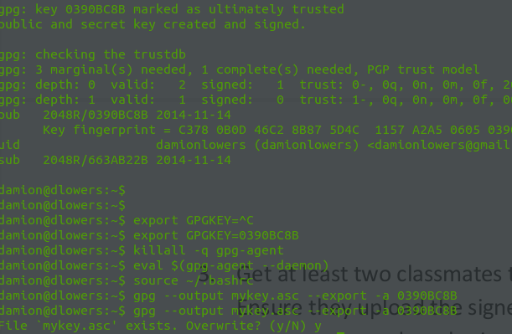

2) Upload your public key to the MIT pgp keyserver, pgp.mit.edu.

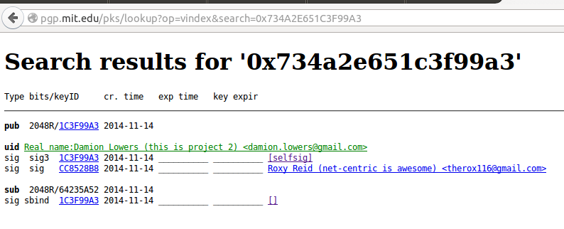

3. Get at least two classmates to sign your public key, and sign at least two classmates public keys.
Ensure they upload the signed key to the MIT keyserver. For each key you signed, explain the
process you used to obtain, verify, and sign the key.

4. Use PGP to send a secure e-mail message to one of the persons with whom you exchanged
public keys.

