FPC Desktop/Server Support Guidelines

Fujitsu PC Corporation will be providing support for Fujitsu Siemens server and desktop products that have been purchased within the U.S.

The following table displays the current desktop and server products. Please be familiar with these models and note that many of the products have model names similar to those of our laptops.

IF YOU HAVE ANY QUESTIONS, OR ARE UNCLEAR ABOUT THE MODELS OR PROCESSES, ESCALATE THE CALL TO LEVEL 2 SUPPORT.

Primergy Servers
Model
B225
F200
H200
L200
N400
N800
P200
Primergy Storage Subsystems
Model
S30
Earlier Desktop Models
Model
Scenic D
Scenic L
Scenic S2
Scenic T
Scenic xB
Fall 2002/Spring 2003 Desktops
Model
Scenic C300
Scenic C600
Scenic C610
Scenic E300
Scenic E600
Scenic E620
Scenic N300
Scenic N320
Scenic N600
Scenic P300
Scenic P320
Scenic P600
Scenic P620
Scenic W600
Scenic W620

Thin Clients
Model
Scovery 110
Scovery xs-1215
Futro B100
Futro B210 (32MB)
Futro B220 (128MB)
Futro D100
Futro C100
Futro S210 (32MB)
Futro S220 (128MB
Futro S230 (256MB)

Workstations
Model
Celsius K320
Celsius K330
Celsius M410
Celsius M420
Celsius M430
Celsius R610
Celsius R630
Celsius V810

Handhelds
Model
Loox 600
Loox 610
Loox 420
Loox 710
Loox 720

Projectors
Model
XP600

Broadband Solutions
Model
Activity 200

Monitors/LCDs
Model
38B2
3816FA-M
383V
19P4
21P4
43B1-M
S5
S7
43B1-M
5110FA
177V
151E
17P4
C792
C779
5110FA
C994
4312
431V
4613
463V

Customers who have purchased these products will call in for support though the Premium Care Support number (1-866-756-8628). Callers will be required to enter an ID number to continue on to a Support Representative. Server IDs begin with 75 and desktop IDs begin with 76. Customers who call in for server support will be directed to Siemens Business Services (SBS). Those calling for desktop support will be directed to Memphis for support (8:00 AM -5:30 PM CST Monday through Friday) or Stream (5:30 PM CST -8:00 AM CST Monday through Friday, all day Saturday, Sunday, and Holidays).

Customers who enter their ID incorrectly or exceed the number of allowed attempts will be forwarded to Level 1 Support for further assistance.

Customer PINs are displayed on the customer information screen in Clientele. If a customer does not know their ID number, locate their record in Clientele the same way you currently would. The ID number will be displayed at the top of the customer record.

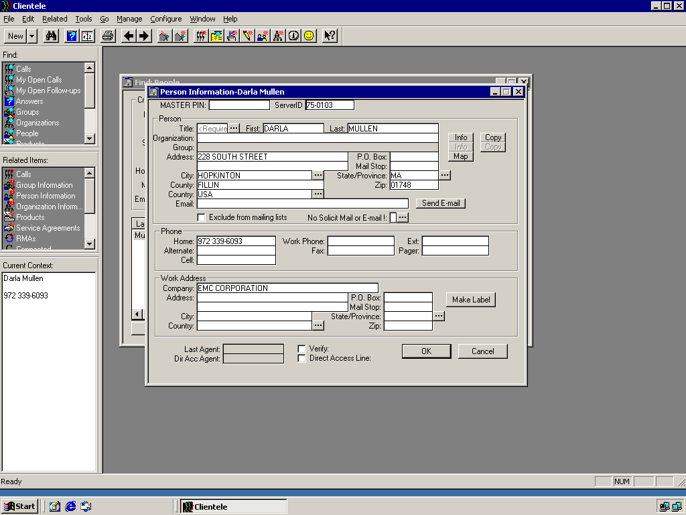

Once you have given the customer their ID number, warm transfer the customer to the Fujitsu Premium Care line (513-336-1545). Please note: this is for Servers and Storage Devices only. If the customer has a desktop issue, go ahead and provide support for the customer.

IF YOU HAVE ANY QUESTIONS, OR ARE UNCLEAR ABOUT THE MODELS OR PROCESSES, ESCALATE THE CALL TO LEVEL 2 SUPPORT.

