**Astana IT University**

**Software Engineering  
Group: SE-2411**

**Report Topic:**

**Assignment 1**

Completed by:  
**Zarkesh Damir**

Astana – 2025

Part 1. Introduction to HTML

I created a new HTML file called index.html and added the basic HTML structure (<!DOCTYPE html>, <html>, <head>, <title>, <body>). The page title is in the form "My first web page".

I added h1-h3 headings with my name, course, and "About Me" section. I also wrote a short paragraph about myself.

I made an ordered list (ol) with my hobbies and an unordered list (ul) with my favorite websites.

I inserted my photo using the img tag and added two clickable links (a) to my favorite websites.

I added a simple button with the text "Click Me" (no functionality).

Part 2. Intermediate HTML

I created a table with different columns: Topic, Day, Time and filled it with a simple class schedule.

As an additional challenge, I created a two-column layout using tables: left menu, right main content.

I added a paragraph with emoji situations describing my current mood.

I created an HTML form with fields: Name (text field), Email (email field), Favorite Color (color field) and a Submit button.

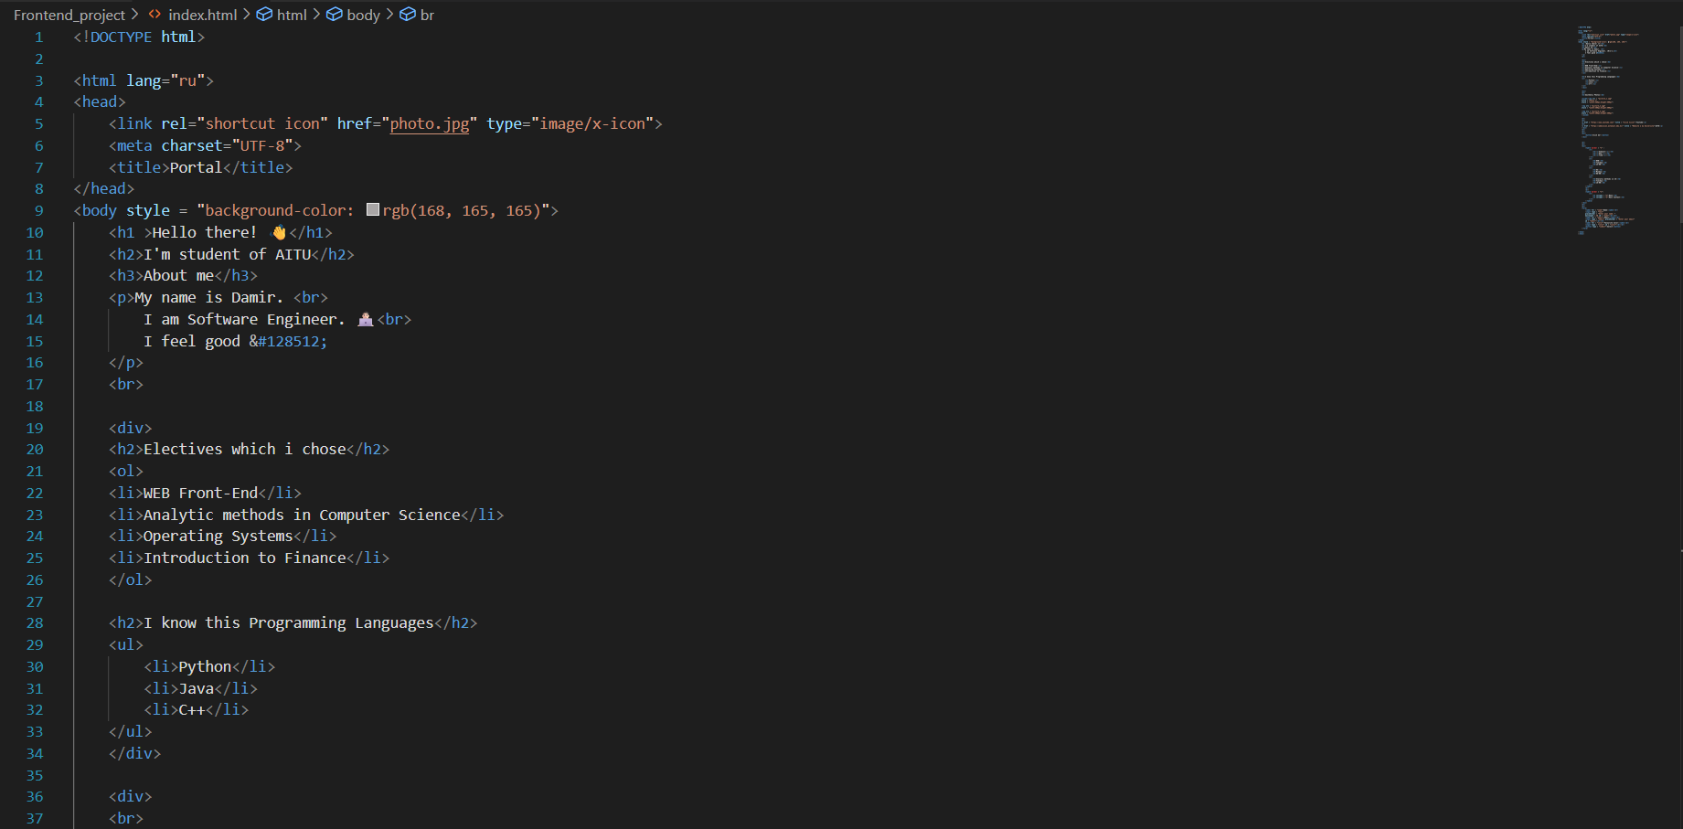

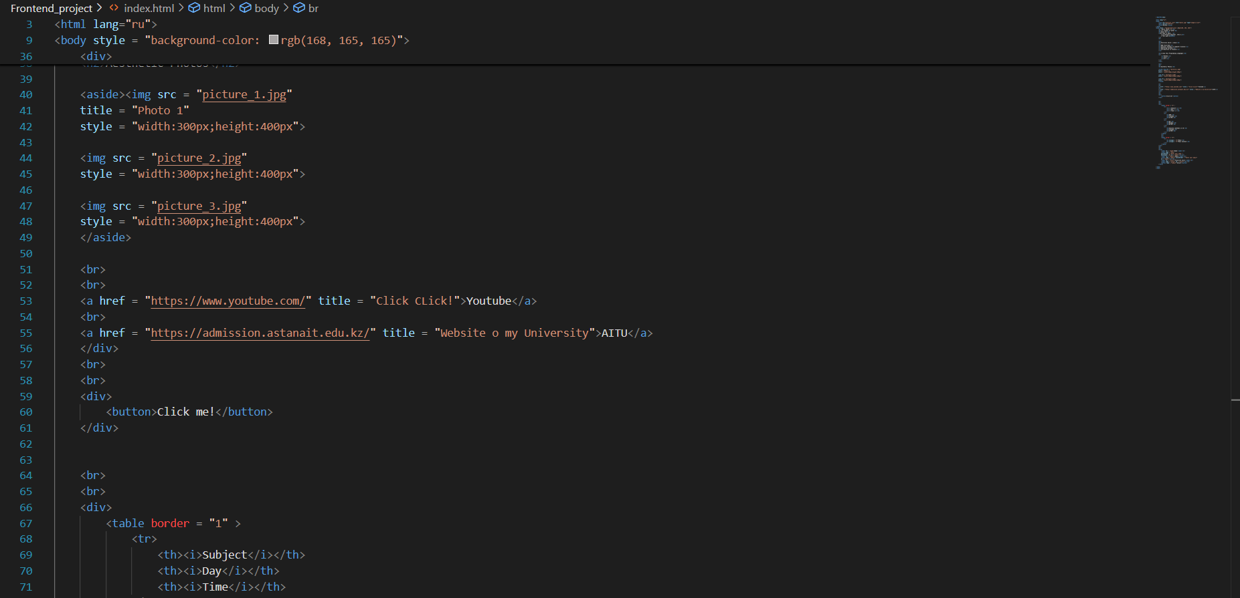

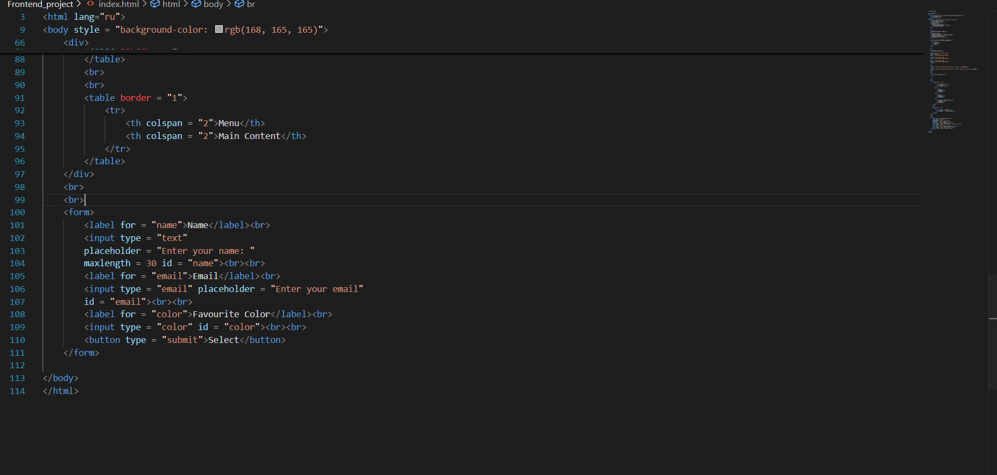

In the end, I published the site using GitHub Pages (or Netlify) and got a link to my first site.

  
