Gamson’s Mistrustful-Efficacious Political Participation Hypothesis in adolescents from 24 countries using the ICCS 2022 study.

Authors:
Daniel Miranda ^{(1,3,4)}
Felipe Sánchez-Barría^{(2,5)}

^{1.} Department of Psychology, Universidad de Chile
^{2.} Institute of Sociology, Pontificia Universidad Católica de Chile
^{3.} Centre for the Social Conflict and Cohesion Studies- COES
_{4.} Millennium Nucleus on Digital Opportunities and Inequalities - NUDOS
_{5.} Millennium Nucelus on Labor Politics and Colective Familiy Life - LABOFAM

Young people have played a prominent role in the global trend towards protest participation to the detriment of more traditional forms of political involvement. In recent years younger generations have not only been the drivers and protagonists of the protest but often exceeded their more peaceful and “normalized” forms to make their demands heard. What drives the youngest to get involved in these highly disruptive actions? What differentiates them from those who opt for other moderate avenues of political action? How and to what extent can the interaction between individual characteristics and context radicalize young people?
William Gamson (1968) proposed that low institutional trust and high internal political efficacy are optimal for political mobilization, including participation in protests and demonstrations. According to Gamson, mobilization against the government occurred primarily because of dissatisfaction with its performance but, at the same time, because they believed they could bring about social change through direct action. This paper follows this hypothesis, using the combination of institutional trust and political self-efficacy to generate typologies of “political participants” and assess the extent to which the expected pattern occurs considering different types of participation: conventional, disruptive and digital.
Using the International Civic and Citizenship Education Study 2022 - ICCS, around 80000 students from 24 countries participated (Schulz, 2025), we evaluated Gamson’s Mistrustful-Efficacious Political Participation Hypothesis. The key independent variable is the "Gamson typology", created by combining high and low levels of self-efficacy with high and low levels of institutional trust. To achieve this, we use the scale Students' citizenship self-efficacy (S_ CITEFF) and institutional trust variables. Students' citizenship self-efficacy is an IRT WLE scores with mean of 50 and standard deviation of 10 across equally weighted participating countries that met sample participation requirements, based on seven items regarding the degree of agreement with the following statements: IS4G29A: Argue your point of view about a controversial political or social issue, IS4G29B: Stand as a candidate in a [school election], IS4G29C: Organise a group of students in order to achieve changes at school, IS4G29D: Follow a debate about a controversial issue, IS4G29E: Write a letter or email to a newspaper giving your view on a current issue, IS4G29F: Speak in front of your class about a social or political issue, IS4G29G: Assess the credibility of information about political or social issues. The Students' trust in civic institutions (S_INTRUST) is an IRT WLE scores with mean of 50 and standard deviation of 10 across equally weighted participating countries that met sample participation requirements, based on six items assessing the degree of trust that students have in the following institutions: IS4G27A: The [national government] of [country of test], IS4G27B:The [local government] of your town or city, IS4G27C: Courts of justice, IS4G27D: The police, IS4G27E:Political parties, and IS4G27F: [Parliament/congress].
Once we have obtained self-efficacy and political confidence measures, we construct the "Gamson typology," consisting of four groups. To create this typology, we defined low and high levels of self-efficacy and political confidence using the 25% and 75% quartiles as cutoff points to categorize students within each group. Thus, those youth who scored above the 75% quartile on internal efficacy and below the 25% quartile on political confidence were categorized as "Dissidents." While respondents who scored above the 75% quartile on the efficacy and trust variables were labeled the "Assureds." On the other hand, the "Alienated" scored below the 25% quartile on self-efficacy and institutional trust. We classified as "Subordinates" those students who combined high trust in institutions, above the 75% quartile but were below the 25% quartile in terms of their self-reported efficacy level. Using quartiles as high and low cutoff points, rather than the mean, allows for a more apparent distinction between 'average' individuals and those with relatively more extreme attitudes or political orientations (Zhang & Lin, 2018). Finally, those youth who reported intermediate levels of self-efficacy and institutional trust are classified as "Moderates." While this category falls outside the "Gamson typology," it represents the sample's more "typical"(average) individuals.
In this study, we use three dependent variables that measure different forms of participation. The first, students' expected participation in legal activities (S_LEGACT), composed of various items that ask whether the students has the intention to participate in different actions: IS4G31A: Talk to others about your views on political or social issues, IS4G31B: Contact an [elected representative], IS4G31C: Take part in a peaceful march or rally, IS4G31D: Collect signatures for a petition, IS4G31E: Contribute to an online discussion about social or political issues and IS4G31F: Organise an online campaign in support of a political or social issue. The second variable is students' expected participation in illegal protest activities (S_ILLACT), composed of various items that ask whether the students has the intention to participate in different actions: IS4G31K Spray-paint protest slogans on walls, IS4G31L: Stage a protest by blocking traffic, and IS4G31M: Occupy public buildings as a sign of protest. The third variable is students' engagement with political or social issues using digital media (S_ENGDM), composed of various items that ask whether the students' involvement in different actions: IS4G13A: Using the internet to find information about political or social issues, IS4G13B: Posting your own content about a political or social issue on the internet or social media, IS4G13C: Sharing content about a political or social issue posted by someone else, IS4G13D: Commenting on an online post about a political or social issue, and IS4G13E: [Liking] an online post about a political or social issue.
We estimate a series of linear regression models to evaluate the hypothesis to assess the relationship between Gamson´s typology and political participation types. In all analyses, the reference category were "Moderates." Any significant difference observed in each category within the "Gamson typology" should thus be interpreted as a difference concerning the more typical group. The absence of a statistically significant association would imply that this category is not different from the "average" group concerning each specific type of participation.

The results show that the typology most willing to participate in legal activities is assured (efficacious and trusted) and then dissidents (efficacious and distrusted) in all countries, although differences are observed in the predicted levels for each country. Regarding illegal participation, as expected according to Gamson's hypothesis, those most willing to participate are dissidents, and then assured. However, in some countries, this order of priority is reversed, with assured students showing a greater willingness to participate in illegal activities. This demonstrates the relevance of self-efficacy as an explanatory factor for participation. Something similar to the pattern of unlawful participation occurs with digital participation. Assured and dissident students tend to show the highest levels of involvement using digital media.

In line with expectations, results showed that efficacious students (trusting and distrustful) are more willing to participate in the different types. These analyses are still in development, but they help demonstrate the relevance of the old-fashioned Gamson hypothesis. Although Gamson theorized about this during the 1960s, it still reflects its relevance in accounting for the changing and new forms of participation among the youth population. For the presentation, we will further compare countries and the regional differences that can be observed.

Keywords: Gamson’s Mistrustful-Efficacious Hypothesis, Digital participation, disruptive participation, conventional participation.

References
Gamson, William A. 1968. Power and Discontent. Homewood,Illinois: The Dorsey Press.
Schulz, W., Ainley, J., Fraillon, J., Losito, B., Agrusti, G., Damiani, V., & Friedman, T. (2025). Education for citizenship in times of global challenge: IEA international civic and citizenship education study 2022 international report. Springer Nature.
Afana, Y., Brese, F., Kowolok, H., Cortes, D. & Scgulz, W. (2024). ICCS 2022 User Guide for the International Database: IEA International Civic and Citizenship Education Study 2022. ICCS IEA.
Zhang, Xinzhi, and Wan-Ying Lin. 2018. “Stoking the Fires of Participation: Extending the Gamson Hypothesis on Social Media Use and Elite-Challenging Political Engagement.” Computers in Human Behavior 79 (February):217–26. https://doi.org/10.1016/j.chb.2017.10.036.

Tables and figures
Table 1. Distribution of typologies by country
Country | Moderates | Alienated | Subordinates | Assured | Dissidents
BGR | 0.59 | 0.10 | 0.04 | 0.09 | 0.08
BRA | 0.59 | 0.10 | 0.04 | 0.12 | 0.06
COL | 0.57 | 0.15 | 0.03 | 0.10 | 0.08
CYP | 0.58 | 0.12 | 0.04 | 0.09 | 0.08
DNK | 0.58 | 0.09 | 0.06 | 0.12 | 0.06
DNW | 0.55 | 0.10 | 0.06 | 0.11 | 0.06
DSH | 0.57 | 0.11 | 0.08 | 0.13 | 0.08
ESP | 0.64 | 0.09 | 0.05 | 0.09 | 0.07
EST | 0.56 | 0.11 | 0.07 | 0.15 | 0.08
FRA | 0.61 | 0.11 | 0.07 | 0.08 | 0.08
HRV | 0.70 | 0.10 | 0.04 | 0.07 | 0.07
ITA | 0.66 | 0.09 | 0.07 | 0.09 | 0.07
LTU | 0.48 | 0.12 | 0.11 | 0.17 | 0.09
LVA | 0.61 | 0.09 | 0.06 | 0.11 | 0.07
MLT | 0.61 | 0.11 | 0.05 | 0.11 | 0.07
NLD | 0.61 | 0.10 | 0.07 | 0.11 | 0.07
NOR | 0.60 | 0.10 | 0.04 | 0.11 | 0.06
POL | 0.64 | 0.10 | 0.06 | 0.07 | 0.11
ROU | 0.65 | 0.11 | 0.05 | 0.09 | 0.08
SRB | 0.59 | 0.11 | 0.06 | 0.13 | 0.08
SVK | 0.65 | 0.09 | 0.07 | 0.09 | 0.07
SVN | 0.68 | 0.10 | 0.05 | 0.10 | 0.05
SWE | 0.57 | 0.12 | 0.06 | 0.11 | 0.08
TWN | 0.55 | 0.12 | 0.11 | 0.16 | 0.06

Figure 1. Predicted values for each typology on expected legal participation
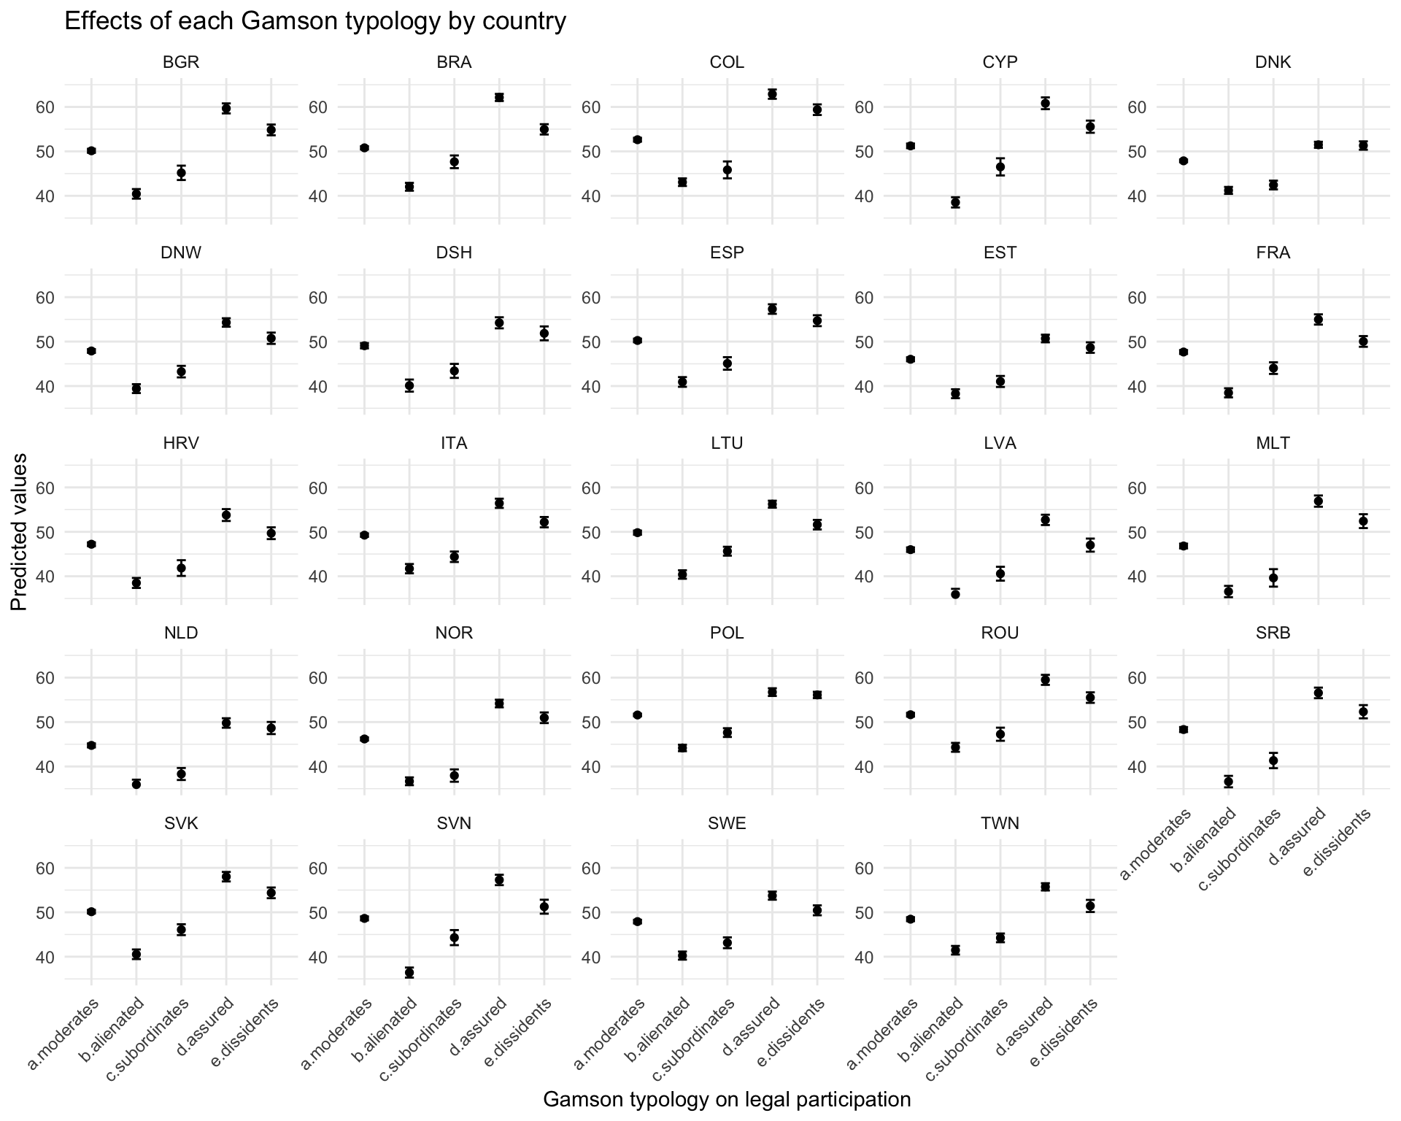

Figure 2. Predicted values for each typology on expected illegal participation
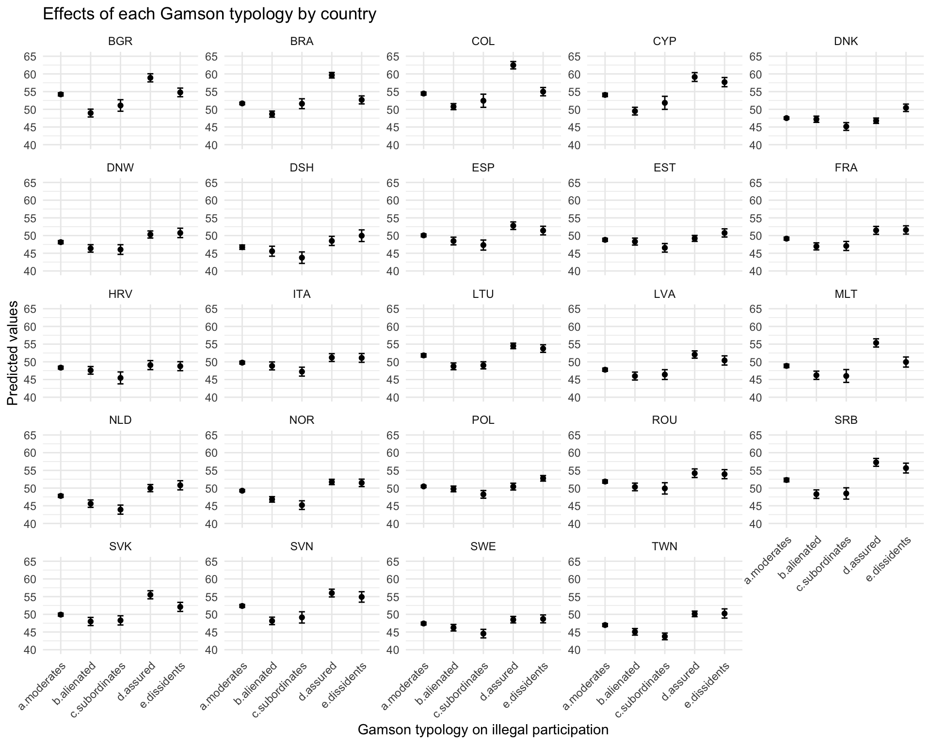

Figure 3. Predicted values for each typology on digital participation
