Final Project Report: Hand-made Akinator

# Game Concept

- The project's centerpiece is an interactive game that draws inspiration from the popular Akinator game.   
 - Utilizing a Decision Tree Classifier, the game intelligently predicts comic book characters based on a series of user responses.   
 - This concept not only demonstrates the application of decision trees in machine learning but also creates an engaging user experience.

# Decision Tree Structure

- The decision tree is the backbone of the game's logic.   
 - Built using various character attributes as nodes, the tree navigates through these nodes based on user responses.   
 - Each decision point in the tree correlates with a character attribute, guiding the game towards a potential character prediction.



Figure: Decision Tree Visualization

# Database of Characters

- The game leverages a comprehensive database containing detailed attributes of comic book characters.   
 - Attributes include alignment, gender, eye color, race, and more, providing a rich dataset for the decision tree to operate on.   
 - This database is pivotal in training the decision tree model, enabling it to make accurate and diverse character predictions.

|  |  |  |  |  |  |  |  |  |  |
| --- | --- | --- | --- | --- | --- | --- | --- | --- | --- |
| Name | Alignment | Gender | EyeColor | Race | HairColor | Publisher | SkinColor | Height | Weight |
| Alfred Pennyworth | good | Male | blue | Human | Black | DC Comics | - | 178 | 72 |
| Ant-Man | good | Male | blue | Human | Blond | Marvel Comics | - | 211 | 122 |
| Anti-Venom | - | Male | blue | Symbiote | Blond | Marvel Comics | - | 229 | 358 |
| Aqualad | good | Male | blue | Atlantean | Black | DC Comics | - | 178 | 106 |
| Aquaman | good | Male | blue | Atlantean | Blond | DC Comics | - | 185 | 146 |

# Console Interface Details

- The user interacts with the game through a console-based interface.   
 - This interface is designed for simplicity and ease of use, allowing users to respond to questions, navigate through the game, and receive predictions.  
 - The interface's intuitive design ensures a seamless and enjoyable user experience, fundamental to the game's appeal.

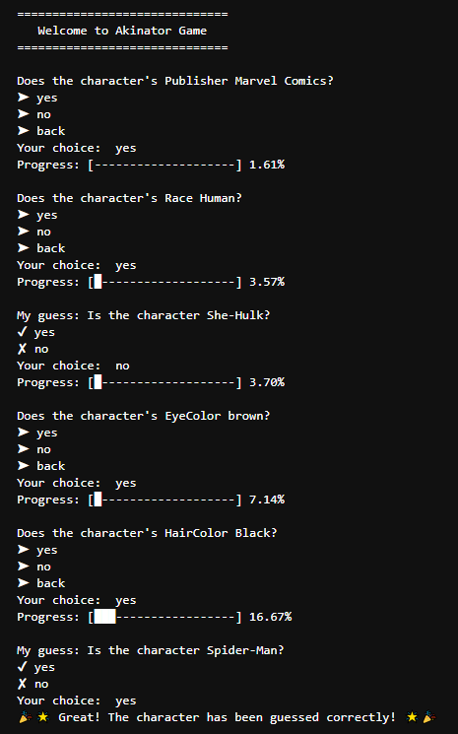

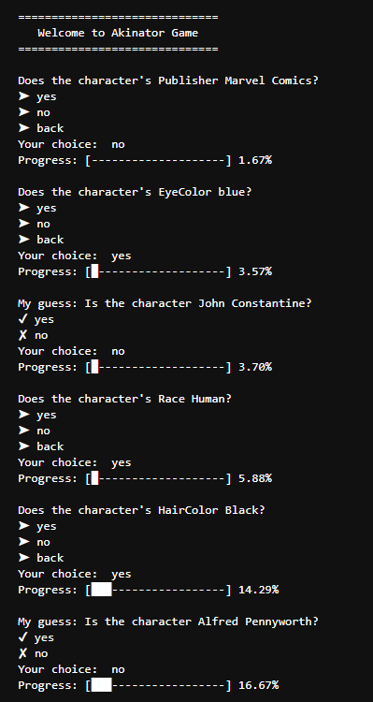 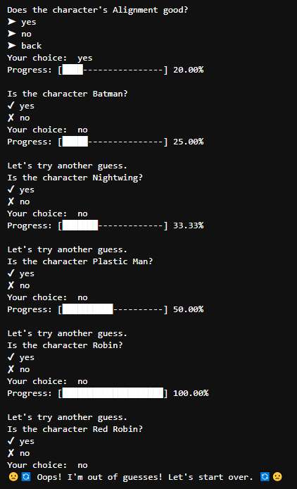

Figure: Placeholder for Console Interface Test Run Screenshots

# Conclusion and Recommendations

- This documentation aims to provide a clear and detailed understanding of the 'Hand-made Akinator' project, highlighting its innovative use of machine learning algorithms and user-centered design.