Multi-stage code generation: Using different LLM’s at different stages
Full First Author¹, Full Second Author^{2, *} and Full Third Author³ (TNR 12pt., centred)
¹Full affiliation of first author, including country (in English, TNR 10pt. centred)
²Full affiliation of second author, including country (in English)
³List all affiliation in the same way (in English)
*Corresponding author
Abstract

Purpose – Text, text, text, text, text, text, text, text, text, text, text, text, text, text, text, text, text, text, text, text, text, text, text, text, text, text, text, text, text, text, text, text, text, text, text, text, text, text, text, text, text, text, text, text, text, text, text, text, text, text.
Design/Methodology/Approach – Text, text, text, text, text, text, text, text, text, text, text, text, text, text, text, text, text, text, text, text, text, text, text, text, text, text, text, text, text, text, text, text, text, text, text, text, text, text, text, text, text, text, text, text, text, text, text, text, text, text.
Findings – Text, text, text, text, text, text, text, text, text, text, text, text, text, text, text, text, text, text, text, text, text, text, text, text, text, text, text, text, text, text, text, text, text, text, text, text, text, text, text, text, text, text, text, text, text, text, text, text, text, text.
Originality/Value – Text, text, text, text, text, text, text, text, text, text, text, text, text, text, text, text, text, text, text, text, text, text, text, text, text, text, text, text, text, text, text, text, text, text, text, text, text, text, text, text, text, text, text, text, text, text, text, text, text, text.
Keywords – Machine Learning; Deep Learning.
Paper Type – Research paper.

Introduction
In today’s world, where computers play an essential role in our daily lives and AI has reached incredible heights of innovation, we are constantly exploring new ways to apply emerging technologies. However, one area where AI has not yet made a significant impact in reaching a wider audience is programming languages.
This paper introduces a multistep based architecture designed to simplify geospatial analysis using open-source large language models (LLMs). These models have transformed how humans interact with computers by advancing natural language processing (NLP). LLMs are effective because of their advanced design and the large datasets they are trained on. While many LLMs are expensive and proprietary, our focus is on using free, open-source models to make these tools more accessible.
A key element of this study is the LUCAS dataset, which stands for Land Use/Cover Area Frame Statistical Survey. LUCAS provides detailed information on soil properties, land use, and land cover across Europe. This dataset is critical for understanding soil health, land degradation, and environmental changes, making it an important resource for scientists and policymakers.
Our project uses the LUCAS dataset to address common challenges in geospatial analysis, such as working with complex spatial data, combining different data sources, and visualizing information. By using open-source LLMs, we aim to create an easy-to-use tool that makes geospatial analysis more accessible to everyone.
By allowing users to input natural language queries, our assistant simplifies geospatial and statistical analysis, eliminating the need for advanced technical skills. This paper evaluates how well open-source LLMs perform in understanding queries, analyzing geospatial data, and producing accurate results. Ultimately, our goal is to make geospatial analysis tools more user-friendly and accessible, using open-source LLMs to bridge the gap between complex data and everyday users.

Related work
In this section, an extensive literature overview is provided. The most important findings and methodological issues are described and summarized with references to the References section of the paper.

Methodology
This research focuses on utilizing publicly available pretrained large language models (LLMs) hosted on the Hugging Face platform. The primary aim is to design an intelligent assistant tailored to simplify statistical analysis. The assistant is specifically intended for individuals who understand statistical concepts but lack the programming skills necessary to implement them. By bridging this gap, the assistant enables users to carry out complex statistical queries and analysis through natural language input, eliminating the need for coding knowledge.
The system is designed to help the user find, calculate or visualize specific data from the LUCAS dataset. Based on a user query, it will perform multiple steps to find the best way to execute the python code and present the user with the final solution. The final solution can be in the form of numbers, graph or text.

Dataset
In this research we used LUCAS (Land Use and Coverage Area frame Survey) Soil dataset from 2018. It is a comprehensive version of the LUCAS survey, providing high-quality data on land use, land cover, and soil properties across the European Union. The dataset provides detailed information about the land use and land cover, soil properties such as texture, organic carbon, pH levels and others. Additionally, it contains subsoil properties such as organic carbon content and calcium carbonate content at bigger depths (20-30cm) and geospatial and administrative data.

Architecture
On Figure 1 system architecture is displayed. First, we receive the user query, that query is then embedded in the system prompt. With the user query, system prompt also contains the description of the columns together with the types of the columns. Descriptions of the columns are taken from the official documentation of the dataset. This ensures that the Instruction LLM has a complete understanding of the dataset's structure and semantics, reducing ambiguity and increasing the quality of the generated instructions. We request from the Instruction LLM the response in the JSON format displayed in the textbox below.
The transform part of the response should contain detailed instructions on what should be done in order to fully prepare the data for the visualization part. These instructions should contain all the steps that the next LLM needs to write the python code for. It should contain expressions like “keep only x and y columns”, “filter the data with x less than 4”, “group the data by x and return mean value by group only for groups that have more than 4 entries” etc. This modular and detailed approach ensures that the transformation is explicitly defined and aligns with the user’s intent. The visualize part of the response should contain only the instructions on how the processed data should be displayed – whether the code the LLM will write should plot some graph, only print a value or something else. By isolating transformation from visualization, the process becomes more structured and easier to debug or extend.
{
"transform": "A single string describing, in detail, the part of the objective that transforms the data. Results are in 'transformed_gdf' GeoDataFrame. Include specific column names and operations. Do NOT include any code.",
"visualize": "A single string describing, in detail, the part of the objective that visualizes specified data from 'transformed_gdf' GeoDataFrame. Visualizations may include printing some result, outputting graphs or overlaying some data on map of Europe. Include specific column names and operations. Do NOT include any code."
}

Once we receive the response from the Instruction LLM, we pass the transform instructions to the Coder LLM. This request is also enriched with the system query. It contains the description of the dataset in exactly the same way as the instruction prompt and we also add the list of the available pandas functions we suggest it to use. Additionally, we instruct the Coder LLM only to return the python code without additional text, tell it where the data about the map of Europe is stored and request it to put the final transformation result in specified variable. The preloaded information about where the map of Europe is stored, along with instructions to place the final transformed dataset into a specific variable, further reduces complexity and the risk of error.
From the response of the Coder LLM we extract the python code and clean it by removing all the comments, import statements, print statements and the empty lines. This cleaning step ensures that the code is streamlined and free of unnecessary clutter, making it more reliable and efficient for execution. After cleaning the code, we execute it and retrieve the description of the data by calling pandas.Dataframe.info() function. This intermediate validation step guarantees that the visualization LLM receives accurate information about the transformed dataset, avoiding potential mismatches between transformation and visualization phases.
As already mentioned, for the visualization part of the task we embed the information about the transformed dataset in the system query. Additionally, we add the detailed visualization instructions from the Instruction LLM, the description of dataset containing the map of Europe that will be preloaded and the list of the functions for visualization we recommend using. This ensures that the visualization LLM has all the context it needs to generate accurate and effective visualization code. By embedding detailed metadata at every step, the process minimizes user effort and reduces the likelihood of errors. This is the last request of our pipeline, and it is sent to Coder LLM.
Once we receive the response, we clean the code in the same way as we cleaned the code generated for transformation, stack those two codes together and run it to retrieve the result.

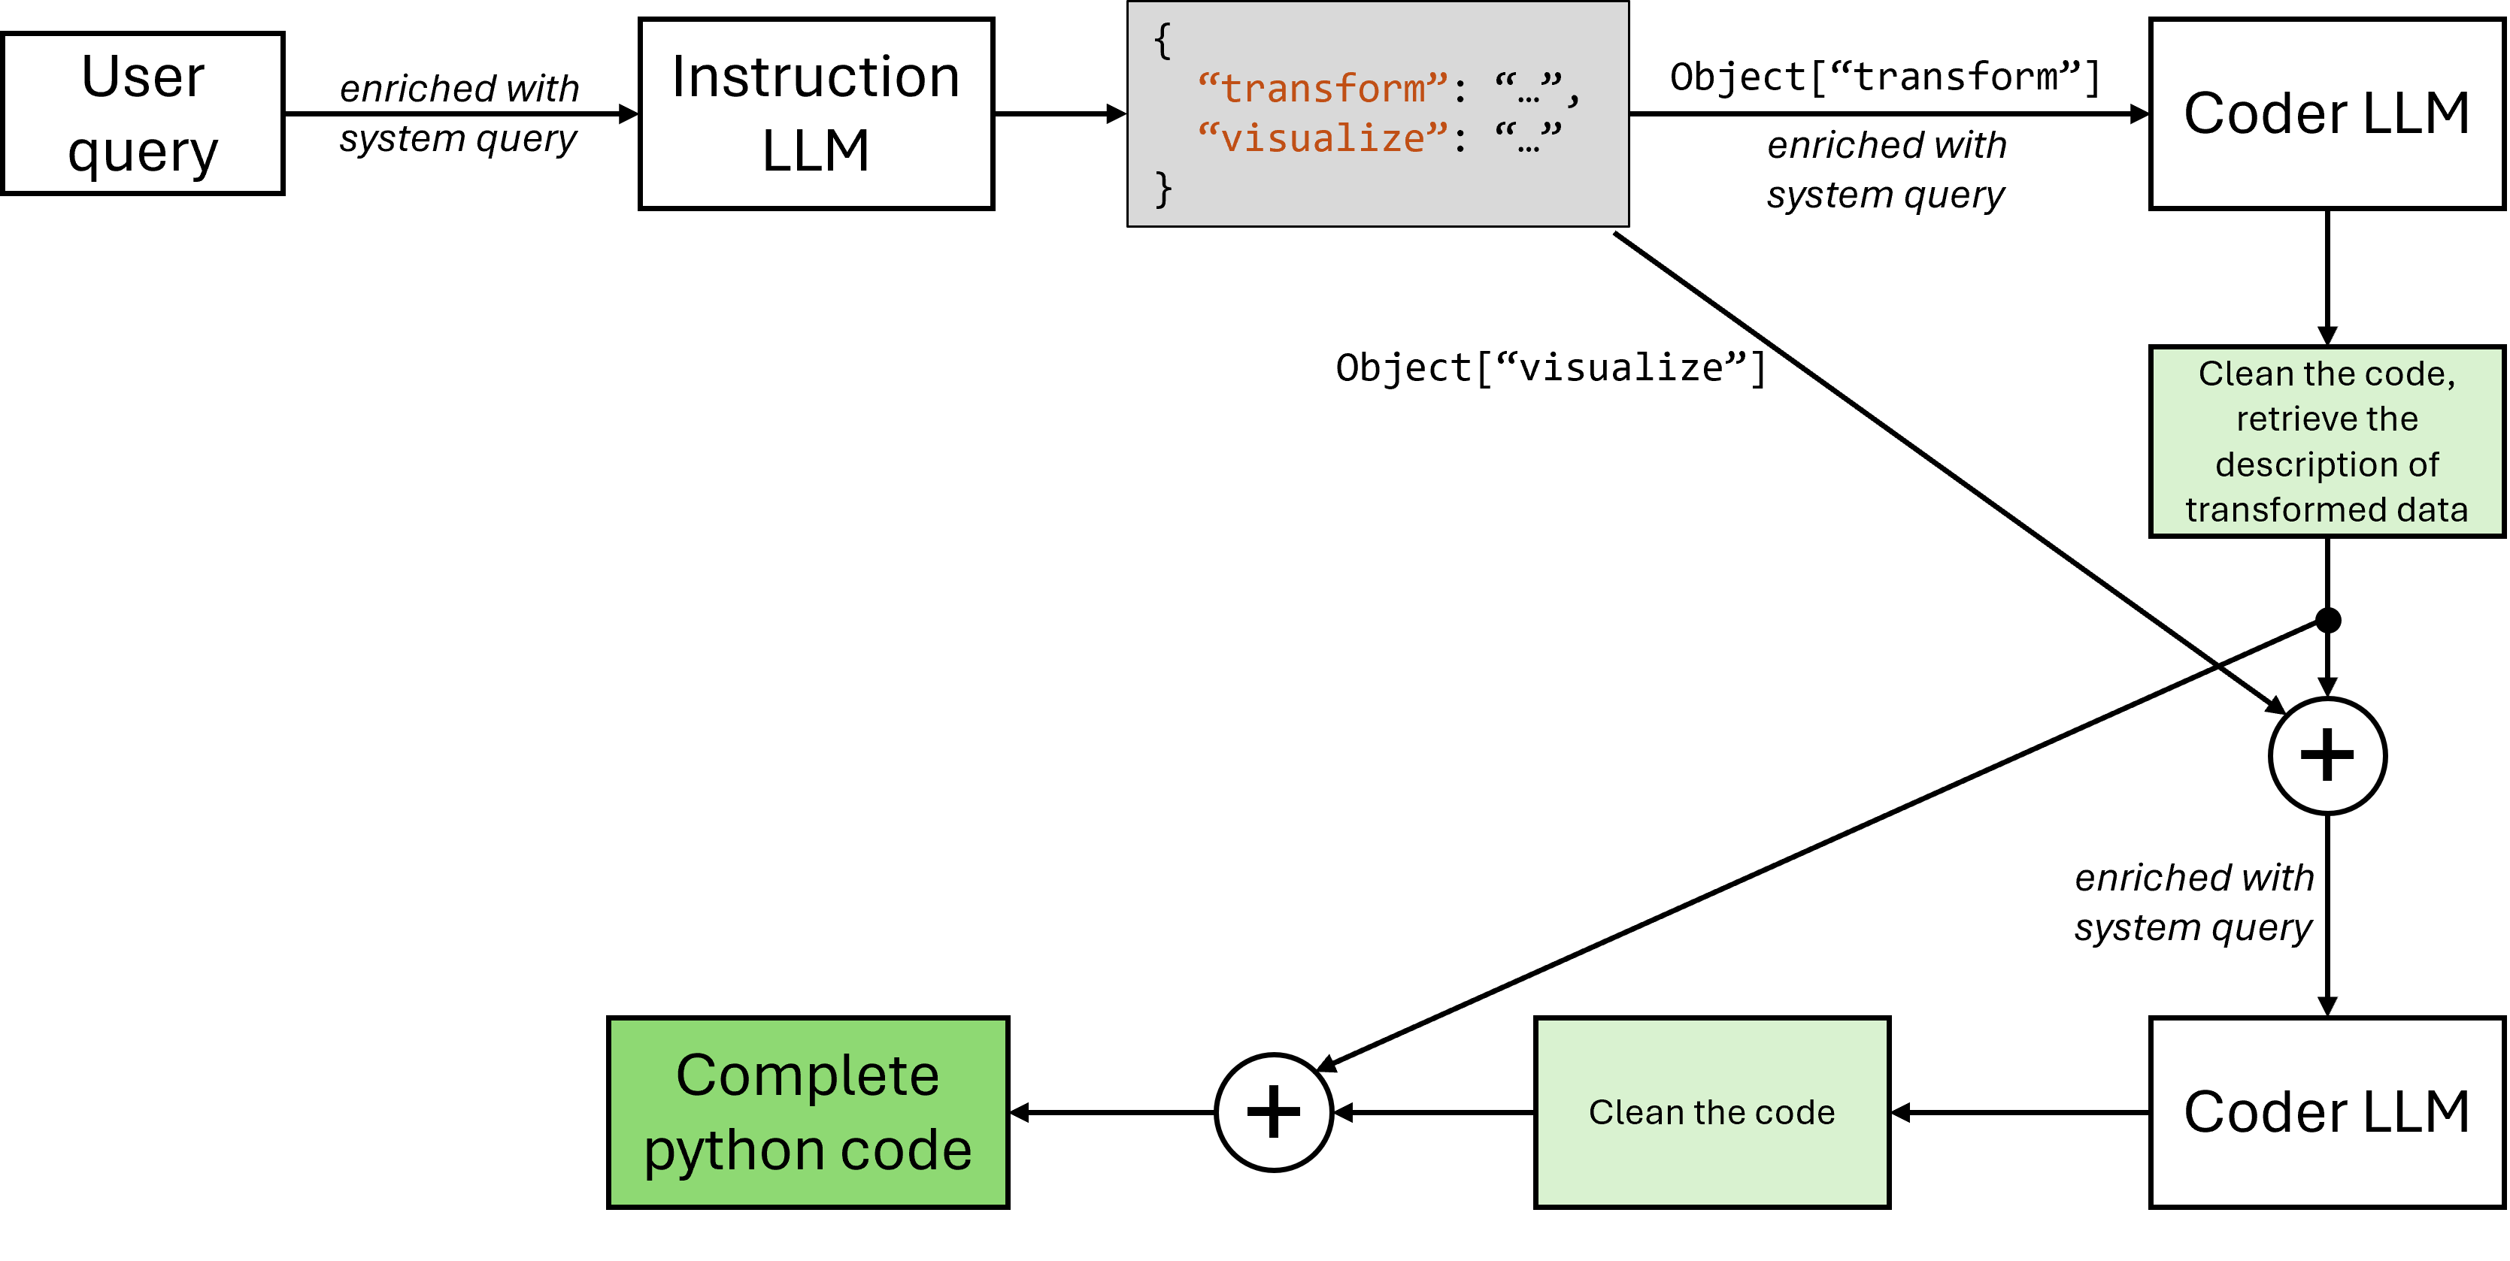
Figure 1 System architecture
The proposed approach is effective because it breaks the process into clear, modular steps, ensuring clarity and reducing complexity. Embedding detailed metadata and dataset descriptions at each stage enables the LLMs to generate accurate and context-aware outputs. Intermediate validation, such as inspecting transformed data, ensures alignment between transformation and visualization. By guiding the Coder LLM with curated functions and focusing it solely on code generation, the pipeline produces efficient and reliable code. Additionally, the structured design enhances flexibility, scalability, and reproducibility, while streamlining the user experience for consistent and high-quality results. It also gives an opportunity to validate each stage of the code generation independently. The code can be tested and executed ensuring correctness at each stage. We can also implement some retry mechanisms that will retry the query to the Coder LLM if the current solution does not satisfy some requirements. For instance, if the transformation code fails or produces unexpected results, the system can automatically request a revised response from the Coder LLM without impacting the subsequent visualization phase.

Results (TNR 14pt., bold)
The article must be divided into chapters. Introduction and conclusion are obligatory. It is recommended to adjust the body of the paper to the common organization structure of scientific papers – IMRaD - Introduction, Methods, Results, and Discussion).

Discussion (TNR 14pt., bold)
5.1 Conclusions
5.2 Theoretical implications
5.2 Practical implications
5.3 Limitations and future research
References (TNR 12pt. bold)
References in text should have this form (surname, year), for example:
1 author: (Krugman, 2012)
1 author and the same year of publication: (Hoffman, 2012, A), (Hoffman, 2012, B)
2 authors: (Krugman & Hoffman, 2014)
3 authors: (Hoffman et al., 2012)

References (TNR 14pt., bold)
For each work shown in the list of references must be a reference in the text. All citations in the text and all references must meet APA styles (American Psychological Association 7th edition – more information http://www.apastyle.org/).

(Book style - Author, year. Title (in italics). Publisher, location of publisher.)
Cichocki, A. and Unbehaven, R., (1993). Neural Networks for Optimization and Signal Processing, 1st ed. Chichester, U.K.: Wiley.
Chen, W. K. (1993). Linear Networks and Systems, Belmont, CA: Wadsworth, pp. 123-135.
(Journal - Author, year. Paper title. Journal name (in italics), volume and issue numbers, inclusive pages.)
Chen, S., Mulgrew, B. and Granta, P. M. (1993). “A clustering technique for digital communications channel equalization using radial basis function networks,” IEEE Trans. on Neural Networks, vol. 4, pp. 570-578.
Hill, R. M. (1997). The single-vendor single-buyer integrated production–inventory model with a generalized policy, European Journal of Operational Research, vol. 97, pp. 493-499.
(Online Sources style)
Vidmar, R. J. (August 1992). On the use of atmospheric plasmas as electromagnetic reflectors. IEEE Trans. Plasma Sci. [Online]. 21(3). pp. 876-880. Available: http://www.halcyon.com/pub/journals/21ps03-vidmar
(Conference paper or contributed volume - Author, year, paper title. Proceedings title (in italics). City, country, inclusive pages.)
Beck, K. and Ralph, J. (1994). Patterns Generates Architectures. Proceedings of European Conference of Object-Oriented Programming. Bologna, Italy, pp. 139-149.

