# Questions:

## How should the system display a bad request to the user? Eg navigate to the URL: <http://computer-database.gatling.io/computers/test> the following is displayed at the moment and the application needs to be reloaded to return to the homepage:

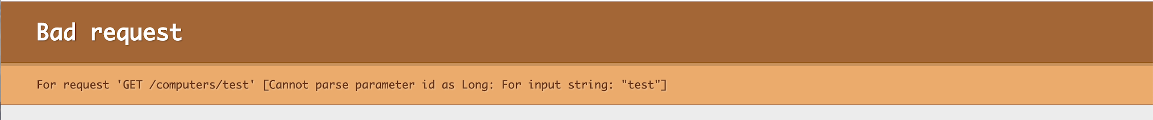

## How should the system display a ‘page not found’ to the user? Eg edit the following URL to an out of bounds value: <http://computer-database.gatling.io/computers/808> the following is displayed at the moment and the application needs to be reloaded to return to the homepage:



 