DS 5216 - Artificial Intelligence
Programming Assignment 02

Student ID: DST/24/27
Report Document

1. Introduction
This report presents a computer vision solution for detecting and tracking players in short sports video clips. The aim was to build a practical pipeline that can take real sports footage, identify the players in each frame, and then follow their movement across the video.
The solution uses a YOLO11n object detection model for player detection and ByteTrack for player tracking. For the bonus requirement, a YOLO pose model was also applied to estimate player body keypoints such as shoulders, elbows, wrists, hips, knees, and ankles. This helped the project move beyond simple bounding boxes and show how player posture can also be analyzed.
Overall, the workflow covers dataset preparation, automatic label generation, model fine-tuning, validation, tracking, keypoint detection, and output visualization.

2. Dataset Preparation
The dataset was created using sports clips collected from publicly available YouTube sources. Each selected video was trimmed to 8 seconds, which fits within the required duration range of 5 to 10 seconds per clip. After trimming, frames were extracted at 10 frames per second so that the model could learn from individual images.
The extracted frames were split into training and validation sets using an 80:20 ratio. The training set was used to fine-tune the detection model, while the validation set was used to check how well the model performed on unseen frames. Since the main task was player detection and tracking, the dataset used a single class: player.
Dataset Item | Description
Input videos | 5-10 sports clips selected from public YouTube sources
Clip duration | 8 seconds per clip
Frame extraction rate | 10 frames per second
Train/validation split | 80% training and 20% validation
Training class | player

3. Methodology

3.1 Player Detection
For player detection, a pretrained YOLO11n model was first used to detect people in the extracted sports frames. Since the COCO dataset already includes the person class, the pretrained model was able to detect players without requiring manual labeling at the initial stage.
The detected person bounding boxes were then converted into YOLO label format and used as training labels for the custom player dataset. Each label contained the class ID and the bounding box values: x-center, y-center, width, and height. All coordinate values were normalized between 0 and 1, as required by the YOLO annotation format.
After the dataset was prepared, YOLO11n was fine-tuned using the generated sports frames and labels. This helped the model adapt to the selected sports scenes and improve its ability to detect players in similar video frames.

3.2 Player Tracking
After training, the best YOLO model weights were used for the tracking stage. ByteTrack was applied to follow detected players across consecutive frames in each video clip.
The main purpose of tracking was to keep a consistent identity for each player while they moved through the video. Instead of treating every frame independently, the system could follow the same detected player over time and display tracking IDs in the output video. This made it easier to visually understand player movement throughout the clips.

3.3 Keypoint Detection Bonus
For the bonus task, a YOLO pose estimation model was used to detect player body keypoints. This extended the project beyond player detection by identifying important body joints and estimating player posture in each frame.
The pose model detects 17 COCO-style human keypoints, including the shoulders, elbows, wrists, hips, knees, and ankles. These keypoints are connected to form a skeleton-like structure over the player body. This is similar to OpenPose because it focuses on understanding human body structure and movement from images or video frames.

4. Training Configuration
The model was trained in Google Colab using GPU acceleration. The main training settings are summarized below.
Parameter | Value
Model | YOLO11n
Image size | 1280 during training; 640 used for safer validation and tracking after Colab memory limitations
Epochs | 80
Batch size | 8 during training
Patience | 20
Optimizer | Ultralytics auto optimizer
Hardware | Google Colab Tesla T4 GPU

5. Results
The fine-tuned YOLO11n detector produced strong results on the validation set. The model was especially effective when players were clearly visible and not heavily occluded.
Metric | Value | Interpretation
Precision | 0.83899 | Most predicted player boxes were correct.
Recall | 0.78985 | The model detected most visible players, although some were missed.
mAP50 | 0.87562 | Strong detection quality at an IoU threshold of 0.50.
mAP50-95 | 0.71212 | Good localization performance across stricter IoU thresholds.

5.1 Model and Component Comparison
Model / Component | Purpose | Result | Comment
Pretrained YOLO11n | Person detection and pseudo-label generation | Used to create the initial player labels | Useful for reducing manual labeling effort
Fine-tuned YOLO11n | Player detection | Precision 0.839, Recall 0.790, mAP50 0.876 | Best quantitative detector in this implementation
YOLO11n + ByteTrack | Player tracking | Generated tracked output videos | Evaluated visually using the tracking output
YOLO Pose | Keypoint detection bonus | Detected 17 body joints | Evaluated visually using pose screenshots and videos

5.2 Output Evidence
The following screenshots provide visual evidence of the training process, detection outputs, and pose estimation results.
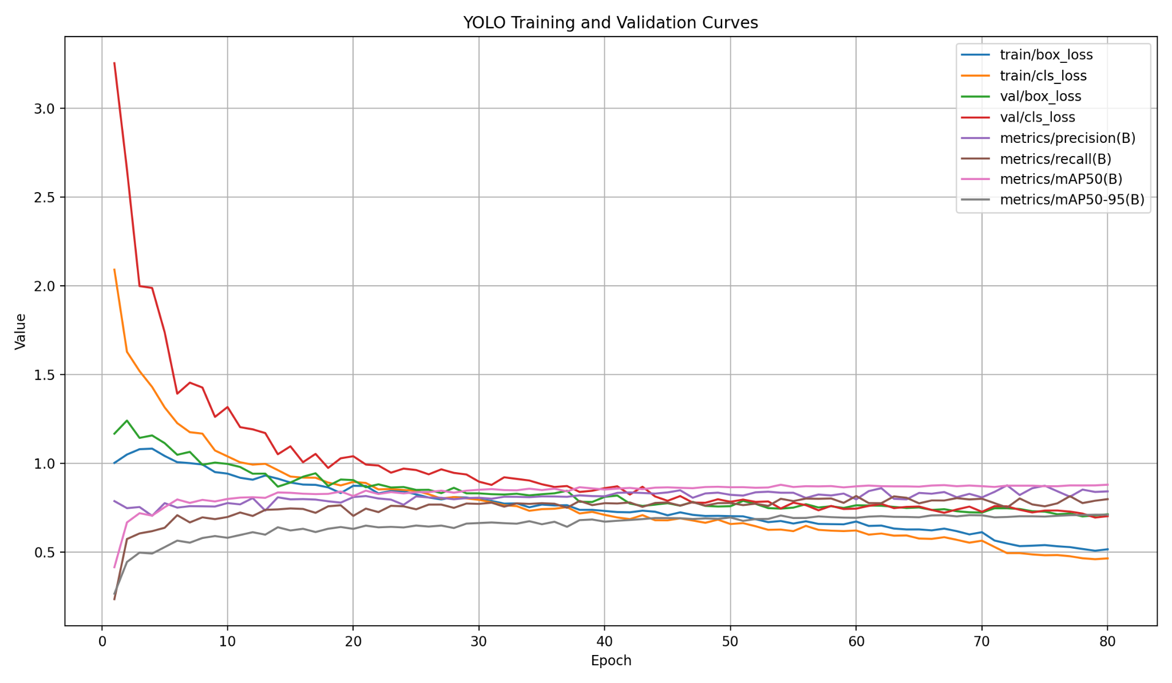
Figure 1: YOLO training and validation curves across 80 epochs.
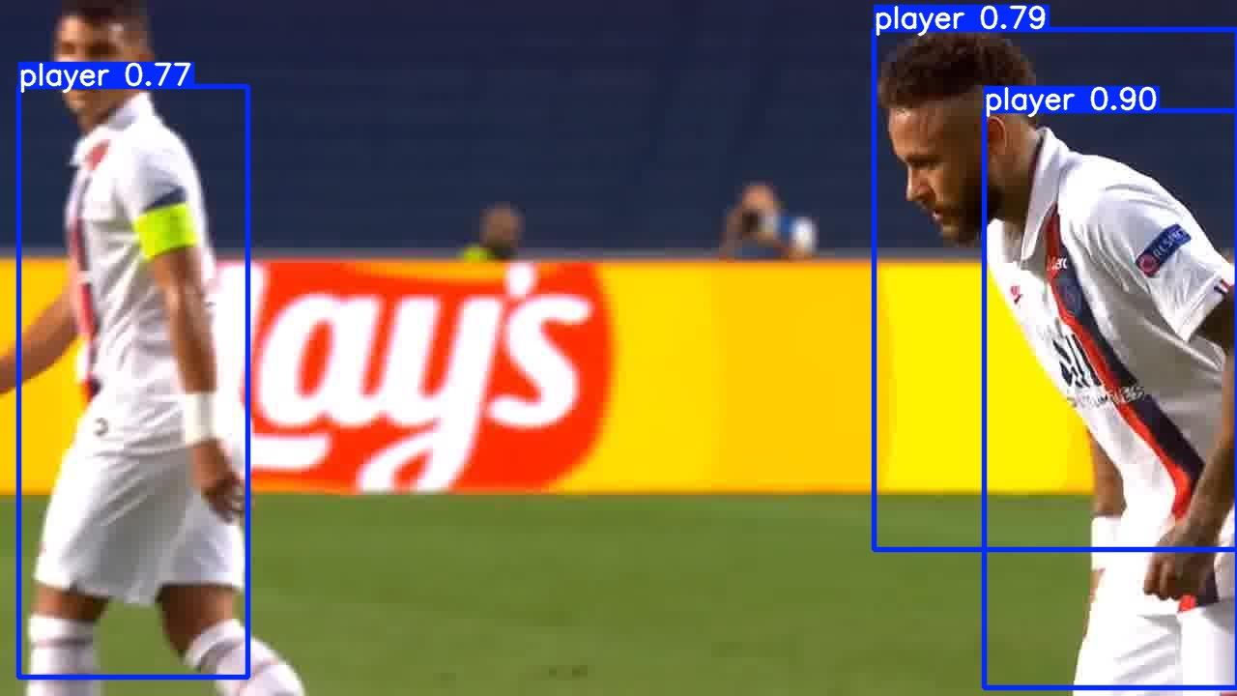
Figure 2: Validation output from the fine-tuned YOLO11 player detection model.
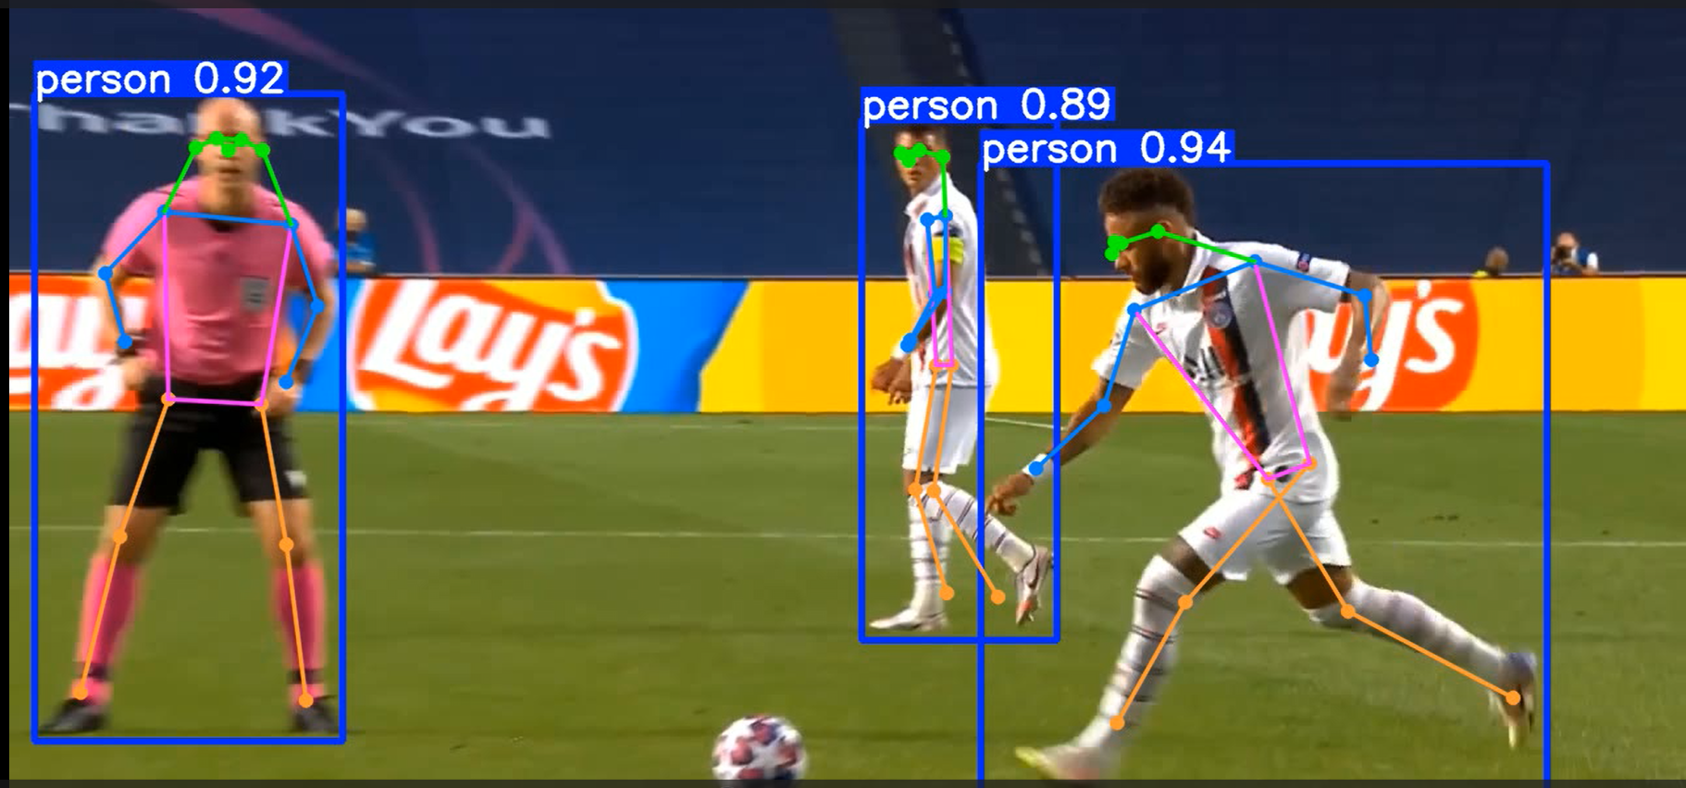
Figure 3: Pose/keypoint output showing body joints and skeleton structure for detected players.
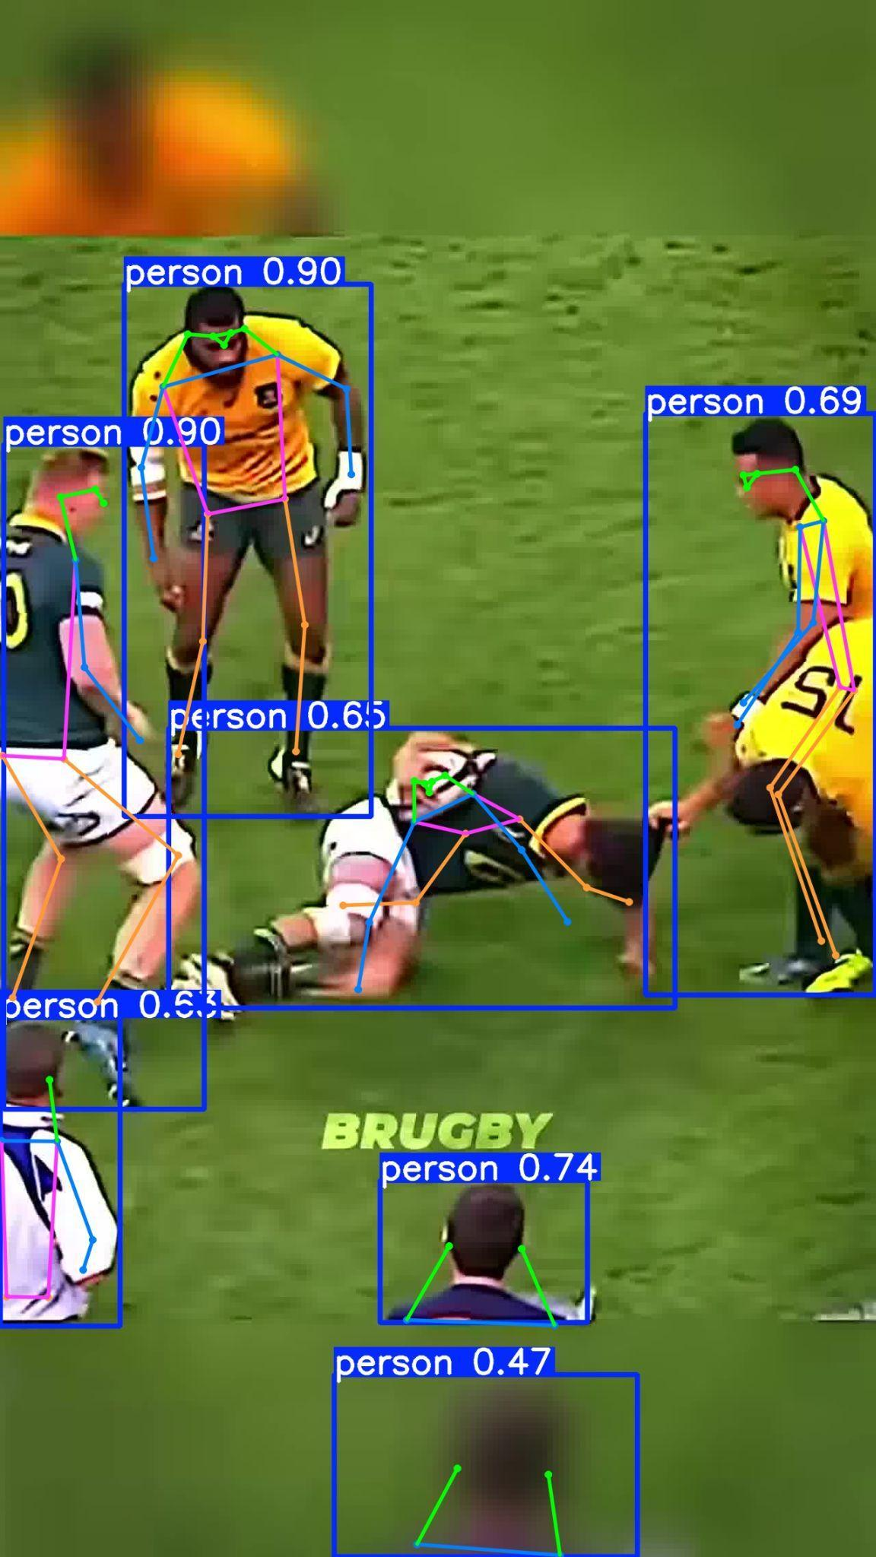
Figure 4: Pose/keypoint output in a crowded rugby scene.

6. Discussion
The player detection model performed well in most sports scenes, especially when the players were clearly visible in the frame. The mAP50 score of 0.8756 shows that the model was able to detect and localize players accurately in most validation images. The mAP50-95 score of 0.7121 also shows that the model maintained a good level of performance even when stricter bounding box matching conditions were applied.
However, the recall value of 0.7898 shows that the model did not detect every player in all frames. Some players were missed in challenging situations such as crowded scenes, motion blur, distant players, occlusion, unusual camera angles, or when players blended into the background. Since tracking depends on consistent detections, missed detections can sometimes lead to temporary identity loss in the tracked videos.
The keypoint detection outputs were useful for understanding body posture and movement, but they were produced using a pretrained pose model. As a result, the pose model was not specifically adapted to the selected sports dataset.

7. Limitations
- The labels were generated automatically using a pretrained detector, so some label noise may be present.
- Small, distant, or partially occluded players may be missed by the detector.
- Fast camera movement and motion blur can reduce both detection and tracking accuracy.
- The dataset is relatively small, so the model may not generalize perfectly to all sports, stadiums, or camera views.
- Keypoint detection was applied using a pretrained pose model and was not fine-tuned on the collected sports dataset.

8. Possible Improvements
- Manually review and correct the automatically generated YOLO labels to reduce label noise.
- Increase the number and diversity of training clips across different sports, camera angles, and lighting conditions.
- Compare YOLO11n with larger models such as YOLO11s or YOLO11m to check whether accuracy improves.
- Train and validate using a consistent image size if sufficient GPU memory is available.
- Fine-tune a pose estimation model using sports-specific keypoint examples.
- Evaluate tracking with tracking-specific metrics if ground-truth track IDs are available.

9. Conclusion
The assignment objective was achieved by building a YOLO-based player detection model and applying ByteTrack for player tracking in sports videos. The fine-tuned YOLO11n model achieved Precision 0.8390, Recall 0.7898, mAP50 0.8756, and mAP50-95 0.7121 on the validation set.
The results show that the model can detect players effectively in many sports scenes, especially when players are visible and not heavily occluded. The bonus keypoint detection task was also completed using a YOLO pose model, which identified human body joints and generated skeleton-style pose outputs. With more labeled data and further tuning, the solution could be improved for more complex sports videos and crowded scenes.

