SCHOLARLY-WORK FOUNDATIONS TEACHING PAPER
Normalization as an Interpretive Intervention
A structured paper built from a fictional postcard catalogue
Version 1.0 | 2 September 2026
Original fictional teaching material — not historical evidence

Contents
Update this field in Word or LibreOffice Writer to generate the table of contents.
Interface note: field-update commands and labels can change between versions. The stable check is that headings populate the contents list and its links reach the right sections.

Abstract
This fictional teaching study asks how documented normalization decisions change what a small postcard catalogue allows a reader to find and compare. Eight retained records show that grouping variant object types and place labels can improve comparison, but only when source strings, exclusions and unresolved cases remain visible. The exercise demonstrates a reproducible scholarly method; it does not offer historical evidence about real collections.
Keywords: metadata, normalization, provenance, catalogue, data cleaning

1. Research question and claim
How do documented normalization decisions change what a small fictional postcard catalogue allows a reader to find and compare? The provisional claim is that normalization improves comparison across inconsistent descriptions, while remaining defensible only when the cleaned table preserves source expressions, names exclusions and exposes uncertainty.

1.1 Distinguishing description and interpretation
The raw table contains four source expressions for two related object types. That is a description of the teaching data. Treating those expressions as two analytical categories is an interpretation encoded as a transformation. The two statements must not be collapsed.

2. Materials and method
The immutable raw layer contains ten records. The method excludes one exact duplicate and one identifier explicitly marked as a test, then retains eight records. It trims surrounding whitespace, preserves identifiers as text, separates source and normalized place labels, records date precision and maps object-type variants to photograph, postcard or unknown. Each decision is reproduced in the transformation log and checked against an independent validation layer.

2.1 Data and provenance
Layer | Rows | Function | Change policy
Raw | 10 | Preserve imported source values | Never overwrite
Cleaned | 8 | Apply documented analytical fields | Refresh from raw
Output | 8 | Summarize for a stated question | Rebuild after changes
Validation | — | Check totals and known values | Keep independent
Table 1. Layer separation in the teaching data package.
Source: Digital Humanities Handbook original teaching sample, version 1.0.

3. Results
The separation of layers summarized in Table 1 makes the chart denominator recoverable. Of the eight retained records, four are normalized as postcards, three as photographs and one as unknown. Missing values remain missing rather than becoming zero.
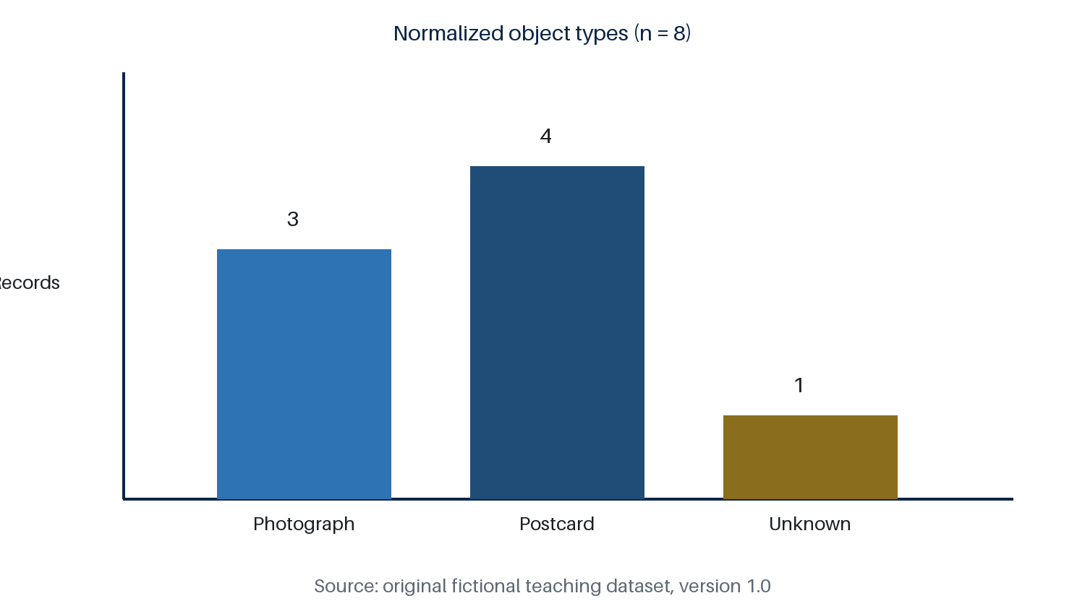
Figure 1. Retained records by normalized object type (n = 8).
Source: `output/chart-data.csv`; exclusions are one exact duplicate and one test record.
Figure 1 retains the unknown category. Removing it would make the chart look cleaner while concealing unresolved metadata.

4. Discussion

4.1 Claim, evidence and reasoning
Grouping makes inconsistent strings countable, but it does not reveal a natural category. The interpretive warrant comes from the stated research question and the preserved source fields. In particular, mapping Laibach to Ljubljana supports present-day aggregation while retaining the historical expression for inspection.

4.2 Counterargument
A reader may object that retaining both source and normalized values complicates the table. The complication is methodologically useful: separate fields permit analysis without erasing the evidence from which the grouping was made.

4.3 Limitations
The corpus is small, fictional and designed to expose common data problems. Its counts demonstrate an auditable workflow but cannot support a claim about real catalogues, institutions or historical patterns. Place mappings also require contextual expertise beyond string matching.

5. Conclusion
The most useful cleaned dataset is not the smoothest one. It is the one whose transformations, exclusions and uncertainties a reader can reconstruct and contest.

References
Digital Humanities Handbook. Fictional Postcard Catalogue Teaching Dataset. Version 1.0. 2026.
Digital Humanities Handbook. “Reading Notes for the Fictional Postcard-Catalogue Study.” Version 1.0. 2026.

