**A**

**Project Report**

**On**

**“Protectnetic”**

**Prepared by**

TANMAY DAMLE (19DCE021)

**Under the guidance of**

Prof. Dhruvi Gosai

A Report Submitted to

Charotar University of Science and Technology

for Partial Fulfillment of the Requirements for the

6th Semester Software Group Project-IV (CE359)

**Submitted at**



**CE**

**DEPSTAR**

**At: Changa, Dist: Anand – 388421**

**April 2022**





# **CERTIFICATE**

# **CERTIFICATE**

This is to certify that the report entitled “**Protectnetic**” is a bonafied work carried out by **Mr. Tanmay Damle** under the guidance and supervision of **Assistant Prof. Dhruvi Gosai** for the subject **CE359-Software Group Project-IV** (CE) of 6th Semester of Bachelor of Technology in **DEPSTAR** at Faculty of Technology & Engineering – CHARUSAT, Gujarat.

To the best of my knowledge and belief, this work embodies the work of candidate himself, has duly been completed, and fulfills the requirement of the ordinance relating to the B.Tech. Degree of the University and is up to the standard in respect of content, presentation and language for being referred to the examiner.

|  |  |
| --- | --- |
| Dhruvi Gosai Assistant Professor  Branch Name(CE/CSE/IT) DEPSTAR, Changa, Gujarat. |  |
| Dr. Dweepna Garg  Head of Department - Computer Engineering, DEPSTAR CHARUSAT, Changa, Gujarat. | Dr. Amit Ganatra Principal, DEPSTAR Dean, FTE  CHARUSAT, Changa, Gujarat. |

**Devang Patel Institute of Advance Technology And Research At: Changa, Ta.**

**Petlad, Dist. Anand, PIN: 388 421. Gujarat**

# **DECLARATION BY THE CANDIDATE**

I hereby declare that the project report entitled **“Protectnetic”** submitted to **Devang Patel Institute of Advance Technology and Research (DEPSTAR), Changa** in partial fulfilment of the requirement for the award of the degree of **B.Tech** in Computer Engineering, from **Devang Patel Institute of Advance Technology and Research (DEPSTAR)**, is a record of bonafide CE359 - Software Group Project - IV (project work) carried out by us under the guidance of **Prof. Dhruvi Gosai**. We further declare that the work carried out and documented in this project report has not been submitted anywhere else either in part or in full and it is the original work, for the award of any other degree or diploma in this institute or any other institute or university.

# 

# **ABSTRACT**

Child Abuse is a major concern in the society today. Many people on the dark web or even the surface web host child abusive content on the internet. Since it’s not feasible for humans to identify 100s of 1000s of links every day; we made a website which can identify child abusive content with just a click of a button. Our goal - to make a website for scraping the dark web website, analyse the content in it and generate a report for the content within it & throw an alert if child abusive content is found on the provided dark web website.

We Believe that the data collected with this project will have various social & business impacts on the society.

# **ACKNOWLEGEMENT**

I would like to express my special thanks of gratitude to my guide **Prof. Dhruvi Gosai** who gave us the opportunity to do this project on the topic **“Protectnetic”**, and was made herself available for all the queries, questions and suggestions from her busy schedule We are really thankful to her for the same.

I would also like to express my thanks to **Prof. Mohammed Bohra (DEPSTAR), Prof. Mrudang Patel (CSPIT), Mr. Dhaiwat Mehta (Dark web expert) for** making themselves available whenever needed and for giving valuable suggestions & support which benefited the team for having a smooth workflow & saved us a lot of time.

# 

# **TABLE OF CONTENTS**

**CERTIFICATE** 2

**DECLARATION BY THE CANDIDATE** 3

**ABSTRACT** 4

**ACKNOWLEGEMENT** 5

**TABLE OF CONTENTS** 6

**TABLE OF FIGURES** 7

**1.** **INTRODUCTION** 8

**1.1** **Origin of Idea** 9

**1.2** **What is Protectnetic?** 9

**2.** **SOFTWARE AND HARDWARE** 10

**2.1 Software** 11

**2.1.1 Python** 11

**2.1.2 Django** 11

**2.1.3 Tor** 11

**2.1.4 Front-End** 11

**2.1.5 Open CV and TensorFlow** 12

**2.1.6 Other Modules** 12

**2.2 Hardware** 12

**2.2.1 Minimum Hardware Requirements** 12

**3.** **IMPLEMENTATION & FUNCTIONALITIES** 13

**3.1 Implementation** 14

**3.1.1** **The Beginning** 14

**3.1.2 Flow of website** 14

**3.2 Functionalities** 15

**4.** **SCREENSHOTS/ OUTPUT** 16

**4.1 Screenshots** 17

**5.** **LIMITATIONS** 19

**5.1 Limitations** 20

**6.** **FUTURE ENHANCEMENTS** 21

**6.1 Future Enhancements** 22

**7.** **REFERENCES** 23

**7.1 References** 24

# **TABLE OF FIGURES**

**Figure 1 Python** 11

**Figure 2 Django** 11

**Figure 3 Tor** 11

**Figure 4 Front-End Technologies** 11

**Figure 5 Open CV**  12

**Figure 6 TensorFlow**.…………………………………………………………………………..….12

**Figure 7 Celery** 12

**Figure 8 Beautiful Soup** 12

**Figure 9 Gantt Chart** 14

**Figure 10 Flowchart** 14

**Figure 11 Home Page** 17

**Figure 12 Search Page** 17

**Figure 13 Reports Page** 18

**Figure 14 Output** 18

# **INTRODUCTION**

## **Origin of Idea**

This idea was originated by the team member Jeet Undaviya (19DCE142) while brainstorming and the team came to a conclusion for making this project, as something like this isn’t made before in practical.

## **What is Protectnetic?**

Protectnetic is a website which takes a surface web links /onion/ dark web links or a text file of multiple links or csv file of multiple links as input and in turn generates a report which detects whether the provided link/links has child abusive content in it or not.

# **SOFTWARE AND HARDWARE**

## **2.1 Software**

### **2.1.1 Python**

This project uses python programming language as the main language of the project & all the implementation part.



**Figure 1 Python**

### **2.1.2 Django**

This project uses Django, a back-end framework for the easement of making the website easily & utilize its different features.



**Figure 2 Django**

### 

### **2.1.3 Tor**

This project uses tor project for scraping the surface links / onion links.****

**Figure 3 Tor**

### **2.1.4 Front-End**

This project uses various front-end technologies for designing.

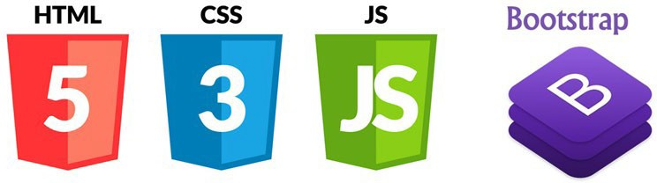

**Figure 4 Front-End Technologies**

### **2.1.5 Open CV and TensorFlow**

This project uses open cv & TensorFlow for child-abuse detection image models.

 

**Figure 5 Open CV Figure 6 TensorFlow**

### **2.1.6 Other Modules**

Along with above mentioned software, the project used many other modules for various purposes.

Here is a full list of the modules we use:

<https://github.com/damletanmay/Protectnetic-child-abuse-prevention/blob/main/requirments.txt>



**Figure 7 Celery**



**Figure 8 Beautiful Soup**

## **2.2 Hardware**

### **2.2.1 Minimum Hardware Requirements**

* A system with minimum 4GBs of RAM
* System must contain and install properly all the software
* System might be either Linux, windows or any other Debian based system
* Intel i5 / AMD Ryzen 5/7 to run the project smoothly

# **IMPLEMENTATION & FUNCTIONALITIES**

## **3.1 Implementation**

### **The Beginning**

The beginning of this project was like any other project, pretty basic stuff, which includes wireframing, role division, brainstorming ideas to make the website efficiently, estimation of project completion, etc.

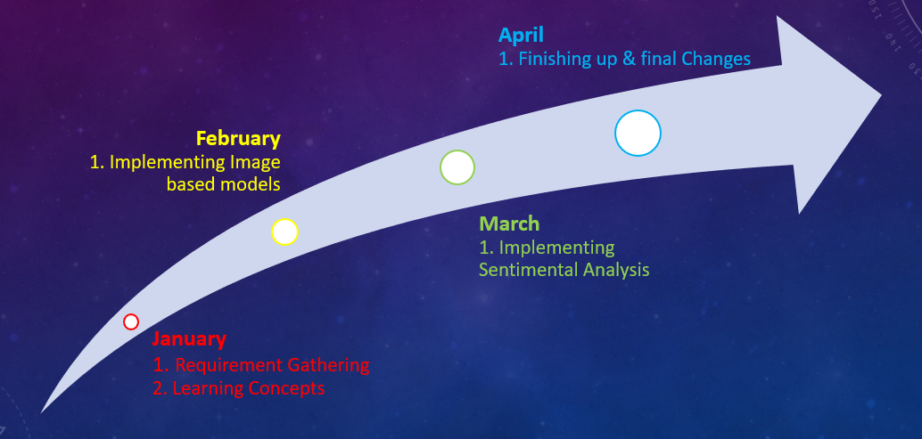

**Figure 9 Gantt Chart**

### **3.1.2 Flow of website**

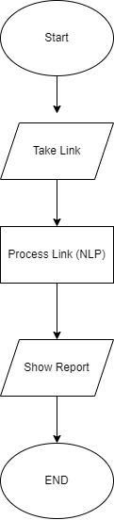

**Figure 10 Flowchart**

The Work flow is shown in above chart. So, when the user accesses the website, he can enter link or either text file of links or csv file of links to get the results. When the user enters the link, data is scrapped from that link &it goes to the NLP model to determine if child abuse is found or not, if NLP model fails, then all the scrapped images will go to the image processing model & report is saved in the Database & is also shown to the user, if the user wants, he/she/they/them can download the report.

Find more information about the project on:

<https://github.com/damletanmay/Protectnetic-child-abuse-prevention/blob/main/README.md>

## **3.2 Functionalities**

* Surface web link processing
* Dark web link processing
* Multiple link processing at the same time
* Database collection for future enhancements
* 75% accuracy with NLP model & 85% accuracy with image processing model i.e., less chances of false positive results.

# **SCREENSHOTS/ OUTPUT**

## **4.1 Screenshots**

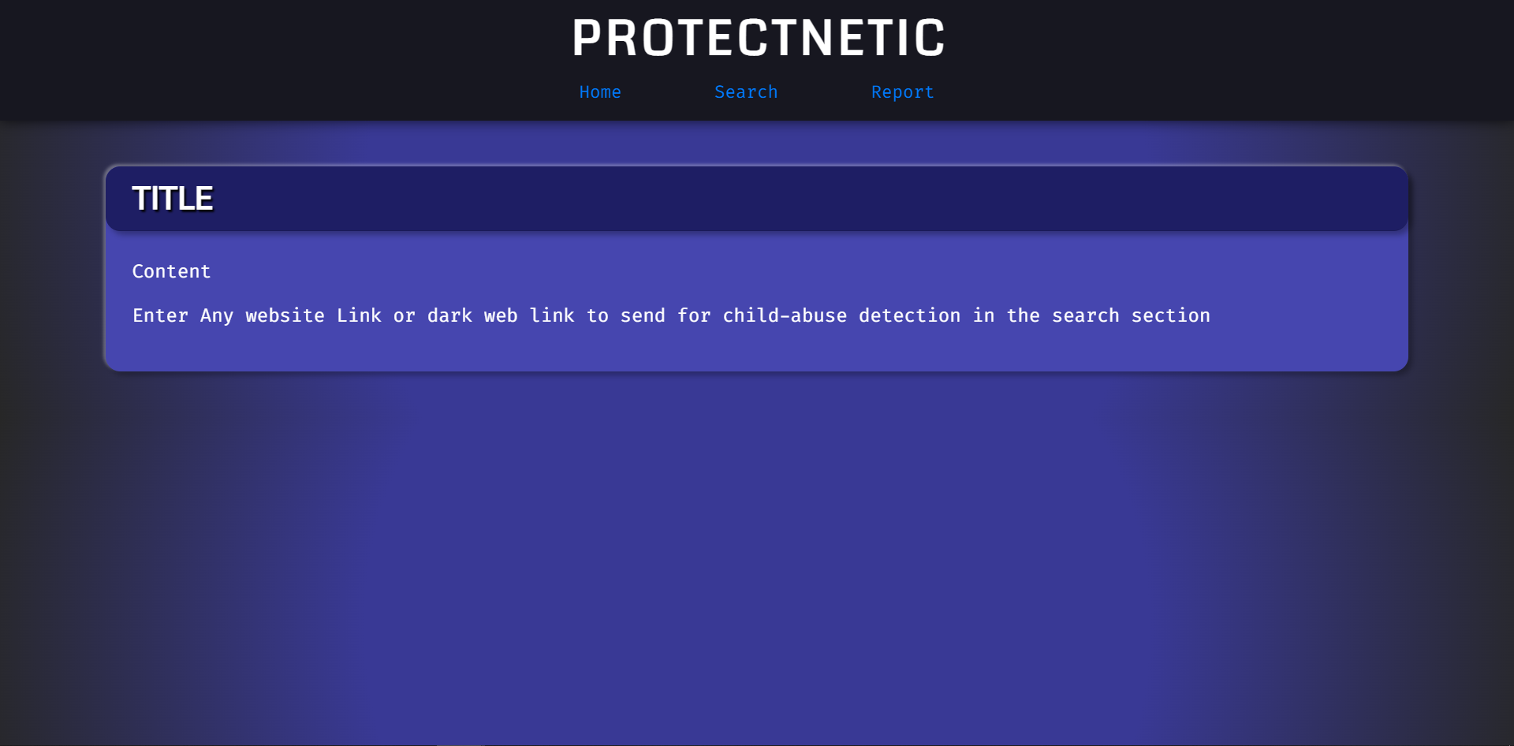

**Figure 11 Home Page**

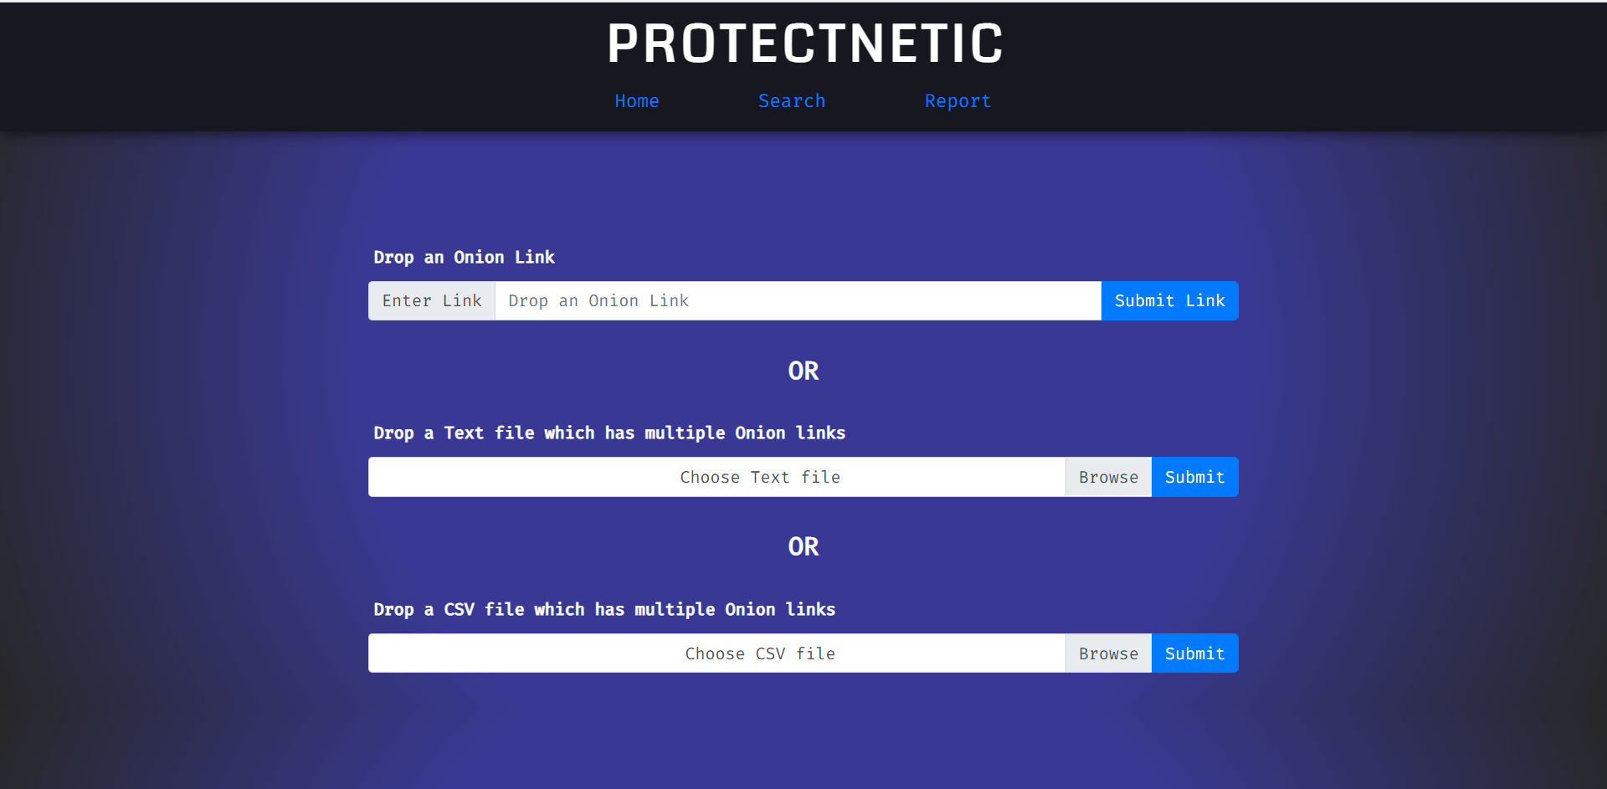

**Figure 12 Search Page**

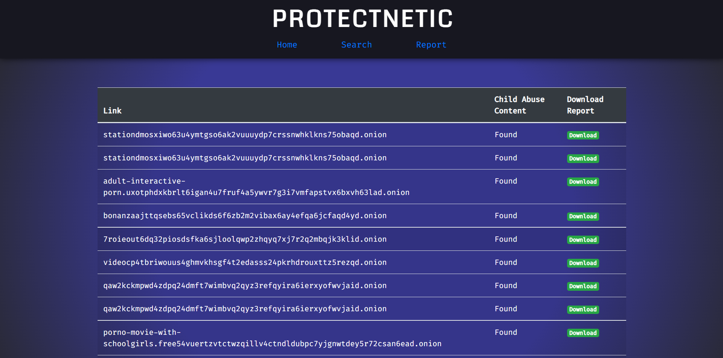

**Figure 13 Reports Page**

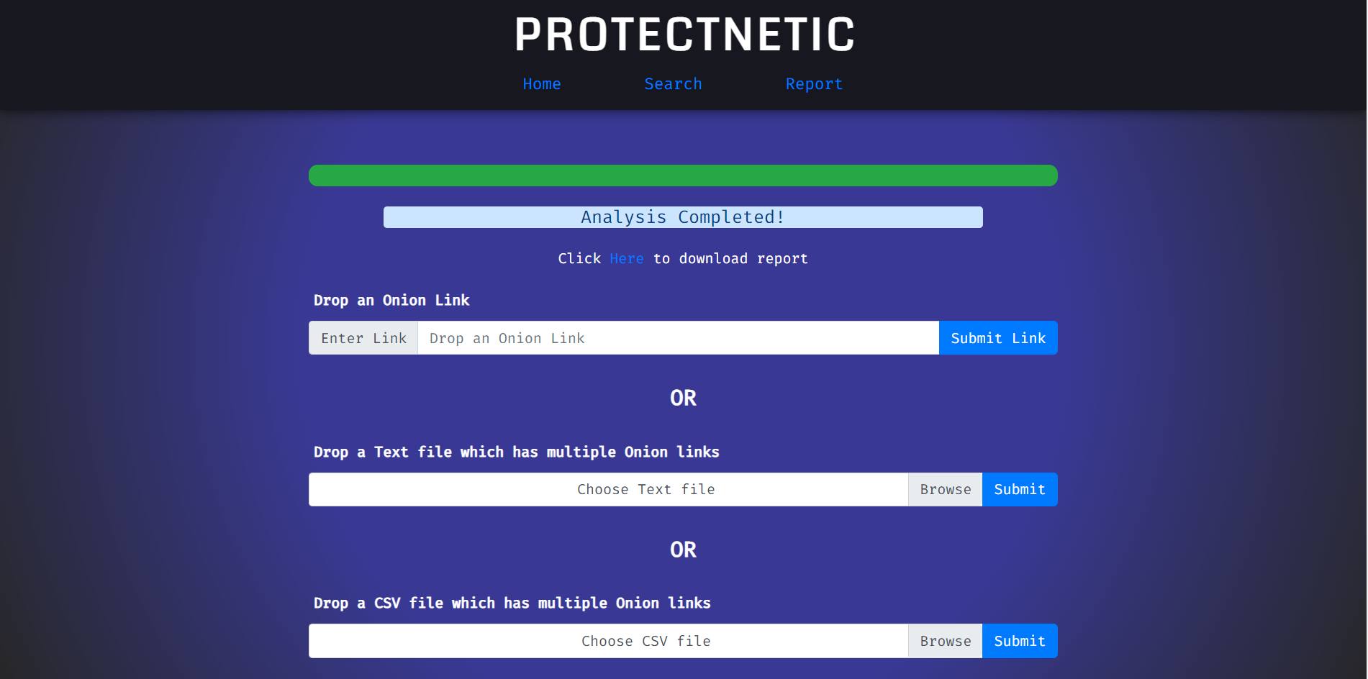

**Figure 14 Output**

# **LIMITATIONS**

## **5.1 Limitations**

* The website only detects child-abusive websites but it can’t actually close the website permanently
* NLP model sometimes randomly misbehaves due to lack of data whilst training
* Sometimes due to load the website might work slow
* Image processing models are trained well but they take time sometimes if image has noise in it.
* Uses extra server which might cause optimization/ hosting problems in the future.

# **FUTURE ENHANCEMENTS**

## **6.1** **Future Enhancements**

* Collection of Data for various other applications like making security web filter for public and private organizations.
* Face Detection to identify child and/or child-abusers
* To get IP address of tor websites in order to permanently close them
* Spread awareness about child abuse
* The data can be made available to govt. organizations to take further steps in banning of such sites in area/state/region/country etc.

# **REFERENCES**

## **7.1 References**

Here mentioned are some of the references to understand technologies used in the project.

* <https://docs.python.org/3/>
* <https://docs.djangoproject.com/en/4.0/>
* <https://docs.opencv.org/4.x/d9/df8/tutorial_root.html>
* <https://www.tensorflow.org/api_docs/>
* <https://beautiful-soup-4.readthedocs.io/en/latest/>
* <https://youtu.be/iGWbqhdjf2s>
* <https://youtu.be/o2BYWYS73G0>
* <https://getbootstrap.com/docs/5.1/getting-started/introduction/>
* <https://github.com/>
* <https://www.torproject.org/>
* <https://pypi.org/project/django-celery/>
* <https://redis.io/>