Національний Технічний Університет України
«Київський політехнічний інститут імені Ігоря Сікорського»
Факультет Інформатики та Обчислювальної Техніки
Кафедра обчислювальної техніки

Лабораторна робота №4
«Програмування мобільних систем»

Виконала:
студентка 3 курсу факультету ІОТ
групи ІВ-81
Лиса Еліза

Перевірив:
Шульга М.В.
Київ 2021
Варіант: 8118 mod 2 + 1 = 1
Варіант 1
Предметна область – фільми
Архів для завантаження

Скріншоти додатка:
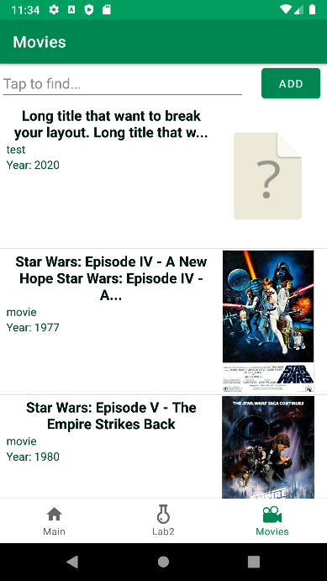
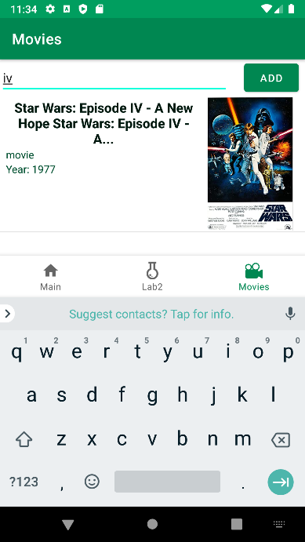

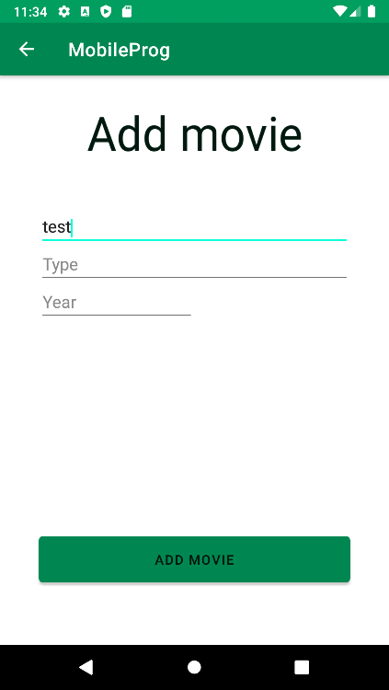

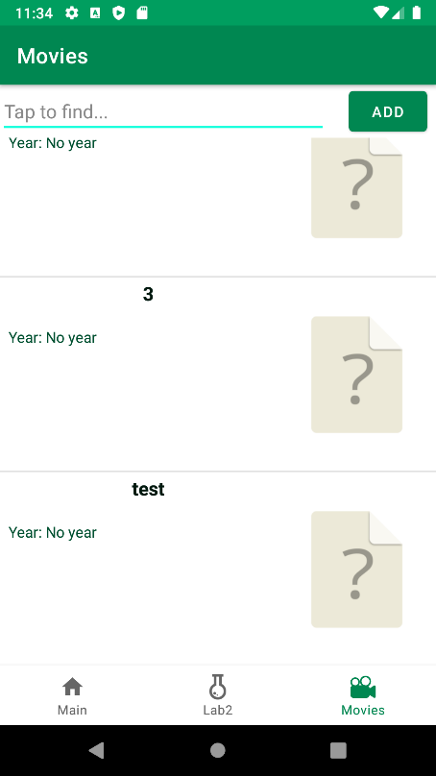

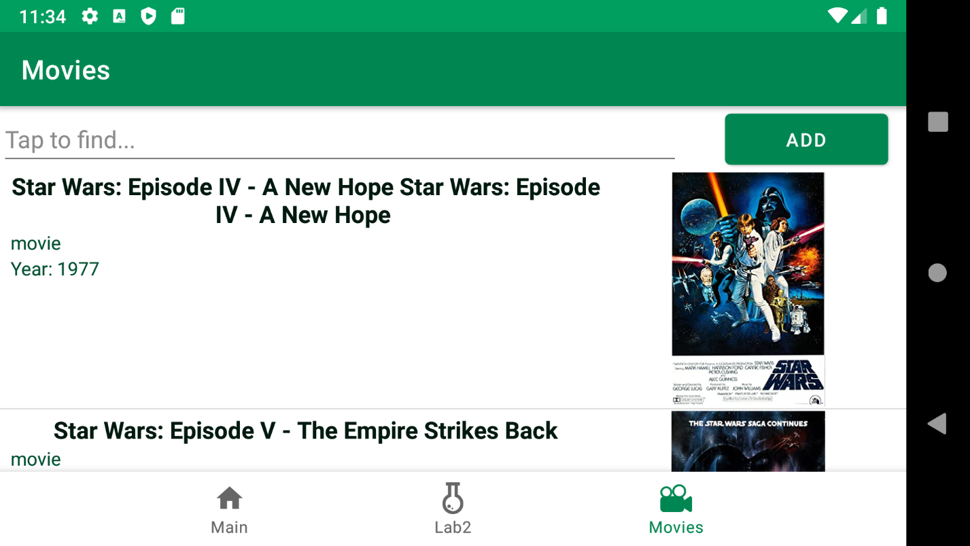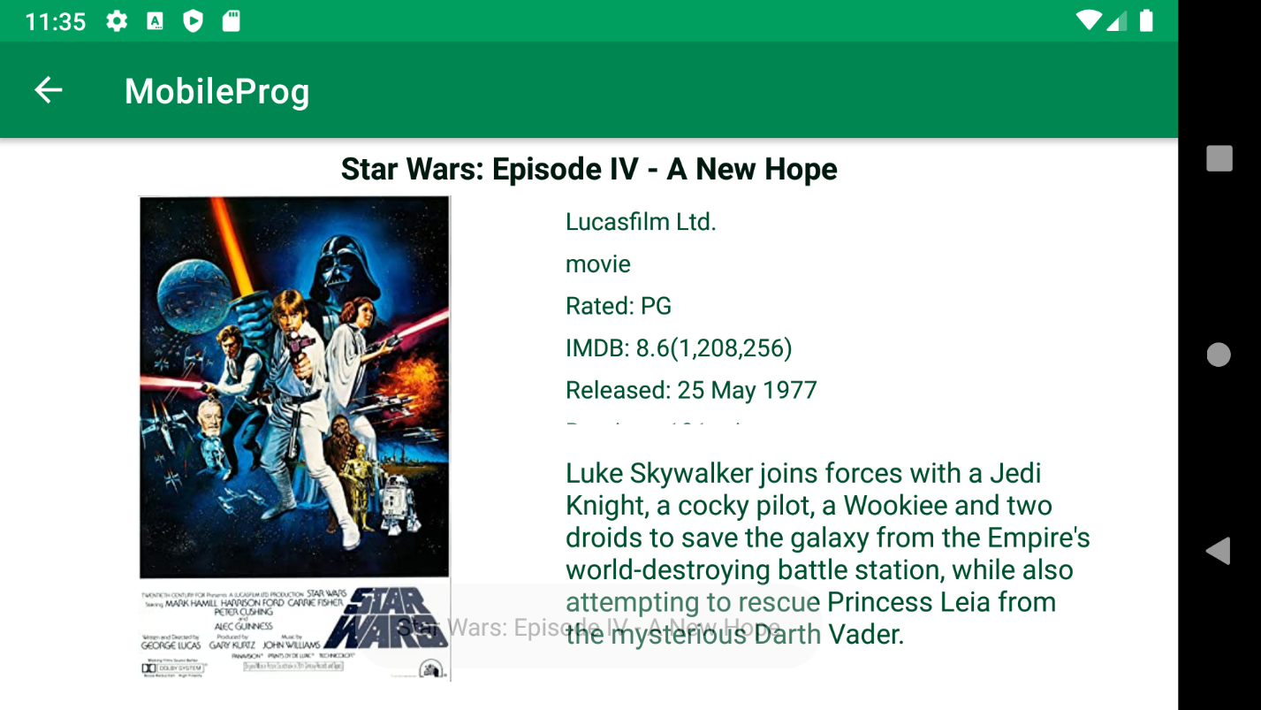
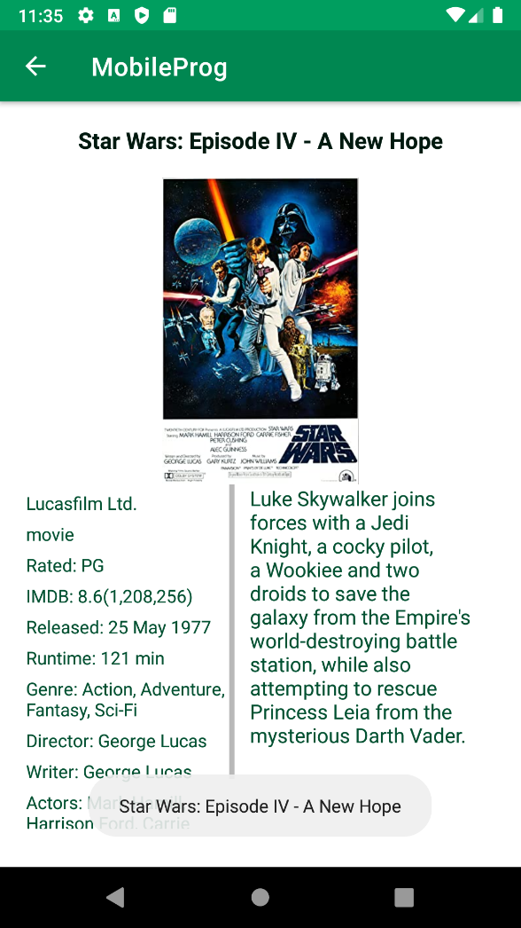
Лістинг:
MoviesFragment.java
package ua.kpi.comsys.IB8118.ui.movies;
import android.annotation.SuppressLint;
import android.app.AlertDialog;
import android.content.Context;
import android.content.DialogInterface;
import android.content.Intent;
import android.graphics.Point;
import android.os.Bundle;
import android.text.Editable;
import android.text.TextWatcher;
import android.view.Display;
import android.view.LayoutInflater;
import android.view.View;
import android.view.ViewGroup;
import android.widget.AdapterView;
import android.widget.ArrayAdapter;
import android.widget.Button;
import android.widget.EditText;
import android.widget.ImageView;
import android.widget.ListView;
import android.widget.TextView;
import android.widget.Toast;
import androidx.annotation.NonNull;
import androidx.annotation.Nullable;
import androidx.fragment.app.Fragment;
import java.util.ArrayList;
import java.util.List;
import ua.kpi.comsys.IB8118.R;
public class MoviesFragment extends Fragment {
private List<Movie> movies;
private final List<Movie> foundMovies = new ArrayList<>();
private List<Movie> adapterObjects;
private Adapter customAdapter;
ListView moviesList;
int widthScreen;
int maximumLattersTitle;
boolean requiredRecreate = false;
EditText findFieldET;
public void handleScreenSize() {
super.onResume();
Display screen = getActivity().getWindowManager().getDefaultDisplay();
Point size = new Point();
screen.getSize(size);
widthScreen = size.x;
maximumLattersTitle = widthScreen /16;
}
@Override
public void onPause() {
super.onPause();
handleScreenSize();
}
@Override
public void onResume() {
super.onResume();
if (requiredRecreate)
requireActivity().recreate();
requiredRecreate = false;
}
@Override
public void onCreate(@Nullable @org.jetbrains.annotations.Nullable Bundle savedInstanceState) {
super.onCreate(savedInstanceState);
handleScreenSize();
}
public View onCreateView(@NonNull LayoutInflater inflater,
ViewGroup container, Bundle savedInstanceState) {
View rootView = inflater.inflate(R.layout.fragment_movies, container, false);
Button buttonAddMovie = rootView.findViewById(R.id.buttonAdd);
findFieldET = rootView.findViewById(R.id.fieldFind);
moviesList = rootView.findViewById(R.id.movies_listView);
movies = MovHandler.getListMovFromRaw(getContext());
if(movies != null){
customAdapter = new Adapter(getActivity(), R.layout.movies, movies);
moviesList.setAdapter(customAdapter);
}
findFieldET.addTextChangedListener(new TextWatcher() { // user print on findField
@Override
public void beforeTextChanged(CharSequence s, int start, int count, int after) {}
@Override
public void onTextChanged(CharSequence s, int start, int before, int count) {}
@Override
public void afterTextChanged(Editable s) {runSearch();}
});
buttonAddMovie.setOnClickListener(new View.OnClickListener() { // start adding
@Override
public void onClick(View v) {
requiredRecreate = true;
startActivity(new Intent(getContext(), MovieAddActivity.class));
}
});
moviesList.setOnItemClickListener(new AdapterView.OnItemClickListener() { // call detail info about movie
@Override
public void onItemClick(AdapterView<?> parent, View view, int position, long id) {
startActivity(new Intent(getContext(), MovieInfoActivity.class).putExtra("imdbID", adapterObjects.get(position).getImdbID()));
}
});
moviesList.setOnItemLongClickListener(new AdapterView.OnItemLongClickListener() { // deleting
@Override
public boolean onItemLongClick(AdapterView<?> parent, View itemClicked, int position,
long id) {
if(findFieldET.getText().toString().equals("")) {
itemClicked.setBackgroundResource(R.color.ocean_main);
try {
AlertDialog.Builder constructor = new AlertDialog.Builder(getActivity());
constructor.setMessage("Do you want to delete selected movie?");
constructor.setCancelable(true);
constructor.setIcon(R.drawable.ic_movie_icon);
constructor.setTitle("Deleting");
constructor.setOnCancelListener(new DialogInterface.OnCancelListener() {
@Override
public void onCancel(DialogInterface dialog) {
itemClicked.setBackgroundResource(R.color.white);
}
});
constructor.setPositiveButton("Delete selected movie", new DialogInterface.OnClickListener() {
@Override
public void onClick(DialogInterface dialog, int which) {
movies.remove((int) id);
customAdapter.notifyDataSetChanged();
MovHandler.exportToCached(getContext(), movies);
requiredRecreate = true;
dialog.dismiss();
}
});
constructor.setNegativeButton("Cancel", new DialogInterface.OnClickListener() {
@Override
public void onClick(DialogInterface dialog, int which) {
dialog.dismiss();
itemClicked.setBackgroundResource(R.color.white);
}
});
AlertDialog alertDialog = constructor.create();
alertDialog.show();
} catch (Exception e) {
Toast.makeText(getContext(), "ERROR", Toast.LENGTH_SHORT).show();
}
}
else Toast.makeText(getContext(), "Clear your search term first.", Toast.LENGTH_SHORT).show();
return true;
}
});
return rootView;
}
private class Adapter extends ArrayAdapter<Movie> {
Adapter(Context context, int textViewResourceId, List<Movie> objects) {
super(context, textViewResourceId, objects);
adapterObjects = objects;
}
@NonNull
@Override
public View getView(int position, @Nullable View convertView, @NonNull ViewGroup parent) {
LayoutInflater inflater = getLayoutInflater();
@SuppressLint("ViewHolder") View row = inflater.inflate(R.layout.movies, parent, false);
TextView titleTV = row.findViewById(R.id.movieTitle),
typeTV = row.findViewById(R.id.movieType),
yearTV = row.findViewById(R.id.movieYear);
String title = (adapterObjects.get(position).getTitle());
if (title.length() > maximumLattersTitle)
title = title.substring(0, maximumLattersTitle) + "...";
titleTV.setText(title);
typeTV.setText(adapterObjects.get(position).getType());
yearTV.setText("Year: " + adapterObjects.get(position).getYear());
ImageView posterIV = row.findViewById(R.id.poster_listview);
String poster = adapterObjects.get(position).getPoster();
int imgResID = getContext().getResources().getIdentifier(poster.replaceAll(".jpg",""), "drawable", getContext().getPackageName());
if(imgResID!=0) posterIV.setImageResource(imgResID);
else posterIV.setImageResource(R.drawable.unknown_file);
return row;
}
}
void runSearch(){
String fieldText = findFieldET.getText().toString().toLowerCase();
if(!fieldText.equals("")){
foundMovies.clear();
for (int i = 0; i < movies.size(); i++)
if(movies.get(i).getTitle().toLowerCase().contains(fieldText))
foundMovies.add(movies.get(i));
if(foundMovies.isEmpty())
Toast.makeText(getContext(), "No movies :(", Toast.LENGTH_SHORT).show();
customAdapter = new Adapter(getActivity(), R.layout.movies, foundMovies);
}
else
customAdapter = new Adapter(getActivity(), R.layout.movies, movies);
moviesList.setAdapter(customAdapter);
}
}

MovieInfoActivity.java
package ua.kpi.comsys.IB8118.ui.movies;
import android.os.Bundle;
import android.view.MenuItem;
import android.widget.ImageView;
import android.widget.TextView;
import android.widget.Toast;
import androidx.annotation.NonNull;
import androidx.annotation.Nullable;
import androidx.appcompat.app.ActionBar;
import androidx.appcompat.app.AppCompatActivity;
import ua.kpi.comsys.IB8118.R;
public class MovieInfoActivity extends AppCompatActivity {
Movie movie;
String imdbID;
@Override
protected void onCreate(@Nullable Bundle savedInstanceState) {
super.onCreate(savedInstanceState);
setContentView(R.layout.movie_full_info);
ActionBar backArrow = getSupportActionBar();
backArrow.setDisplayHomeAsUpEnabled(true);
Bundle arguments = getIntent().getExtras();
imdbID = arguments.get("imdbID").toString();
int resource = this.getResources().getIdentifier(imdbID, "raw", this.getPackageName());
if(resource!=0) {
movie = MovHandler.movFromRes(this, resource);
if (movie!=null)
Toast.makeText(this, movie.getTitle(), Toast.LENGTH_SHORT).show();
System.out.println("IMDB:"+imdbID+"; mov: "+movie);
String title = movie.getTitle();
if (title.length()>60)
title = title.substring(0, 60) + "...";
((TextView)findViewById(R.id.fullTitle)).setText(title);
((TextView)findViewById(R.id.fullProduction)).setText(movie.getProduction());
((TextView)findViewById(R.id.fullType)).setText(movie.getType());
((TextView)findViewById(R.id.fullRated)).setText("Rated: "+movie.getRated());
((TextView)findViewById(R.id.fullImdbRating)).setText("IMDB: "+movie.getImdbRating());
((TextView)findViewById(R.id.fullImdbVotes)).setText("("+movie.getImdbVotes()+")");
((TextView)findViewById(R.id.fullReleased)).setText("Released: "+movie.getReleased());
((TextView)findViewById(R.id.fullRuntime)).setText("Runtime: "+movie.getRuntime());
((TextView)findViewById(R.id.fullGenre)).setText("Genre: "+movie.getGenre());
((TextView)findViewById(R.id.fullDirector)).setText("Director: "+movie.getDirector());
((TextView)findViewById(R.id.fullWriter)).setText("Writer: "+movie.getWriter());
((TextView)findViewById(R.id.fullActors)).setText("Actors: "+movie.getActors());
((TextView)findViewById(R.id.fullLanguage)).setText("Language: "+movie.getLanguage());
((TextView)findViewById(R.id.fullPlot)).setText(movie.getPlot());
ImageView poster = (ImageView) findViewById(R.id.fullPoster);
int posterRes;
try {
String imageName = movie.getPoster().replaceAll(".jpg","").toLowerCase();
posterRes = getResources().getIdentifier(imageName, "drawable", getPackageName());
} catch (Exception e){posterRes = 0;};
if(posterRes!=0) poster.setImageResource(posterRes);
else poster.setImageResource(R.drawable.unknown_file);
}
else {Toast.makeText(this, "No data available", Toast.LENGTH_LONG).show(); finish();}
}
@Override
public boolean onOptionsItemSelected(@NonNull MenuItem item) {
switch (item.getItemId()) {
case android.R.id.home:
this.finish();
return true;
}
return super.onOptionsItemSelected(item);
}
}

MovieAddActivity.java
package ua.kpi.comsys.IB8118.ui.movies;
import android.os.Bundle;
import android.text.Editable;
import android.text.TextWatcher;
import android.view.MenuItem;
import android.view.View;
import android.widget.EditText;
import android.widget.Toast;
import androidx.annotation.NonNull;
import androidx.annotation.Nullable;
import androidx.appcompat.app.ActionBar;
import androidx.appcompat.app.AppCompatActivity;
import java.util.List;
import ua.kpi.comsys.IB8118.R;
public class MovieAddActivity extends AppCompatActivity {
EditText movieNameET;
@Override
public void onCreate(@Nullable Bundle savedInstanceState) {
super.onCreate(savedInstanceState);
setContentView(R.layout.movie_add);
ActionBar actionBar = getSupportActionBar();
actionBar.setDisplayHomeAsUpEnabled(true);
movieNameET = findViewById(R.id.fieldAddName);
movieNameET.addTextChangedListener(new TextWatcher() {
@Override
public void beforeTextChanged(CharSequence s, int start, int count, int after) {}
@Override
public void onTextChanged(CharSequence s, int start, int before, int count) {}
@Override
public void afterTextChanged(Editable s) {
movieNameET.setHintTextColor(getColor(R.color.hint_color));
movieNameET.setHint(R.string.default_hint_title);
}
});
}
@Override
public boolean onOptionsItemSelected(@NonNull MenuItem item) {
switch (item.getItemId()) {
case android.R.id.home:
this.finish();
return true;
}
return super.onOptionsItemSelected(item);
}
public void buttonAddMovie(View view) {
String movieName = movieNameET.getText().toString();
String movieType = ((EditText)findViewById(R.id.fieldAddType)).getText().toString();
String movieYear = ((EditText)findViewById(R.id.fieldAddYear)).getText().toString();
if (movieNameET.getText().toString().length()>0){
MovHandler movHandler = new MovHandler();
List<Movie> movies = movHandler.getUserMovies(view.getContext());
movies.add(new Movie(movieName, movieType, movieYear));
movHandler.exportToCached(view.getContext(), movies);
finish();
Toast.makeText(view.getContext(), "Success", Toast.LENGTH_SHORT).show();
} else{ // incorrect name
movieNameET.setHintTextColor(getColor(R.color.error));
movieNameET.setHint(R.string.warning_hint_title);
}
}
}

