Національний Технічний Університет України
«Київський політехнічний інститут імені Ігоря Сікорського»
Факультет Інформатики та Обчислювальної Техніки
Кафедра обчислювальної техніки

Лабораторна робота №6
«Програмування мобільних систем»

Виконала:
студентка 3 курсу факультету ІОТ
групи ІВ-81
Лиса Еліза

Перевірив:
Шульга М.В.
Київ 2021
Варіант: 8118 mod 6 + 1 = 1
8118 mod 2 + 1 = 1
Варіант 1
Предметна область – фільми
URL-адреса для отримання даних – http://www.omdbapi.com/?apikey=API_KEY&s=REQUEST&page=1, де API_KEY – 7e9fe69e, REQUEST – запит із поля для пошуку.
Зверніть увагу на те, що використання ключа API_KEY обмежене до 1000 запитів на день, якщо буде вичерпано кількість запитів на день для наведеного ключа, то можна отримати власний ключ, зареєструвавшись за посиланням.

Варіант 1
Предметна область – фільми
URL-адреса для отримання даних – http://www.omdbapi.com/?apikey=API_KEY&i=IDENTIFIER, де API_KEY – 7e9fe69e, IDENTIFIER – ідентифікатор відповідного фільму (поле imdbID із сутності фільму).
Зверніть увагу на те, що використання ключа API_KEY обмежене до 1000 запитів на день, якщо буде вичерпано кількість запитів на день для наведеного ключа, то можна отримати власний ключ, зареєструвавшись за посиланням.

Варіант 1
REQUEST – “yellow+flowers”
COUNT – 27

Скріншоти додатка:
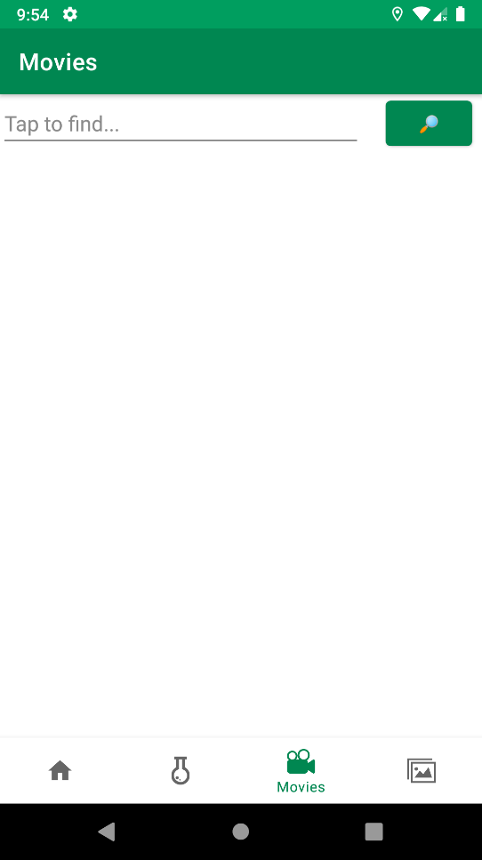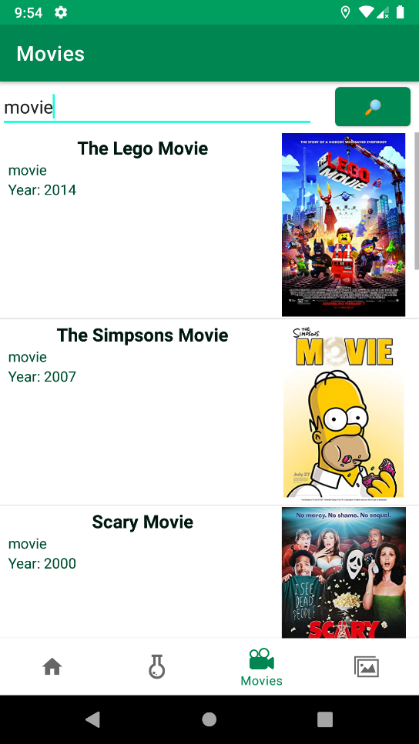
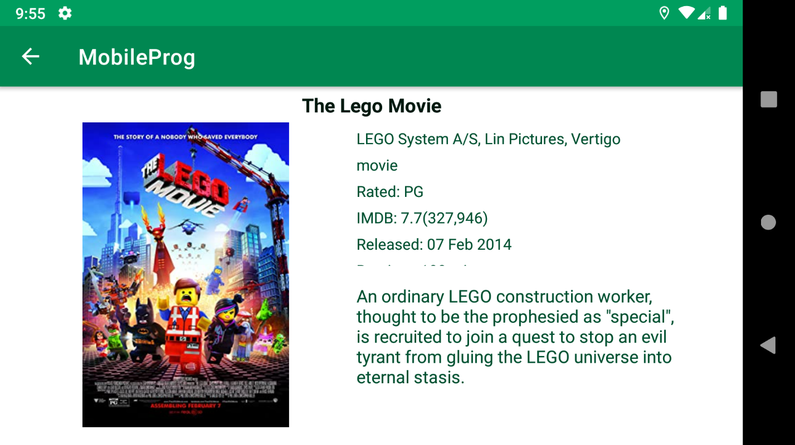
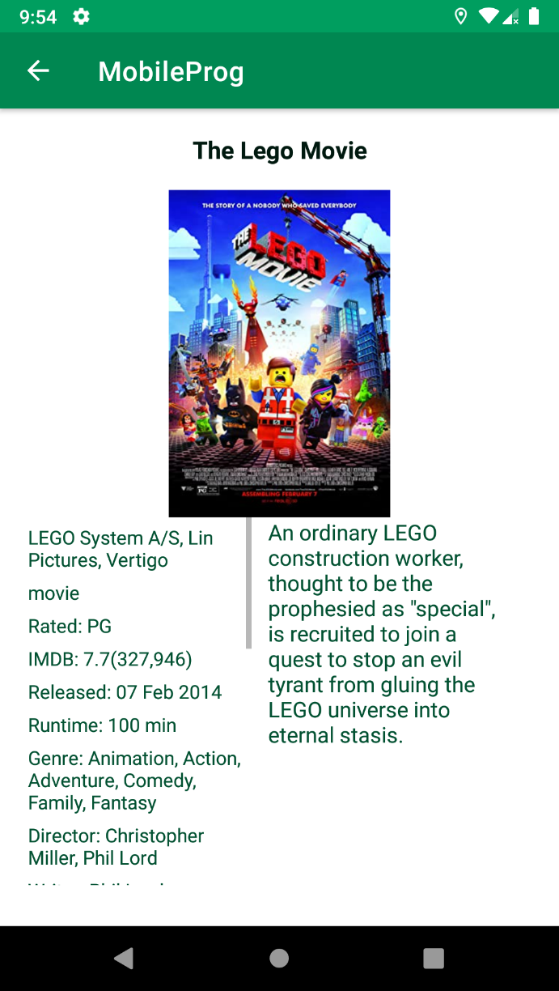

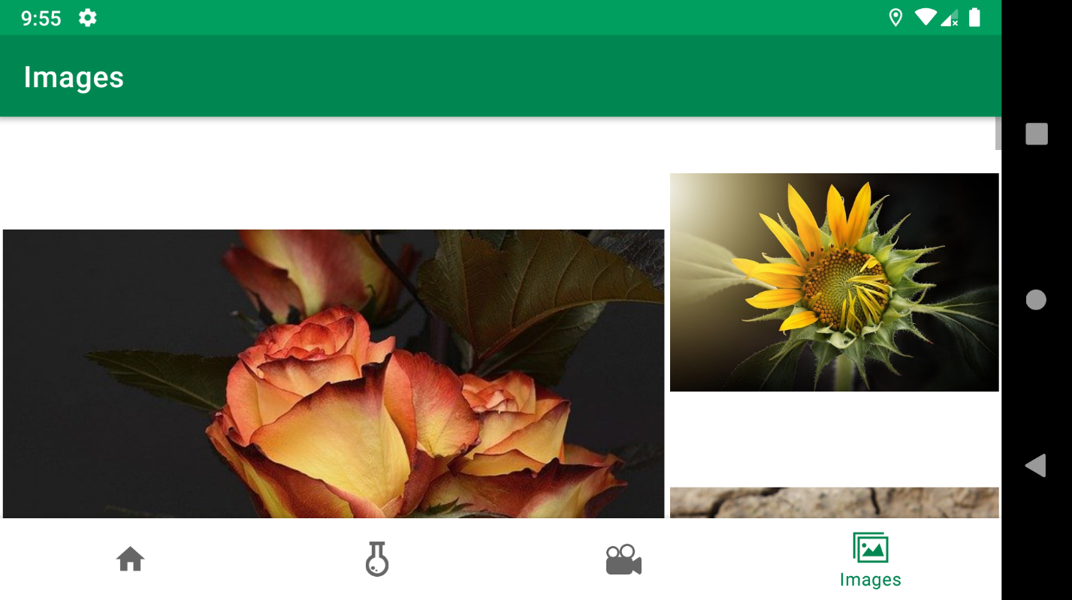
Лістинг:
MoviesFragment.java
package ua.kpi.comsys.IB8118.ui.movies;
import android.annotation.SuppressLint;
import android.content.Context;
import android.content.Intent;
import android.graphics.Bitmap;
import android.graphics.BitmapFactory;
import android.graphics.Point;
import android.os.AsyncTask;
import android.os.Bundle;
import android.view.Display;
import android.view.LayoutInflater;
import android.view.View;
import android.view.ViewGroup;
import android.view.animation.RotateAnimation;
import android.widget.AdapterView;
import android.widget.ArrayAdapter;
import android.widget.Button;
import android.widget.EditText;
import android.widget.ImageView;
import android.widget.ListView;
import android.widget.TextView;
import android.widget.Toast;
import androidx.annotation.NonNull;
import androidx.annotation.Nullable;
import androidx.fragment.app.Fragment;
import java.io.BufferedReader;
import java.io.InputStreamReader;
import java.net.URL;
import java.util.ArrayList;
import java.util.List;
import ua.kpi.comsys.IB8118.R;
public class MoviesFragment extends Fragment {
List<Movie> movies;
final List<Movie> foundMovies = new ArrayList<>();
List<Movie> adapterObjects;
Adapter customAdapter;
ListView filmEntityLV;
int widthScreen;
int maximumLettersTitle;
boolean requiredRecreate = false;
EditText findField;
String API_KEY = "7e9fe69e",
REQUEST;
View rootView;
public void handleScreenSize() {
super.onResume();
Display screen = getActivity().getWindowManager().getDefaultDisplay();
Point size = new Point();
screen.getSize(size);
widthScreen = size.x;
maximumLettersTitle = widthScreen /16;
}
@Override
public void onPause() {
super.onPause();
handleScreenSize();
}
@Override
public void onResume() {
super.onResume();
if (requiredRecreate)
requireActivity().recreate();
requiredRecreate = false;
}
@Override
public void onCreate(@Nullable @org.jetbrains.annotations.Nullable Bundle savedInstanceState) {
super.onCreate(savedInstanceState);
handleScreenSize();
}
public View onCreateView(@NonNull LayoutInflater inflater,
ViewGroup container, Bundle savedInstanceState) {
rootView = inflater.inflate(R.layout.fragment_movies, container, false);
Button buttonSearch = rootView.findViewById(R.id.buttonSearch);
findField = rootView.findViewById(R.id.fieldFind);
filmEntityLV = rootView.findViewById(R.id.movies_listView);
movies = MovHandler.getUserMovies(getContext());
if(movies != null){
customAdapter = new Adapter(getActivity(), R.layout.movies, movies);
filmEntityLV.setAdapter(customAdapter);
}
buttonSearch.setOnClickListener(new View.OnClickListener() { // search
@Override
public void onClick(View v) {
if (findField.getText().toString().length()>2)
search();
else
Toast.makeText(getContext(), "Request must be more than 2 symbols", Toast.LENGTH_SHORT);
}
});
filmEntityLV.setOnItemClickListener(new AdapterView.OnItemClickListener() { // call detail info about movie
@Override
public void onItemClick(AdapterView<?> parent, View view, int position, long id) {
startActivity(new Intent(getContext(), MovieInfoActivity.class).putExtra("imdbID", adapterObjects.get(position).getImdbID()));
}
});
return rootView;
}
private class Adapter extends ArrayAdapter<Movie> {
Adapter(Context context, int textViewResourceId, List<Movie> objects) {
super(context, textViewResourceId, objects);
adapterObjects = objects;
}
@NonNull
@Override
public View getView(int position, @Nullable View convertView, @NonNull ViewGroup parent) {
LayoutInflater inflater = getLayoutInflater();
@SuppressLint("ViewHolder") View row = inflater.inflate(R.layout.movies, parent, false);
TextView titleTV = row.findViewById(R.id.movieTitle),
typeTV = row.findViewById(R.id.movieType),
yearTV = row.findViewById(R.id.movieYear);
// ImageView loading = row.findViewById(R.id.loading);
RotateAnimation rotate = new RotateAnimation(0, 999999999);
rotate.setDuration(9999);
// loading.startAnimation(rotate);
String title = (adapterObjects.get(position).getTitle());
if (title.length() > maximumLettersTitle)
title = title.substring(0, maximumLettersTitle) + "...";
titleTV.setText(title);
typeTV.setText(adapterObjects.get(position).getType());
yearTV.setText("Year: " + adapterObjects.get(position).getYear());
ImageView posterIV = row.findViewById(R.id.poster_listview);
String poster = adapterObjects.get(position).getPoster();
try {
new DownloadPoster(posterIV).execute(poster);
} catch (Exception e) {
posterIV.setImageResource(R.drawable.unknown_file);
// loading.setVisibility(View.INVISIBLE);
}
return row;
}
}
void search(){
foundMovies.clear();
REQUEST = findField.getText().toString().toLowerCase();
new LoadRequest("search").start();
}
class LoadRequest extends Thread {
LoadRequest(String name){
super(name);
}
public void run(){
try {
URL url = new URL("http://www.omdbapi.com/?apikey="+API_KEY+"&s="+REQUEST+"&page=1");
String found = (new BufferedReader(new InputStreamReader(url.openStream()))).readLine();
movies = MovHandler.movsFromJson(found);
if (movies.size()==0)
getActivity().runOnUiThread(new Runnable() {
@Override
public void run() {
Toast.makeText(getContext(), "No movies", Toast.LENGTH_SHORT).show();
rootView.findViewById(R.id.movies_listView).setVisibility(View.INVISIBLE);
}
});
else
getActivity().runOnUiThread(new Runnable() {
@Override
public void run() {
rootView.findViewById(R.id.movies_listView).setVisibility(View.VISIBLE);
}
});
MovHandler.exportToCached(getContext(), movies);
try {
if (!(movies.size()==0))
getActivity().runOnUiThread(new Runnable() {
@Override
public void run() {
customAdapter = new Adapter(getActivity(), R.layout.movies, movies);
filmEntityLV.setAdapter(customAdapter);
}
});
} catch (Exception ignored){}
} catch (Exception e) {
e.printStackTrace();
getActivity().runOnUiThread(new Runnable() {
@Override
public void run() {
Toast.makeText(getContext(), "Check internet connection", Toast.LENGTH_SHORT).show();
}
});
}
}
}
private class DownloadPoster extends AsyncTask<String, Void, Bitmap> {
ImageView bitmap;
public DownloadPoster(ImageView bitmap) {
this.bitmap = bitmap;
}
protected Bitmap doInBackground(String... links) {
String link = links[0];
Bitmap bitmap = null;
try {
bitmap = BitmapFactory.decodeStream(new java.net.URL(link).openStream());
} catch (Exception ignored) {}
return bitmap;
}
protected void onPostExecute(Bitmap bitmap) {
this.bitmap.setImageBitmap(bitmap);
}
}
}

MoviesInfoActivity.java
package ua.kpi.comsys.IB8118.ui.movies;
import android.graphics.Bitmap;
import android.graphics.BitmapFactory;
import android.os.AsyncTask;
import android.os.Bundle;
import android.view.MenuItem;
import android.widget.ImageView;
import android.widget.TextView;
import androidx.annotation.NonNull;
import androidx.annotation.Nullable;
import androidx.appcompat.app.ActionBar;
import androidx.appcompat.app.AppCompatActivity;
import java.io.BufferedReader;
import java.io.InputStreamReader;
import java.net.URL;
import ua.kpi.comsys.IB8118.R;
public class MovieInfoActivity extends AppCompatActivity {
Movie movie;
String API_KEY = "7e9fe69e";
@Override
protected void onCreate(@Nullable Bundle savedInstanceState) {
super.onCreate(savedInstanceState);
setContentView(R.layout.movie_full_info);
ActionBar backArrow = getSupportActionBar();
backArrow.setDisplayHomeAsUpEnabled(true);
try {
new LoadRequest("NAME").start();
} catch (Exception ignored){}
// ((TextView)findViewById(R.id.fullTitle)).setText(title);
// ((TextView)findViewById(R.id.fullProduction)).setText(movie.getProduction());
// ((TextView)findViewById(R.id.fullType)).setText(movie.getType());
// ((TextView)findViewById(R.id.fullRated)).setText("Rated: "+movie.getRated());
// ((TextView)findViewById(R.id.fullImdbRating)).setText("IMDB: "+movie.getImdbRating());
// ((TextView)findViewById(R.id.fullImdbVotes)).setText("("+movie.getImdbVotes()+")");
// ((TextView)findViewById(R.id.fullReleased)).setText("Released: "+movie.getReleased());
// ((TextView)findViewById(R.id.fullRuntime)).setText("Runtime: "+movie.getRuntime());
// ((TextView)findViewById(R.id.fullGenre)).setText("Genre: "+movie.getGenre());
// ((TextView)findViewById(R.id.fullDirector)).setText("Director: "+movie.getDirector());
// ((TextView)findViewById(R.id.fullWriter)).setText("Writer: "+movie.getWriter());
// ((TextView)findViewById(R.id.fullActors)).setText("Actors: "+movie.getActors());
// ((TextView)findViewById(R.id.fullLanguage)).setText("Language: "+movie.getLanguage());
// ((TextView)findViewById(R.id.fullPlot)).setText(movie.getPlot());
}
class LoadRequest extends Thread {
LoadRequest(String name){
super(name);
}
public void run(){
BufferedReader bufferedReader;
URL link;
try {
Bundle extras = getIntent().getExtras();
String IDENTIFIER = extras.get("imdbID").toString();
link = new URL("http://www.omdbapi.com/?apikey="+API_KEY+"&i="+IDENTIFIER);
bufferedReader = new BufferedReader(new InputStreamReader(link.openStream()));
String found = (bufferedReader).readLine();
movie = MovHandler.movFromJson(found);
System.out.println(IDENTIFIER+" / "+movie);
runOnUiThread(new Runnable() {
@Override
public void run() {
System.out.println("IMDB:"+IDENTIFIER+"; mov: "+movie);
String title = movie.getTitle();
if (title.length()>60)
title = title.substring(0, 60) + "...";
((TextView)findViewById(R.id.fullTitle)).setText(title);
((TextView)findViewById(R.id.fullProduction)).setText(movie.getProduction());
((TextView)findViewById(R.id.fullType)).setText(movie.getType());
((TextView)findViewById(R.id.fullRated)).setText("Rated: "+movie.getRated());
((TextView)findViewById(R.id.fullImdbRating)).setText("IMDB: "+movie.getImdbRating());
((TextView)findViewById(R.id.fullImdbVotes)).setText("("+movie.getImdbVotes()+")");
((TextView)findViewById(R.id.fullReleased)).setText("Released: "+movie.getReleased());
((TextView)findViewById(R.id.fullRuntime)).setText("Runtime: "+movie.getRuntime());
((TextView)findViewById(R.id.fullGenre)).setText("Genre: "+movie.getGenre());
((TextView)findViewById(R.id.fullDirector)).setText("Director: "+movie.getDirector());
((TextView)findViewById(R.id.fullWriter)).setText("Writer: "+movie.getWriter());
((TextView)findViewById(R.id.fullActors)).setText("Actors: "+movie.getActors());
((TextView)findViewById(R.id.fullLanguage)).setText("Language: "+movie.getLanguage());
((TextView)findViewById(R.id.fullPlot)).setText(movie.getPlot());
ImageView posterIV = (ImageView) findViewById(R.id.fullPoster);
String poster = movie.getPoster();
try {
new DownloadPoster(posterIV).execute(poster);
} catch (Exception e){posterIV.setImageResource(R.drawable.unknown_file);};
}
});
} catch (Exception e){
e.printStackTrace();
}
}
}
private class DownloadPoster extends AsyncTask<String, Void, Bitmap> {
ImageView bitmap;
public DownloadPoster(ImageView bitmap) {
this.bitmap = bitmap;
}
protected Bitmap doInBackground(String... links) {
String link = links[0];
Bitmap bitmap;
try {
bitmap = BitmapFactory.decodeStream(new java.net.URL(link).openStream());
} catch (Exception e) {
bitmap = null;
}
return bitmap;
}
protected void onPostExecute(Bitmap bitmap) {
this.bitmap.setImageBitmap(bitmap);
}
}
@Override
public boolean onOptionsItemSelected(@NonNull MenuItem item) {
switch (item.getItemId()) {
case android.R.id.home:
this.finish();
return true;
}
return super.onOptionsItemSelected(item);
}
}

ImageContainerFragment.java
package ua.kpi.comsys.IB8118.ui.images;
import android.annotation.SuppressLint;
import android.app.Activity;
import android.content.Context;
import android.graphics.Bitmap;
import android.graphics.BitmapFactory;
import android.graphics.Point;
import android.os.AsyncTask;
import android.os.Bundle;
import android.view.Display;
import android.view.LayoutInflater;
import android.view.View;
import android.view.ViewGroup;
import android.widget.ArrayAdapter;
import android.widget.ImageView;
import android.widget.LinearLayout;
import android.widget.ListView;
import androidx.annotation.NonNull;
import androidx.annotation.Nullable;
import androidx.constraintlayout.widget.ConstraintLayout;
import androidx.fragment.app.Fragment;
import java.io.BufferedReader;
import java.io.InputStreamReader;
import java.net.URL;
import java.util.ArrayList;
import java.util.List;
import ua.kpi.comsys.IB8118.R;
public class ImageContainerFragment extends Fragment {
View rootView;
Adapter customAdapter;
ListView imagesLV;
static int widthScreen;
List<List<String>> handledImages = new ArrayList<>();
String sharedPref = "images";
boolean fragmentInFocus = false;
ConstraintLayout containerImages;
double aspectRatio = 5.0/3.0;
//url settings in 117 line
public View onCreateView(@NonNull LayoutInflater inflater,
ViewGroup container, Bundle savedInstanceState) {
rootView = inflater.inflate(R.layout.fragment_images, container, false);
Display screensize = getActivity().getWindowManager().getDefaultDisplay();
Point size = new Point();
screensize.getSize(size);
widthScreen = size.x;
imagesLV = rootView.findViewById(R.id.images);
containerImages = rootView.findViewById(R.id.containerImages);
new ParseAndSetImage("StartLoad").start();
return rootView;
}
double getSizeListViewOfCoefficient(int usedHeight){
return 1.0-(double)usedHeight/5.0;
}
void setListViewHeight(){
try {
if (customAdapter != null) {
ConstraintLayout main = rootView.findViewById(R.id.imageFragment);
int actualHeightLV, imgOnLV = handledImages.get(handledImages.size()-1).size(),
defaultHeight = main.getHeight();
float useOfScreen = (float)(widthScreen*aspectRatio)/(float)defaultHeight;
double sizeListViewMul;
if (imgOnLV < 4)
sizeListViewMul = getSizeListViewOfCoefficient(2);
else if (imgOnLV < 7)
sizeListViewMul = getSizeListViewOfCoefficient(3);
else if (imgOnLV < 8)
sizeListViewMul = getSizeListViewOfCoefficient(4);
else
sizeListViewMul = 0.0;
actualHeightLV = defaultHeight+(int)(defaultHeight*useOfScreen*sizeListViewMul);
ConstraintLayout.LayoutParams paramCL = (ConstraintLayout.LayoutParams) containerImages.getLayoutParams();
paramCL.height = actualHeightLV;
containerImages.setLayoutParams(paramCL);
}
} catch (Exception ignored){}
}
class ParseAndSetImage extends Thread {
ParseAndSetImage(String name){
super(name);
}
public void run(){
List<String> links = new ArrayList<>();
List<List<String>> listOfLinks = new ArrayList<>();
try {
URL url = new URL("https://pixabay.com/api/?key="+"19193969-87191e5db266905fe8936d565"+"&q="+"yellow+flowers"+"&image_type=photo&per_page="+27);
BufferedReader bufferedReader = new BufferedReader(new InputStreamReader(url.openStream()));
String currentLine;
StringBuilder finalString = new StringBuilder();
while ((currentLine = bufferedReader.readLine()) != null) {
finalString.append(currentLine);
}
String[] strings = finalString.toString().split("\"webformatURL\":\"");
for (String entity : strings){
if (entity.startsWith("htt")){
links.add(entity.split("\",\"")[0]);
}
}
String currentLink;
for (int j = 0; j < links.size(); j++) {
currentLink = links.get(j);
if (listOfLinks.isEmpty()){
List<String> additional = new ArrayList<>();
listOfLinks.add(additional);
}
if (listOfLinks.get(listOfLinks.size()-1).size()>=9){
List<String> additional = new ArrayList<>();
additional.add(currentLink);
listOfLinks.add(additional);
}
else {
listOfLinks.get(listOfLinks.size()-1).add(currentLink);
}
}
} catch (Exception ignored) {}
getActivity().runOnUiThread(new Runnable() {
@Override
public void run() {
customAdapter = new Adapter(getActivity(), R.layout.images, listOfLinks, getActivity());
imagesLV.setAdapter(customAdapter);
}
});
}
}
class Adapter extends ArrayAdapter<List<String>> {
private final List<List<String>> unableImages;
Activity generalAct;
Adapter(Context context, int textViewResourceId, List<List<String>> objects, Activity generalAct) {
super(context, textViewResourceId, objects);
this.unableImages = objects;
this.generalAct = generalAct;
setListViewHeight();
}
@NonNull
@Override
public View getView(int position, @Nullable View convertView, @NonNull ViewGroup parent) {
LayoutInflater inflater = (LayoutInflater) getContext().getSystemService(Context.LAYOUT_INFLATER_SERVICE);
View container = inflater.inflate(R.layout.images, parent, false);
LinearLayout containerGroup = container.findViewById(R.id.imgSet);
ViewGroup.LayoutParams lp = containerGroup.getLayoutParams();
lp.height = (int)(widthScreen *aspectRatio);
containerGroup.setLayoutParams(lp);
List<ImageView> listIV = new ArrayList<>();
listIV.add(container.findViewById(R.id.img1));
listIV.add(container.findViewById(R.id.img2));
listIV.add(container.findViewById(R.id.img3));
listIV.add(container.findViewById(R.id.img4));
listIV.add(container.findViewById(R.id.img5));
listIV.add(container.findViewById(R.id.img6));
listIV.add(container.findViewById(R.id.img7));
listIV.add(container.findViewById(R.id.img8));
listIV.add(container.findViewById(R.id.img9));
int sizeOfImages = unableImages.get(position).size();
for (int j=0; j<sizeOfImages; j++){
try {
new DownloadPoster(listIV.get(j)).execute(unableImages.get(position).get(j));
} catch (Exception ignored){}
}
return container;
}
}
private static class DownloadPoster extends AsyncTask<String, Void, Bitmap> {
@SuppressLint("StaticFieldLeak")
ImageView bitmap;
public DownloadPoster(ImageView bitmap) {
this.bitmap = bitmap;
}
protected Bitmap doInBackground(String... links) {
String link = links[0];
Bitmap bitmap;
try {
bitmap = BitmapFactory.decodeStream(new java.net.URL(link).openStream());
} catch (Exception ignored) {
bitmap = null;
}
return bitmap;
}
protected void onPostExecute(Bitmap bitmap) {
this.bitmap.setImageBitmap(bitmap);
}
}
}

