Національний Технічний Університет України
«Київський політехнічний інститут імені Ігоря Сікорського»
Факультет Інформатики та Обчислювальної Техніки
Кафедра обчислювальної техніки

Лабораторна робота №7
«Програмування мобільних систем»

Виконала:
студентка 3 курсу факультету ІОТ
групи ІВ-81
Лиса Еліза

Перевірив:
Шульга М.В.
Київ 2021
Варіант:
8118 mod 2 + 1 = 1
Обрано База даних SQLite, оскільки Android не має Core Data.
Скріншоти додатка:
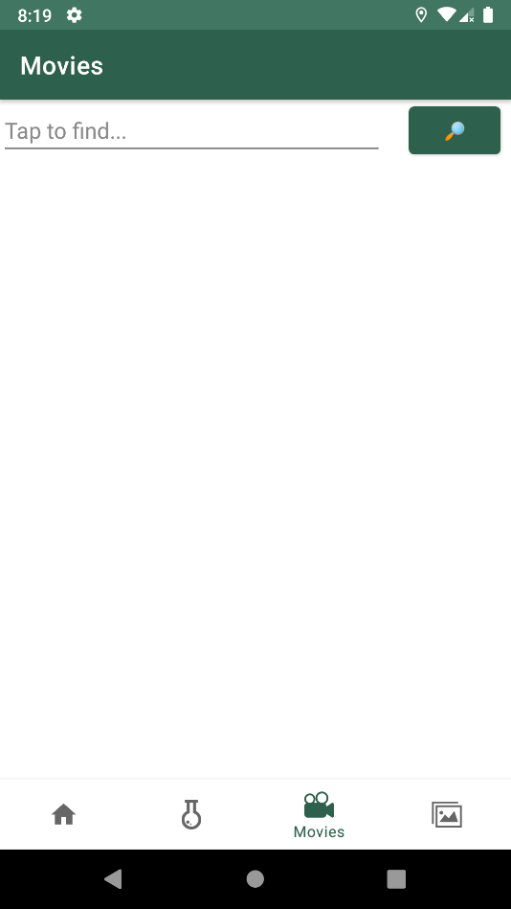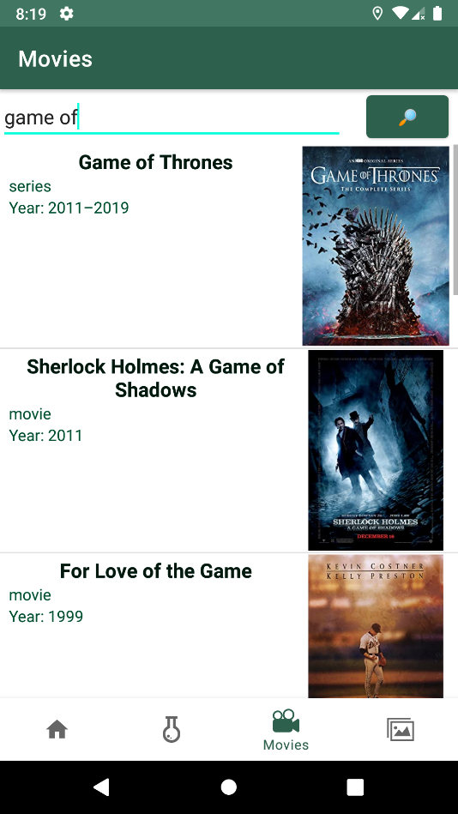
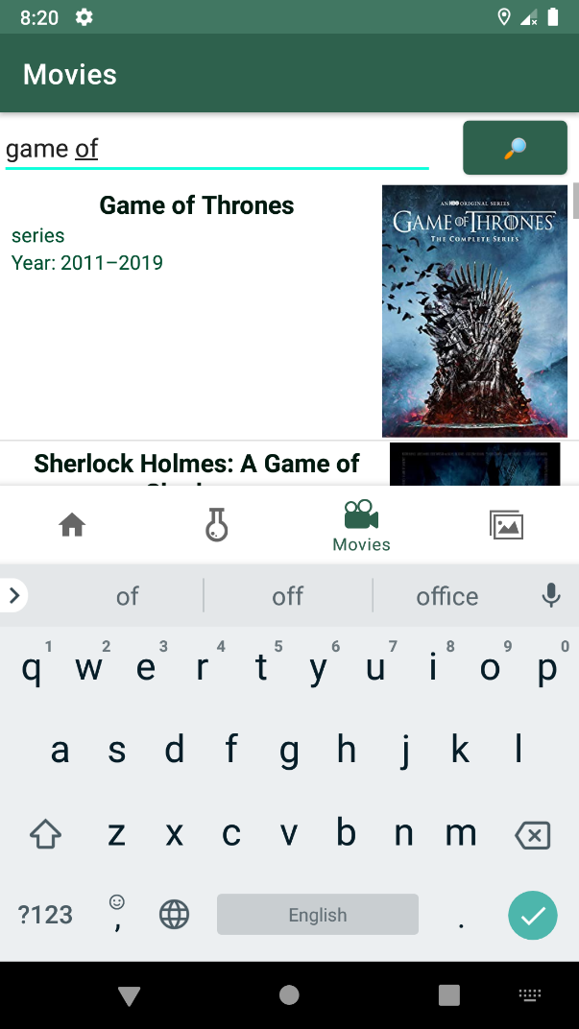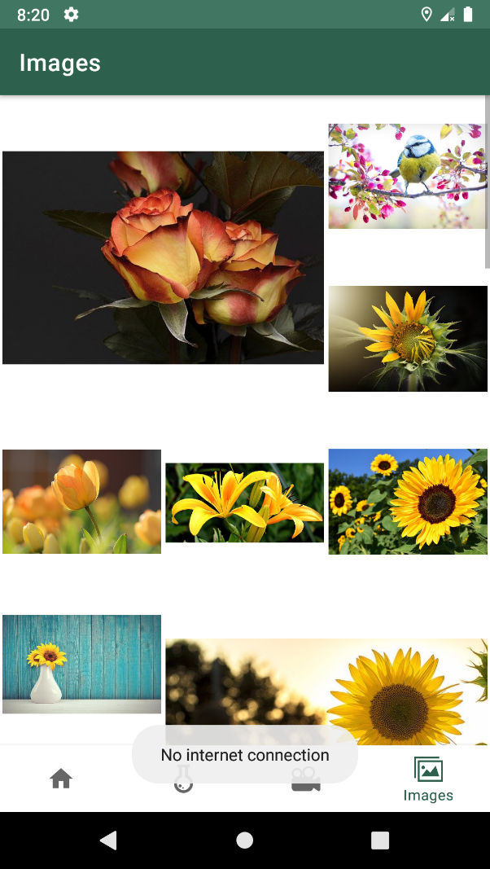

Лістинг:
MoviesFragment.java
package ua.kpi.comsys.IB8118.ui.movies;
import android.annotation.SuppressLint;
import android.app.Activity;
import android.content.Context;
import android.content.Intent;
import android.graphics.Bitmap;
import android.graphics.BitmapFactory;
import android.graphics.Point;
import android.os.Bundle;
import android.view.Display;
import android.view.LayoutInflater;
import android.view.View;
import android.view.ViewGroup;
import android.view.animation.RotateAnimation;
import android.widget.AdapterView;
import android.widget.ArrayAdapter;
import android.widget.Button;
import android.widget.EditText;
import android.widget.ImageView;
import android.widget.ListView;
import android.widget.TextView;
import android.widget.Toast;
import androidx.annotation.NonNull;
import androidx.annotation.Nullable;
import androidx.fragment.app.Fragment;
import java.io.BufferedReader;
import java.io.File;
import java.io.FileInputStream;
import java.io.FileOutputStream;
import java.io.InputStream;
import java.io.InputStreamReader;
import java.io.OutputStream;
import java.net.URL;
import java.util.ArrayList;
import java.util.List;
import ua.kpi.comsys.IB8118.R;
import ua.kpi.comsys.IB8118.sqlite.App;
import ua.kpi.comsys.IB8118.sqlite.MovieDao;
import ua.kpi.comsys.IB8118.sqlite.Poster;
import ua.kpi.comsys.IB8118.sqlite.PosterDao;
import ua.kpi.comsys.IB8118.sqlite.SQLiteDB;
public class MoviesFragment extends Fragment {
List<ua.kpi.comsys.IB8118.ui.movies.Movie> movies;
List<ua.kpi.comsys.IB8118.ui.movies.Movie> foundMovies = new ArrayList<>();
List<ua.kpi.comsys.IB8118.ui.movies.Movie> adapterObjects;
Adapter customAdapter;
ListView movieEntityLV;
int widthScreen;
int maximumLettersTitle;
boolean requiredRecreate = false;
EditText findField;
String API_KEY = "7e9fe69e",
REQUEST;
View rootView;
MovieDao movieDao;
PosterDao posterDao;
public void handleScreenSize() {
super.onResume();
Display screen = getActivity().getWindowManager().getDefaultDisplay();
Point size = new Point();
screen.getSize(size);
widthScreen = size.x;
maximumLettersTitle = widthScreen /16;
}
@Override
public void onPause() {
super.onPause();
handleScreenSize();
}
@Override
public void onResume() {
super.onResume();
if (requiredRecreate)
requireActivity().recreate();
requiredRecreate = false;
}
@Override
public void onCreate(@Nullable @org.jetbrains.annotations.Nullable Bundle savedInstanceState) {
super.onCreate(savedInstanceState);
handleScreenSize();
SQLiteDB database = App.getInstance().getDatabase();
movieDao = database.filmDao();
posterDao = database.posterDao();
}
public View onCreateView(@NonNull LayoutInflater inflater,
ViewGroup container, Bundle savedInstanceState) {
rootView = inflater.inflate(R.layout.fragment_movies, container, false);
Button buttonSearch = rootView.findViewById(R.id.buttonSearch);
findField = rootView.findViewById(R.id.fieldFind);
movieEntityLV = rootView.findViewById(R.id.movies_listView);
movies = MovHandler.getUserMovies(getContext());
if(movies != null){
customAdapter = new Adapter(getActivity(), R.layout.movies, movies);
movieEntityLV.setAdapter(customAdapter);
}
buttonSearch.setOnClickListener(new View.OnClickListener() { // search
@SuppressLint("ShowToast")
@Override
public void onClick(View v) {
if (findField.getText().toString().length()>2)
search();
else
Toast.makeText(getContext(), "Request must be more than 2 symbols", Toast.LENGTH_SHORT);
}
});
movieEntityLV.setOnItemClickListener(new AdapterView.OnItemClickListener() { // call detail info about movie
@Override
public void onItemClick(AdapterView<?> parent, View view, int position, long id) {
startActivity(new Intent(getContext(), MovieInfoActivity.class).putExtra("imdbID", adapterObjects.get(position).getImdbID()));
}
});
return rootView;
}
private class Adapter extends ArrayAdapter<ua.kpi.comsys.IB8118.ui.movies.Movie> {
Adapter(Context context, int textViewResourceId, List<ua.kpi.comsys.IB8118.ui.movies.Movie> objects) {
super(context, textViewResourceId, objects);
adapterObjects = objects;
}
@NonNull
@Override
public View getView(int position, @Nullable View convertView, @NonNull ViewGroup parent) {
LayoutInflater inflater = getLayoutInflater();
@SuppressLint("ViewHolder") View row = inflater.inflate(R.layout.movies, parent, false);
TextView titleTV = row.findViewById(R.id.movieTitle),
typeTV = row.findViewById(R.id.movieType),
yearTV = row.findViewById(R.id.movieYear);
// ImageView loading = row.findViewById(R.id.loading);
RotateAnimation rotate = new RotateAnimation(0, 999999999);
rotate.setDuration(9999);
// loading.startAnimation(rotate);
String title = (adapterObjects.get(position).getTitle());
if (title.length() > maximumLettersTitle)
title = title.substring(0, maximumLettersTitle) + "...";
titleTV.setText(title);
typeTV.setText(adapterObjects.get(position).getType());
yearTV.setText("Year: " + adapterObjects.get(position).getYear());
ImageView posterIV = row.findViewById(R.id.poster_listview);
String poster = adapterObjects.get(position).getPoster();
try {
new Thread(new DownloadPoster(posterIV, getActivity(), poster, getContext())).start();
} catch (Exception e) {
posterIV.setImageResource(R.drawable.unknown_file);
// loading.setVisibility(View.INVISIBLE);
}
return row;
}
}
void search(){
foundMovies.clear();
REQUEST = findField.getText().toString().toLowerCase();
new LoadRequest("search").start();
}
class LoadRequest extends Thread {
LoadRequest(String name){
super(name);
}
public void run(){
List<ua.kpi.comsys.IB8118.sqlite.Movie> entityByRequest = movieDao.getByRequest(REQUEST);
try {
URL url = new URL("http://www.omdbapi.com/?apikey="+API_KEY+"&s="+REQUEST+"&page=1");
String found = (new BufferedReader(new InputStreamReader(url.openStream()))).readLine();
movies = MovHandler.movsFromJson(found);
if (movies.size()==0) // success request, movies not found
getActivity().runOnUiThread(new Runnable() {
@Override
public void run() {
Toast.makeText(getContext(), "No movies", Toast.LENGTH_SHORT).show();
rootView.findViewById(R.id.movies_listView).setVisibility(View.INVISIBLE);
}
});
else {// success request, movies found
new pushMoviesToSqlite("saver").start();
getActivity().runOnUiThread(new Runnable() {
@Override
public void run() {
rootView.findViewById(R.id.movies_listView).setVisibility(View.VISIBLE);
}
});
}
MovHandler.exportToCached(getContext(), movies);
try {
if (!(movies.size()==0))
getActivity().runOnUiThread(new Runnable() {
@Override
public void run() {
customAdapter = new Adapter(getActivity(), R.layout.movies, movies);
movieEntityLV.setAdapter(customAdapter);
}
});
} catch (Exception ignored){}
} catch (Exception e) { // no connection
e.printStackTrace();
if (entityByRequest.size()>0){ // data has in DB
movies = ua.kpi.comsys.IB8118.ui.movies.Movie.movieEntitiesToListMovies(entityByRequest);
MovHandler.exportToCached(getContext(), movies);
try {
if (movies == null)
movies = new ArrayList<>();
getActivity().runOnUiThread(new Runnable() {
@Override
public void run() {
customAdapter = new Adapter(getActivity(), R.layout.movies, movies);
movieEntityLV.setAdapter(customAdapter);
}
});
} catch (Exception exc) {
exc.printStackTrace();
}
} else { // data hasn't in DB
movies = new ArrayList<>();
customAdapter = new Adapter(getContext(), R.layout.movies, movies);
getActivity().runOnUiThread(new Runnable() {
@Override
public void run() {
Toast.makeText(getContext(), "No record in database", Toast.LENGTH_SHORT).show();
movieEntityLV.setAdapter(customAdapter);
}
});
}
// getActivity().runOnUiThread(new Runnable() {
// @Override
// public void run() {
// Toast.makeText(getContext(), "Check internet connection", Toast.LENGTH_SHORT).show();
// }
// });
}
}
}
public class DownloadPoster implements Runnable {
String link;
ImageView posterIV;
Context context;
Activity appAct;
public DownloadPoster(ImageView posterIV, Activity appAct, String link, Context context) {
this.link = link;
this.posterIV = posterIV;
this.context = context;
this.appAct = appAct;
}
public void run() {
Poster workingImg = new Poster();
String fileStr;
if (link.startsWith("http")) { // if link is correct
List<Poster> posters = posterDao.getByUrl(link);
String cacheDir = context.getCacheDir().toString();
boolean hasImage = false;
if (posters.size() != 0) {
String imageCachePath = cacheDir + "/" + posters.get(0).getFileName();
hasImage = new File(imageCachePath).exists();
}
if (posters.size() == 0 | !hasImage) {
if (!hasImage & posters.size()>0)
fileStr = posters.get(0).getFileName();
else {
fileStr = "poster_"+hashCode()+".png";
}
URL link;
try {
link = new URL(this.link);
try (InputStream is = link.openStream()) {
try (OutputStream os = new FileOutputStream(cacheDir + "/" + fileStr)) {
byte[] buffer = new byte[2048];
int bytesRead;
while ((bytesRead = is.read(buffer, 0, buffer.length)) >= 0) {
os.write(buffer, 0, bytesRead);
}
}
}
} catch (Exception e) {
e.printStackTrace();
}
workingImg.link = this.link;
workingImg.fileName = fileStr;
posterDao.insert(workingImg);
}
try {
String imageName = posterDao.getByUrl(link).get(0).getFileName();
File f = new File(context.getCacheDir() + "/" + imageName);
InputStream is = new FileInputStream(f);
Bitmap bitmap = BitmapFactory.decodeStream(is);
appAct.runOnUiThread(new Runnable() {
@Override
public void run() {
posterIV.setImageBitmap(bitmap);
}
});
} catch (Exception e) {
e.printStackTrace();
}
} else if (posterIV != null) {
appAct.runOnUiThread(new Runnable() {
@Override
public void run() {
posterIV.setImageResource(R.drawable.unknown_file);
}
});
}
}
}
class pushMoviesToSqlite extends Thread {
pushMoviesToSqlite(String name){
super(name);
}
public void run(){
ua.kpi.comsys.IB8118.sqlite.Movie filmEntity = new ua.kpi.comsys.IB8118.sqlite.Movie();
try {
if (movieDao.getByRequest(REQUEST).size() == 0) {
if (movies != null)
for (ua.kpi.comsys.IB8118.ui.movies.Movie movie : movies) {
filmEntity.setTitle(movie.getTitle());
filmEntity.setImdbID(movie.getImdbID());
filmEntity.setType(movie.getType());
filmEntity.setPoster(movie.getPoster());
filmEntity.setYear(movie.getYear());
filmEntity.SearchRequest = REQUEST;
movieDao.insert(filmEntity);
}
}
} catch (Exception ignored){}
}
}
}

ImageContainerFragment.java
package ua.kpi.comsys.IB8118.ui.images;
import android.app.Activity;
import android.content.Context;
import android.graphics.Bitmap;
import android.graphics.BitmapFactory;
import android.graphics.Point;
import android.os.Bundle;
import android.view.Display;
import android.view.LayoutInflater;
import android.view.View;
import android.view.ViewGroup;
import android.widget.ArrayAdapter;
import android.widget.ImageView;
import android.widget.LinearLayout;
import android.widget.ListView;
import android.widget.Toast;
import androidx.annotation.NonNull;
import androidx.annotation.Nullable;
import androidx.constraintlayout.widget.ConstraintLayout;
import androidx.fragment.app.Fragment;
import java.io.BufferedReader;
import java.io.File;
import java.io.FileInputStream;
import java.io.FileOutputStream;
import java.io.InputStream;
import java.io.InputStreamReader;
import java.io.OutputStream;
import java.net.URL;
import java.util.ArrayList;
import java.util.List;
import ua.kpi.comsys.IB8118.R;
import ua.kpi.comsys.IB8118.sqlite.App;
import ua.kpi.comsys.IB8118.sqlite.Image;
import ua.kpi.comsys.IB8118.sqlite.ImageDao;
public class ImageContainerFragment extends Fragment {
View rootView;
Adapter customAdapter;
ListView imagesLV;
static int widthScreen;
List<List<String>> handledImages = new ArrayList<>();
ConstraintLayout containerImages;
double aspectRatio = 5.0 / 3.0;
ImageDao imageDao;
//url settings in 113 line
public View onCreateView(@NonNull LayoutInflater inflater,
ViewGroup container, Bundle savedInstanceState) {
rootView = inflater.inflate(R.layout.fragment_images, container, false);
imageDao = App.getInstance().getDatabase().imageDao();
new Thread(new ClearDatabase()).start();
Display screenSize = getActivity().getWindowManager().getDefaultDisplay();
Point size = new Point();
screenSize.getSize(size);
widthScreen = size.x;
imagesLV = rootView.findViewById(R.id.images);
containerImages = rootView.findViewById(R.id.containerImages);
new ParseAndSetImage("StartLoad").start();
return rootView;
}
double getSizeListViewOfCoefficient(int usedHeight) {
return 1.0 - (double) usedHeight / 5.0;
}
void setListViewHeight() {
try {
if (customAdapter != null) {
ConstraintLayout main = rootView.findViewById(R.id.imageFragment);
int actualHeightLV, imgOnLV = handledImages.get(handledImages.size() - 1).size(),
defaultHeight = main.getHeight();
float useOfScreen = (float) (widthScreen * aspectRatio) / (float) defaultHeight;
double sizeListViewMul;
if (imgOnLV < 4)
sizeListViewMul = getSizeListViewOfCoefficient(2);
else if (imgOnLV < 7)
sizeListViewMul = getSizeListViewOfCoefficient(3);
else if (imgOnLV < 8)
sizeListViewMul = getSizeListViewOfCoefficient(4);
else
sizeListViewMul = 0.0;
actualHeightLV = defaultHeight + (int) (defaultHeight * useOfScreen * sizeListViewMul);
ConstraintLayout.LayoutParams paramCL = (ConstraintLayout.LayoutParams) containerImages.getLayoutParams();
paramCL.height = actualHeightLV;
containerImages.setLayoutParams(paramCL);
}
} catch (Exception ignored) {
}
}
class ParseAndSetImage extends Thread {
ParseAndSetImage(String name) {
super(name);
}
public void run() {
List<String> links = new ArrayList<>();
List<List<String>> listOfLinks = new ArrayList<>();
try { // has connection
URL url = new URL("https://pixabay.com/api/?key=" + "19193969-87191e5db266905fe8936d565" + "&q=" + "yellow+flowers" + "&image_type=photo&per_page=" + 27);
BufferedReader bufferedReader = new BufferedReader(new InputStreamReader(url.openStream()));
String currentLine;
StringBuilder finalString = new StringBuilder();
while ((currentLine = bufferedReader.readLine()) != null) {
finalString.append(currentLine);
}
String[] strings = finalString.toString().split("\"webformatURL\":\"");
for (String entity : strings) {
if (entity.startsWith("htt")) {
links.add(entity.split("\",\"")[0]);
}
}
String currentLink;
for (int j = 0; j < links.size(); j++) {
currentLink = links.get(j);
if (listOfLinks.isEmpty()) {
List<String> additional = new ArrayList<>();
listOfLinks.add(additional);
}
if (listOfLinks.get(listOfLinks.size() - 1).size() >= 9) {
List<String> additional = new ArrayList<>();
additional.add(currentLink);
listOfLinks.add(additional);
} else {
listOfLinks.get(listOfLinks.size() - 1).add(currentLink);
}
}
getActivity().runOnUiThread(new Runnable() {
@Override
public void run() {
customAdapter = new Adapter(getActivity(), R.layout.images, listOfLinks, getActivity());
imagesLV.setAdapter(customAdapter);
}
});
} catch (Exception ignored) { // hasn't connection
List<Image> listOfImagesEnt = imageDao.getAll();
for (Image entity : listOfImagesEnt) {
if (handledImages != null) {
if (handledImages.size() == 0) {
List<String> list = new ArrayList<>();
handledImages.add(list);
}
if (handledImages.get(handledImages.size() - 1).size() >= 9) {
List<String> list = new ArrayList<>();
list.add(entity.getUrl());
handledImages.add(list);
} else {
handledImages.get(handledImages.size() - 1).add(entity.getUrl());
}
}
}
getActivity().runOnUiThread(new Runnable() {
@Override
public void run() {
Toast.makeText(getContext(), "No internet connection", Toast.LENGTH_SHORT).show();
if (handledImages != null) {
imagesLV = rootView.findViewById(R.id.images);
customAdapter = new Adapter(getActivity(), R.layout.images, handledImages, getActivity());
imagesLV.setAdapter(customAdapter);
} else {
Toast.makeText(getContext(), "Error getting imgs", Toast.LENGTH_SHORT).show();
}
}
});
}
}
}
class Adapter extends ArrayAdapter<List<String>> {
final List<List<String>> unableImages;
Activity generalAct;
Adapter(Context context, int textViewResourceId, List<List<String>> objects, Activity generalAct) {
super(context, textViewResourceId, objects);
this.unableImages = objects;
this.generalAct = generalAct;
setListViewHeight();
}
@NonNull
@Override
public View getView(int position, @Nullable View convertView, @NonNull ViewGroup parent) {
LayoutInflater inflater = (LayoutInflater) getContext().getSystemService(Context.LAYOUT_INFLATER_SERVICE);
View container = inflater.inflate(R.layout.images, parent, false);
LinearLayout containerGroup = container.findViewById(R.id.imgSet);
ViewGroup.LayoutParams lp = containerGroup.getLayoutParams();
lp.height = (int) (widthScreen * aspectRatio);
containerGroup.setLayoutParams(lp);
List<ImageView> listIV = new ArrayList<>();
listIV.add(container.findViewById(R.id.img1));
listIV.add(container.findViewById(R.id.img2));
listIV.add(container.findViewById(R.id.img3));
listIV.add(container.findViewById(R.id.img4));
listIV.add(container.findViewById(R.id.img5));
listIV.add(container.findViewById(R.id.img6));
listIV.add(container.findViewById(R.id.img7));
listIV.add(container.findViewById(R.id.img8));
listIV.add(container.findViewById(R.id.img9));
int sizeOfImages = unableImages.get(position).size();
for (int j = 0; j < sizeOfImages; j++) {
try {
new Thread(new DownloadPoster(listIV.get(j), getActivity(), unableImages.get(position).get(j), getContext())).start();
} catch (Exception e) {
e.printStackTrace();
}
}
return container;
}
}
public class DownloadPoster implements Runnable {
String link;
ImageView posterIV;
Context context;
Activity appAct;
public DownloadPoster(ImageView posterIV, Activity appAct, String link, Context context) {
this.link = link;
this.posterIV = posterIV;
this.context = context;
this.appAct = appAct;
System.out.println("INIT HANDLE");
}
public void run() {
Image workingImg = new Image();
String fileStr;
if (link.startsWith("http")) {
List<Image> imageEntities = imageDao.getByUrl(link);
String cacheDir = context.getCacheDir() + "";
System.out.println("STARTS WITH HTTP");
boolean hasImage = false;
if (imageEntities.size() != 0) {
String imageCachePath = cacheDir + "/" + imageEntities.get(0).getFileName();
hasImage = new File(imageCachePath).exists();
}
if (imageEntities.size() == 0 | !hasImage) {
System.out.println("IMG HASN'T IN DB");
if (!hasImage & imageEntities.size() > 0)
fileStr = imageEntities.get(0).getFileName();
else {
fileStr = "img_" + hashCode() + ".png";
}
URL link;
try {
link = new URL(this.link);
try (InputStream input = link.openStream()) {
try (OutputStream output = new FileOutputStream(cacheDir + "/" + fileStr)) {
byte[] buffer = new byte[2048];
int bytesRead;
while ((bytesRead = input.read(buffer, 0, buffer.length)) >= 0) {
output.write(buffer, 0, bytesRead);
}
}
}
} catch (Exception e) {
e.printStackTrace();
}
workingImg.url = this.link;
workingImg.fileName = fileStr;
imageDao.insert(workingImg);
}
try {
String imageName = imageDao.getByUrl(link).get(0).getFileName();
File f = new File(context.getCacheDir() + "/" + imageName);
InputStream is = new FileInputStream(f);
Bitmap bitmap = BitmapFactory.decodeStream(is);
appAct.runOnUiThread(new Runnable() {
@Override
public void run() {
posterIV.setImageBitmap(bitmap);
}
});
} catch (Exception e) {
e.printStackTrace();
}
} else if (posterIV != null) {
appAct.runOnUiThread(new Runnable() {
@Override
public void run() {
posterIV.setImageResource(R.drawable.unknown_file);
}
});
}
}
}
public class ClearDatabase implements Runnable {
@Override
public void run() {
imageDao.clearTrash();
}
}
}

