Національний Технічний Університет України
«Київський політехнічний інститут імені Ігоря Сікорського»
Факультет Інформатики та Обчислювальної Техніки
Кафедра обчислювальної техніки

Лабораторна робота №5
«Програмування мобільних систем»

Виконала:
студентка 3 курсу факультету ІОТ
групи ІВ-81
Лиса Еліза

Перевірив:
Шульга М.В.
Київ 2021
Варіант: 8118 mod 6 + 1 = 1
Варіант 1
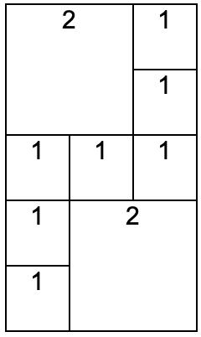

Скріншоти додатка:
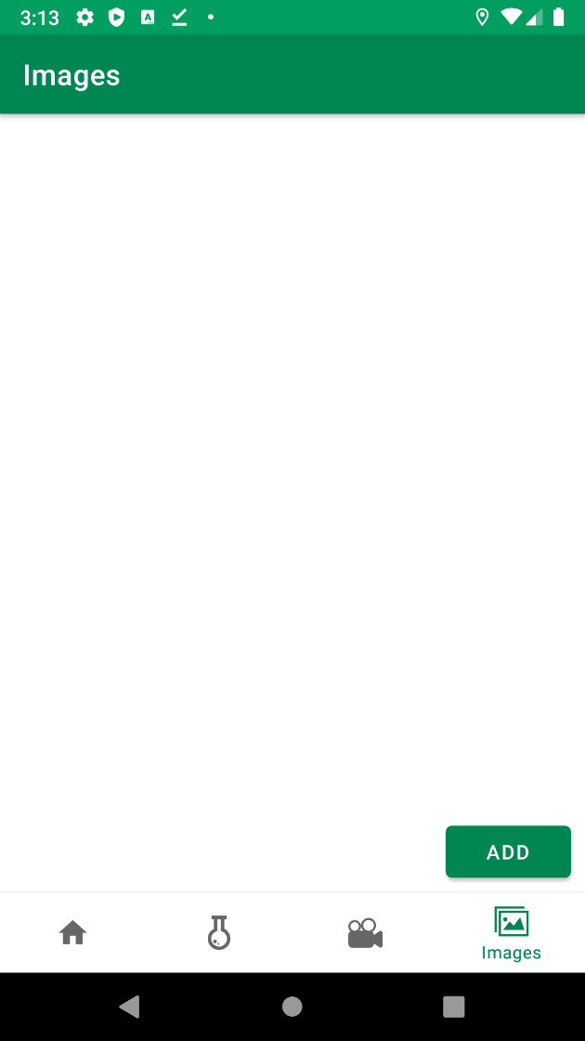
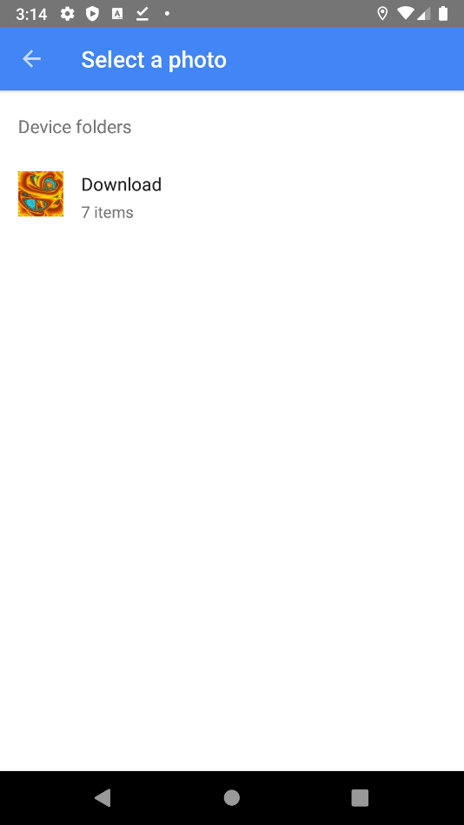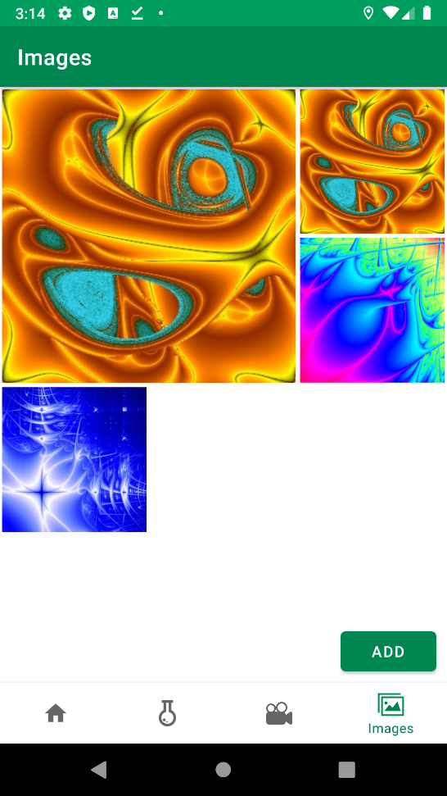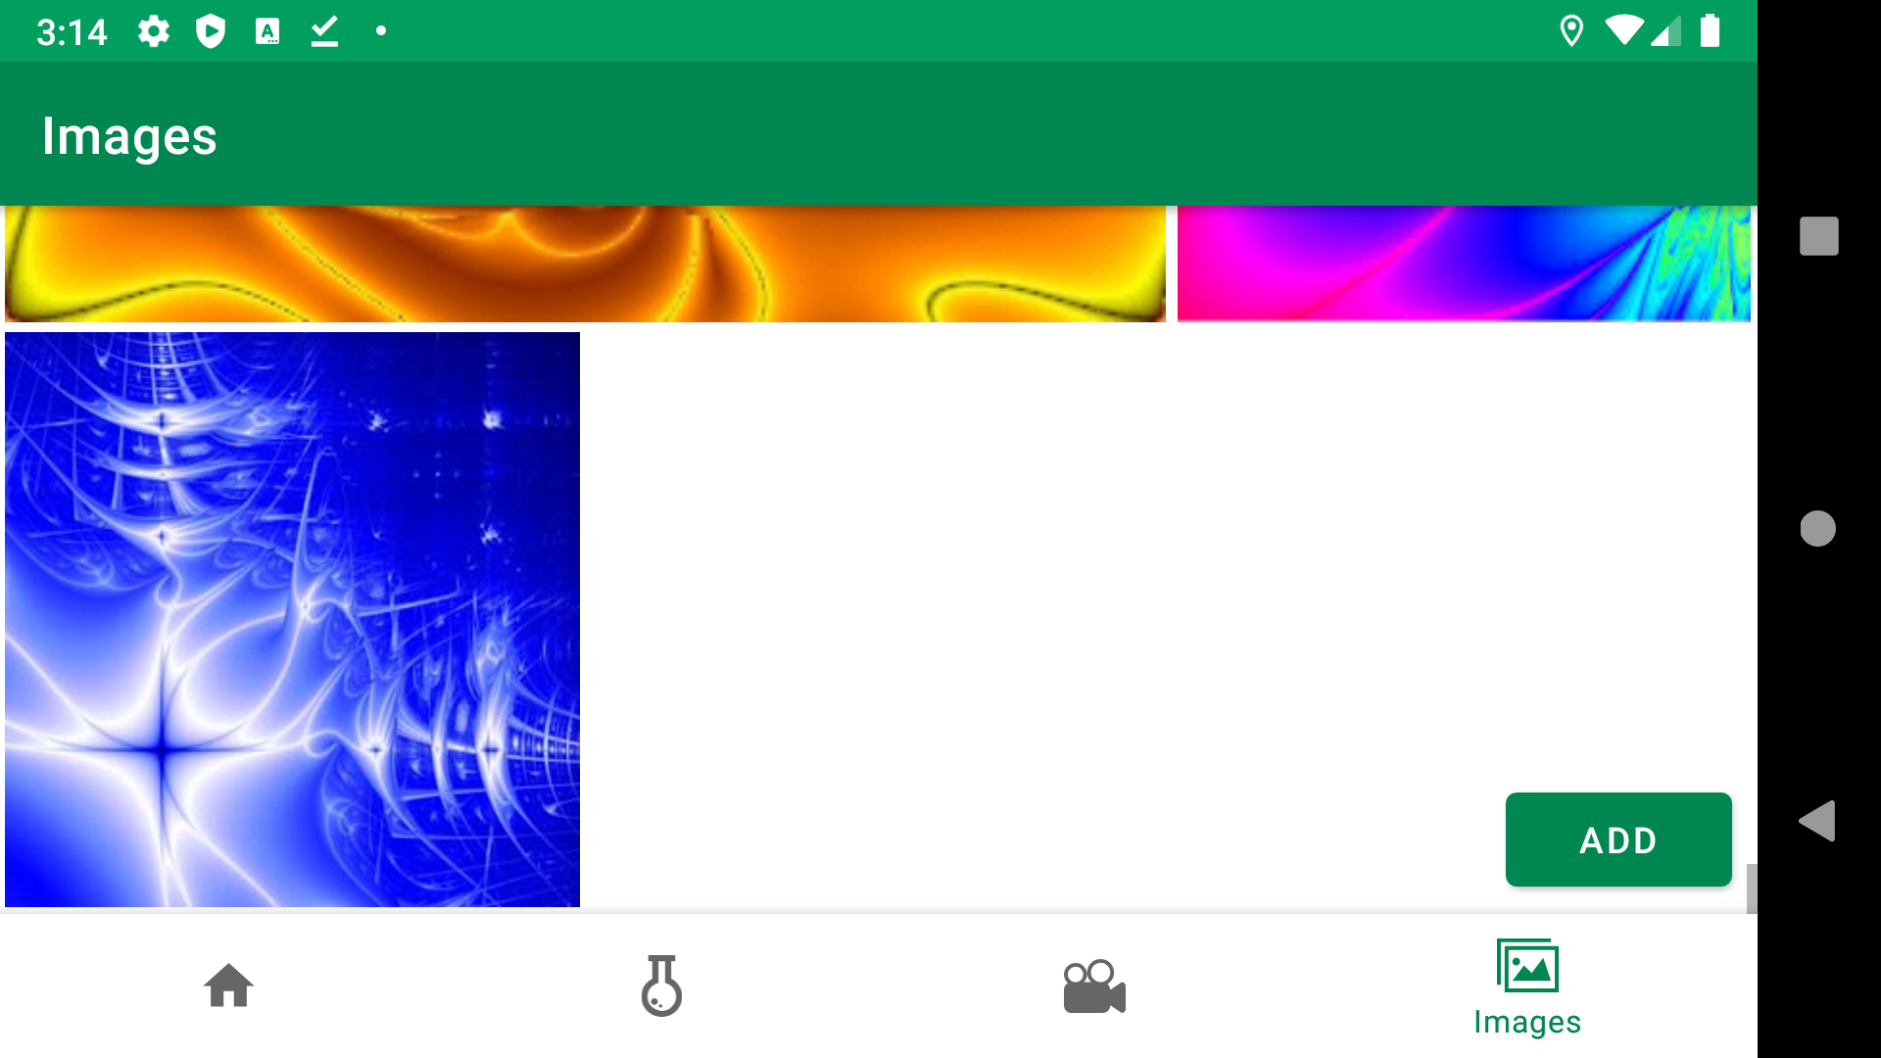

Лістинг:
ImageCollectionFragment.java
package ua.kpi.comsys.IB8118.ui.images;

import android.app.Activity;
import android.content.Context;
import android.content.Intent;
import android.content.SharedPreferences;
import android.graphics.Bitmap;
import android.graphics.BitmapFactory;
import android.graphics.Point;
import android.net.Uri;
import android.os.Bundle;
import android.view.Display;
import android.view.LayoutInflater;
import android.view.View;
import android.view.ViewGroup;
import android.widget.ArrayAdapter;
import android.widget.Button;
import android.widget.ImageView;
import android.widget.LinearLayout;
import android.widget.ListView;

import androidx.annotation.NonNull;
import androidx.annotation.Nullable;
import androidx.constraintlayout.widget.ConstraintLayout;
import androidx.fragment.app.Fragment;

import java.io.ByteArrayOutputStream;
import java.io.File;
import java.io.FileInputStream;
import java.io.FileOutputStream;
import java.io.InputStream;
import java.util.ArrayList;
import java.util.Arrays;
import java.util.List;

import ua.kpi.comsys.IB8118.R;

import static android.app.Activity.RESULT_OK;

public class ImageCollectionsFragment extends Fragment {
View root;
Adapter adapter;
ListView images;

static int screenSizeY;
List<List<String>> handledImages = new ArrayList<>();
String sharedPref = "images";
boolean fragmentInFocus = false;
ConstraintLayout containerImages;
double aspectRatio = 5.0/3.0;

/**
* Called when the Fragment is no longer started. This is generally
* tied to {Activity.onStop} of the containing
* Activity's lifecycle.
*/
@Override
public void onStop() {
super.onStop();
//fragment closed
}

@Override
public void onPause() {
super.onPause();
// if fragment be inactive, run once
SharedPreferences sharedPreferences = getActivity().getSharedPreferences(sharedPref, Context.MODE_PRIVATE);
SharedPreferences.Editor handlerSettings = sharedPreferences.edit();
handlerSettings.putString(sharedPref, makeStringFromImgLists(handledImages));
handlerSettings.apply();
}

@Override
public void onResume() {
super.onResume();
setImagesList();
}

public View onCreateView(@NonNull LayoutInflater inflater,
ViewGroup container, Bundle savedInstanceState) {
root = inflater.inflate(R.layout.fragment_images, container, false);

Display screensize = getActivity().getWindowManager().getDefaultDisplay();
Point size = new Point();
screensize.getSize(size);
screenSizeY = size.x;

Button buttonAddImage = root.findViewById(R.id.buttonAddImage);
images = root.findViewById(R.id.images);
containerImages = root.findViewById(R.id.containerImages);

buttonAddImage.setOnClickListener(new View.OnClickListener() {
public void onClick(View view) {
Intent intent = new Intent(Intent.ACTION_PICK,
android.provider.MediaStore.Images.Media.EXTERNAL_CONTENT_URI);
startActivityForResult(intent, 1);
}
});

return root;
}

@Override
public void onActivityResult(int requestCode, int resultCode, Intent imageReturnedIntent) {
super.onActivityResult(requestCode, resultCode, imageReturnedIntent);

if (!fragmentInFocus){
fragmentInFocus = true;
}

if (requestCode == 1 & imageReturnedIntent!=null) {
if (resultCode == RESULT_OK) {
try {
final Uri source = imageReturnedIntent.getData();
final InputStream is = getContext().getContentResolver().openInputStream(source);
Bitmap imageBitmp = BitmapFactory.decodeStream(is);

String imgName = "userImage-"+source.hashCode();

if (handledImages != null){
if (handledImages.size()==0){
List<String> imgList = new ArrayList<>();
handledImages.add(imgList);
}
if (handledImages.get(handledImages.size()-1).size()>=9){
List<String> imgList = new ArrayList<>();
imgList.add(imgName);
handledImages.add(imgList);
}
else
handledImages.get(handledImages.size()-1).add(imgName);
}

ByteArrayOutputStream bos = new ByteArrayOutputStream();
if (imageBitmp.getWidth() < 450 | imageBitmp.getHeight() < 450)
imageBitmp.compress(Bitmap.CompressFormat.PNG, 100, bos);
else {
float ratioImage = (float)imageBitmp.getWidth()/imageBitmp.getHeight();
imageBitmp = Bitmap.createScaledBitmap(imageBitmp, (int)(450*ratioImage), 450, false);
imageBitmp.compress(Bitmap.CompressFormat.PNG, 100, bos);
}

byte[] bitmapdata = bos.toByteArray();
File imageFile = new File(getContext().getFilesDir(), imgName);

try {
FileOutputStream fos = new FileOutputStream(imageFile);
fos.write(bitmapdata);
fos.flush();
fos.close();

} catch (Exception ignored) {}

if(handledImages != null & handledImages.get(0).size()==1){
adapter = new Adapter(getActivity(), R.layout.images, handledImages, getActivity());
images.setAdapter(adapter);
}
else if (handledImages.size()>0)
adapter.notifyDataSetChanged();
setListViewHeight();

} catch (Exception e) {
e.printStackTrace();
}
}
}
}

double getSizeListViewOfCoefficient(int usedHeight){
return 1.0-(double)usedHeight/5.0;
}

void setListViewHeight(){
if (adapter != null) {
int totalHeight, imgOnLV = handledImages.get(handledImages.size()-1).size();
ConstraintLayout main = root.findViewById(R.id.imageFragment);

int heightView = main.getHeight();

float useOfScreen = (float)(screenSizeY *aspectRatio)/(float)heightView;
double sizeListViewMul;

if (imgOnLV < 4)
sizeListViewMul = getSizeListViewOfCoefficient(2);
else if (imgOnLV < 7)
sizeListViewMul = getSizeListViewOfCoefficient(3);
else if (imgOnLV < 8)
sizeListViewMul = getSizeListViewOfCoefficient(4);
else
sizeListViewMul = 0.0;
totalHeight = heightView+(int)(heightView*useOfScreen*sizeListViewMul);

ConstraintLayout.LayoutParams lp = (ConstraintLayout.LayoutParams) containerImages.getLayoutParams();
lp.height = totalHeight;
containerImages.setLayoutParams(lp);
}
}

public String makeStringFromImgLists(List<List<String>> listOfImage){
StringBuilder stringBuilder = new StringBuilder();
for (List<String> image : listOfImage)
for (int j = 0; j < image.size(); j++) {
stringBuilder.append(image.get(j));
stringBuilder.append("@");
}
String finalString = stringBuilder.toString();
if (finalString.length()>0)
return finalString.substring(0, finalString.length() - 1);
return "";
}

public List<List<String>> makeImgListsFromString(String stringOfImages){
List<List<String>> listsOfImages = new ArrayList<>();
List<String> generalSplitList = new ArrayList<>(Arrays.asList(stringOfImages.split("@")));
if (stringOfImages.equals(""))
return listsOfImages;
for (String secondaryImageList : generalSplitList) {
if (listsOfImages.size() <1) {
List<String> imgList = new ArrayList<>();
listsOfImages.add(imgList);
}
if (listsOfImages.get(listsOfImages.size() - 1).size() >= 9) {
List<String> imgList = new ArrayList<>();
imgList.add(secondaryImageList);
listsOfImages.add(imgList);
} else
listsOfImages.get(listsOfImages.size()-1).add(secondaryImageList);
}
return listsOfImages;
}

public void setImagesList(){
if (!fragmentInFocus) {
SharedPreferences sharedPreferences = getActivity().getSharedPreferences(sharedPref, Context.MODE_PRIVATE);
handledImages = makeImgListsFromString(sharedPreferences.getString(sharedPref, ""));
if (handledImages != null & handledImages.size() > 0) {
if (handledImages.get(0).size() > 0) {
adapter = new Adapter(getActivity(), R.layout.images, handledImages, getActivity());
images.setAdapter(adapter);
setListViewHeight();
} else
handledImages = new ArrayList<>();
} else
handledImages = new ArrayList<>();
fragmentInFocus = true;
}
}

class Adapter extends ArrayAdapter<List<String>> {
private final List<List<String>> taskImg;
Activity generalAct;

Adapter(Context context, int textViewResourceId, List<List<String>> objects, Activity generalAct) {
super(context, textViewResourceId, objects);
this.taskImg = objects;
this.generalAct = generalAct;
}

@NonNull
@Override
public View getView(int position, @Nullable View convertView, @NonNull ViewGroup parent) {
LayoutInflater layoutInflater = (LayoutInflater) getContext().getSystemService(Context.LAYOUT_INFLATER_SERVICE);
View mainView = layoutInflater.inflate(R.layout.images, parent, false);
setListViewHeight();

LinearLayout LV = mainView.findViewById(R.id.imgSet);
ViewGroup.LayoutParams lp = LV.getLayoutParams();
lp.height = (int)(screenSizeY *aspectRatio);
lp.width = screenSizeY;
LV.setLayoutParams(lp);

List<ImageView> listIV = new ArrayList<>();
listIV.add(mainView.findViewById(R.id.img1));
listIV.add(mainView.findViewById(R.id.img2));
listIV.add(mainView.findViewById(R.id.img3));
listIV.add(mainView.findViewById(R.id.img4));
listIV.add(mainView.findViewById(R.id.img5));
listIV.add(mainView.findViewById(R.id.img6));
listIV.add(mainView.findViewById(R.id.img7));
listIV.add(mainView.findViewById(R.id.img8));
listIV.add(mainView.findViewById(R.id.img9));

int imgsNum = taskImg.get(position).size();

for (int i=0; i<imgsNum; i++){
try {
SetIV setIV = new SetIV(listIV.get(i), generalAct, getContext(), taskImg.get(position).get(i)); // download + set image
new Thread(setIV).start();
} catch (Exception ignored){}
}
return mainView;
}

public class SetIV implements Runnable {
protected ImageView IV;
protected Activity mainActivity;
protected Context context;
protected String imgFile;

public SetIV(ImageView IV, Activity mainActivity, Context context, String imgFile) {
this.IV = IV;
this.mainActivity = mainActivity;
this.context = context;
this.imgFile = imgFile;
}

public void run() {
try {
String filePath = context.getFilesDir() + "/" + imgFile;
InputStream is = new FileInputStream(new File(filePath));
Bitmap bitmapImage = BitmapFactory.decodeStream(is);
mainActivity.runOnUiThread(new Runnable() {
@Override
public void run() {
IV.setImageBitmap(bitmapImage);
}
});
} catch (Exception e) {
e.printStackTrace();
}
}
}
}
}

