

{Date}

The Medical Director

{HospitalName}

{HospitalStreet},

{HospitalCity},

{HospitalState}.

**MEDICAL EXAMINATION**

The above subject refers.

Kindly carry out medical examinations on the named client as stated below:

|  |  |  |
| --- | --- | --- |
| **Name of Client** | **Medical Test** | **Phone Number** |
| {PatientName} | {MedicalTest} | {PatientPhoneNumber} |

We look forward to receiving the medical results in good time to enable us conclude the necessary underwriting.

Yours faithfully,

For: **AXA MANSARD INSURANCE PLC**

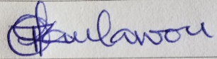

Authorized Signatory